2.4 QUANTITY SALES

This allows registering of items with more than one quantity. A number must be prefixed before pressing the <QTY> key. This speeds up registration.

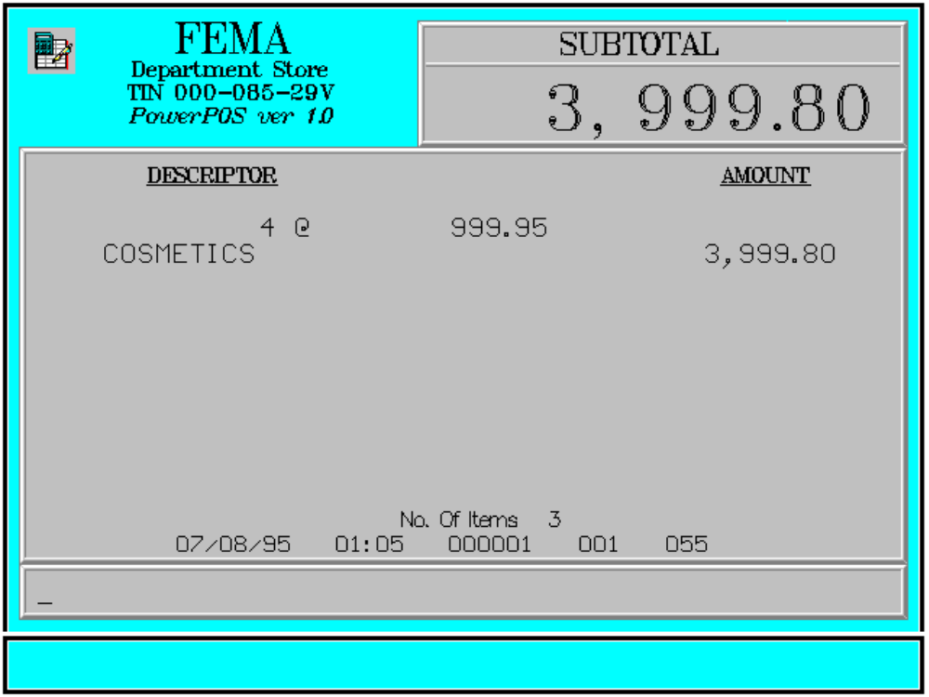

Key Sequence:

1
2
quantity QTY

SCAN

PLU PLU
code

1-14 digits

price DEPART
MENT

price DEPT department ENTER
CODE code

1-4 digits

Error Condition:

Invalid Sequence

This is due to pressing an invalid key with respect to the sequence of operations.

Sample Printout:

RECEIPT JOURNAL

FEMA DEPARTMENT STORE COSMETICS
MAKATI 4 @ 999.95
TIN 123-456-29V 3,999.80
SUBTOTAL 3,999.80
4 @ 999.95 CASH 4,000.00
COSMETICS 3,999.80 CHANGE 0.20

SUBTOTAL 3,999.80 4 ITEMS
CASH 4,000.00
CHANGE 0.20
12300 000 0815 01:23 005
NO. OF ITEMS 4

08/15/95 01:23 12300 000 005

WE ARE HAPPY TO SERVE YOU
THANK YOU, COME AGAIN

TERMINAL CODE
CASHIER KNOWN CODE
TRANSACTION NUMBER
TIME
DATE

