2.5 CASH TENDER

For cash tendering of sales order where the amount paid may be less than, greater than, or equal to order value.

2.5.1 Direct Tender

Amount paid is equal to the balance due.

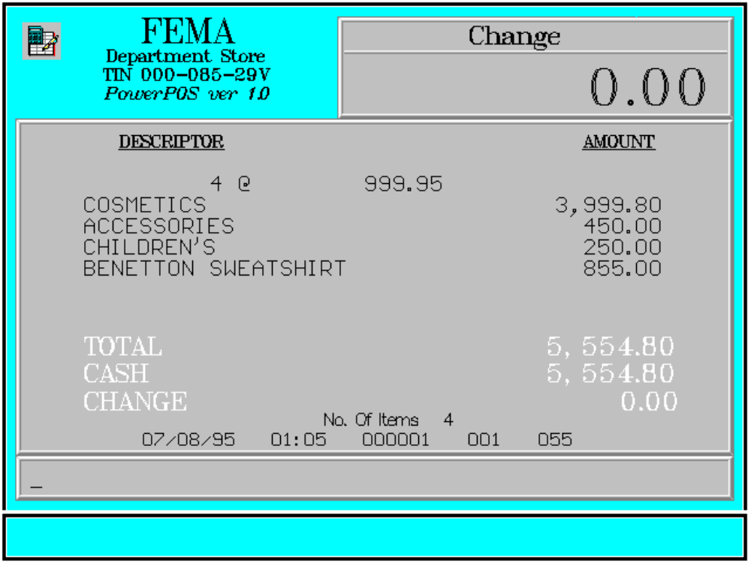

Key Sequence:

1
2 item SUB CASH
registration TOTAL

Error Condition:

Invalid Sequence

This is due to pressing an invalid key with respect to the sequence of operations.

Sample Printout:

RECEIPT JOURNAL

FEMA DEPARTMENT STORE COSMETICS
MAKATI 4 @ 999.95
TIN 000-085-29V 3,999.80
ACCESSORIES 450.00
CHILDREN’S 250.00 4 @ 999.95 BENETTON SWEATSHIRT 855.00
COSMETICS 3,999.80
ACCESSORIES 450.00 SUBTOTAL 5,554.80
CHILDREN’S 250.00 CASH 5,554.80
BENETTON SWEATSHIRT 855.00
7 ITEMS
SUBTOTAL 5,554.80
CASH 5,554.80 12300 000 0815 01:23 005
CHANGE 0.00
NO. OF ITEMS 7

08/15/95 01:23 12300 000 005

WE ARE HAPPY TO SERVE YOU
THANK YOU, COME AGAIN

TERMINAL CODE
CASHIER KNOWN CODE
TRANSACTION NUMBER
TIME
DATE

2.5.2 Amount Tender

Amount paid is greater than the balance due.

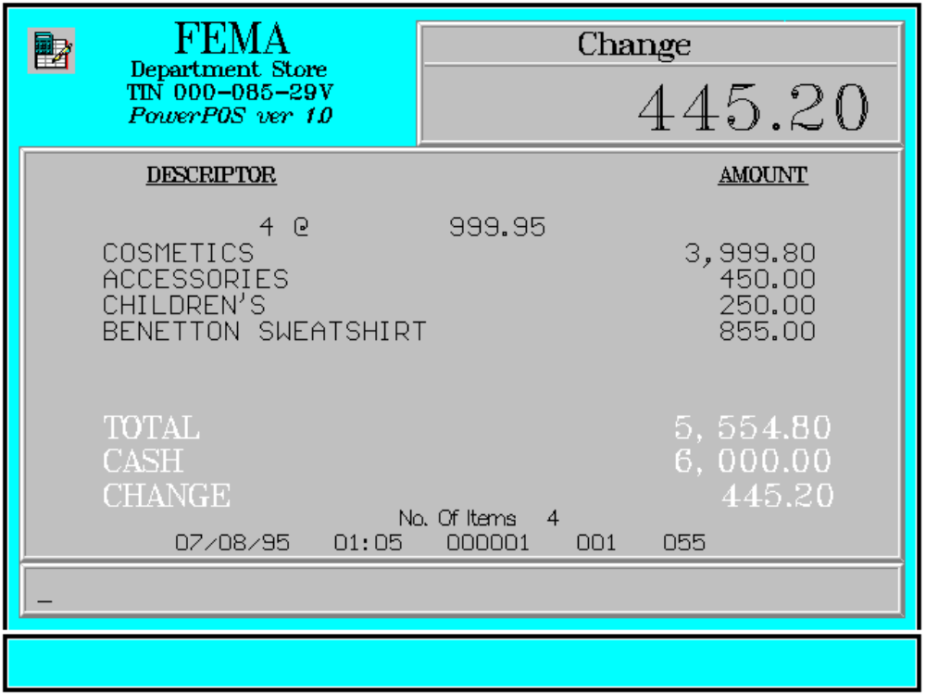

Key Sequence:

1
2 item SUB tendered CASH
registration TOTAL amount

Error Condition:

Invalid Sequence

This is due to pressing an invalid key with respect to the key sequence.

Sample Printout:

RECEIPT JOURNAL

FEMA DEPARTMENT STORE COSMETICS
MAKATI 4 @ 999.95
TIN 000-085-29V 3,999.80
ACCESSORIES 450.00
CHILDREN’S 250.00 4 @ 999.95 BENETTON SWEATSHIRT 855.00
COSMETICS 3,999.80
ACCESSORIES 450.00 SUBTOTAL 5,554.80
CHILDREN’S 250.00 CASH 6,000.00
BENETTON SWEATSHIRT 855.00
7 ITEMS
SUBTOTAL 5,554.80
CASH 6,000.00 12300 000 0815 01:23 005
CHANGE 445.20
NO. OF ITEMS 7

08/15/95 01:23 12300 000 005

WE ARE HAPPY TO SERVE YOU
THANK YOU, COME AGAIN

TERMINAL CODE
CASHIER KNOWN CODE
TRANSACTION NUMBER
TIME
DATE

2.5.3 Multiple Tender

Amount paid is less than the balance due.

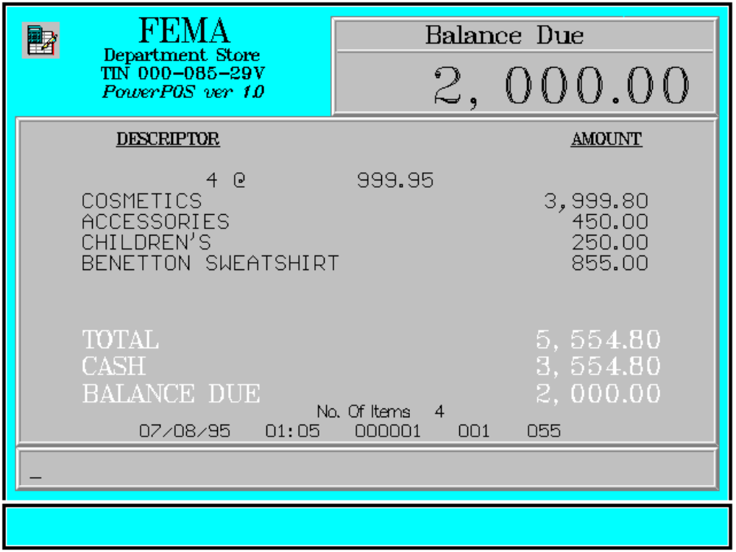

Key Sequence:
repeat as necessary

1 *
2 item SUB tendered
registration TOTAL amount CASH

*For the final payment the amount charged need not be entered.
The remaining balance due may be paid in cash or in other payment mode.

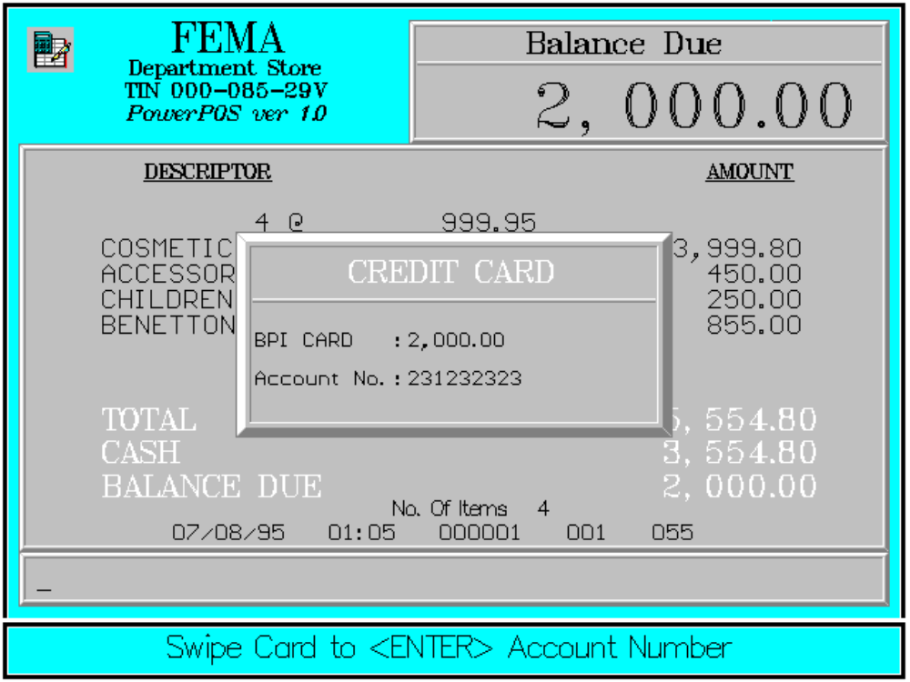

For payment using cash with other modes of payment, see split payment mode.

Error Condition:

Invalid Sequence

This is due to pressing an invalid key with respect to the sequence of operations.

Sample Printout:

RECEIPT JOURNAL

FEMA DEPARTMENT STORE COSMETICS
MAKATI 4 @ 999.95
TIN 000-085-29V 3,999.80
ACCESSORIES 450.00
CHILDREN’S 250.00 4 @ 999.95 BENETTON SWEATSHIRT 855.00
COSMETICS 3,999.80
ACCESSORIES 450.00 CASH 3,554.80
CHILDREN’S 250.00 BPI CARD 2,000.00
BENETTON SWEATSHIRT 855.00 Acct# 00000000000231232323
2,000.00
CASH 3,554.80 SUBTOTAL 2,000.00
SUBTOTAL 5,554.80
BAL. DUE 2,000.00 7 ITEMS

Acct# 00000000000231232323 12300 000 0815 01:23 005
BPI CARD 2,000.00

SUBTL 2,000.00
TOTAL 2,000.00

NO. OF ITEMS 7

08/15/95 01:23 12300 000 005

WE ARE HAPPY TO SERVE YOU
THANK YOU, COME AGAIN

TERMINAL CODE
CASHIER KNOWN CODE
TRANSACTION NUMBER
TIME
DATE

