2.6 CREDIT CARD TENDER

For non-cash payment of sales order with the use of credit cards. Amount paid may be equal to or less than the order value (in the case of multiple card or split payment modes). Each tender will be validated unless validation is set off.

This is the initial screen upon invoking the credit card payment mode.

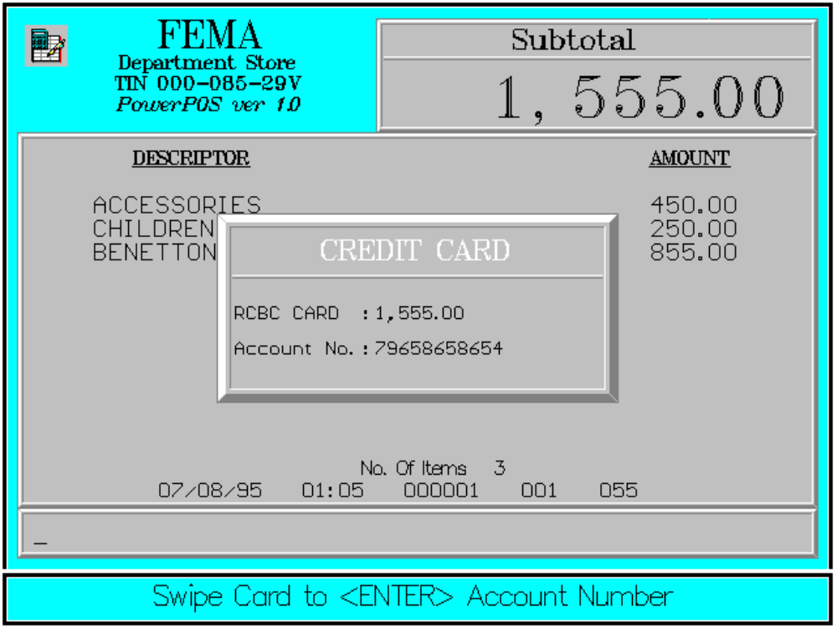

The screen upon payment in credit card.

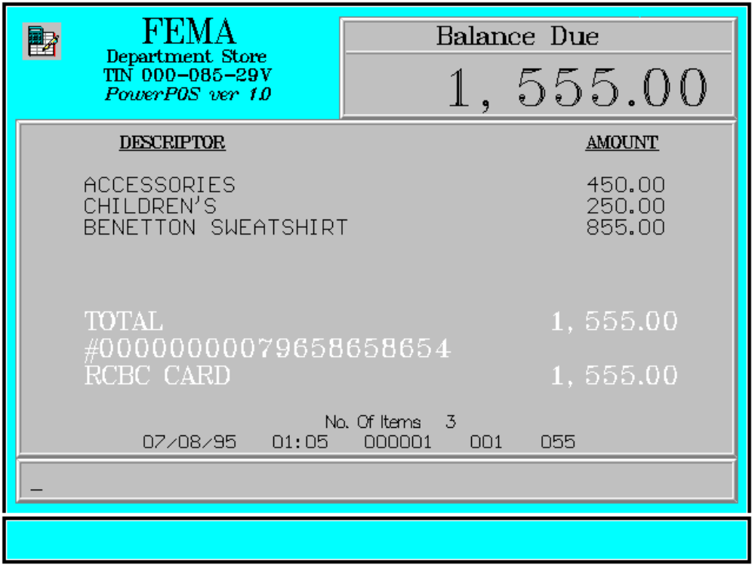

2.6.1 SINGLE CREDIT CARDS

The entire amount due is chargeable on a single card. Amount due is equal to the balance due.

Key Sequence:

Amount charged is equal to the balance due.

1
2
item SUB
registration TOTAL

Enter CREDIT window Swipe
amount CARD display credit card
charged to read

MANUAL Enter ENTER
card number

Insert slip
for VALID validation

Sample Printout:

RECEIPT JOURNAL

FEMA DEPARTMENT STORE ACCESSORIES 450.00
MAKATI CHILDREN’S 250.00
TIN 000-085-29V BENETTON SWEATSHIRT 855.00
ACCESSORIES 450.00 RCBC CARD
CHILDREN’S 250.00 Acct# 00000000079658658654
BENETTON SWEATSHIRT 855.00 1,555.00
SUBTOTAL 1,555.00

Acct# 00000000079658658654 3 ITEMS
RCBC CARD 1,555.00
SUBTL 1,555.00 12300 000 0815 01:23 005

TOTAL 1,555.00

NO. OF ITEMS 3

08/15/95 01:23 12300 000 005

WE ARE HAPPY TO SERVE YOU
THANK YOU, COME AGAIN

TERMINAL CODE
CASHIER KNOWN CODE
TRANSACTION NUMBER
TIME
DATE

2.6.2 MULTIPLE CREDIT CARD

This mode of payment allows the amount due to be charged on more than one credit card.

Key Sequence:

1
2
item SUB
registration TOTAL

repeat as necessary

*
Enter CREDIT window Swipe
amount CARD display credit card
charged to read

MANUAL Enter ENTER
card number

Insert slip
for VALID validation

*For the final payment the amount charged need not be entered.

For payment using credit card with other modes of payment, please refer to the split payment mode.
Sample Printout:

RECEIPT JOURNAL

FEMA DEPARTMENT STORE COSMETICS
MAKATI 4 @ 999.95
TIN 000-085-29V 3,999.80
ACCESSORIES 450.00
CHILDREN’S 250.00 4 @ 999.95 BENETTON SWEATSHIRT 855.00
COSMETICS 3,999.80
ACCESSORIES 450.00 RCBC CARD
CHILDREN’S 250.00 Acct# 00000000079658658654
BENETTON SWEATSHIRT 855.00 2,000.00
BPI CARD
Acct# 00000000079658658654 Acct# 00000000000231232323
RCBC CARD 2,000.00 3,554.80
SUBTOTAL 3,554.80 SUBTOTAL 3,554.80
BAL. DUE 3,554.80 7 ITEMS
Acct# 00000000000231232323
BPI CARD 12300 000 0815 01:23 005

SUBTL 3,554.80
TOTAL 3,554.80

NO. OF ITEMS 7

08/15/95 01:23 12300 000 005

WE ARE HAPPY TO SERVE YOU
THANK YOU, COME AGAIN

TERMINAL CODE
CASHIER KNOWN CODE
TRANSACTION NUMBER
TIME
DATE

Error Conditions:

a. Press Subtotal First

<CREDIT CARD> key has been pressed without pressing first the <SUBTOTAL> key.

b. Invalid Sequence

This is due to pressing an invalid key with respect to the sequence of operations.

In case of wrong data in the manual entry of account number, press <CLEAR> once to erase.

If the customer decides not to use his/her local credit card, press <CLEAR> twice to exit the credit card mode of payment.

