2.7 CORRECTIONS

2.7.1 Last Item Void

Last Item Void operation is used to cancel the previous registration in the order.

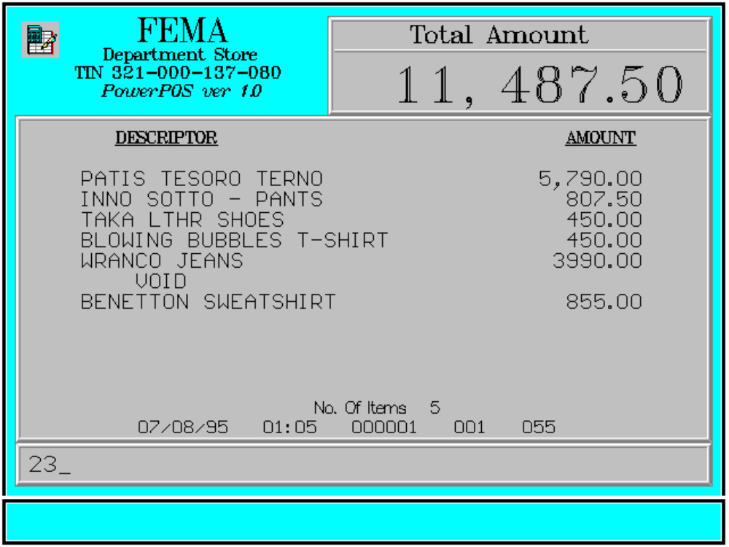

Key Sequence:

1
2 incorrect
registration VOID

Error Conditions:

a. No Item Transacted

<VOID> key was pressed before item registration.

b. Item Already Void

<VOID> can only be used for as many times as the quantity of the last item. If the <VOID> key is pressed and the last item has already been voided, this message appears.

Sample Printout:

RECEIPT JOURNAL

FEMA DEPARTMENT STORE 07490345678910
MAKATI PATIS TESORO TERNO 5,790.00
TIN 921-000-137-080 07123456789101
INNO SOTTO-PANTS 807.50
08771345789101
PATIS TESORO TERNO 5,790.00 TAKA LTHR SHOES 450.00
INNO SOTTO-PANTS 807.50 00008771344567
TAKA LTHR SHOES 450.00 BLOWING BUBBLES T-SH 450.00
BLOWING BUBBLES T-SH 450.00 00000003457134
WRANCO JEANS 3,990.00 WRANCO JEANS 3,990.00
BENETTON SWEATSHIRT 855.00 00000000789101
VOID BENETTON SWEATSHIRT 855.00
BENETTON SWEATSHIRT -855.00 VOID
00000000789101
BENETTON SWEATSHIRT -855.00
Acct# 00000000079658658654
RCBC CARD 11,487.50 RCBC CARD
SUBTL 11,487.50 Acct# 00000000079658658654
11,487.50
SUBTOTAL 11,487.50
TOTAL 11,487.50
6 ITEMS
NO. OF ITEMS 6
12300 000 0815 01:23 005
08/15/95 01:23 12300 000 005

WE ARE HAPPY TO SERVE YOU
THANK YOU, COME AGAIN

TERMINAL CODE
CASHIER KNOWN CODE
TRANSACTION NUMBER
TIME
DATE

