2.7.2 Manager’s Void

Manager’s Void operation is used to cancel an entry after subsequemt registrations have been made.

This is the initial screen before using the Manager’s Void operation.

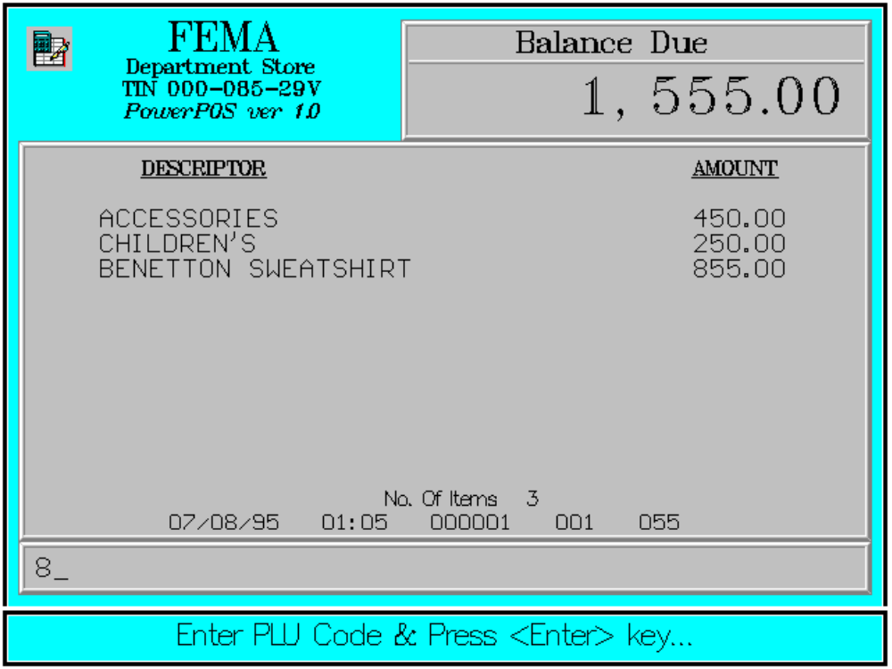

The screen upon using the Manager’s Void operation.

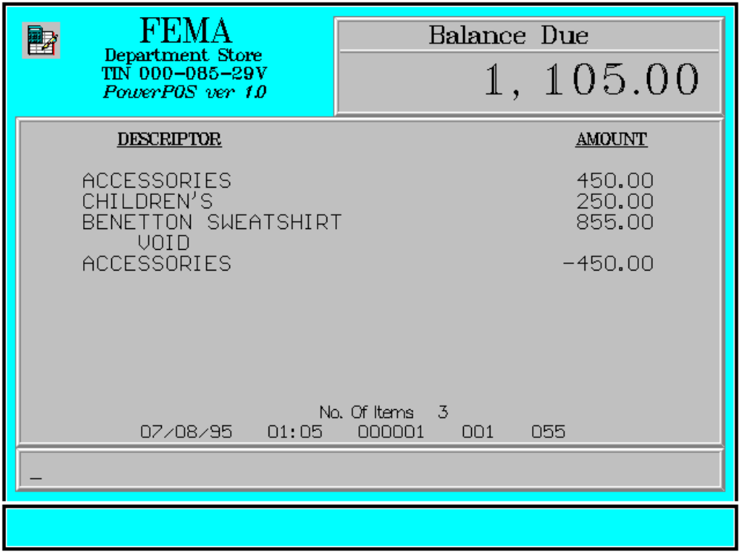

Key Sequence:

2 Enter
MGR’S item/PLU
VOID code

ENTER

SCAN
Error Conditions:

a. Invalid Sequence

This is due to pressing an invalid key with respect to the sequence of operations.

b. Item Not Found

The item code entered has not been registered.

Sample Printout:

RECEIPT JOURNAL

FEMA DEPARTMENT STORE ACCESSORIES 450.00
MAKATI CHILDREN’S 250.00
TIN 123-456-29V 00000000789101
855.00
ACCESSORIES 450.00 MANAGER’S VOID
CHILDREN’S 250.00 ACCESSORIES -450.00
BENETTON SWEATSH 855.00
MANAGER’S VOID TOTAL 1,105.00
ACCESSORIES -450.00 CASH 1,105.00

SUBTOTAL 1,105.00 2 ITEMS
CASH 1,105.00
CHANGE 0.00 08/15/95 01:23 12300 000 5

NO. OF ITEMS 2

08/15/95 01:23 12300 000 5

WE ARE HAPPY TO SERVE YOU
THANK YOU, COME AGAIN

TERMINAL CODE
CASHIER KNOWN CODE
TRANSACTION NUMBER
TIME
DATE

