2.8 DISCOUNT

2.8.1 Item/Department Discount

Item/Department Discount is used to register a discount by a percentage rate or by an amount, for a Department or PLU Registration .

2.8.1.1 Item/Department Automatic Percentage Discount

Pressing the <ITEM % DISCT.> key gives the discount amount equivalent to the discount rate configured at the front-end software.

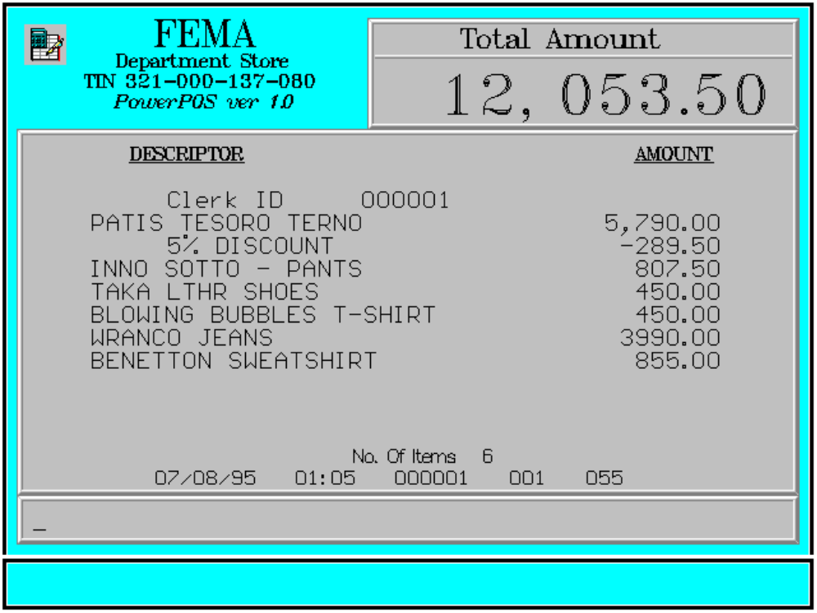

Key Sequence:

1
2 item %
registration DISCT

Error Condition:

Invalid Sequence

This is due to pressing an invalid key with respect to the sequence of operations.

Sample Printout:

RECEIPT JOURNAL

FEMA DEPARTMENT STORE 000001 CLERK
MAKATI 07490345678910
TIN 921-000-137-080 PATIS TESORO TERNO 5,790.00
5 % DISCOUNT -289.50
Clerk ID 000001 07123456789101
PATIS TESORO TERNO 5,790.00 INNO SOTTO-PANTS 807.50
5 % DISCOUNT -289.50 08771345789101
INNO SOTTO-PANTS 807.50 TAKA LTHR SHOES 450.00
TAKA LTHR SHOES 450.00 00008771344567
BLOWING BUBBLES T-S 450.00 BLOWING BUBBLES T-S 450.00
WRANCO JEANS 3,990.00 00000003457134
BENETTON SWEATSHIRT 855.00 WRANCO JEANS 3,990.00
00000000789101
TOTAL 12,053.50 BENETTON SWEATSHIRT 855.00
CASH 12,100.00
CHANGE 46.50 SUBTOTAL 12,053.50
CASH 12,100.00
NO. OF ITEMS 6
6 ITEMS
08/15/95 01:23 000 000 005
12300 000 0815 01:23 005
WE ARE HAPPY TO SERVE YOU
THANK YOU, COME AGAIN

TERMINAL CODE
CASHIER KNOWN CODE
TRANSACTION NUMBER
TIME
DATE

