2.8.1.2 Item/Department Manual Percentage Discount

The percentage rate of discount is manually entered by the user.

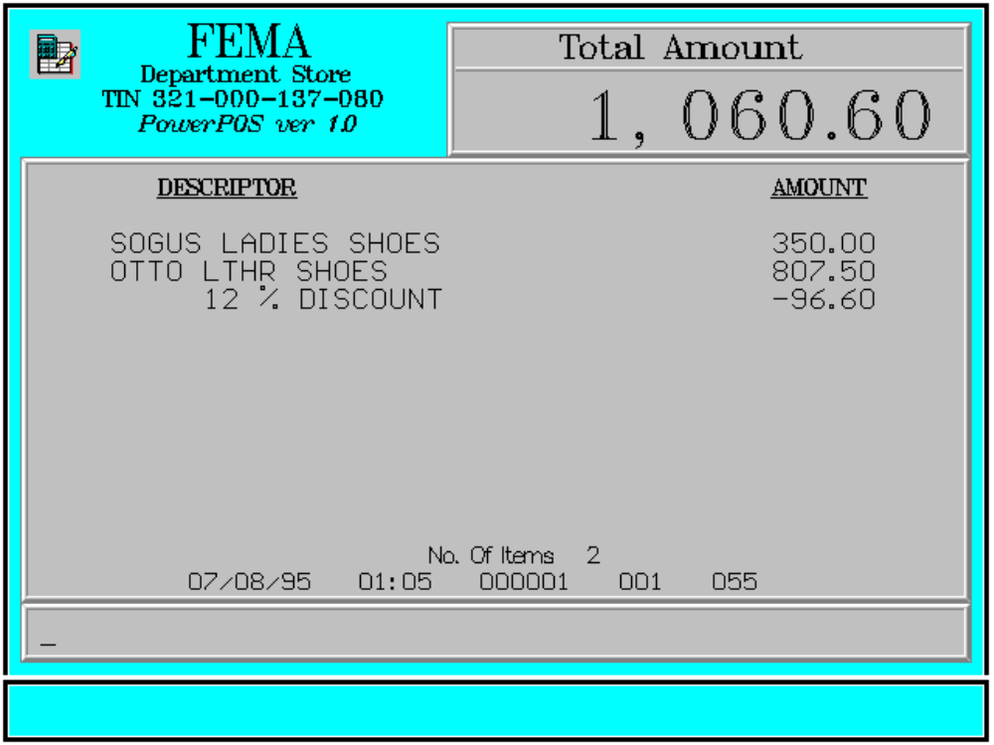

Key Sequence:

1
2 Enter
item discount %
registration rate (xx.xx) DISCT

Error Condition:

Invalid Sequence

This is due to pressing an invalid key with respect to the sequence of operations.

Sample Printout:

RECEIPT JOURNAL

FEMA DEPARTMENT STORE 07910345674908
MAKATI SOGUS LADIES SHOES 350.00
TIN 921-000-137-080 07490345103493
OTTO LTHR SHOES 807.50
SOGUS LADIES SHOES 350.00 12 % DISCOUNT -96.90
OTTO LTHR SHOES 807.50
12 % DISCOUNT -96.90 SUBTOTAL 1,060.60
CASH 1,100.00
TOTAL 1,060.60
CASH 1,100.00 2 ITEMS
CHANGE 39.40
12300 000 0815 01:23 005
NO. OF ITEMS 2

08/15/95 01:23 000 000 005

WE ARE HAPPY TO SERVE YOU
THANK YOU, COME AGAIN

TERMINAL CODE
CASHIER KNOWN CODE
TRANSACTION NUMBER
TIME
DATE

