2.8.1.3 Item/Department Automatic Amount Discount

Pressing the <ITEM AMT. DISCT.> key gives the discount amount configured at the front-end software.

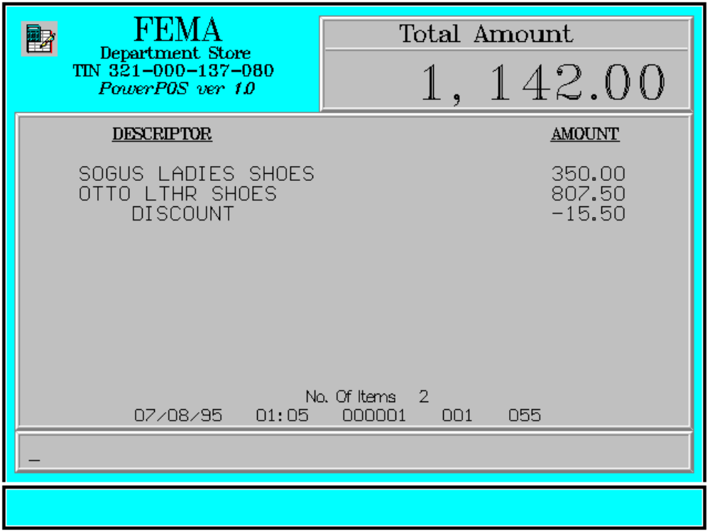

Key Sequence:

1
2 item AMT
registration DISCT

Error Condition:

Invalid Sequence

This is due to pressing an invalid key with respect to the sequence of operations.

Sample Printout:

RECEIPT JOURNAL

FEMA DEPARTMENT STORE 07910345674908
MAKATI SOGUS LADIES SHOES 350.00
TIN 921-000-137-080 07490345103493
OTTO LTHR SHOES 807.50
SOGUS LADIES SHOES 350.00 DISCOUNT -15.50
OTTO LTHR SHOES 807.50
DISCOUNT -15.50 SUBTOTAL 1,142.00
CASH 1,150.00
TOTAL 1,142.00
CASH 1,150.00 2 ITEMS
CHANGE 8.00
12300 000 0815 01:23 005
NO. OF ITEMS 2

08/15/95 01:23 000 000 005

WE ARE HAPPY TO SERVE YOU
THANK YOU, COME AGAIN

TERMINAL CODE
CASHIER KNOWN CODE
TRANSACTION NUMBER
TIME
DATE

