2.8.1.4 Item/Department Manual Amount Discount

The amount of item discount is manually entered by the user.

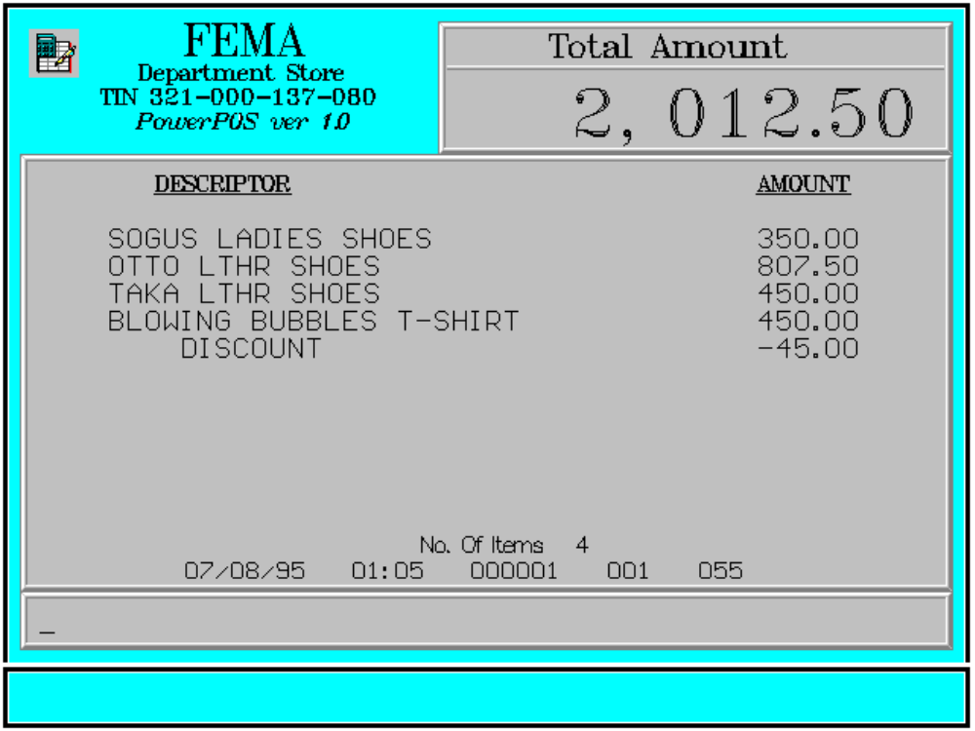

Key Sequence:

1
2 Enter
item amount of AMT
registration item DISCT
discount

Error Condition:

Invalid Sequence

This is due to pressing an invalid key with respect to the sequence of operations.

Sample Printout:

RECEIPT JOURNAL

FEMA DEPARTMENT STORE 07910345674908
MAKATI SOGUS LADIES SHOES 350.00
TIN 921-000-137-080 07490345103493
OTTO LTHR SHOES 807.50
SOGUS LADIES SHOES 350.00 08771345789101
OTTO LTHR SHOES 807.50 TAKA LTHR SHOES 450.00
TAKA LTHR SHOES 450.00 00008771344567
BLOWING BUBBLES T-S 450.00 BLOWING BUBBLES T-S 450.00
DISCOUNT -45.00 DISCOUNT -45.00

SUBTOTAL 2,012.50
CASH 2,012.50
TOTAL 2,012.50
CASH 2,012.50 4 ITEMS
CHANGE 0.00
12300 000 0815 01:23 005
NO. OF ITEMS 4

08/15/95 01:23 000 000 005

WE ARE HAPPY TO SERVE YOU
THANK YOU, COME AGAIN

TERMINAL CODE
CASHIER KNOWN CODE
TRANSACTION NUMBER
TIME
DATE

