2.8.2 Sub-Total Discount

2.8.2.1 Sub-Total Automatic Percentage Discount

Sub-Total Automatic Percentage Discount is used to discount a whole transaction by the percentage rate configured at the front-end system.

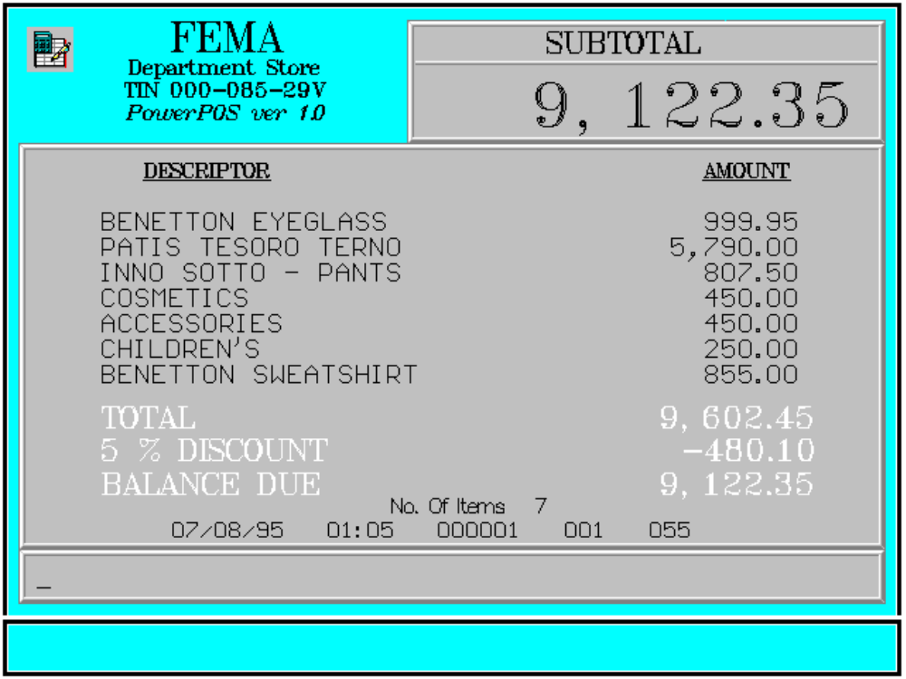

Key Sequence:

1
2 item SUB %
registration TOTAL DISCT

Error Condition:

Invalid Sequence

This is due to pressing an invalid key with respect to the sequence of operations.

Sample Printout:

RECEIPT JOURNAL

FEMA DEPARTMENT STORE 00000000789134
MAKATI BENETTON EYEGLASS 999.95
TIN 921-000-137-080 07490345678910
PATIS TESORO TERNO 5,790.00
BENETTON EYEGLASS 999.95 07123456789101
PATIS TESORO TERNO 5,790.00 INNO SOTTO-PANTS 807.50
INNO SOTTO-PANTS 807.50 COSMETICS 450.00
COSMETICS 450.00 ACCESSORIES 450.00
ACCESSORIES 450.00 CHILDREN’S 250.00
CHILDREN’S 250.00 00000000789101
BENETTON SWEATSHIRT 855.00 BENETTON SWEATSHIRT 855.00

SUBTOTAL 9,602.45 SUBTOTAL 9,602.45
5 % DISCOUNT -480.10 5 % DISCOUNT -480.10

Acct# 0002018116500729 VISA CARD 9,122.35
VISA CARD 9,122.35 Acct# 0002018116500729
SUBTOTAL 9,122.35

NO. OF ITEMS 6 6 ITEMS

08/15/95 01:23 12300 000 005 12300 000 0815 01:23 005

WE ARE HAPPY TO SERVE YOU
THANK YOU, COME AGAIN

TERMINAL CODE
CASHIER KNOWN CODE
TRANSACTION NUMBER
TIME
DATE

2.8.2.2 Sub-Total Manual Amount Discount

This is used to discount a whole transaction by an amount to be entered manually by the user.

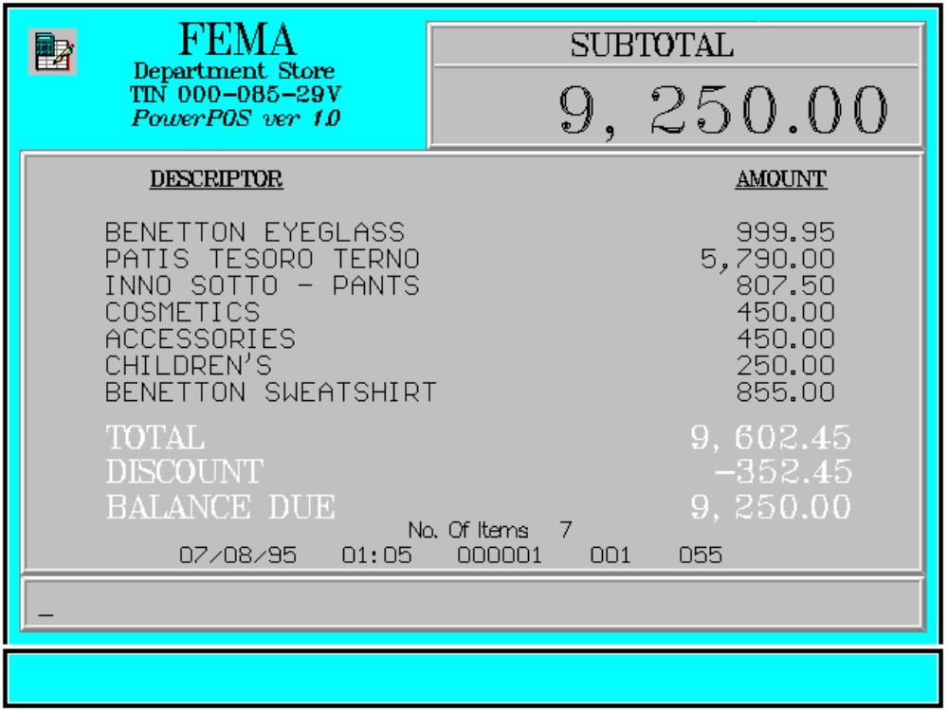

Key Sequence:

1
2 Enter
item SUB amount of AMT
registration TOTAL transaction DISCT
discount

Error Condition:

Invalid Sequence

This is due to pressing an invalid key with respect to the sequence of operations.

Sample Printout:

RECEIPT JOURNAL

FEMA DEPARTMENT STORE 00000000789134
MAKATI BENETTON EYEGLASS 999.95
TIN 921-000-137-080 07490345678910
PATIS TESORO TERNO 5,790.00
BENETTON EYEGLASS 999.95 07123456789101
PATIS TESORO TERNO 5,790.00 INNO SOTTO-PANTS 807.50
INNO SOTTO-PANTS 807.50 COSMETICS 450.00
COSMETICS 450.00 ACCESSORIES 450.00
ACCESSORIES 450.00 CHILDREN’S 250.00
CHILDREN’S 250.00 00000000789101
BENETTON SWEATSHIRT 855.00 BENETTON SWEATSHIRT 855.00

SUBTOTAL 9,602.45 SUBTOTAL 9,602.45
DISCOUNT -352.45 DISCOUNT -352.45

Acct# 0002018116500729 VISA CARD 9,250.00
VISA CARD 9,250.00 Acct# 0002018116500729
SUBTOTAL 9,250.00

NO. OF ITEMS 6 6 ITEMS

08/15/95 01:23 12300 000 005 12300 000 0815 01:23 005

WE ARE HAPPY TO SERVE YOU
THANK YOU, COME AGAIN

TERMINAL CODE
CASHIER KNOWN CODE
TRANSACTION NUMBER
TIME
DATE

