2.9 ADD-ON

Add-on is used to register a surplus either by a percentage rate or by an amount, for a Department or Item Registration.

2.9.1 Item/Department Add-On

2.9.1.2 Item/Department Manual Percentage Add-On

The percentage rate of add-on is manually entered by the user.

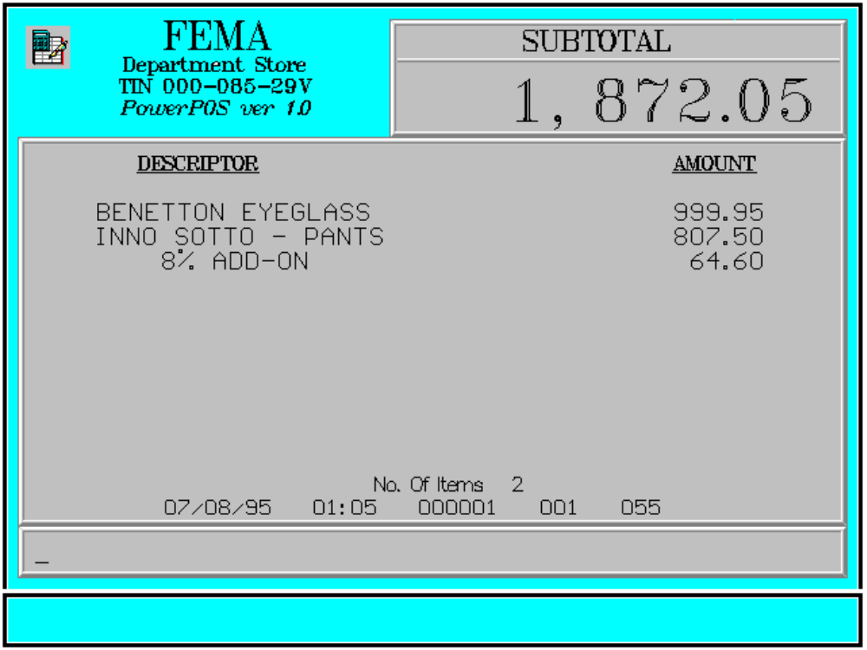

Key Sequence:

1
2 item Enter %
registration add-on rate ADD-ON
(xx.xx)

Error Condition:

Invalid Sequence

This is due to pressing an invalid key with respect to the sequence of operations.

Sample Printout:

RECEIPT JOURNAL

FEMA DEPARTMENT STORE 00000000789134
MAKATI BENETTON EYEGLASS 999.95
TIN 921-000-137-080 07123456789101
INNO SOTTO-PANTS 807.50
BENETTON EYEGLASS 999.95 8 % ADD-ON 64.60
INNO SOTTO-PANTS 807.50
8 % ADD-ON 64.60 SUBTOTAL 1,872.05
CASH 2,000.00
TOTAL 1,872.05
CASH 2,000.00 2 ITEMS
CHANGE 127.95
12300 000 0815 01:23 005
NO. OF ITEMS 2

08/15/95 01:23 12300 000 005

WE ARE HAPPY TO SERVE YOU
THANK YOU, COME AGAIN

TERMINAL CODE
CASHIER KNOWN CODE
TRANSACTION NUMBER
TIME
DATE

2.9.1.2 Item/Department Manual Amount Add-On

The amount of add-on to the item is manually entered by the user.

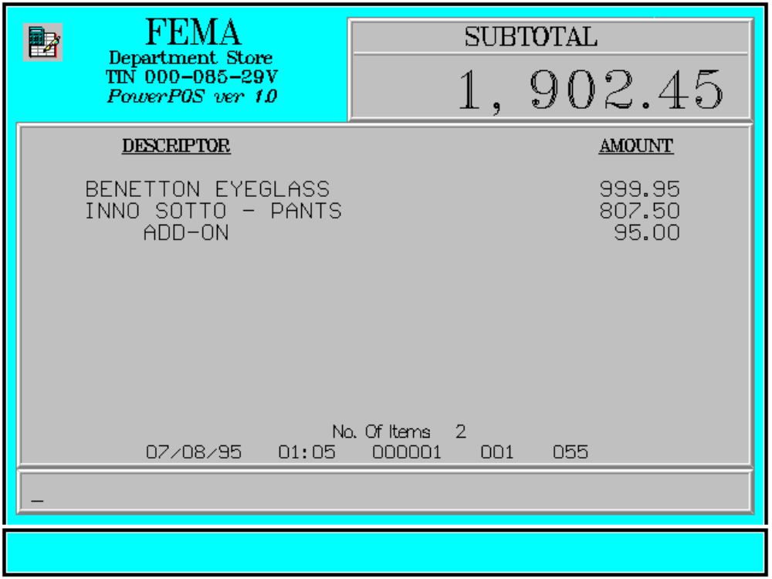

Key Sequence:

1
2 item Enter AMT
registration amount of ADDON
add-on

Error Condition:

Invalid Sequence

This is due to pressing an invalid key with respect to the sequence of operations.

Sample Printout:

RECEIPT JOURNAL

FEMA DEPARTMENT STORE 00000000789134
MAKATI BENETTON EYEGLASS 999.95
TIN 921-000-137-080 07123456789101
INNO SOTTO-PANTS 807.50
BENETTON EYEGLASS 999.95 ADD-ON 95.00
INNO SOTTO-PANTS 807.50
ADD-ON 95.00 SUBTOTAL 1,902.45
CASH 2,000.00
TOTAL 1,902.45
CASH 2,000.00 2 ITEMS
CHANGE 97.55
12300 000 0815 01:23 005
NO. OF ITEMS 2

08/15/95 01:23 12300 000 005

WE ARE HAPPY TO SERVE YOU
THANK YOU, COME AGAIN

TERMINAL CODE
CASHIER KNOWN CODE
TRANSACTION NUMBER
TIME
DATE

