2.9.2 SUB-TOTAL ADD-ON

2.9.2.1 Sub-Total Automatic Percentage Add-On

Sub-Total Automatic Percentage Add-On is used to register a surplus for the whole transaction by the percentage rate configured at the front-end system system.

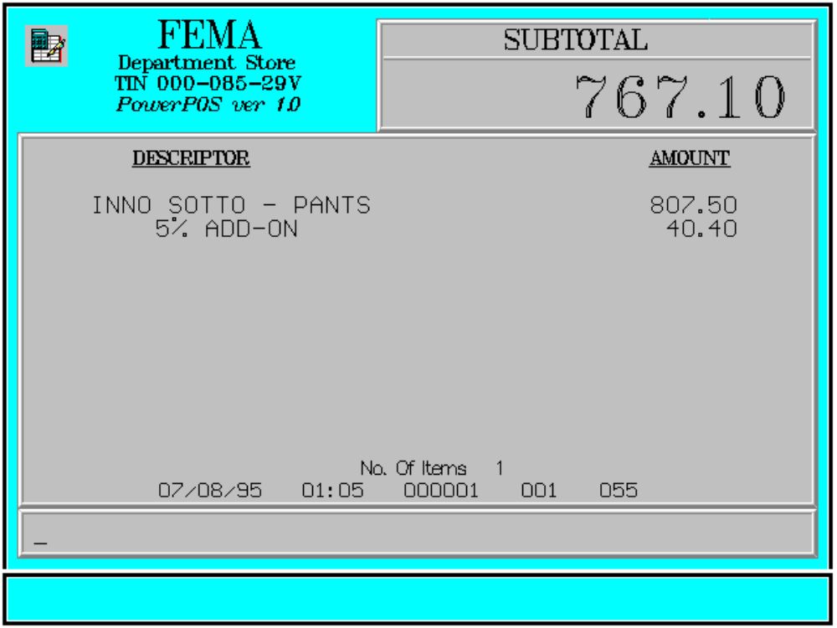

Key Sequence:

1
2 item SUB %
registration TOTAL PLUS

Error Condition:

Invalid Sequence

This is due to pressing an invalid key with respect to the sequence of operations.

Sample Printout:

RECEIPT JOURNAL

FEMA DEPARTMENT STORE 07123456789101
MAKATI INNO SOTTO-PANTS 807.50
TIN 921-000-137-080
SUBTOTAL 807.50
INNO SOTTO-PANTS 807.50 5 % ADD-ON 40.40

SUBTOTAL 807.50 VISA CARD 847.90
5 % ADD-ON 40.40 Acct# 0002018116500729
SUBTOTAL 847.90
Acct# 0002018116500729
VISA CARD 847.90 1 ITEMS

NO. OF ITEMS 1 12300 000 0815 01:23 005

08/15/95 01:23 12300 000 005

WE ARE HAPPY TO SERVE YOU
THANK YOU, COME AGAIN

TERMINAL CODE
CASHIER KNOWN CODE
TRANSACTION NUMBER
TIME
DATE

2.9.2.2 Sub-Total Manual Amount Add-On

Sub-Total Manual Amount Add-On is used to register a surplus for the whole transaction by an amount to be manually entered by the user.

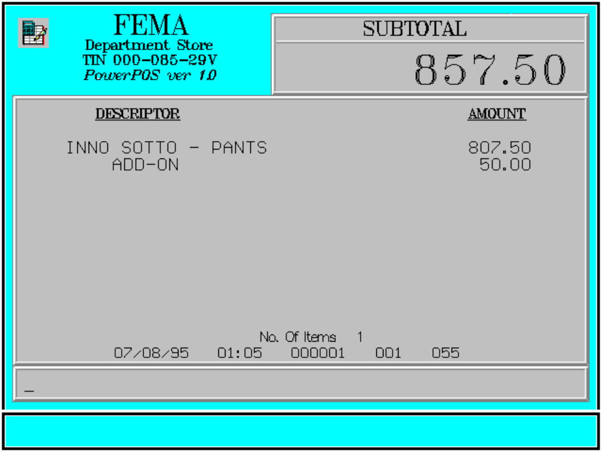

Key Sequence:

1
2 Enter
item SUB amount of AMT
registration TOTAL transaction PLUS
add-on

Error Condition:

Invalid Sequence

This is due to pressing an invalid key with respect to the sequence of operations.

Sample Printout:

RECEIPT JOURNAL

FEMA DEPARTMENT STORE 07123456789101
MAKATI INNO SOTTO-PANTS 807.50
TIN 921-000-137-080
SUBTOTAL 807.50
INNO SOTTO-PANTS 807.50 ADD-ON 50.00

SUBTOTAL 807.50 VISA CARD 857.50
ADD-ON 50.00 Acct# 0002018116500729
SUBTOTAL 857.50
Acct# 0002018116500729
VISA CARD 857.50 1 ITEMS

NO. OF ITEMS 1 12300 000 0815 01:23 005

08/15/95 01:23 12300 000 005

WE ARE HAPPY TO SERVE YOU
THANK YOU, COME AGAIN

TERMINAL CODE
CASHIER KNOWN CODE
TRANSACTION NUMBER
TIME
DATE

