Bees need larger brains to thrive in urban environments

Estación Biológica de Doñana (EBD-CSIC), E-41092 Seville, Spain

Departamento de Ciencias de la Computación e Inteligencia Artificial, Universidad de Sevilla, Seville, Spain

Centre for Ecological Research and Forestry Applications (CREAF), Bellaterra, Catalonia, Spain

# Abstract

The rapid conversion of natural habitats to anthropogenic landscapes is threatening insect pollinators worldwide, raising concern on the consequences for their fundamental role as plant pollinators. However, not all pollinators are negatively affected by habitat conversion, as certain species find in anthropogenic landscapes appropriate resources to persist and proliferate. The reason why some species thrive in anthropogenic environments while most find them inhospitable remains poorly understood. The cognitive buffer hypothesis, widely supported in vertebrates but untested in insects, offers a potential explanation. This theory suggests that species with larger brains have enhanced behavioural plasticity, enabling them to confront and adapt to novel challenges. To investigate this hypothesis in insects, we measured brains for 335 individuals from 89 species of bees, and evaluated the association of their brain sizes with detailed information on habitat preferences. Our analyses revealed that bees that prefer urban habitats had larger brains relative to their body size than those who prefer forested or agricultural habitats. Additionally, urban bees exhibited larger body sizes and, consequently, larger absolute brain sizes. Our results provide the first empirical support to this hypothesis in invertebrates, suggesting that a large brain in bees could confer behavioural advantages to tolerate urban environments.

Keywords: relative brain size, habitat preference, Apoidea, urbanisation, pollinators

# 1. Introduction

Pollinators deliver a fundamental ecosystem service on which the earth’s vegetation and human economy depend [1]. Regrettably, there is increasing evidence of recent declines in pollinator populations [2–4]. One of the main contributing factors to the current pollinator declines is the alteration and loss of their habitat due to human activity [5,6]. Anthropogenic landscapes present new challenges for survival and reproduction of organisms, increasing their risk of extinction by maldaptation [7,8,9]. Yet, not all pollinator species are negatively affected by land use change. For instance, some bee species are able to tolerate human-altered environments [10–12] or even to thrive [e.g., *Bombus terrestris*; 13,14].

Human-dominated habitats —notably cities— drastically modify the original conditions where pollinators evolved, but can also offer unique ecological opportunities in the form of new nesting spots, reduced predation pressure and high food availability associated with non-indigenous plants [7,12,15]. The question is then why only some species are able to tolerate urban environments. The “cognitive buffer hypothesis” provides an explanation for this conundrum, suggesting that in novel environments the chances to successfully survive and reproduce depends on cognition [16], that is, the processes involved in gathering, storing and reacting to environmental information [17]. While the “cognitive buffer hypothesis” receives ample support from studies of vertebrates [18–21], similar evidence is lacking for insects.

Insects have been long associated with the most basic types of learning due to their miniature brain [22,23]. However, numerous recent studies have shown that bees and other insects have sophisticated cognition that goes beyond simple associative learning or conditioning [24–26]. Some of these more complex forms of cognition involve the use of simple tools, attention, social learning or metacognitive processes [22,23]. In addition, there is also evidence for substantial variation across species in brain size—both in absolute terms and relative to body size— with species that have larger brains also exhibiting enhanced cognitive performance [27]. Therefore, we can ask whether the varying success of insects in human-altered habitats might be explained by variation in brain size.

Here, we report the first test of the “cognitive-buffer hypothesis“ in insects. Our test is based on a unique database of brain measures for 116 European and North American bee species. By means of detailed georeferenced information of species occurrences (GBIF; <http://www.gbif.org/>), we characterise habitat preferences for all the species, and use a phylogenetically-informed comparative analysis to assess whether bees that proliferate in human-altered habitats have enlarged brains compared to those that avoid them.

# 2. Methods

## (a) Bee species dataset

Our dataset contains measurements of brain and body size for bee specimens captured on flowers by hand netting in different areas of the East Coast of the United States and Europe (Spain and the Netherlands). The dataset includes information of 335 female individuals from 89 species that represent 6 families and 31 genera. We only considered female specimens because: (i) they are involved in a greater diversity of tasks than males, and hence are expected to experience greater environmental pressures; and (ii), have brains that are structurally and functionally different from those of males [28,29]. Brain size was measured as the weight of fixed brains [30] and body size as intertegular span [31; see supplementary text]. Given that brain size scales allometrically with body size [30], we considered for our analysis the size of the brain relative to the body.

Following [30], we estimated relative brain size as the residuals of a log-log phylogenetic linear model of brain mass against body size, using the Bayesian approximation implemented in the function *brm* from the package *brms* version 2.18 [32]. The phylogeny was built with the help of a previously published genus-level phylogeny and it was processed with the help of the packages ape 5.6-2 [33], phytools 1.2-0 [34] and MCMCglmm version 2.33 [35]. High values of relative brain size indicate larger brains than expected for their body size and low values denote smaller brains than expected. Our bee dataset showed a strong allometric relationship between brain and body size (Bayesian R = 0.9) that was constrained by the evolutionary history of the species (phylogenetic signal of relative brain size, = 0.6; *P* < 0.01). However, we found considerable variability in relative brain size within and across the different taxonomic groups (i.e., genera and subfamily level; Figure S1; Figure 1A).

## (b) Occurrence data

We downloaded occurrence information for all species from the Global Biodiversity Information Facility (GBIF; <http://www.gbif.org/>) for North America and Europe. The data was downloaded through R programming language with the help of the function *occ_download* from the package *rgbif* version 3.7.3 [36]. We selected the states or countries with the highest density of records for our set of species. For North America, we selected states located on the East Coast of the United States (Figure S2A), covering an approximate area of 136,937 km. For Europe, we selected countries located on the north and centre of the continent (Figure S2B), representing a total area of 600,497 km. To further reduce biases in the data, we only included species with a minimum number of 50 records and whose geographic distribution was larger than the sampled area (i.e., excluding species at the edge of their distributions). In addition, we optimised the match between species occurrence and the land cover data by only using georeferenced records obtained between 1990 and 2022 with a minimum of two decimals of latitude/longitude coordinates.

## (c) Land cover classification

We assigned a habitat type to each GBIF occurrence by merging land cover information with the georeferenced records of species occurrences. The land cover classification was obtained from the 2006 online inventories of the National Land Cover Database (NLCD) for United States and the Corine Land Cover (CLC) for Europe. After downloading these inventories as raster files, we used the functions *rast* and *extract* from the *Terra* package version 1.6-41 [37] to read and obtain the cover classification of the different georeferenced records, respectively. To simplify the interpretation and conduct a joint analysis for both regions, we divided the resulting cover classes into three single categories: (i) natural, (ii) agricultural and (iii) urban (see Tables S1 and S2 for details).

## (d) Analysis

Habitat preferences were estimated by assessing whether the occurrences of species in a given habitat were more frequent than expected by chance. For this, we generated 10,000 randomised matrices based on the occurrence matrix (i.e., species in rows and habitats in columns) with the function *nullmodel* from the package *bipartite* version 2.16 [38]. We used the method ‘r2dtable’, which maintains row and column sums constant by using Patefield’s algorithm [39]. This maintains the proportional dominance of the species and habitats constant but reshuffles their associations. We then estimated the percentage of simulated occurrences per species and habitat that were under the observed ones (i.e., percentile). Lastly, we considered that a bee species exhibited a “high preference” for any of the three studied habitats when the number of occurrences observed in this habitat exceeded the 80th percentile of the values obtained from the simulations. On the contrary, the species was considered to exhibit “low preference or avoidance” for the habitat when the observed occurrences were below the 20th percentile. To better understand if our findings are affected by the evolutionary histories of the species, we estimated the phylogenetic signal of relative brain size and habitat preference across habitats for our set of species with the help of the function *phylosig* from the *phytools* package.

To evaluate how the association between habitat preference and relative brain size changed by habitat type, we modelled with Bayesian generalised linear models their association. For this, we first joined the resulting habitat preference and relative brain size datasets by species and extracted those with statistical habitat preference on any of these three habitats. The resulting distribution of habitat preferences for each of the habitats analysed followed a zero-one inflated beta distribution (Figure S3), indicating that there were high frequencies of habitat preferences close to 0 or 1 but low frequencies of intermediate values between 0 and 1. Hence, in our analyses we only modelled the extremes of the distribution (i.e., species classified as avoiding or preferring a given habitat). Because we assessed habitat preference as binary (low or high), we specified a Bernouilli distribution where habitat preference was the response variable and relative brain size the predictor. Again, we included the phylogenetic covariance matrix as a random factor. Moreover, we also explored how habitat preference changed by brain weight and intertegular span independently. For this, we conducted two analogous models with these two different predictors. In addition, we also investigated the different trends for the United States and Europe separately.

All our models were run with 4,000 iterations with previous 1,000 warm up iterations, using non-informative or weakly informative priors [32]. Further, the different posterior predictive checks were conducted with the function *pp_check*, also from the *brms* package. All our analyses were undertaken in R version 4.0.5 [40], and all data processing and graphics were done with the set of packages from the tidyverse version 1.3.0 [41].

# 3. Results

Habitat preference varied substantially across species (Figure 1B) but showed none (i.e., preference for agricultural and rural habitats) or moderate phylogenetic signal (i.e., preference for natural habitat; = 0.38; *P* = 0.02). In general, most bee species preferred one or two habitat types but more rarely occurred indistinctly in the three habitats (Figure 1B). The most preferred habitats were the agricultural and natural ones with 49 and 48 species over 80% of the values from null models, respectively (Figure 1B and Figure S3). In contrast, most species avoided urban habitats (56 species under the 20th percentile) and just 28 species showed high preference for this habitat type (Figure 1B and Figure S3).

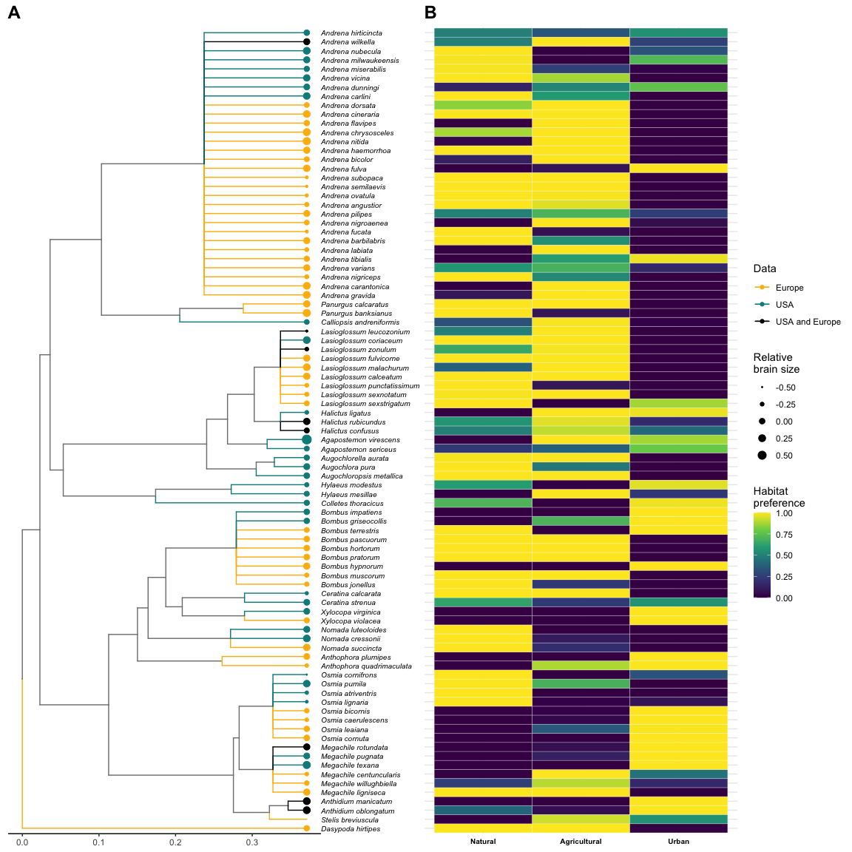

Phylogenetic relationship and habitat preferences for the selected bee species with brain weight and intertegular distance information (N=89). A) Phylogenetic tree at the genus level. Tree branches are coloured based on the geographical location of the different bee species (North of Europe, East Coast of United States or from both regions). The deviation of the brain size in relation to the body (i.e., residuals) is indicated with weighted points at the end of the tip branches. Larger points indicate larger brains in proportion to their body size and vice versa. B) Heatmap showing the habitat preference for each bee species. The columns delimit the habitat type (i.e., natural, agricultural, semideveloped and urban) and the rows the different bee species.

Although the model evaluating how relative brain size was associated with habitat preference explained little of the overall variance (Bayesian R = 0.11), we found evident trends when we explored this association by habitat type (Figure 2A). Specifically, we found that bees with larger brains relative to body size showed a higher preference for urban habitats than bees with smaller relative brain sizes (Figure 2A). Contrarily, bees with smaller relative brains showed higher preference in natural and agricultural habitats than bees with larger relative brain sizes (Figure 2A). The models of the association between absolute brain size and intertegular span with habitat preference captured also little of the overall variance (Bayesian R = 0.25; Bayesian R = 0.23, respectively). However, we found again marked differences between habitat types (Figures 2B and 2C). Specifically, we found that bees with larger brains and body sizes tend to appear more in urban habitats and bees with smaller brains and body sizes are more common in natural and agricultural ones (Figures 2B and 2C). These findings were consistent with the analogous analyses separated by geographical regions (United States and Europe; Figure S4).

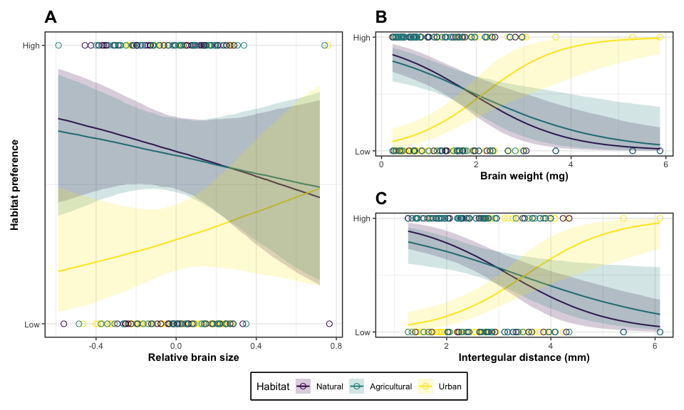

Association between relative brain size (A), brain weight (B) and intertegular distance (C) with habitat preference by habitat type (i.e., natural, agricultural and urban). The shaded and coloured areas by habitat type represent 95% credible intervals.

# 4. Discussion

Using data from two different continents and 89 bee species, we find that bees with a preference for inhabiting urban habitats tended to have larger brains relative to their body while those with forest or agricultural preferences had relatively smaller brains. These results are in line with the cognitive buffer hypothesis [16], which predicts that a large relative brain should provide enhanced behavioural plasticity to persist and thrive in novel environments. In urban environments, individuals are frequently exposed to a variety of new challenges such as novel resources or human disturbances that can change fast in time and space [42]. In such scenarios, a large brain could confer the cognitive flexibility needed to efficiently exploit novel resources while avoiding risks. While the exact mechanisms are unclear, we expect cognitive flexibility to be essential in a variety of contexts such as the use of human-made materials for the nest [43] or the need to collect pollen and nectar from exotic flowers [44].

Also in line with the cognitive buffer hypothesis [45], we find that bees that proliferate in urban habitats have bigger bodies and larger absolute brains. Larger species obtain greater net benefits from exploring and learning, especially in heterogeneous environments [46,47]. The patchiness of urban resources seems indeed to favour larger body sizes, as suggests the observation that foraging distance is positively associated with body size in bees [31,48]. There are also shreds of evidence that associate increased tolerance to urbanisation with wider ecological niches [49–51], and both larger bodies and relative brains are thought to be features that can facilitate broader diets and niche expansion. Further understanding all these processes represent an important avenue of future research.

Overall, our findings support and expand previous evidence found in vertebrates that having a large brain size can allow survival in novel environments [52,53], highlighting that a cognitive buffer is possible even with tiny brains. The use of the entire brain size as a proxy for cognitive performance is not exempt from criticism [24,54]. Our analyses focused on brain size mainly for reasons of data availability. The use of brain size is justified by the existence of previous evidence that enlarged brains enhance cognitive performance in bees [27]. Moreover, brain size is less subject to measurement error or context-dependent biases in comparison with other experimental measures of cognition [24,54]. Although the use in the future of finer measures like neuropils size or mushroom bodies [the suspected centres of cognitive processes in bees; 55,56,57] is likely to help improve our understanding of bee cognitive abilities. Our findings highlight the importance of behavioural responses for understanding the dynamics of insect populations in altered environments and stresses the need to avoid viewing them as passive agents of external pressures.

# Data accessibility

All occurrence data used in this study can be downloaded from <https://doi.org/10.15468/dl.5s5kuf>. In addition, bee trait data and code can be found in the online repositories of Zenodo XXXXXXXKXX and Github <https://github.com/ibartomeus/declines_brain.git>.

# Authors’ contributions

MAC, IB and JBL designed the study. MAC and FS collected the data. JBL led the analysis with help from MAC and IB. JBL and IB wrote the manuscript with contributions from all authors.

# Funding

Ministerio de Economía y Competitividad, Gobierno de España, Grant/Award Number: CGL2013-47448-P

# Acknowledgements

# Conflict of interest declaration

We declare we have no competing interests.

# References

1. Ollerton J. 2017 Pollinator diversity: Distribution, ecological function, and conservation. *Annual review of ecology, evolution, and systematics* **48**, 353–376.

2. Bartomeus I, Stavert J, Ward D, Aguado O. 2019 Historical collections as a tool for assessing the global pollination crisis. *Philosophical Transactions of the Royal Society B* **374**, 20170389.

3. Potts SG, Biesmeijer JC, Kremen C, Neumann P, Schweiger O, Kunin WE. 2010 Global pollinator declines: Trends, impacts and drivers. *Trends in ecology & evolution* **25**, 345–353.

4. Scheper J, Reemer M, Kats R van, Ozinga WA, Linden GT van der, Schaminée JH, Siepel H, Kleijn D. 2014 Museum specimens reveal loss of pollen host plants as key factor driving wild bee decline in the netherlands. *Proceedings of the National Academy of Sciences* **111**, 17552–17557.

5. Harrison T, Winfree R. 2015 Urban drivers of plant-pollinator interactions. *Functional Ecology* **29**, 879–888.

6. Harrison T, Gibbs J, Winfree R. 2018 Forest bees are replaced in agricultural and urban landscapes by native species with different phenologies and life-history traits. *Global Change Biology* **24**, 287–296.

7. Winfree R, Bartomeus I, Cariveau DP, *et al.* 2011 Native pollinators in anthropogenic habitats. *Annual Review of Ecology, Evolution and Systematics* **42**, 1–22.

8. Brown MJ, Paxton RJ. 2009 The conservation of bees: A global perspective. *Apidologie* **40**, 410–416.

9. Harrison T, Gibbs J, Winfree R. 2019 Anthropogenic landscapes support fewer rare bee species. *Landscape Ecology* **34**, 967–978.

10. Biesmeijer JC *et al.* 2006 Parallel declines in pollinators and insect-pollinated plants in britain and the netherlands. *Science* **313**, 351–354.

11. Bartomeus I, Ascher JS, Gibbs J, Danforth BN, Wagner DL, Hedtke SM, Winfree R. 2013 Historical changes in northeastern US bee pollinators related to shared ecological traits. *Proceedings of the National Academy of Sciences* **110**, 4656–4660.

12. Collado MÁ, Sol D, Bartomeus I. 2019 Bees use anthropogenic habitats despite strong natural habitat preferences. *Diversity and Distributions* **25**, 924–935.

13. Rasmont P, Coppée A, Michez D, De Meulemeester T. 2008 An overview of the bombus terrestris (l. 1758) subspecies (hymenoptera: apidae). In *Annales de la société entomologique de france*, pp. 243–250. Taylor & Francis.

14. Theodorou P *et al.* 2020 Urban areas as hotspots for bees and pollination but not a panacea for all insects. *Nature communications* **11**, 576.

15. Cane JH, Minckley RL, Kervin LJ, Roulston TH, Williams NM. 2006 Complex responses within a desert bee guild (hymenoptera: Apiformes) to urban habitat fragmentation. *Ecological applications* **16**, 632–644.

16. Sol D. 2009 Revisiting the cognitive buffer hypothesis for the evolution of large brains. *Biology letters* **5**, 130–133.

17. Shettleworth SJ. 2009 *Cognition, evolution, and behavior*. Oxford university press.

18. Sol D, Bacher S, Reader SM, Lefebvre L. 2008 Brain size predicts the success of mammal species introduced into novel environments. *the american naturalist* **172**, S63–S71.

19. Amiel JJ, Tingley R, Shine R. 2011 Smart moves: Effects of relative brain size on establishment success of invasive amphibians and reptiles. *PLoS One* **6**, e18277.

20. Sayol F, Maspons J, Lapiedra O, Iwaniuk AN, Székely T, Sol D. 2016 Environmental variation and the evolution of large brains in birds. *Nature Communications* **7**, 13971.

21. Howell KJ, Walsh MR. 2023 Transplant experiments demonstrate that larger brains are favoured in high-competition environments in trinidadian killifish. *Ecology Letters* **26**, 53–62.

22. Giurfa M. 2015 Learning and cognition in insects. *Wiley Interdisciplinary Reviews: Cognitive Science* **6**, 383–395.

23. Perry CJ, Barron AB, Chittka L. 2017 The frontiers of insect cognition. *Current Opinion in Behavioral Sciences* **16**, 111–118.

24. Chittka L, Niven J. 2009 Are bigger brains better? *Current biology* **19**, R995–R1008.

25. Avargues-Weber A, Deisig N, Giurfa M. 2011 Visual cognition in social insects. *Annual review of entomology* **56**, 423–443.

26. Sheehan MJ, Tibbetts EA. 2011 Specialized face learning is associated with individual recognition in paper wasps. *science* **334**, 1272–1275.

27. Collado MÁ, Montaner CM, Molina FP, Sol D, Bartomeus I. 2021 Brain size predicts learning abilities in bees. *Royal Society open science* **8**, 201940.

28. Streinzer M, Kelber C, Pfabigan S, Kleineidam CJ, Spaethe J. 2013 Sexual dimorphism in the olfactory system of a solitary and a eusocial bee species. *Journal of Comparative Neurology* **521**, 2742–2755.

29. Roselino AC, Hrncir M, Cruz Landim C da, Giurfa M, Sandoz J-C. 2015 Sexual dimorphism and phenotypic plasticity in the antennal lobe of a stingless bee, melipona scutellaris. *Journal of Comparative Neurology* **523**, 1461–1473.

30. Sayol F *et al.* 2020 Feeding specialization and longer generation time are associated with relatively larger brains in bees. *Proceedings of the Royal Society B* **287**, 20200762.

31. Kendall LK *et al.* 2019 Pollinator size and its consequences: Robust estimates of body size in pollinating insects. *Ecology and Evolution* **9**, 1702–1714.

32. Bürkner P-C. 2017 Brms: An r package for bayesian multilevel models using stan. *Journal of statistical software* **80**, 1–28.

33. Paradis E, Blomberg S, Bolker B, Brown J, Claude J, Cuong HS, Desper R, Didier G. 2019 Package ‘ape’. *Analyses of phylogenetics and evolution* **2**, 47.

34. Revell LJ. 2012 Phytools: An r package for phylogenetic comparative biology (and other things). *Methods in ecology and evolution*, 217–223.

35. Hadfield JD. 2010 MCMC methods for multi-response generalized linear mixed models: The MCMCglmm r package. *Journal of statistical software* **33**, 1–22.

36. Chamberlain S, Ram K, Barve V, Mcglinn D, Chamberlain MS. 2017 Package ‘rgbif’. *Interface to the Global Biodiversity Information Facility ‘API* **5**, 0–9.

37. Hijmans RJ, Bivand R, Forner K, Ooms J, Pebesma E, Sumner MD. 2022 Package ‘terra’.

38. Dormann CF *et al.* 2008 Prediction uncertainty of environmental change effects on temperate european biodiversity. *Ecology letters* **11**, 235–244.

39. Patefield W. 1981 Algorithm AS 159: An efficient method of generating random r c tables with given row and column totals. *Journal of the Royal Statistical Society. Series C (Applied Statistics)* **30**, 91–97.

40. R Core Team. 2021 *R: A language and environment for statistical computing*. Vienna, Austria: R Foundation for Statistical Computing. See <https://www.R-project.org/>.

41. Wickham H *et al.* 2019 Welcome to the tidyverse. *Journal of Open Source Software* **4**, 1686. (doi:[10.21105/joss.01686](https://doi.org/10.21105/joss.01686))

42. Wheater CP. 2002 *Urban habitats*. Routledge.

43. Allasino ML, Marrero HJ, Dorado J, Torretta JP. 2019 Scientific note: First global report of a bee nest built only with plastic. *Apidologie* **50**, 230–233.

44. Lowenstein DM, Matteson KC, Minor ES. 2019 Evaluating the dependence of urban pollinators on ornamental, nonnative, and weedy floral resources. *Urban Ecosystems* **22**, 293–302.

45. Ducatez S, Sol D, Sayol F, Lefebvre L. 2020 Behavioural plasticity is associated with reduced extinction risk in birds. *Nature Ecology & Evolution* **4**, 788–793.

46. Bateman PW, Fleming PA. 2012 Big city life: Carnivores in urban environments. *Journal of Zoology* **287**, 1–23.

47. Theodorou P, Baltz LM, Paxton RJ, Soro A. 2021 Urbanization is associated with shifts in bumblebee body size, with cascading effects on pollination. *Evolutionary Applications* **14**, 53–68.

48. Greenleaf SS, Williams NM, Winfree R, Kremen C. 2007 Bee foraging ranges and their relationship to body size. *Oecologia* **153**, 589–596.

49. Geslin B, Gauzens B, Thébault E, Dajoz I. 2013 Plant pollinator networks along a gradient of urbanisation. *PloS one* **8**, e63421.

50. Buchholz S, Egerer MH. 2020 Functional ecology of wild bees in cities: Towards a better understanding of trait-urbanization relationships. *Biodiversity and Conservation* **29**, 2779–2801.

51. Prendergast KS, Dixon KW, Bateman PW. 2022 A global review of determinants of native bee assemblages in urbanised landscapes. *Insect Conservation and Diversity* **15**, 385–405.

52. Santini L, González-Suárez M, Russo D, Gonzalez-Voyer A, Hardenberg A von, Ancillotto L. 2019 One strategy does not fit all: Determinants of urban adaptation in mammals. *Ecology Letters* **22**, 365–376.

53. Sayol F, Sol D, Pigot AL. 2020 Brain size and life history interact to predict urban tolerance in birds. *Frontiers in Ecology and Evolution* **8**, 58.

54. Lihoreau M, Latty T, Chittka L. 2012 An exploration of the social brain hypothesis in insects. *Frontiers in physiology* **3**, 442.

55. Barth M, Heisenberg M. 1997 Vision affects mushroom bodies and central complex in drosophila melanogaster. *Learning & Memory* **4**, 219–229.

56. Withers G, Fahrbach S, Robinson G. 1995 Effects of experience and juvenile hormone on the organization of the mushroom bodies of honey bees. *Journal of neurobiology* **26**, 130–144.

57. Fahrbach SE, Robinson GE. 1995 Behavioral development in the honey bee: Toward the study of learning under natural conditions. *Learning & Memory* **2**, 199–224.

# Supplementary material

## Brain and body size measurements

Brain size was measured as the weight of the fixed brain for each specimen. First, all collected individuals were kept in cold and sent to the laboratory where they were identified by expert taxonomists and anaesthetised in cold. Then, heads were removed with a scalpel and placed in a fixative solution (4% paraformaldehyde in 0.1 M phosphate-buffered saline -PBS- pH = 7.4) to avoid degradation. Subsequently, brains were extracted from the head capsule and placed on a petri dish after removing the retina from the optic lobes and cleaning the entire brain of all tracheae and fat bodies. By doing this, we ensured that our brain measurements mainly accounted for neural tissue. We then placed the brains on a small piece of Parafilm® and dried the exceeding fixative solution with Kimwipes® tissues. Then, within 4 seconds of the liquid removal, we weighted the brains with the help of a microbalance Sartorius Cubis®. Finally, we calculated the average weight for the species with more than one specimen. Because weighing bee brains is a highly error-prone task, we excluded values that were under or above 1.5 times the interquartile range for each species.

We considered as a proxy of body size the average intertegular span (ITS) per species. ITS represents the distance between the base of the wings (tegulae) on the bee thorax and has been shown to accurately predict body size as it is highly correlated with dry body weight (Cane et al., 2006; Kendall et al., 2019). All ITS measurements were conducted with a stereomicroscope (magnification 16x or 80x) with a calibrated ocular micrometre (resolution down to 0.02 mm).

Cane, J. H., Minckley, R. L., Kervin, L. J., Roulston, T. A. H., & Williams, N. M. (2006). Complex responses within a desert bee guild (Hymenoptera: Apiformes) to urban habitat fragmentation. *Ecological applications*, *16*(2), 632-644.

Kendall, L. K., Rader, R., Gagic, V., Cariveau, D. P., Albrecht, M., Baldock, K. C., … & Bartomeus, I. (2019). Pollinator size and its consequences: Robust estimates of body size in pollinating insects. *Ecology and Evolution*, *9*(4), 1702-1714.

Original downloaded cover classes for United States with the respective assigned cover classes and number of bee occurrences found on each of them.

Original NLCD Cover class

Occurrences

Assigned cover class

Hay/Pasture

3837

Agricultural

Developed, Open Space

3470

Urban

Developed, Low Intensity

2844

Urban

Deciduous Forest

2825

Natural

Developed, Medium Intensity

2320

Urban

Cultivated Crops

1038

Agricultural

Mixed Forest

1017

Natural

Woody Wetlands

989

Natural

Developed, High Intensity

962

Urban

Shrub/Scrub

492

Natural

Evergreen Forest

395

Natural

Herbaceous

353

Natural

Open Water

293

Discarded

Emergent Herbaceous Wetlands

278

Natural

Barren Land

143

Discarded

Original downloaded cover classes for Europe with the respective assigned cover classes and number of bee occurrences found on each of them.

Original CLC Cover class

Occurrences

Assigned cover class

Discontinuous urban fabric

109779

Urban

Non-irrigated arable land

60722

Agricultural

Pastures

52571

Agricultural

Complex cultivation patterns

20975

Agricultural

Broad-leaved forest

15013

Natural

Land principally occupied by agriculture

10400

Agricultural

Sport and leisure facilities

9534

Urban

Industrial or commercial units

9258

Urban

Mixed forest

8513

Natural

Coniferous forest

7308

Natural

Green urban areas

5924

Urban

Natural grasslands

2900

Agricultural

Moors and heathland

2826

Natural

Water bodies

2578

Discarded

Vineyards

2191

Agricultural

Continuous urban fabric

1875

Urban

Water courses

1848

Discarded

Road and rail networks and associated land

1731

Discarded

Inland marshes

1611

Natural

Mineral extraction sites

1248

Discarded

Fruit trees and berry plantations

1192

Agricultural

Peat bogs

1092

Natural

Construction sites

1085

Urban

Transitional woodland-shrub

1067

Natural

Beaches, dunes, sands

696

Natural

Intertidal flats

576

Natural

Sea and ocean

426

Discarded

Estuaries

422

Discarded

Port areas

376

Urban

Airports

371

Urban

Dump sites

285

Discarded

Salt marshes

166

Natural

Sparsely vegetated areas

33

Natural

Coastal lagoons

23

Natural

Bare rocks

8

Discarded

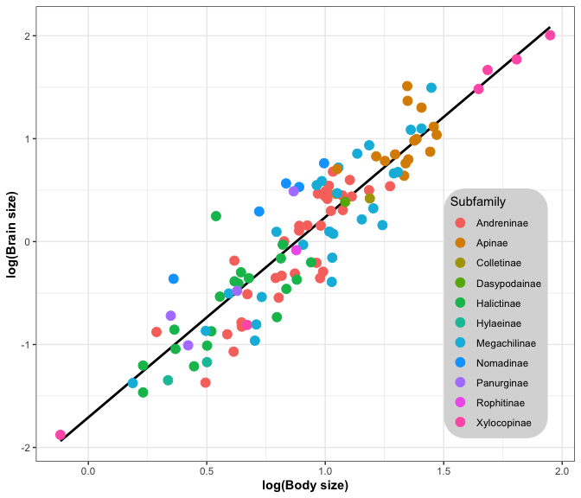

Association between the log-transformed values of brain and body size (N = 116). The different raw values or points are coloured by the subfamily taxonomic rank.

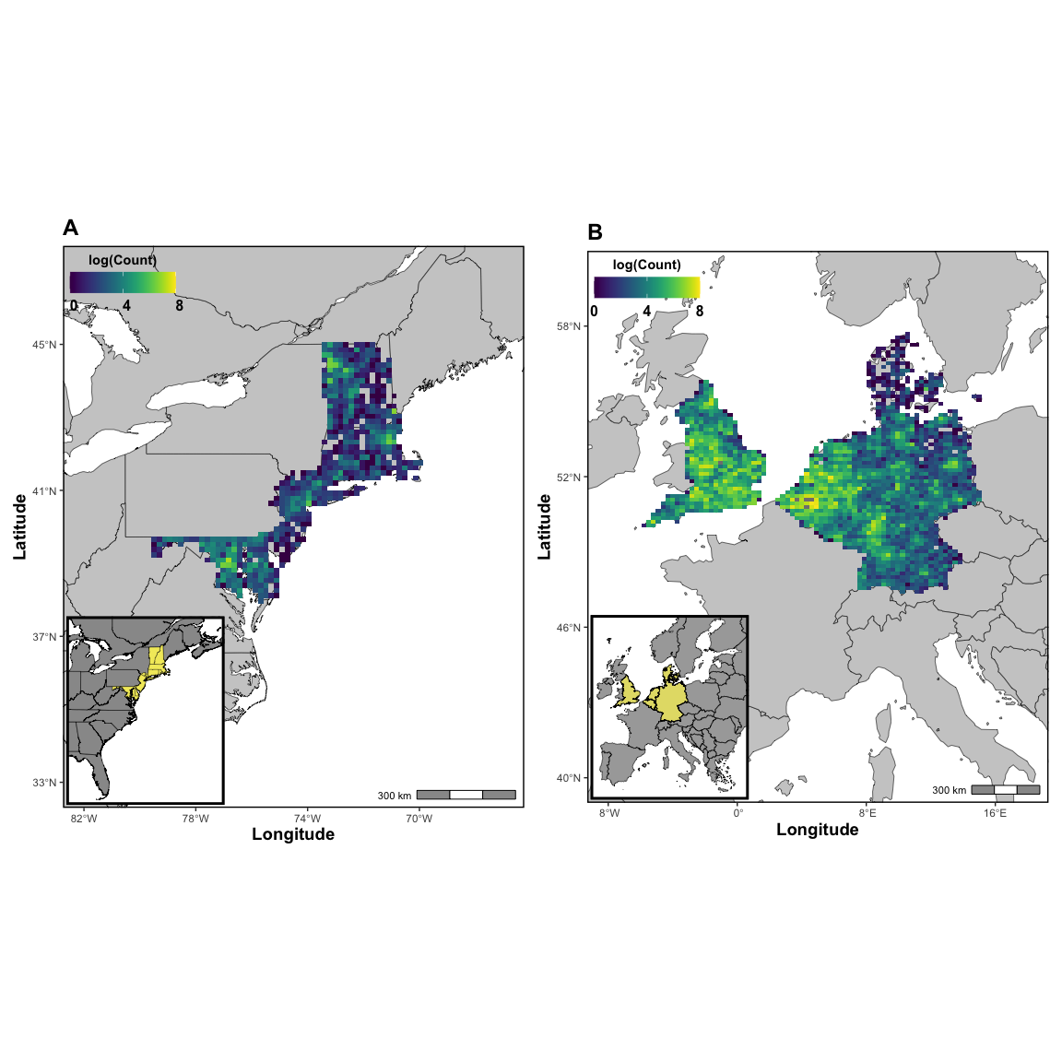

Maps showing the study areas and the number of GBIF occurrences in logarithmic scale for the selected bee species. A) East Coast of United States with records for Vermont, New Hampshire, Massachusetts, Rhode Island, Connecticut, New York metropolitan area, New Jersey, Delaware and Maryland. B) European continent with records downloaded for England, Belgium, Netherlands, Germany and Denmark.

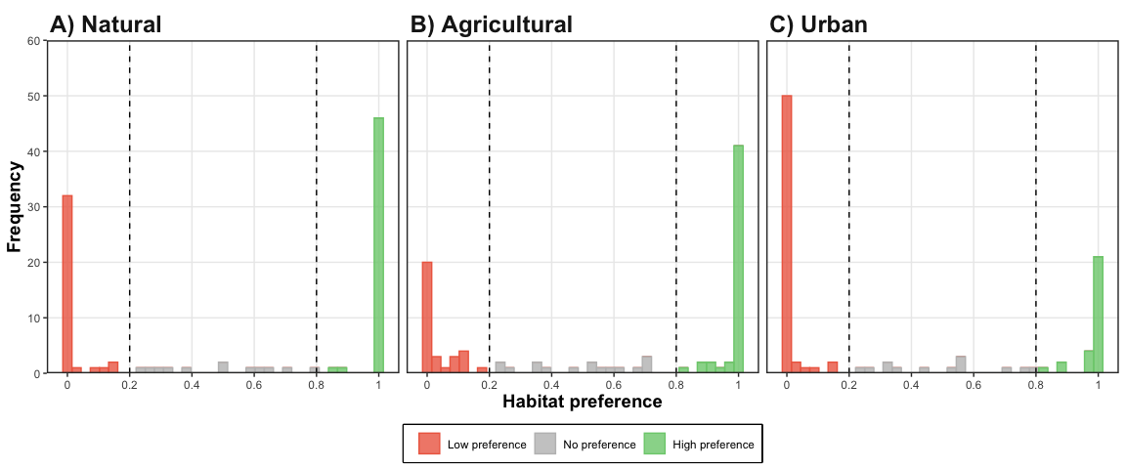

Frequency distribution of the bee preferences for each habitat type (i.e., natural, agricultural and urban). The different habitats are reclassifications from the 2006 land use categories of the Corine Land Cover (CLC) inventory for Europe and the National Land Cover (NLC) database for Unites States.

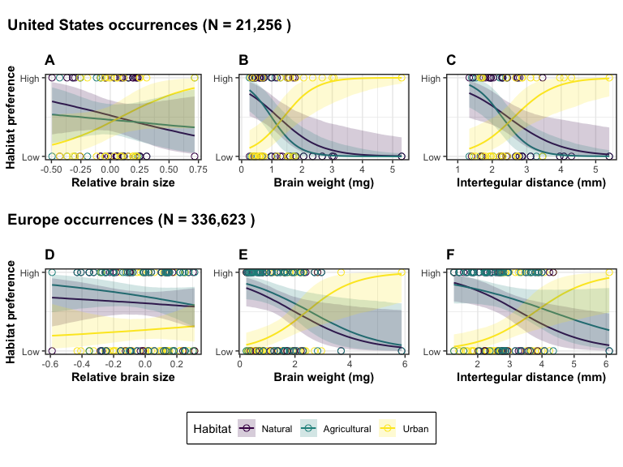

. Association between relative brain size (A and D), brain weight (B and E) and intertegular distance (C and F) with habitat preference separated by habitat type (i.e., natural, agricultural and urban) and geographical region (USA in the upper panel and Europe in the lower one). The shaded and coloured areas by habitat type represent 95% credible intervals.