# Report on plant-pollinator network description from Cantavieja and Ejea de los Caballeros

**Data collection: O. Aguado**  
**Analysis: J. B. Lanuza and I. Bartomeus**  
**Coordination: E. Nuñez**

## Objectives

The objective of this report is to describe the current status of two plant-pollinator networks located at Cantavieja and Ejea de los Caballeros before any restoration is implemented. Understanding which plants and pollinators conform the community, as well as how they interact will allow us to characterize the baseline with which to compare after restoration process have been conducted.

## Field sampling

Two distinct locations are being monitored with different historical land-use and management in the region of Aragón (Spain): Cantavieja (40º 30’ 44”, N 0º 22’ 59” W) at 1450m above sea level with a total of 30 plots and Ejea de los Caballeros (42º 01’ 06” N, 1º 08’ 53” W) at 350m. In each location, a total of 21 plots were monitored. Plot size is 2m by 2m and they are randomly distributed within each location (see **Figure 1**). Importantly, since the start of the project vegetation has remained undisturbed without grazing or clearing.

Each plot was surveyed three times at the beggining of the season, at the peak of flowering and at the end of the season. In each occasion, all plant-pollinator interactions observed were documented. Pollinator specimens not identified in the field were captured and identified in the lab.

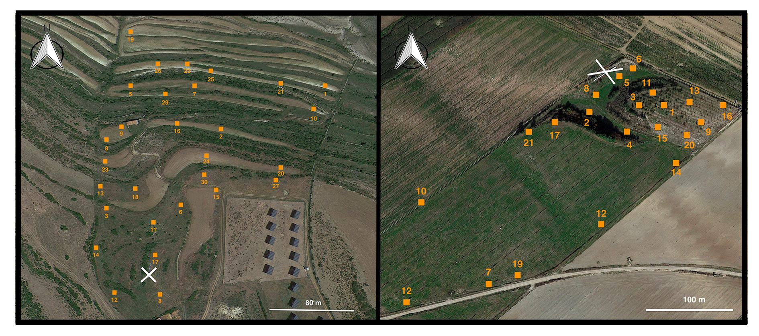

Cantavieja (left) and Ejea de los Caballeros (right) locations with the different sampling plots indicated with an orange square plus the plot identifier. The position of the bee hives is shown with a white cross for both locations.

## Network descriptions

All analyses are conducted in R Core Team (2021) version *4.0.5*.

### Location 1 ‘Cantavieja’

In this network we find 29 plant species interacting with 69 insect pollinators. Overall, its connectance (i.e. the fraction of interactions established from all posible interactions) is very low (connectance = 0.05), indicating that most interactions are quite specialized. Indeed, the overall specialization or ‘selectiveness’ as estimated in Blüthgen, Menzel, and Blüthgen (2006) (i.e. H2) is 0.56, which indicates also that the network is rather specialised (H2 ranges between 0 and 1 for extreme generalization and specialization, respectively.). In **figure 2** we can see the network representation. The frequency of each plant and pollinator observed can be found in Appendix 1.

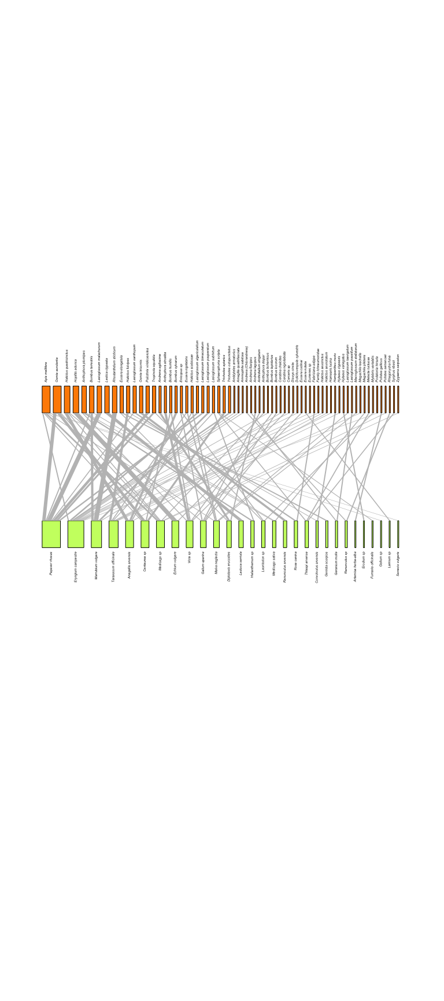

Bipartie plant-pollinator network from Cantavieja location. Pollinators are coloured in orange and plants in green. The width of the conection between plants and pollinators represent the strength of the interaction (number of links) and the width of the different nodes corresponds to the total number of links.

### Location 2 ‘Ejea de los caballeros’

In Ejea de los caballeros, the network is composed by 26 plant species interacting with 60 insect pollinators. Overall, its connectance (i.e. the fraction of interactions established from all posible interactions) is equally low (connectance = 0.05), indicating that most interactions are quite specialized. Indeed, the overall specialization or ‘selectiveness’ (i.e. H2) is 0.58 (range 0-1). In figure 3 we can see the network representation. The frequency of each plant and pollinator observed can be found in Appendix 1.

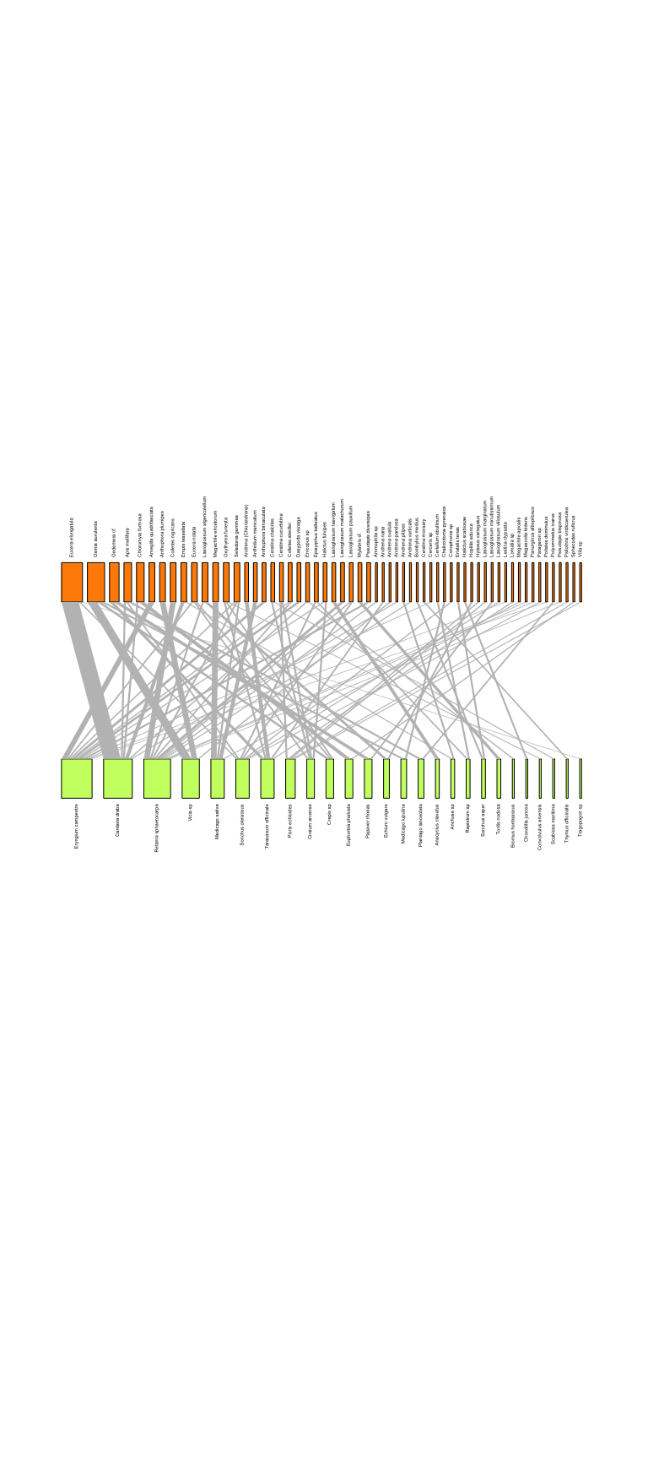

Bipartie plant-pollinator network from Ejea de los Caballeros location. Pollinators are coloured in orange and plants in green. The width of the conection between plants and pollinators represent the strength of the interaction (number of links) and the width of the different nodes corresponds to the total number of links.

## Analysis of network structure

Three main aspects of network structure are going to be analyzed for each location: weighted nestedness (NODF) implemented in Almeida-Neto et al. (2008), the quantitative version of modularity (Dormann and Strauss 2014), and the network robustness in front of perturbations (Memmott and Price 2004) The first value indicates if there is a core of species strongly interacting among them, and a series of species that interact with this core, but not among them. Nested structures are common in plant-pollinator networks and are suggested to be more stable. The second value describes if sets of species are forming modules that are tightly connected. A modular structure may emerge due to phenological constraints and studing modularity is useful to identify groups of species that depend on each others. Finally, we analyze how robust are the networks to the loss of random plant species. Networks that dismantle quickly after a few species removals are less robust in front of perturbations than networks that can mantain most pollinators despites losing a few plant species.

To understand how nested or modular are these two networks, the resulting values are compared with nestedness and modularity values of the same networks after randomization (N=1000). This is done because species richness and connectance can influence those values, and hence its important to control for those.

### Location 1 ‘Cantavieja’

Nestedness of the plant-pollinator network from Cantavieja is similar to the one that is expected by chance (P = 0.50). This indicates that smaller subsets of interacting species are not contained in larger subsets of interacting ones. Theoretical studies indicate that this structures may be less stable than more nested ones.

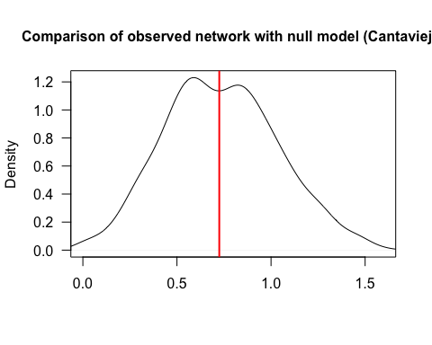

Density plot of the nestedness values for the different random networks (N=1000). The red vertical line indicates the observed nestedness in Cantavieja.

Cantavieja plant-pollinator network is more modular than expected by chance (P < 0.01). This suggest that the are subgroups or modules of species with strong connections but these modules are weakly connected. This also supports the lack of nestedness found previously.

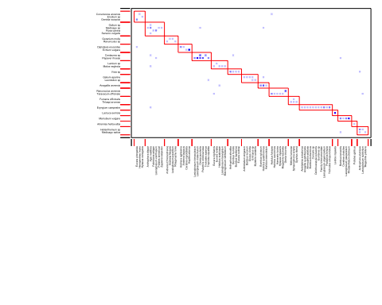

Interaction modules of the plant-pollinator network from Cantavieja.

Finally, the robustness analysis shows that Cantavieja is moderately robust to plants loss (robustness = 0.54). Values near one indicate that most pollinators can survive until almost all plants are removed, while values near zero indicate a disproportional loss of pollinators when removing a few plant species.

### Location 2 ‘Ejea de los Caballeros’

The plant-pollinator network from Ejea de los Caballeros is also not more nested than expected by chance (P = 0.98).

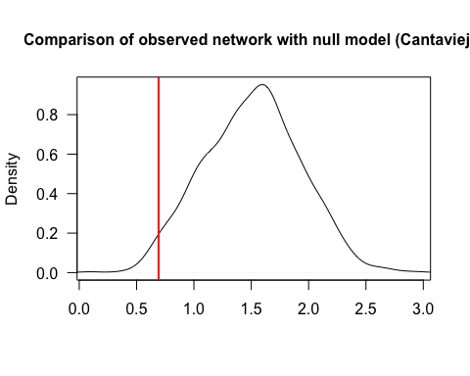

Density plot of the nestedness values for the different random networks (N=1000). The red vertical line indicates the observed nestedness in Ejea de los Caballeros

Similar to Cantavieja, the plant-pollinator of Ejea de los Caballeros is also more modular than expected by chance (P < 0.01). Again, this indicates the presence of subgroups of species with strong connections but weakly connected between these subgroups or modules.

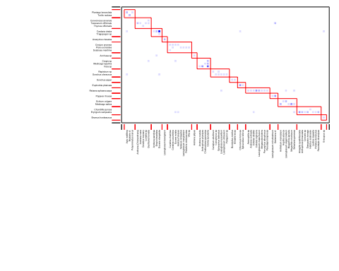

Interaction modules of the plant-pollinator network from Ejea de los Caballeros

Finally, the robustness analysis shows that Ejea de los caballeros is moderately robust to plants loss (robustness = 0.56). Values near one indicate that most pollinators can survive until almost all plants are removed, while values near zero indicate a disproportional loss of pollinators when removing a few plant species.

## References

Almeida-Neto, Mário, Paulo Guimaraes, Paulo R Guimaraes Jr, Rafael D Loyola, and Werner Ulrich. 2008. “A Consistent Metric for Nestedness Analysis in Ecological Systems: Reconciling Concept and Measurement.” *Oikos* 117 (8): 1227–39. <https://doi.org/10.1111/j.0030-1299.2008.16644.x>.

Blüthgen, Nico, Florian Menzel, and Nils Blüthgen. 2006. “Measuring Specialization in Species Interaction Networks.” *BMC Ecology* 6 (1): 1–12. <https://doi.org/10.1186/1472-6785-6-9>.

Dormann, Carsten F, and Rouven Strauss. 2014. “A Method for Detecting Modules in Quantitative Bipartite Networks.” *Methods in Ecology and Evolution* 5 (1): 90–98. <https://doi.org/10.1111/2041-210X.12139>.

Memmott, Waser, J., and M. V. Price. 2004. “Tolerance of Pollination Networks to Species Extinctions.” *Proceedings of the Royal Society B* 271: 2605–11.

R Core Team. 2021. *R: A Language and Environment for Statistical Computing*. Vienna, Austria: R Foundation for Statistical Computing. <https://www.R-project.org/>.

## Appendix