# Report on plant-pollinator network description from Cantavieja and Ejea de los Caballeros

**Data collection: O. Aguado**  
**Analysis: J. B. Lanuza and I. Bartomeus**  
**Coordination: E. Nuñez**

## Objectives

The objective of this report is to describe the differences between two plant-pollinator networks located in Cantavieja and Ejea de los Caballeros before and after restoration is implemented.

## Field sampling

Two distinct locations are being monitored with different historical land-use and management in the region of Aragón (Spain): Cantavieja (40º 30’ 44”, N 0º 22’ 59” W) at 1450m above sea level with a total of 30 plots and Ejea de los Caballeros (42º 01’ 06” N, 1º 08’ 53” W) at 350m. In each location, a total of 21 plots were monitored. Plot size is 2m by 2m and they are randomly distributed within each location (see **Figure 1**). Importantly, since the start of the project vegetation has remained undisturbed without grazing or clearing.

Each plot was surveyed three times at the beggining of the season, at the peak of flowering and at the end of the season. In each occasion, all plant-pollinator interactions observed were documented. Pollinator specimens not identified in the field were captured and identified in the lab.

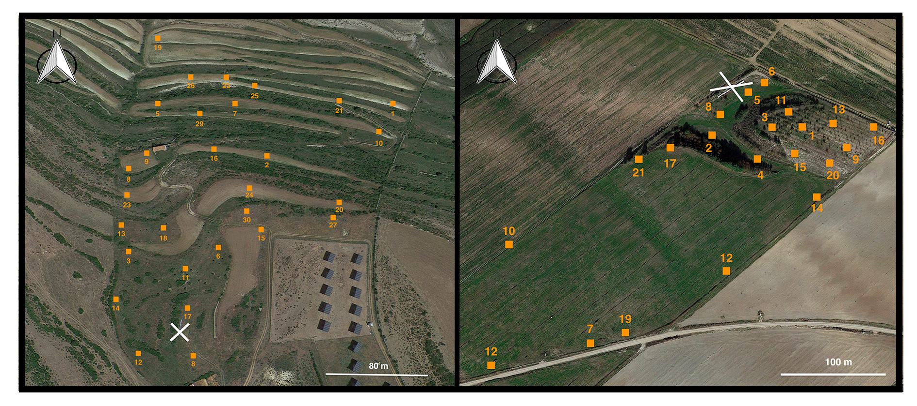

Cantavieja (left) and Ejea de los Caballeros (right) locations with the different sampling plots indicated with an orange square plus the plot identifier. The position of the bee hives is shown with a white cross for both locations.

