Week 5 Visualizations Activity

Iryna Barvi

4/17/2022

# Section 2: Reading the data into R. (5 points)  
airlines <- "https://raw.githubusercontent.com/fivethirtyeight/data/master/airline-safety/airline-safety.csv"  
airline_safety <- read.csv(airlines)

hist(airline_safety$fatalities_00_14, main= "Total fatalities between 2000 and 2014", xlab = "Fatalities", breaks=4)

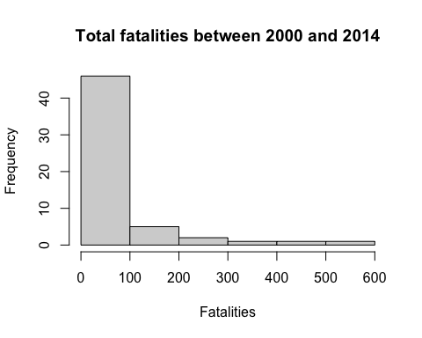

airline_safety$total_incidents = airline_safety$incidents_85_99 + airline_safety$incidents_00_14  
airline_safety$total_seat_km_per_incident = airline_safety$avail_seat_km_per_week / airline_safety$total_incidents  
segdata = data.table(airline_safety)  
  
working_data = segdata[,.(incidents_00_14,avail_seat_km_per_week)]  
  
kmean_output = kmeans(working_data, center=3)  
cluster = kmean_output$cluster  
centers = kmean_output$centers  
qplot(x=avail_seat_km_per_week, y=incidents_00_14, data=working_data,color=factor(cluster))

