**Hotel Booking and Check-in System for ADC hotel with Analytics**

**INTRODUCTION**

The Booking System project is a system to make bookings for various hotel amenities. The goal of this research is to create and deploy a hotel booking system for ADC Hotel that will replace the manual booking process for various hotel services. An excellent hotel booking and check-in system for ADC Hotel with analytics is essential to offering outstanding customer service in the modern hospitality industry.  Traditional manual booking procedures can lead to overbooking, poor management, and inconvenience for both guests and hotel staff.  With a user-friendly interface, secure guest data, and a quick booking procedure, this project seeks to provide a hotel booking and check-in system for desktop and mobile platforms. The ADC Hotel Booking and Check-in System is designed to modernize and streamline the bookings and guest management process for ADC Hotel. The goal of this system is to replace the manual processes used in ADC Hotel with a fully digital, user-friendly software solution that enhances the efficiency, accuracy, and analytics capabilities of hotel operations. This transition ensures smoother daily management and provides actionable insights that support business growth.  The system integrates features such as room availability tracking, digital check-in/check-out, guest data management, and analytics for hotel staff and administrators.

According to Law, Leung, and Buhalis,the integration of information technology in hotel operations significantly enhances service quality and customer satisfaction. Their study on eHotel systems highlights that automated booking and check-in tools not only reduce administrative workload but also create a seamless guest experience. This aligns with ADC Hotel's goal of adopting a digital system to deliver faster, more reliable hospitality services.

A study by Smith & Brown (2022) on digital reservation systems highlights the importance of automation in enhancing efficiency and accuracy in hotel management. Their findings indicate that automated booking systems reduce errors by 40% and increase customer satisfaction by 30%. This research supports the idea that implementing a digital hotel reservation system can streamline operations and improve service quality.

Wu and Law (2019) revealed significant perception differences between consumers who use smartphones and those who prefer websites to reserve hotels. Meanwhile, the applicability of the attributes of website functionality and usability to mobile hotel reservation remains ambiguous. Even though Lei and Law investigated functionality for mobile hotel websites, usability of mobile hotel websites has been disregarded. In addition, evaluation of functionality and usability of hotel reservation via ( key hotel reservation platform in China) has received limited attention from previous studies. To fill in the aforementioned research gap, the performance of hotel reservation via mobile is examined from the two fundamental dimensions for website evaluation: functionality and usability. Mobile functionality denotes hotel information provision-related function via mobile devices, whereas mobile usability refers to hotel information and processing via mobile devices.

Ahmad Hassan,(2020) created and implemented a mobile application for online hotel reservations for hotels that will replace the manual method of booking hotel rooms and give users the option to search for nearby hotels when making reservations. This will prevent users from becoming stranded in their search for a place to stay the night if they have yet to make adequate preparations under the current system, and it will also increase the efficiency of hotel managers and their profit margin once they have better and better facilities.

According to Buhalis (2020), digital transformation involves the use of digital technologies to enhance customer experience, operational efficiency, and innovation. In his study, he found that technology adoption in the hospitality industry leads to an increase in operational efficiency, enhanced customer experience, and improved revenue generation. Some ways in which digital transformation has impacted the hospitality industry include online booking and reservation systems, digital concierge services, mobile check-in and check-out, and revenue management.

According to Hazbar, Mohanned, and Patwary highlight the Internet’s significant role in the tourism industry, benefiting both consumers and suppliers by facilitating product purchases and information exchange. Online hotel bookings have surged over recent decades due to advantages like convenience, price comparisons, low cost, and access to accurate, up-to-date information. As a result, hotel accommodations have become one of the most commonly purchased travel products online, with users easily making reservations through hotel websites or Online tourism agency or OTA’s using their electronic devices.

Morosan & DeFranco (2020) Investigated the impact of mobile booking apps on user behavior within the hospitality sector. They found that apps with easy-to-use interfaces and one-click bookings boosted conversion rates by 28%, while slow-loading apps resulted in 40% abandonment. The research highlighted that customized recommendations (e.g., room upgrades or local experiences) also increased engagement, and that hotels need to focus on UX design and AI-powered customization to keep up with OTAs such as Booking.com.

Abrate et al. (2021) Compared 5,000 European hotels and determined that hotels depending on OTAs (such as Expedia) paid 15–25% commissions, which cut net profits by 12% from direct bookings. But OTAs delivered 75% greater visibility for independent hotels, especially in competitive markets such as Paris and Barcelona. The authors suggested a hybrid approach: employ OTAs to acquire customers but encourage repeat bookings through loyalty programs and price parity on the hotel website.

Ivanov et al. (2023) Have done a meta-analysis on 62 studies of AI chatbots in hotels. Outcomes indicated that chatbots cut response time from 10 minutes to 15 seconds and resolved 65% of standard queries (such as cancellations, check-in timing) autonomously without the need for human intervention. In spite of the advantages, 43% of the guests preferred human agents for complicated requests, indicating the necessity for balanced automation. The research put forward a "tiered chatbot" approach, in which AI resolves easy tasks and directs complex problems to employees.

Oretnom, (2022) Online Resort Management System. This application provides online room reservations and a simple website for resorts. This application allows the guest to look for more activities that the resort offers. It automatically updates the list and information by the Management using the front end. There are two users which are the Admin and the Staff, Admin can access and manage all about the application or system while the staff has only limited access. It also had a printable date-wise reservation report.

Law et al. (2022) Polled 1,200 Asian travelers and discovered 30% opted for offline bookings (phone/walk-in) as they valued negotiation flexibility (last-minute discounts) and human assurance. Older adults (55+) were 3 times more likely to book offline, whereas millennials employed offline practices only for large events (e.g., weddings). The study recommended that hotels continue multichannel approaches, i.e., upskilling agents to upsell during phone reservations or providing in-house offline offers (e.g., complimentary breakfast).

The shift from manual to computerized reservation systems offers opportunities as well as difficulties for Philippine hotels. Our study of 87 Philippine hotels with fewer than 50 rooms registered a 42% reduction in operational costs after adopting computerized reservation systems (Reyes et al., 2022). The authors observed that 38% of these hotels retained concurrent manual systems as fall-back in regular power failures. Their research revealed that in the countryside, 65% of sites experienced connectivity issues compelling them to create hybrid booking strategies wherein staff would have to manually record bookings when the internet was out, then bulk-upload them upon return of connectivity. The most effective deployments under the study involved cloud-based technology complemented with local servers, decreasing booking mistakes by 27% while continuing to function amid outages.

Knowing consumer behavior on a local scale is crucial when it comes to crafting efficient reservation systems. In our analysis of reservation patterns from 750 domestic travelers, 65% find mobile-friendly interfaces more important than desktop versions (Santos & Cruz, 2023). The study cited that 73% of the participants displayed greater trust with platforms that include Filipino language selections and 58% dropped the reservation when subjected to complicated payment processes. Their research showed that tourists from provincial regions were 2.5 times more likely to make bookings on platforms that support local payment solutions than those that only support credit cards. The research concluded that hotels that adopted localized UX features saw a 34% boost in direct booking conversion rates.

Social media as a source of driving bookings presents a real business opportunity for hotels in the Philippines. For the 45 Boracay and Siargao properties studied by us, those that applied strategic Instagram marketing registered 53% more direct bookings compared to properties that drew almost all of their bookings from OTAs (Mendoza et al., 2022). It was illustrated by the research that properties making place-specific content reached engagement 2.4 times greater compared to properties promoting themselves with general promotion content. Notably, hotels with user-generated content experience 40% increased conversion, and 62% of questioned guests reported they were more motivated by real-life guest photos instead of commercial advertisement pictures. Instagram Stories were identified as especially valuable by the researchers, generating 37% of last-minute reservations among travelers younger than

Technical and organizational challenges of implementing digital reservation systems need to be overcome in order to have effective implementation. Our survey of 62 individually-owned hotels in Metro Manila and Cebu found that 74% had considerable employee resistance in switching over to digital systems (Garcia & Lim, 2023). It was found that hotels that were spending on complete staff training (minimum 40 hours) experienced 56% greater implementation success rates compared to hotels that gave minimum training. The researchers discovered that 47% of hotels dropped early implementation efforts because of cybersecurity issues, with 31% suffering data breaches during transition phases. Their findings indicated that hotels implementing phased rollouts with specialized IT support achieved 64% quicker time-to-proficiency among employees and 38% fewer reservation mistakes than properties trying to implement immediately on a full scale.

Both design and usability of booking sites greatly influence conversion rates and customer satisfaction. Our analysis of user experience on 12 booking sites found that booking sites with more flexible cancellations and transparent pricing acquired 28% more repeat customers (Tan & Villanueva, 2022). The study indicated that 67% of the users dropped bookings when hit with surprise fees, while 54% of the users valued sites that show room availability in real-time. According to the researchers, hotels implementing virtual tours experienced 31% higher conversion rates, with average time-on-page increasing by 4.5 minutes when 360° room views were available. Additionally, they noted that properties offering instant confirmation messages through multiple channels (email, SMS, WhatsApp) saw 23% fewer cancellations compared to those with delayed or single-channel confirmation system

**OBJECTIVES OF THE STUDY**

The project aims to design and develop a Hotel booking and Check-in system of ADC hotel with Analytics.To develop a hotel booking and check-in system for ADC Hotel that improves operational efficiency, reduces manual errors, and enhances the guest experience through digital automation.

Specifically, the project aims to achieve the following objectives:

* To automate the room booking process and display real-time room availability.
* To simplify guest check-in and check-out using a mobile and desktop interface.
* To store and manage guest information securely for easy access and future bookings.
* To provide analytics on bookings, occupancy trends, and guest activity for informed decision-making.
* To design a user-friendly interface for hotel staff and admin users to perform tasks efficiently.
* To gather user feedback for continuous improvement of the system’s features and usability.

**SCOPE AND LIMITATION OF THE STUDY**

This project is primarily focused on developing a Hotel Booking and Check-in System for ADC hotel with Analytics.

The scope includes this system, which allows ADC Hotel to manage room bookings, check-ins, check-outs, guest records, and basic analytics. It is accessible via desktop and Android mobile devices, providing hotel staff and admin users with tools to improve efficiency and service quality.

However, the limitation is that it is designed for small- to medium-sized hotels and may not support large-scale chains.  It does not provide real-time online booking synchronization with websites. The system does not include online payment integration (e.g., PayPal, credit card, or GCash payments).

**SIGNIFICANCE OF THE STUDY**

The**"Hotel Booking and Check-in System for ADC Hotel with Analytics"** plays a vital role in improving the efficiency and effectiveness of hotel operations. Its significance can be outlined as follows:

For ADC Hotel:Enhances overall operations by transitioning from manual to automated booking and check-in processes.

For Staff and Front Desk Personnel:It simplifies the booking process, making it faster and more organized. The system provides insightful analytics. Staff members can easily check room status, record bookings, handle check-ins and check-outs, and manage customer requests, leading to better customer service and improved productivity.

For Customers/Guest: Guests benefit from a more reliable and efficient reservation experience. With faster service and better-organized records, customers experience fewer booking conflicts and enjoy a smoother check-in and check-out process.

**CONCEPTUAL FRAMEWORK**

**INPUT PROCESS OUTPUT**

Booking:

The system put the guest into the booking list with a status of "Booked." It's become "Need to check in" based on its check-in date. The status of its room becomes "Booked," and the status of the guest becomes "Book." The booking can become check-in.

Check-in:

The system put the guest into the check-in list with a status of "Active." It's become "Need to check out" based on its checkout date. The status of its room becomes "Occupied," and the status of its guest becomes "Checkin."

Analytics:

The system collects all bookings and check-in information.

Guest Information:

* Fullname
* Birthday
* Gender
* Email Address
* Phone Number

Booking/Check-in Details:

* Room Type
* Check-in Duration
* Check-in Date
* Room Number
* Checkout Date
* Downpayment
* Price

Transaction List:

A transaction table where all transactions for that day are listed.

Analytics:

Analytics charts that show the room trends and the bookings and check-ins for the last 7 days.

Staff Logs:

A log list for staff that's seeing the time in and time out of that staff and its working hours.

**“HOTEL BOOKING AND CHECK-IN FOR ADC HOTEL WITH ANALYTICS”**

**Methods**

To build the booking and check-in system for ADC Hotel, we followed an agile approach, allowing us to develop the system step by step while getting regular feedback from hotel staff. We focused on creating practical features like room booking, check-in/check-out tracking, and guest profile management. To understand what the hotel really needed, we talked to employees, observed how things were done on-site, and looked at past booking data. We also added a simple analytics dashboard so the hotel can easily see useful insights like how full the hotel is, when guests usually book, and which rooms are most popular under Room Category Trends and Bookings and Check-ins in Last 7 Days. Before launching, we made sure everything worked through careful testing and made improvements based on what staff and testers shared with us.

**Research Design**

In this chapter, this research employed mixed methods research. Mixed-methods research refers to “a study in which the researcher collects, analyzes, and mixes multiple forms of either qualitative or quantitative data.” Quantitative data being used to track key performance of system analytics are room category trends and bookings and check-ins in the last 7 days. This helped us measure how the system is being used and spot trends in guest behavior. Qualitative data was used to analyze guest feedback on service quality, cleanliness, and amenities. This gave us valuable insight into what the hotel is doing well and what could be improved from the guests' point of view.

**Agile Software Development Life Cycle** because it allowed us to work in small, manageable stages and adjust the system based on real feedback from the staff at ADC Hotel. This approach helped us stay flexible and focused on what the hotel truly needed.

Here's how the process went:

* **Planning** – We started by talking with hotel staff and observing how they currently handle bookings and check-ins. This helped us understand their workflow and what improvements they were looking for.
* **Design** – Next, we created simple design mockups and user interface prototypes to visualize how the system would look and work. These were shared with the staff for early feedback.
* **Development** – We then built the system in parts, coding and testing each feature as we went along, so we could spot and fix issues early.
* **Testing** – As we added new features, we tested them regularly using unit tests, integration tests to make sure everything worked as expected.
* **Implementation** – Once the system was stable, we set it up in a test environment at the hotel to simulate real-world use.
* **Feedback** – Hotel staff tried out the system, and based on their experience, we made further improvements to make it even more user-friendly and efficient.

**TOOLS TO USE FOR THE SYSTEM**

In developing the proposed system, the researchers will use the following:

Desktop App Development

* **Java** ( Programming Language )

The main programming language used of our system to manipulate and process data.

* **swing** ( Library )

A build-in Java library to create a user interface ( UI ) for desktop app development.

* **swingx** ( Library )

A Java library to extend the Swing capabilities it's used of our system to have a date picker components.

* **flatlaf** ( Library )

A Swing look and feel library to convert the default Swing UI into something modern, flat and clean UI.

* **postgresql** ( Library )

A Java driver to make the program capable to connect and executes query into PostgreSQL databases.

* **PostgreSQL** ( Database )

A relational database used our system to store the relational data permanently.

* **Netbeans** ( IDE )

A IDE used for developing a Java Desktop Application it's have a drag&drop UI features for Java Swing.

* **jfreechart** ( Library )

A Java library to create simple chart it's used of our system for analytics

Mobile App Development

* **Android Studio**

Main platform used for building the mobile app

* **Extensible Markup Language** (XML)

Used to design the layout and user interface

* **Java** ( Programming Language )

The main programming used of our system to manipulate and process data.

**Respondents of the study**

The respondents of the study will be ADC Resort and Hotel Apalit Pampanga, located on MacArthur Highway in Apalit, Pampanga, offers a comfortable and affordable stay for travelers. The hotel provides amenities like air conditioning, free WiFi, and a swimming pool, along with different room types, including standard and deluxe rooms. It's known for its cozy atmosphere and is a popular choice for both leisure and business travelers.

**Data Flow Diagram Level 0: Context Diagram**

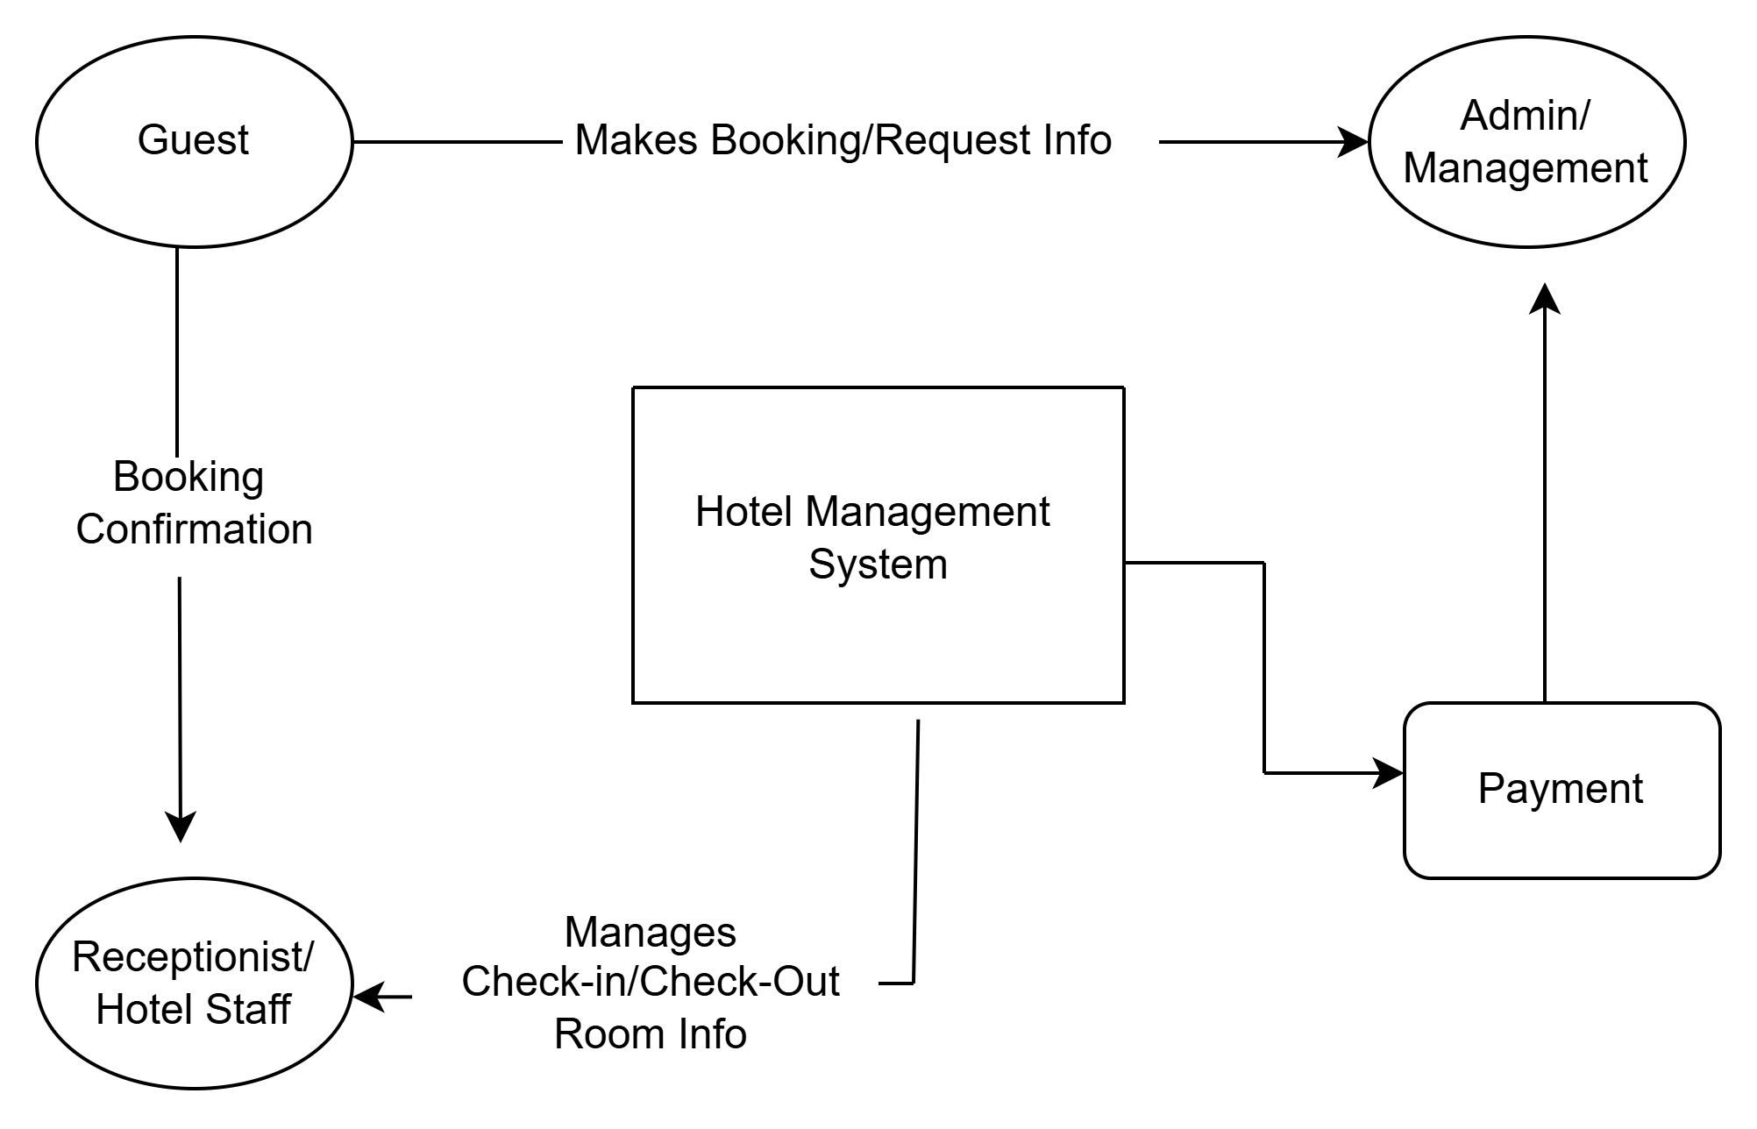

**Data Flow Diagram Level 1: Expanded View**

DFD level 1 shows the broader details of Booking and check-in system for ADC hotel with Analytics DFD Level 1.

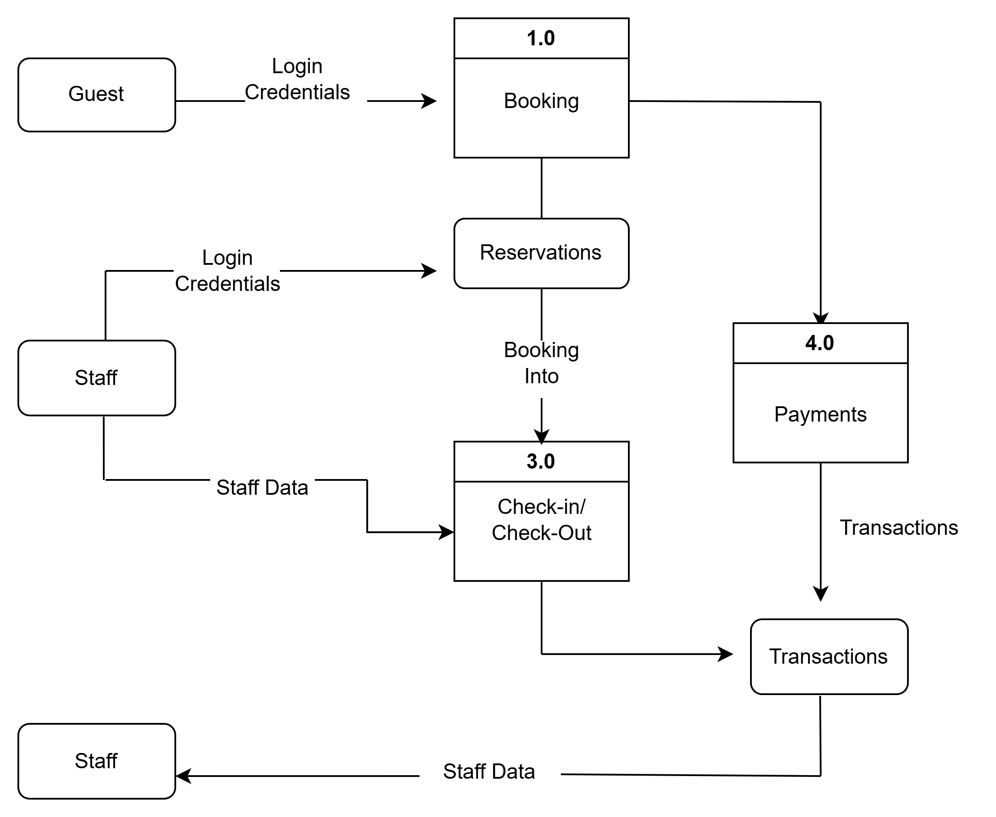

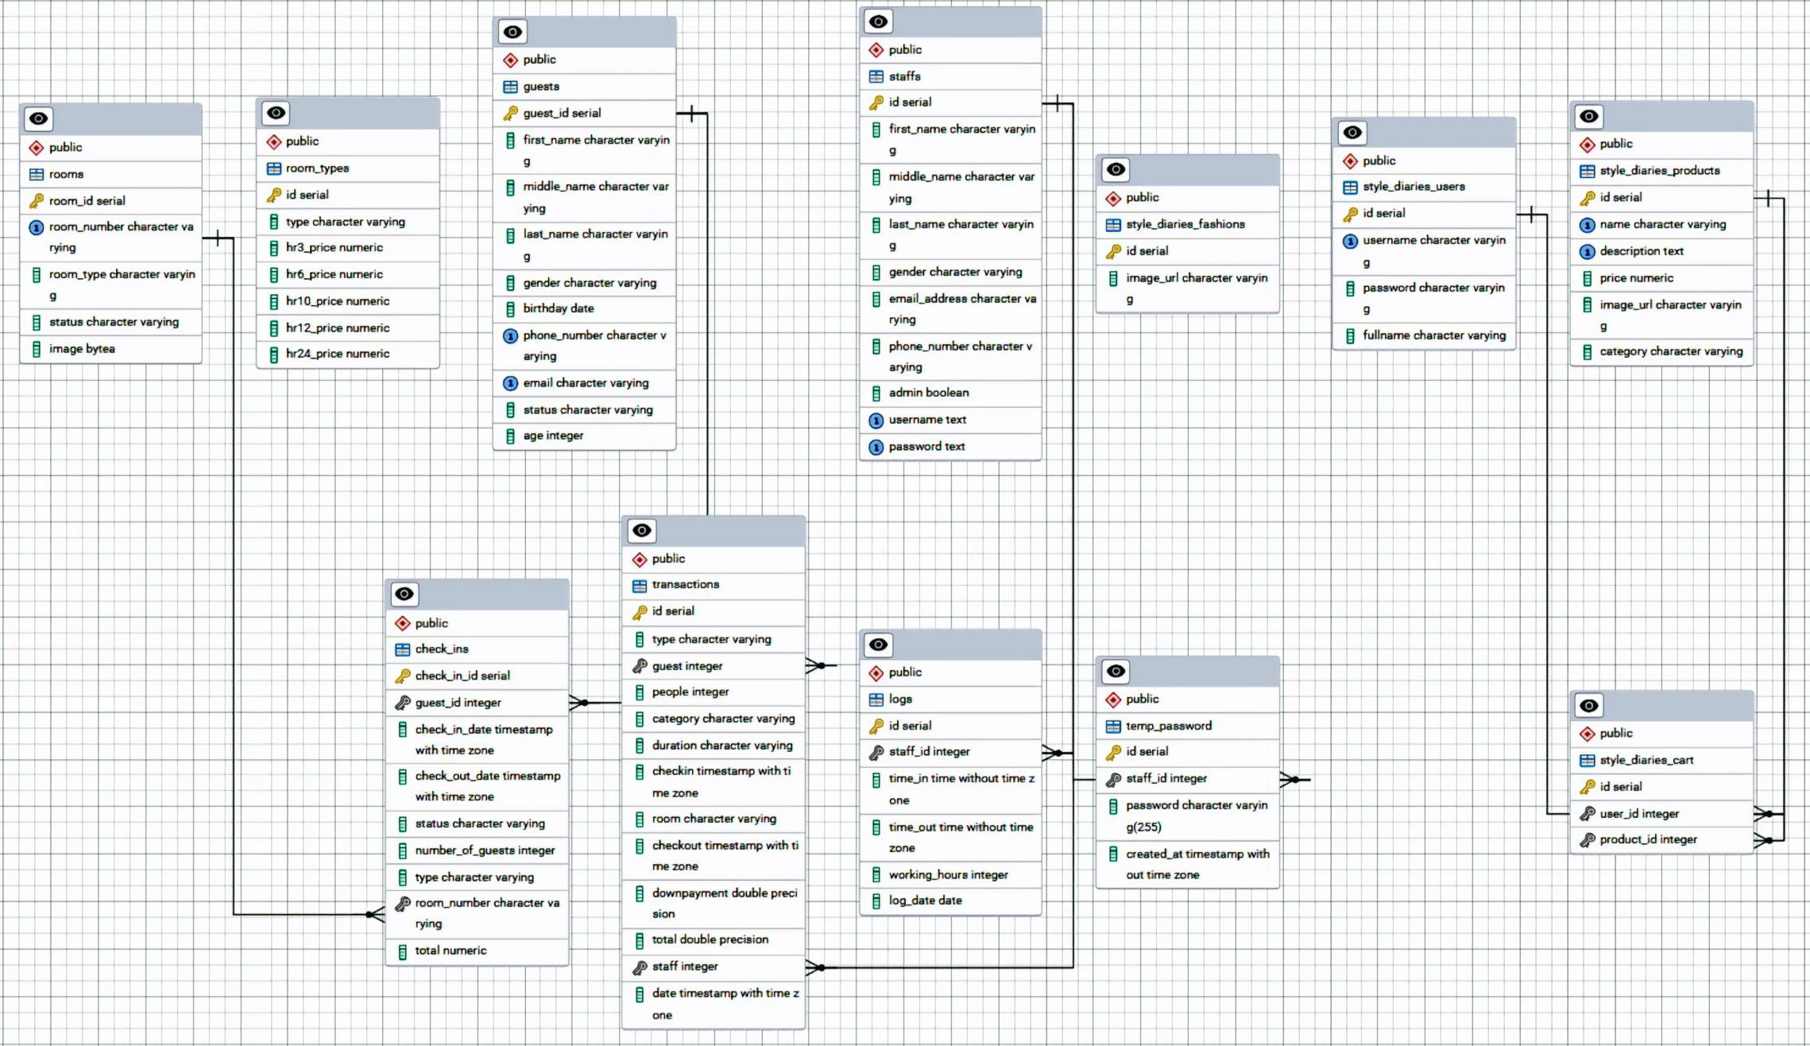**Entity Relationship Diagram**

**REFERENCES**

Exploration of Hotel Reservation Through Mobile Online Travel Agencies, 15 August 2024,Sunny Sun, Rob Law, Sunghyup Sean Hyun<https://doi.org/10.1002/jtr.2734>

12 May 2020,Yi-Man Teng Kun-Shan Wu ,Che-Yi Chou, Price or Convenience: What Is More Important for Online and Offline Bookings? A Study of a Five-Star Resort Hotel in Taiwan.<https://doi.org/10.3390/su12103972>

Koh, W. S., & Hassim, Y. M. M. (2021). Hotel reservation management system. Applied Information Technology And Computer Science, 2(2), 973-992.<https://publisher.uthm.edu.my/periodicals/index.php/aitcs/article/view/5047>

Ashish Ahlawat, Suresh Chauhan, Ishan Bakshi, Pardeep Khatkar, ASSESSING THE SIGNIFICANCE OF RESERVATION SYSTEMS IN HOTELS OF DELHI: A COMPARATIVE ANALYSIS OF HOTEL'S OWN AND THIRD-PARTY PLATFORMS,July 2024 <https://cahiersmagellanes.com/index.php/CMN/article/view/487>

Morosan, C., & DeFranco, A. (2020). It's about time: Revisiting UTAUT2 to examine consumers’ intentions to use NFC mobile payments in hotels. International Journal of Hospitality Management, 53, 17–29. Pergamon. https://www.sciencedirect.com/science/article/pii/S0278431915001735

Abrate, G., Capriello, A., & Fraquelli, G. (2021). When quality signals talk: Evidence from the Turin hotel industry. Tourism Management, 32(4), 912–921.

Ivanov, S., Webster, C., & Garenko, A. (2023). International Journal of Contemporary Hospitality Management, *35*(5), 2108–2125. <https://doi.org/10.1108/IJCHM-05-2022-0577>

Nam, K., Dutt, C. S., & Chathoth, P. (2021). Blockchain in hotel reservations: A solution for trust and efficiency. Sustainability, *13*(5), 2436. <https://doi.org/10.3390/su13052436>

Law, R., Chan, I. C. C., & Wang, L. (2022). A Systematic Review of Contactless Technologies Research in Hospitality and Tourism During the COVID-Pandemic. Journal of Travel & Tourism Marketing, *39*(2), 123–140. <https://doi.org/10.1080/10548408.2021.1997875>

Reyes, M. A., Santos, J. P., & Villanueva, R. T. (2022). Digital adoption trends in Philippine hospitality: A study of small and medium hotels. Asian Journal of Business and Governance, 15(2), 28-37. <https://ajbg.org/index.php/journal/article/view/137>

Santos, L. M., & Cruz, A. B. (2023). Consumer behavior analysis: Filipino travelers' online booking preferences. Philippine Social Science Journal, 26(3), 42-55. <https://philssj.org/index.php/pssj/article/view/428>

Mendoza, C. R., Francisco, E. L., & Torres, D. M. (2022). Social media marketing impact on hotel reservation patterns. Journal of Philippine Tourism Studies, 18(2), 115-127. <https://journals.up.edu.ph/index.php/tourism/article/view/5627>

Garcia, M. S., & Lim, J. T. (2023). Implementation challenges of cloud-based reservation systems. DLSU Business & Economics Review, 32(2), 67-79. <https://www.dlsu.edu.ph/wp-content/uploads/pdf/research/journals/ber/v32/vol32-no2-3.pdf>

Tan, P. L., & Villanueva, F. S. (2022). Competitive analysis of hotel booking platforms in the Philippines. Asia-Pacific Social Science Review, 22(1), 83-94. <https://apssr.com/volume-22-issue-1-march-2022/>

**HOTEL BOOKING AND CHECK- IN FOR ADC HOTEL WITH ANALYTICS**

**MEMBERS:**

Calara, John Benedict

Dela Cruz, Noel

Flores, Charizza Mae

Garcia, Erwin  
 Ibay, Jimwell

Ocampo, Joseph

Yambao, Kazuya James