Board 3 - Report : Golden Arduino

Ibrahim Muadh

Nov 10th, 2025

Table of Contents
1) Objective: 1
2) Components Required: 1
3) Plan of Record: 1
4) Napkin Sketch: 2
5) Procedure to Bootload: 2
6) What it means to work 2
7) Debugging 3
8) Schematic : 3
9) Layout : 4
10) Board: 4
11) Assembled Board: 5
12) After Powering Up: 5
13) Scope Output : 6
15) SHIELD BOARD ON TOP OF ARDUINO: 7
16) Current Measurement Across R4 (49 Ω) – D12 Pin 7
18) Switching Behavior of Arduino I/O Pins 8
19) Switching Behavior of MOSFET 10
20) Near-Field Emission: 11
21) BEST DESIGN PRACTICES FOLLOWED 12
22) IMPROVEMENTS TO BE IMPLEMENTED 13
23) Conclusion: 13

Objective:
The purpose of this project is to design and build a custom Arduino compatible circuit board that functions with the same reliability and performance as a commercial Arduino Uno. The board aims to apply standard design principles and best engineering practices to improve circuit stability, minimize noise, and enhance signal integrity. Through systematic design, testing, and comparison with a commercial reference board, the project evaluates how optimized layout techniques and effective power distribution can improve overall performance.

Components Required:
- ATmega328P microcontroller
- CH340G USB-to-UART converter
- 16 MHz crystal (for ATmega328P)
- 12 MHz crystal (for CH340G)
- 5V DC barrel jack connector
- USB mini-B connector
- 3.3V LDO-AMS1117
- Ferrite bead (for AVCC filtering)
- TVS diode (for USB ESD protection)
- 0.5 Ω sense resistor (for current measurement)
- capacitors (1uf = 1 ; 22uf = 9; 22pF = 4)
- Resistors (1KΩ =7; 10KΩ=1; 1MΩ=2; 0.5Ω=1)
- LED - 5
- Mini Slide switch
- Reset push button
- ICSP programming header
- I/O header pins

Plan of Record:
- 5V Power Input: Provided through a 5V DC power plug or a USB Mini female connector with TVS protection for surge and ESD protection.
- 3.3V Regulator: A 3.3V LDO regulator supplies the 3.3V rail for low-voltage components.
- Sense Resistor: A 500 mΩ resistor is included to measure inrush current.
- LED Indicators: LEDs indicate the operational status of the 5V and 3.3V power supplies.
- Mini Slide Switch: Selects between USB Mini or external 5V power source.
- Isolation Switch: Allows control and measurement of the effect of output capacitors on the 3.3V power rail.
- USB to UART Interface: CH340G IC converts USB data signals to UART signals.
- Test Points: Provided for USB data lines (D+ and D−) and for UART TX/RX signals.
- Microcontroller: Atmega328 for control and processing functions.
- Programming Interface: ICSP header provided for bootloading the Atmega328.
- Reset Circuit: Ensures reliable system reset functionality.
- Clock Sources: Includes 12 MHz and 16 MHz crystals for timing requirements.
- Mini Slide Switch: Allows selection between 3.3V or 5V mode for powering the hex inverters.

Napkin Sketch:
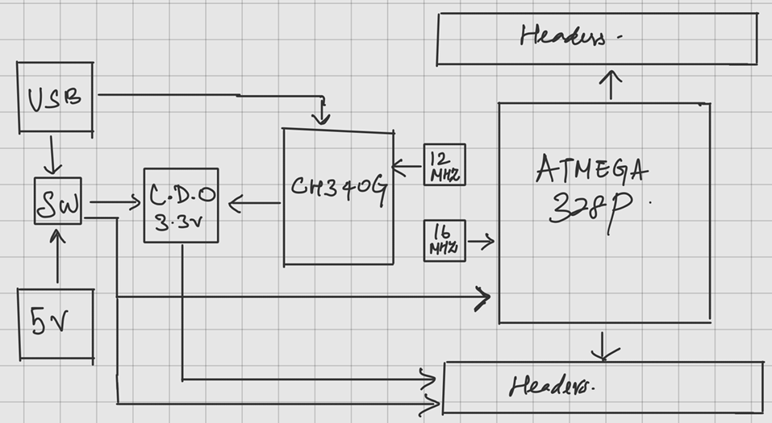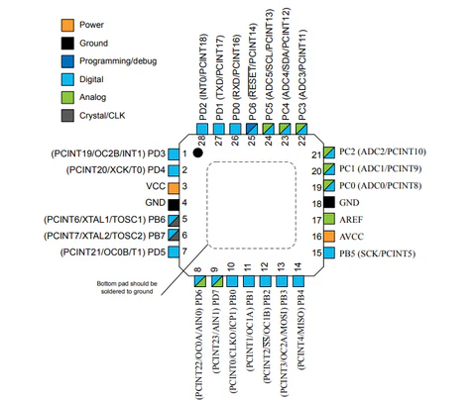
Figure 1 - Napkin Sketch Figure 2 - Atmega 328P pinouts

Procedure to Bootload:
1. Connect SCK to SCK
2. MISO to MISO
3. MOSI to MOSI
4. VCC to 5V header socket (of new board) and ground to ground (of new board)
5. Pin 10 to Reset header pin (of new board)
6. After this is done, connect the commercial Arduino to PC and go to File> examples>11(Arduino ISP), upload it.
7. Tools>programmer (Arduino as ISP) and make sure port and board is selected appropriately. Then click Burn bootloader.
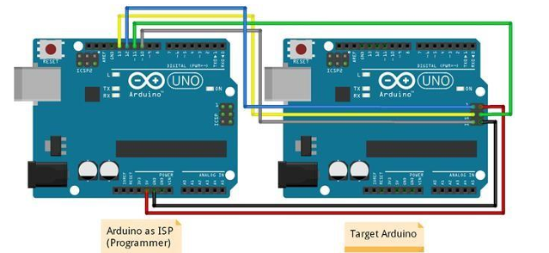
Figure 3 : Connection for Bootloading

What it means to work
- The board should power up correctly from both the USB and external 5 V inputs through the selector switch.
- Voltage regulators must provide 5 V and 3.3 V outputs..
- The reset circuit must ensure reliable system recovery after power cycling or manual reset.
- Both crystals (16 MHz and 12 MHz) must oscillate at their rated frequencies with stable signals observable on an oscilloscope.
- The board should establish serial communication with the Arduino IDE via USB and allow successful program upload.
- All digital I/O pins must toggle correctly when programmed and match expected logic levels.
- Decoupling capacitors should effectively suppress transient noise, verified through stable oscilloscope waveforms.
- Switching noise and near-field emissions must remain lower than those observed on a commercial Arduino under similar conditions.

Debugging
The 5V power supply showed a lot of droop when tested with a shield. A decoupling capacitor placed near the headers could have solved this problem. Other than that, the golden Arduino worked as expected in all other criteria.

Schematic :
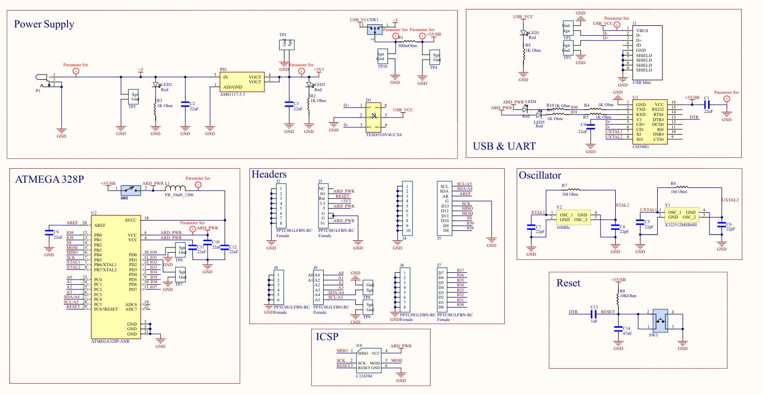
Figure 4 - Schematics

Layout :
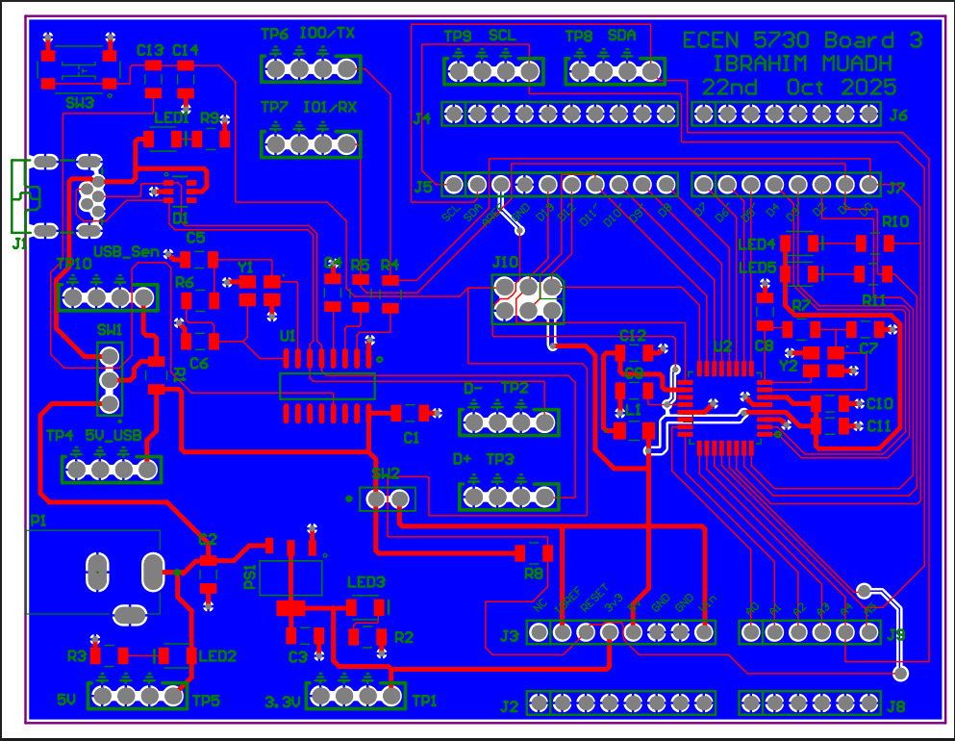
Figure 5 - Layout

Board:
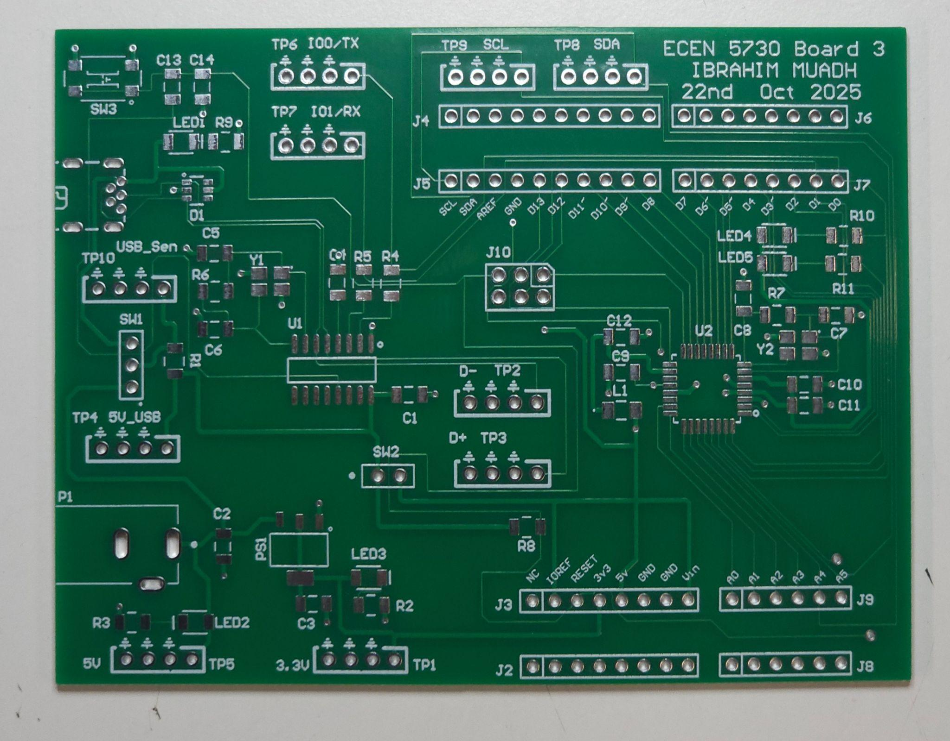
Figure 6 - Before Assembling

Assembled Board:
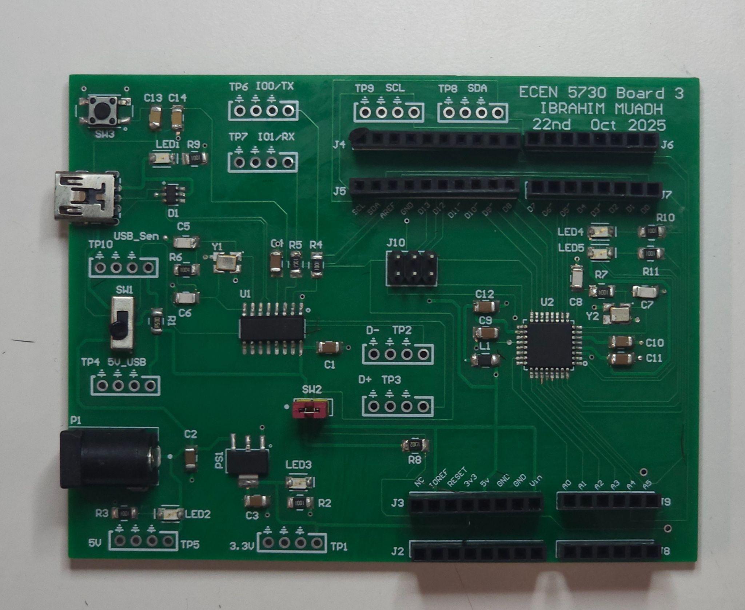
Figure 7 - Assembled Board

After Powering Up:
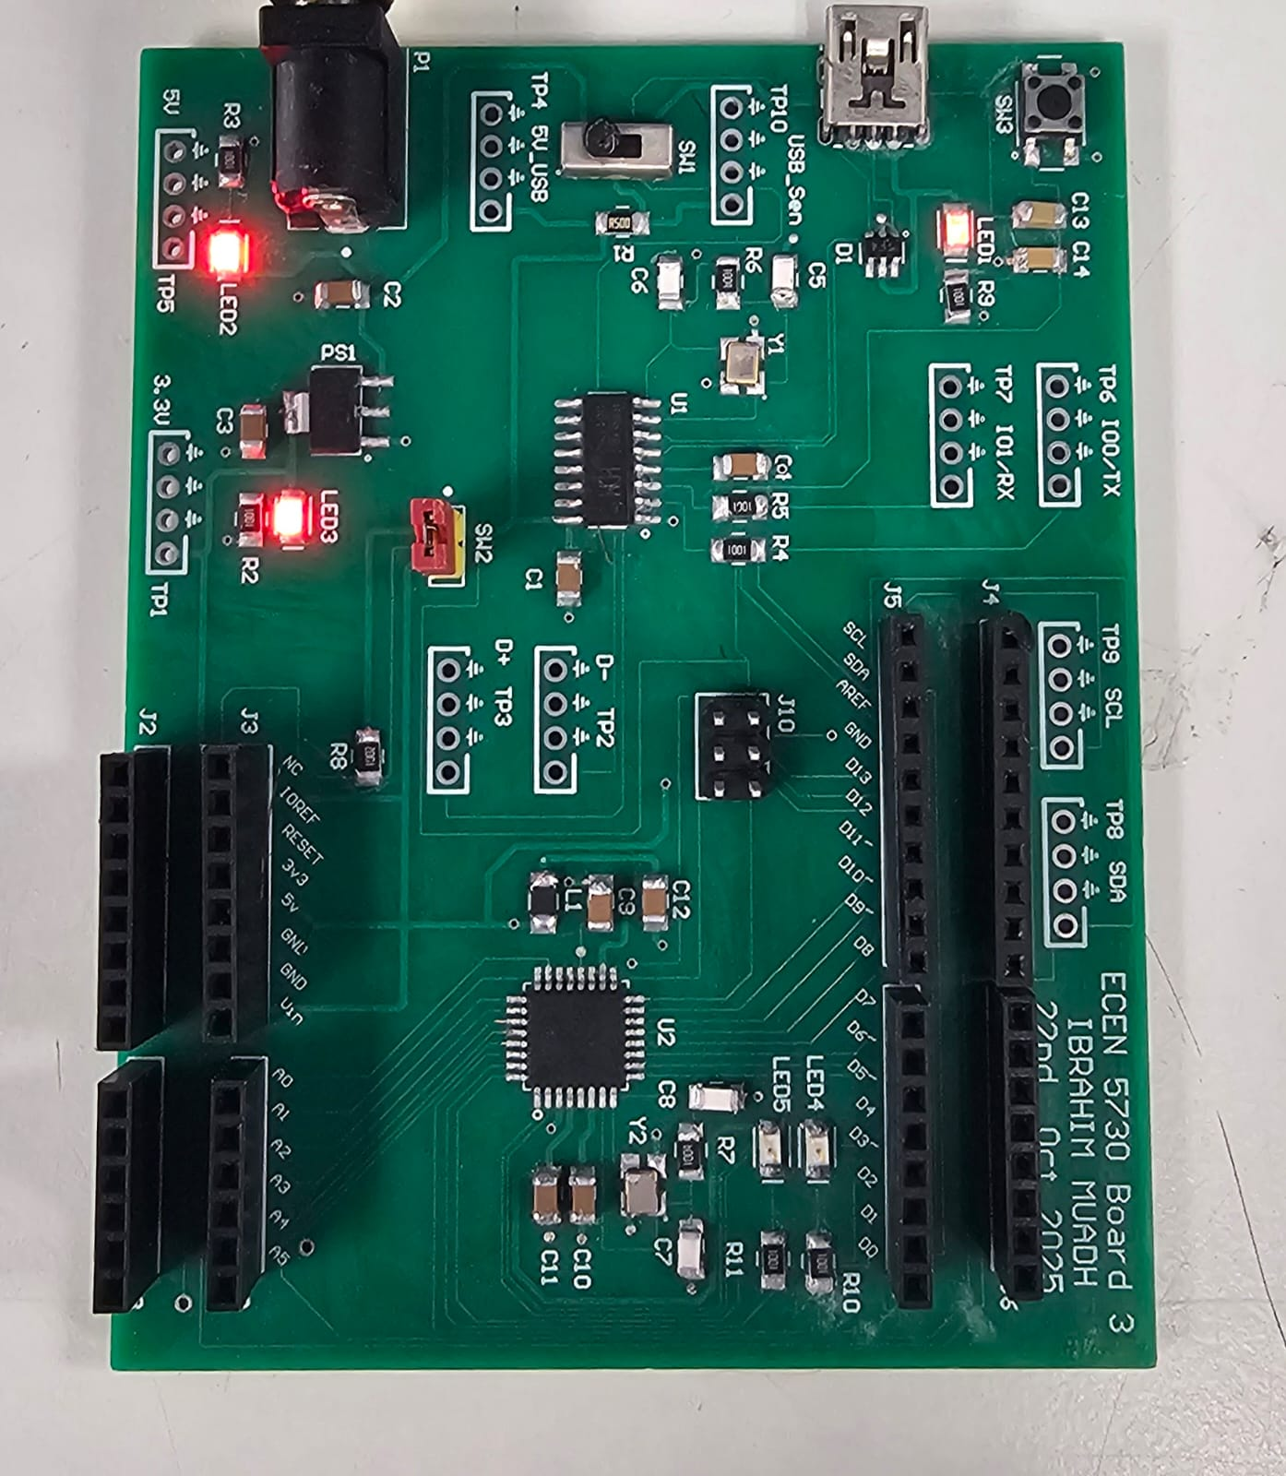
Figure 8 - After Powering up

Scope Output :

- Measured and verified that 5V DC voltage is coming from the power jack and USB mini, which is then converted to 3.3V by the LDO.
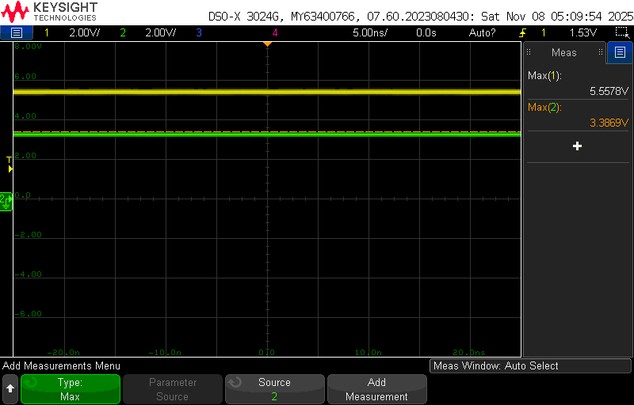
Figure 9: 5V (Yellow) and 3.3V (Green) rail measured at TP5 and TP1 respectively.

- Verified UART and USB functionality by observing the TX and RX signals during data transmission from the Arduino board.

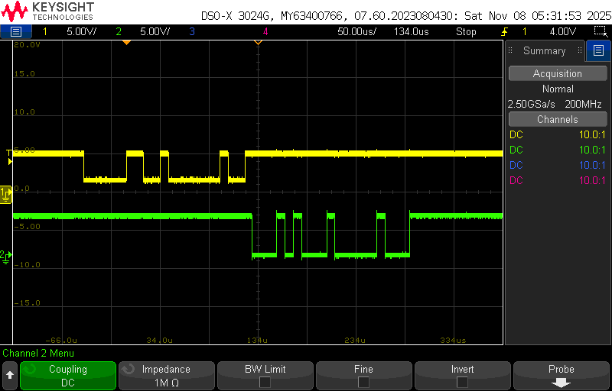Figure 10: UART signal, yellow - RX, green-TX | 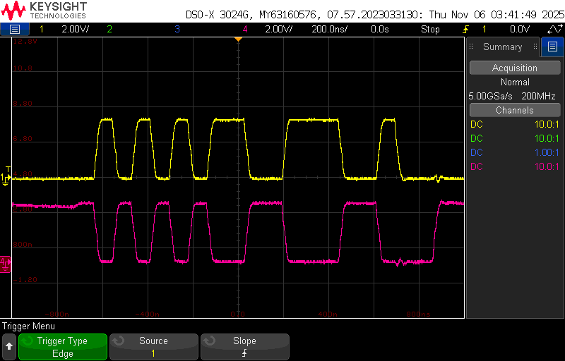  Figure 11: USB signals, yellow - D-, Green- D+

The UART and USB lines were probed at TP6 (TX), TP7 (RX) and TP2 and TP3 while uploading the code, with signal capture performed in Normal trigger mode.

- In-rush Current:
The inrush current was measured across the 0.5 Ω sense resistor placed on the 5 V input line of the Golden Arduino board. The captured waveform shows a sharp current spike at power up, followed by a smooth flow as the decoupling capacitors charge.

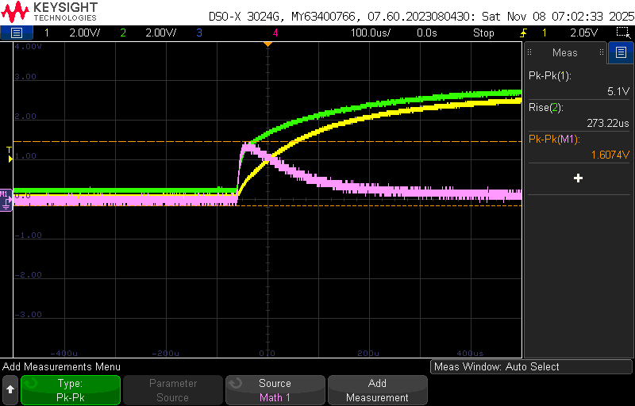
FIgure 12: In-rush Current
Green High side of resistor
Yellow Low side of resistor
Pink Math function(Yellow-green)
Inrush current = 1.60 volts/0.5ohms = 3.21A

15) SHIELD BOARD ON TOP OF ARDUINO:
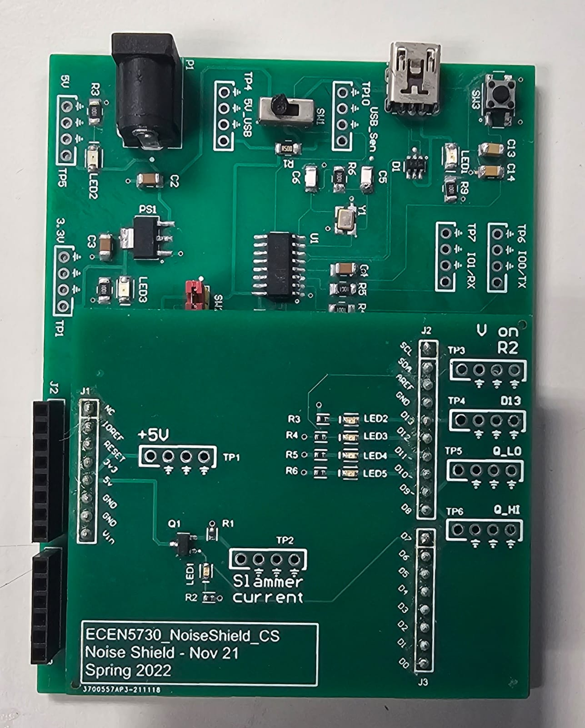  Figure 13: SHIELD BOARD ON TOP OF ARDUINO | void setup()  {  DDRB = B00111111;  pinMode(7, OUTPUT);  digitalWrite(7, LOW);  }  void loop()  {  PORTB = B00111101;  delayMicroseconds(4);  PORTB = B00000001;  delay(1);  digitalWrite(7, HIGH);  delayMicroseconds(400);  digitalWrite(7, LOW);  delay(10);  }

For these measurements,a specially designed shield board was connected to the Arduino headers for measurement purposes. It includes three 49 Ω resistive loads connected to D10, D11, and D12, each driving an LED for visual indication. Pin D13 drives a trigger LED through a 1 kΩ resistor, which is also accessible using test point TP4. The uploaded program generates square-wave outputs on the digital pins while keeping D9 fixed low (Q_low) and D10 fixed high (Q_high). Additionally, the shield integrates a MOSFET circuit with a 10 Ω sense resistor at its source terminal. The MOSFET’s gate is controlled by D7 (indicated by LED1), and its drain is connected to the 5 V rail, enabling controlled switching and current measurement during testing.

16) Current Measurement Across R4 (49 Ω) – D12 Pin
In Figure , the yellow trace represents the trigger signal from D13, while the green trace shows the voltage across the 49 Ω resistor connected to D12, measured at TP3 on the shield board.
The measured voltage drop is 1.75 V, I = V/R = 1.75/49 = 0.0357A. This confirms that the current through D12 is about 35.7 mA. Since D10 and D11 are configured with identical 49 Ω + LED loads, they also conduct approximately the same current under the same conditions.
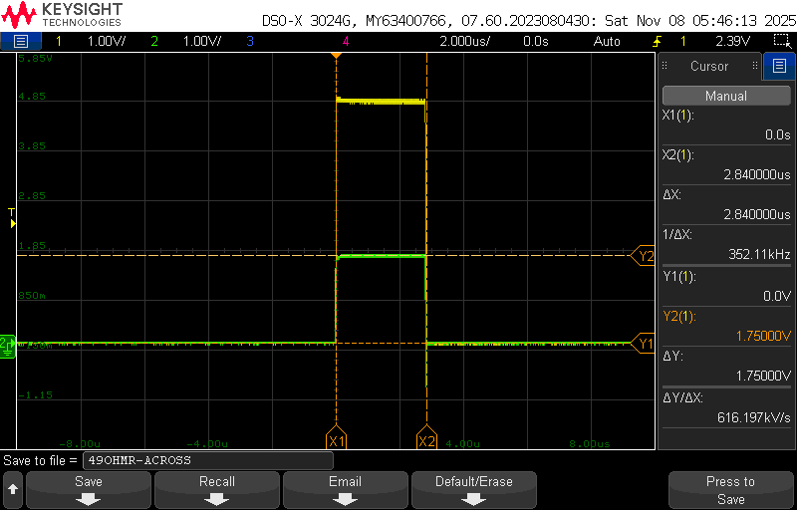
Figure 14: Current through 49 ohms

17) Thevenin Resistance of the 5V pin on the Golden Arduino header.
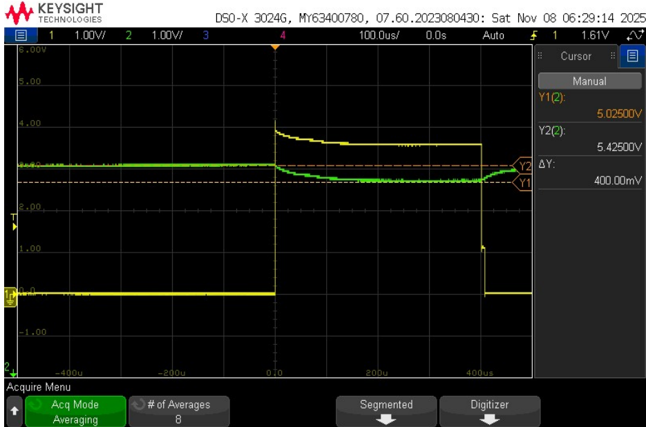
Figure 15: Thevenin’s Resistance

𝑅𝑡ℎ = V_{Th} - V_{Load} / I_{Load} = 5.425 - 5.025 / 0.4 = 1 ohms
Vth = 5.425V = Voltage on the 5 V rail when the slammer circuit is off
Vload = 5.025 V = Voltage on the 5 V rail when the slammer circuit is on
Iload = 0.4 A = Calculated from the voltage across the 10 Ω resistor

18) Switching Behavior of Arduino I/O Pins

In this, the code was modified so that digital pins D13, D12, D11, and D10 continuously toggle, while the MOSFET remains off (the D7 control line is disabled in the code). As these I/O pins switch simultaneously, rapid changes in current (dI/dt) occur, creating mutual coupling between signal paths. This interaction introduces switching noise on the 5 V rail observed both on the board and at the microcontroller output as well as on the ground line. 5 V rail board node TP1 (pink) and on-die Q_high at TP6 (blue), Q_low at TP5 (green). D13 at TP4 (yellow) is the trigger
- Rising Edge’s Quiet low and Quiet high:
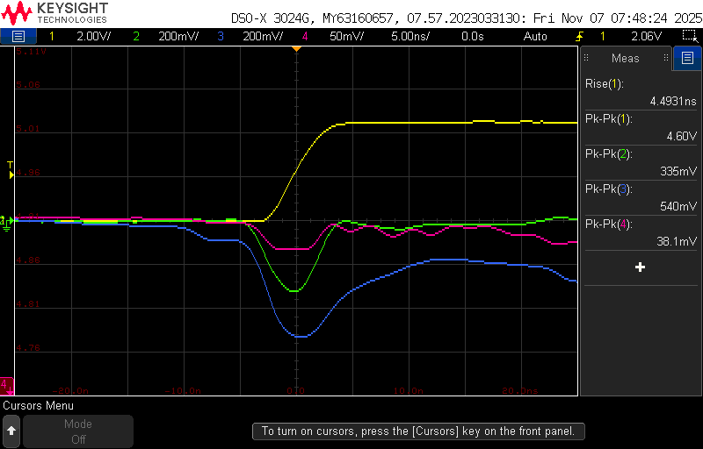  Figure 16: commercial arduino I/O switching noise for rising edge | 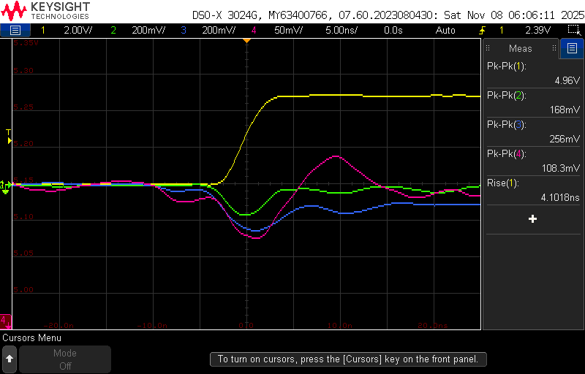  Figure 17: Golden Arduino I/O switching noise for rising edge

Measurements | Commercial Arduino | Golden Arduino
On board | 38.1 mv | 108.3mv
Quiet low: Vp-p | 335mv | 168mv
Quiet high: Vp-p | 540mv | 256mv
Rise Time | 4.49ns | 4.10ns

- Falling Edge’s Quiet low and Quiet high:

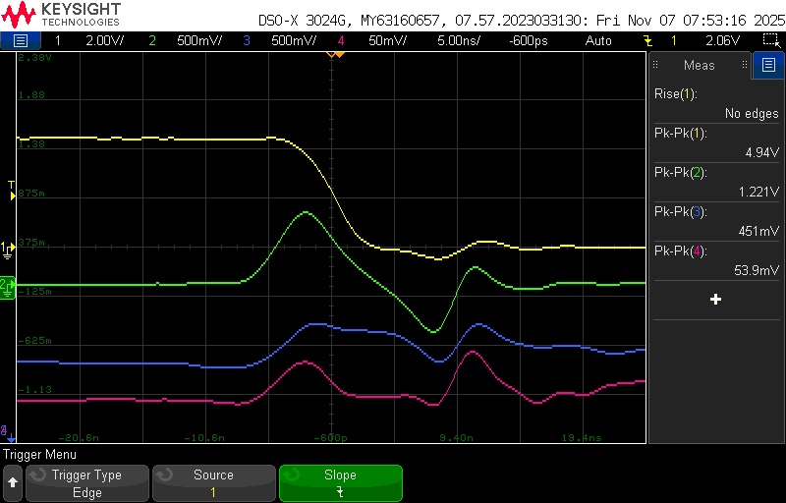  Figure 18: commercial Arduino I/O switching noise for falling edge | 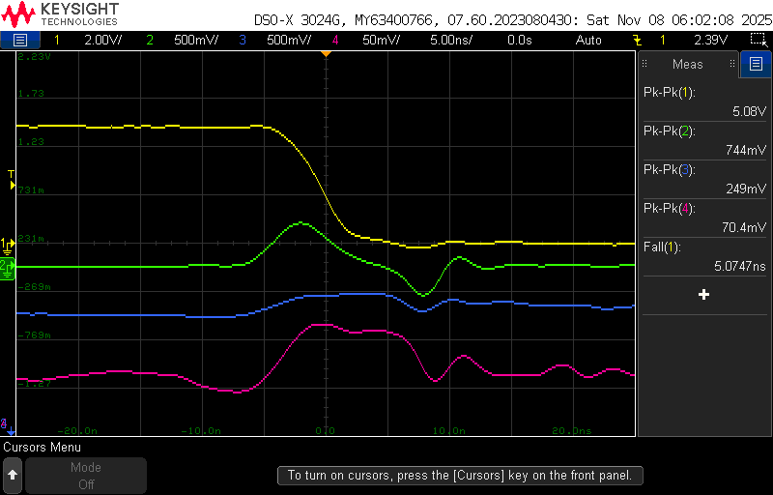  Figure 19: Golden Arduino I/O switching noise for falling edge

Measurements | Commercial Arduino | Golden Arduino
On board | 53.9mv | 70.4mv
Quiet low: Vp-p | 1.221v | 744mv
Quiet high: Vp-p | 451mv | 249mv
Fall Time | 4.8ns | 5.07ns

- The Golden Arduino shows less switching noise on the chip (both Quiet Low and Quiet High), which means the board layout and signal return paths are well designed.
- The on-board 5 V ripple seen is slightly higher for both rising and falling edges.
- The slightly higher 5 V noise on the board happens because there are no decoupling capacitors placed near the header pins.

19) Switching Behavior of MOSFET
For this measurement, the code was modified to keep D13, D12, D11, and D10 inactive while enabling switching on the MOSFET through D7. The yellow trace shows the voltage across the 10 Ω sense resistor, The blue trace corresponds to the on-die 5 V rail, while the pink trace represents the on-board 5 V rail. This setup allows observation of the MOSFET’s switching behavior and its effect on the power rail during operation.
- Rising Edge
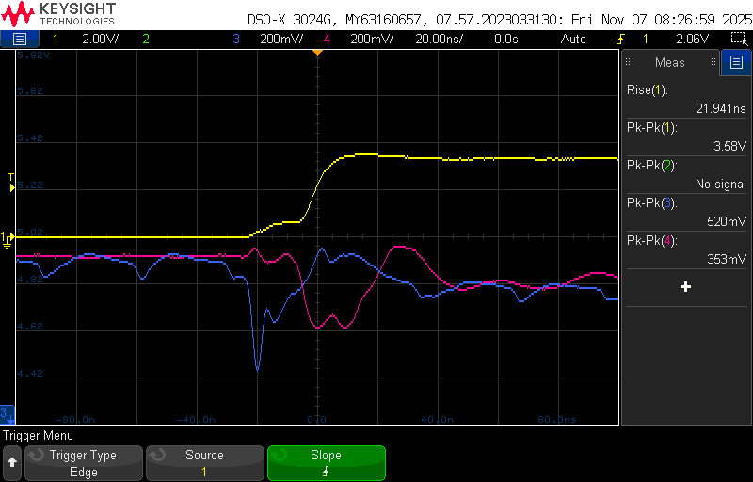  Figure 20: Commercial arduino mosfet switching noise for rising edge | 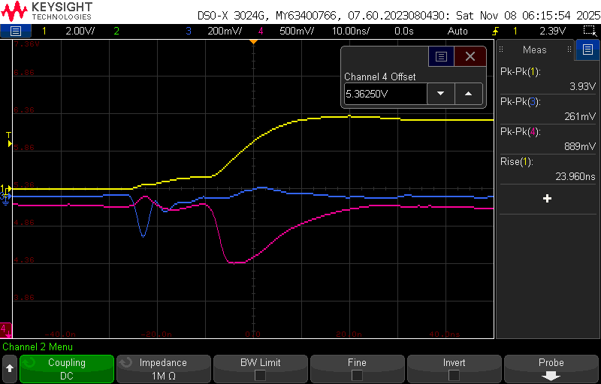  Figure 21: Golden Arduino mosfet switching noise for rising edge

Measurements | Commercial Arduino | Golden Arduino
Rise Time | 21.94ns | 23.90ns
Quiet High | 520mv | 261mv
On board 5v | 353mv | 889mv

- Falling Edge
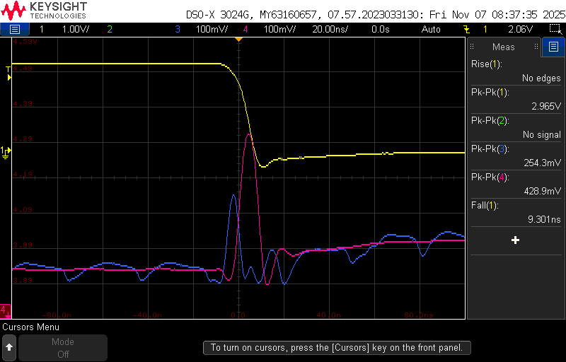  Figure 22: Commercial arduino mosfet switching noise for falling edge | 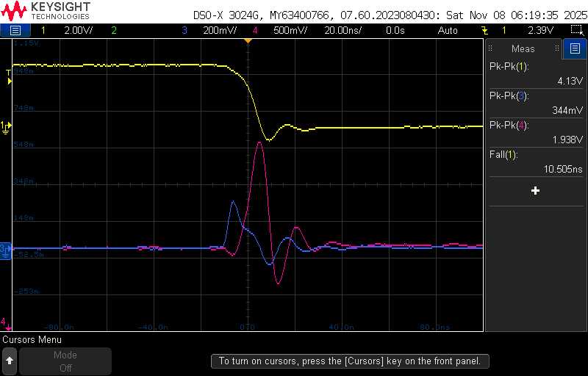  Figure 23: Golden arduino mosfet switching noise for rising edge

Measurements | Commercial Arduino | Golden Arduino
Fall Time | 9.3ns | 10.505ns
Quiet High | 254.3mv | 344mv
On Board | 428.9mv | 1.938v

When the slammer circuit is active, the on-board 5 V ripple is slightly higher on the Golden Arduino, which is expected due to the longer current path and the decoupling capacitor being farther from the MOSFET drain. The on-die Q_High measurement shows lower switching noise during the rising edge, but higher noise during the falling edge, suggesting that the power distribution network (PDN) and return path behavior vary depending on the signal transition.

20) Near-Field Emission:
In this setup, D13 (TP4) serves as the trigger signal (yellow trace). A 10× oscilloscope probe connected to Channel 4 (pink) is shorted at its tip and ground to form a loop antenna. The probe is placed beneath the Arduino board to detect radiated electromagnetic noise through mutual coupling with the board’s near-field emissions.
- Rising Edge NFE
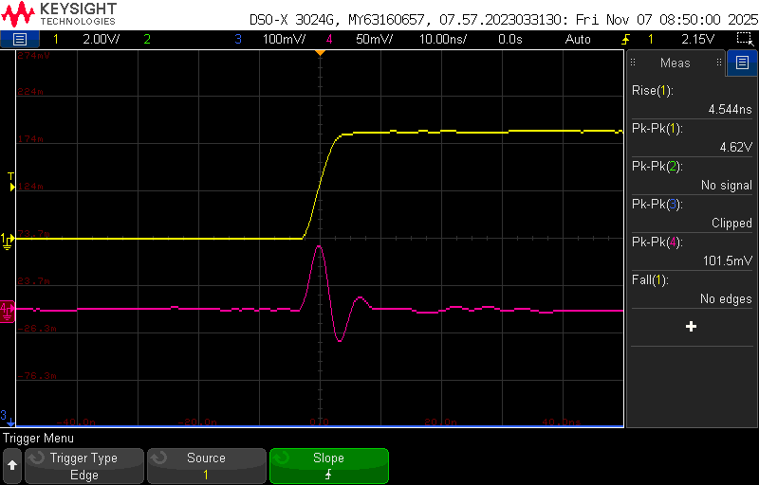  Figure 24: Commercial Arduino Near field emission for rising edge | 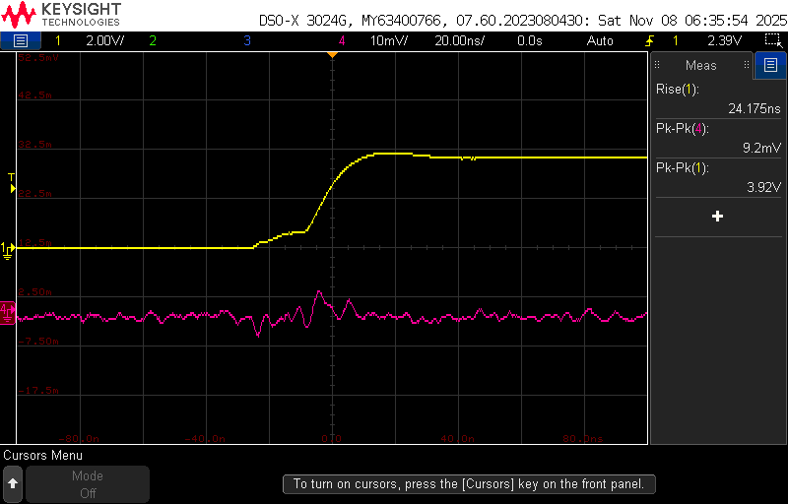  Figure 25: Golden Arduino Near field emission for rising edge

Measurements | Commercial Arduino | Golden Arduino
Near Field Emission | 101.5mv | 9.2mv

- Falling Edge NFE

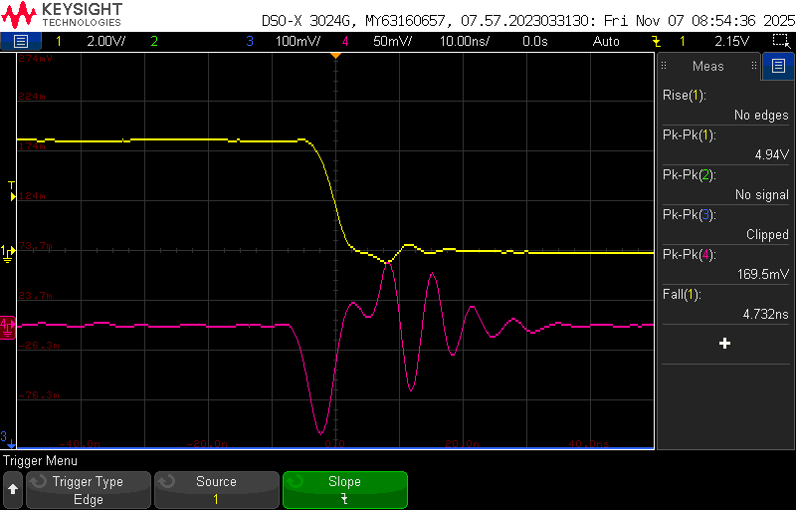  Figure 26 :Commercial Arduino Near field emission for falling edge | 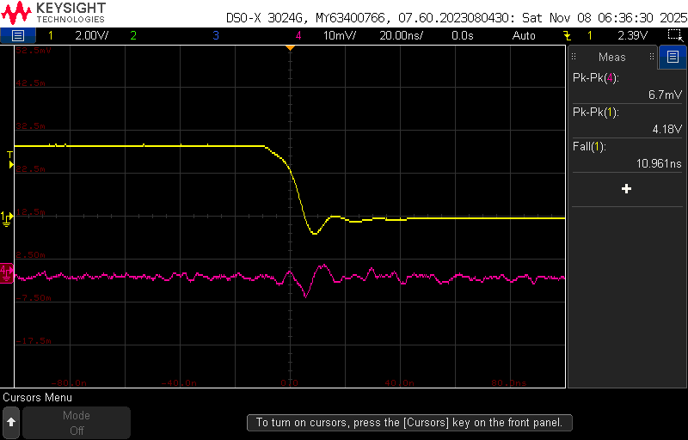  Figure 27 :Golden Arduino Near field emission for falling edge

Measurements | Commercial Arduino | Golden Arduino
Near Field Emission | 169.5mv | 6.7mv

The Golden Arduino produces much less near-field noise compared to the commercial board on both signal transitions.

21) BEST DESIGN PRACTICES FOLLOWED
- A decoupling capacitor was placed close to the IC to reduce voltage noise caused by voltage drops across the power rail’s loop inductance.
- All switches and test points were clearly labeled to enhance board readability and understanding.
- Switches were strategically placed between different circuit sections, with indicator LEDs included to assist in debugging.
- A continuous ground plane was implemented on the bottom layer to ensure a proper return path, and wider trace widths were used for power nets to reduce resistance.
- 1206 component packages were selected to facilitate easy hand assembly.

22) IMPROVEMENTS TO BE IMPLEMENTED
To add decoupling capacitors on 5V or 3.3V header pins to have reduced noise in the power rail.

23) Conclusion:
The Golden Arduino prototype was designed following PCB best practices, including a continuous ground plane, optimized decoupling at ICs with ferrite filtering on AVCC, minimized unique components, and controlled trace geometry. Characterization results indicate that the Golden Arduino exhibits substantially reduced on-die switching noise and electromagnetic emissions relative to the commercial board, confirming the effectiveness of these design improvements.

