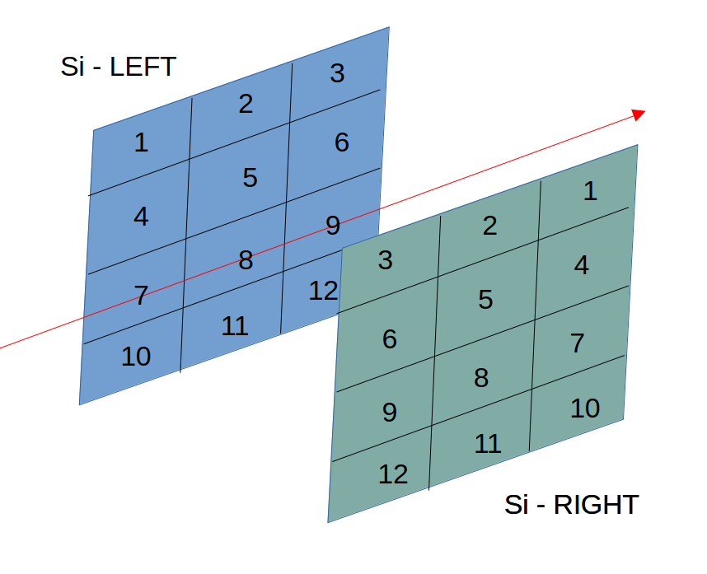

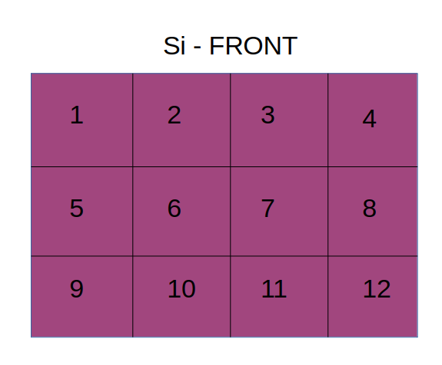

position | #detector | Preamp Ch | Amp Ch | ADC 2 ch
Left 1 | 9 | 1 | 0 | 16
Left 2 | 20 | 2 | 1 | 17
Left 3 | 16 | 3 | 2 | 18
Left 4 | 4 | 4 | 3 | 19
Left 5 | 21 | 5 | 4 | 20
Left 6 | 17 | 6 | 5 | 21
Left 7 | 10 | 7 | 6 | 22
Left 8 | 1 | 8 | 7 | 23
Left 9 | 14 | 9 | 8 | 24
Left 10 | 5 | 10 | 12 | 28
Left 11 | 8 | 11 | 10 | 26
Left 12 | 19 | 12 | 13 | 29
Right 1 | 28 | 1 | 13 | 13
Right 2 | 25 | 2 | 1 | 1
Right 3 | 34 | 3 | 2 | 2
Right 4 | 13 | 4 | 12 | 12
Right 5 | 35 | 5 | 4 | 4
Right 6 | 3 | 6 | 5 | 5
Right 7 | 30 | 7 | 6 | 6
Right 8 | 33 | 8 | 7 | 7
Right 9 | 38 | 9 | 8 | 8
Right 10 | 31 | 10 | 9 | 9
Right 12 | 37 | 11 | 10 | 10
Right 13 | 39 | 12 | 11 | 11
position | #detector | Preamp Ch | Amp Ch | ADC 3 ch
Front 1 1 | 12 CS | 1 |  | 0
Front 1 2 | 12 FS | 2 |  | 1
Front 1 3 | 8 FS | 3 |  | 2
Front 1 4 | 8 CS | 4 |  | 3
Front 1 5 | 16 CS | 13 |  | 13 foto JP???
Front 1 6 | 16 FS | 6 |  | 5
Front 1 7 | 11 FS | 7 |  | 6
Front 1 8 | 11 CS | ??? |  | ???
Front 1 9 | 9 CS | 9 |  | 9
Front 1 10 | 9 FS | 10 |  | 10
Front 1 11 | 15 CS |  |  | 11
Front 1 12 | 15 FS |  |  | 12
 |  |  |  | ADC 1 ch
DE1 - 0° | 1 | 1
DE2 - 0° | 2 | 2
DE3 - 0° | 3 | 3
DE4 - 0° | 4 | 4
E - 0° | 5 | 5 |  | 5

