Problem 8.2.1

Source Code:

function [t,x]=TaylorIntegration821(a,b,h,x0)

t=a:h:b

x=zeros(size(t));

x(1)=x0;

for i=1:length(x)-1

x1=x(i)+exp(t(i))+t(i)\*x(i);

x2=exp(t(i))+x(i)+(1+t(i))\*x1;

x3=2\*x1+(1+t(i))\*x2+exp(t(i));

x4=3\*x2+(1+t(i))\*x3+exp(t(i));

x(i+1)=x(i)+h\*x1+h^2/2\*x2+h^3/6\*x3+ h^4/24\*x4;

end

end

Relevant Output:

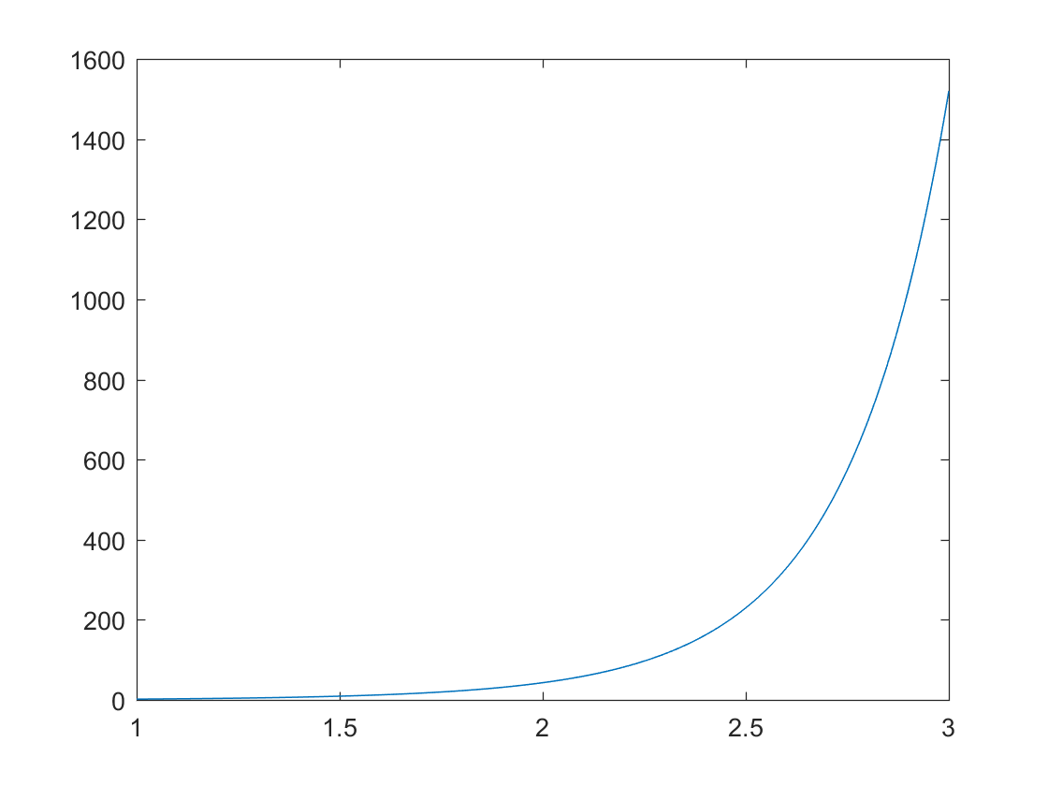

8.2.6

Source Code:

function [t,x]=TaylorIntegration826(a,b,h,x0)

t=a:h:b;

x=zeros(size(t));

x(1)=x0;

for i=1:length(x)-1

x1=(t(i)+x(i))/(t(i)-x(i));

x2=2\*(t(i)\*x1-x(i))/(t(i)-x(i))^2;

x3=2/(t(i)-x(i))^3\*(t(i)^2\*x2+t(i)\*(2\*(x1-1)\*x1-x(i)\*x2)-2\*x(i)\*(x1-1));

x4=2/(t(i)-x(i))^6\*((x3+t(i)\*x2)\*(t(i)-x(i))+(t(i)\*x3)\*(1-x1)+2\*(t(i)\*x2)\*(1-x1)-2\*(t(i)\*x1-x(i))\*x3-x3\*(t(i)-x(i)));

x(i+1)=x(i)+h\*x1+h^2/2\*x2+h^3/6\*x3+ h^4/24\*x4;

end

end

Relevant Output:

I had formatting issues, but found that I got NaN for many of the extremal t vals.