%creates a table of values for 4 values of epsilon and 4 values of n for
%problem 7.5.1b
f=@(x) sqrt(1-x);
es=[.05,.001,10^-5, 10^-12];
ns=[1,2,8,10];
ints=[];
epss=[];
errs=[];
N=[];
for i=1:4
for j=1:4
[int,err]=adaptSimpson(0,1,es(i),ns(j),f);
ints=[ints;int];
errs=[errs;err];
epss=[epss; es(i)];
N=[N;ns(j)];
end
end
T=table(ints,errs,epss,N,'VariableNames',{'NumericIntegral','ErrorBool','Epsilon','n'})
uitable('Data',T{:,:},'ColumnName',T.Properties.VariableNames,...
'RowName',T.Properties.RowNames);
Cant reach desired precision in this few intervals
Cant reach desired precision in this few intervals
Cant reach desired precision in this few intervals
Cant reach desired precision in this few intervals
Cant reach desired precision in this few intervals
Cant reach desired precision in this few intervals
Cant reach desired precision in this few intervals
Cant reach desired precision in this few intervals
Cant reach desired precision in this few intervals
Cant reach desired precision in this few intervals
T =
NumericIntegral ErrorBool Epsilon n
_________________ _________ _______ __
0.681326829321114 0 0.05 1
0.681326829321114 0 0.05 2
0.681326829321114 0 0.05 8
0.681326829321114 0 0.05 10
0 1 0.001 1
0 1 0.001 2
0.66627239731497 0 0.001 8
0.66627239731497 0 0.001 10
0 1 1e-05 1
0 1 1e-05 2
0 1 1e-05 8
0 1 1e-05 10
0 1 1e-12 1
0 1 1e-12 2
0 1 1e-12 8
0 1 1e-12 10
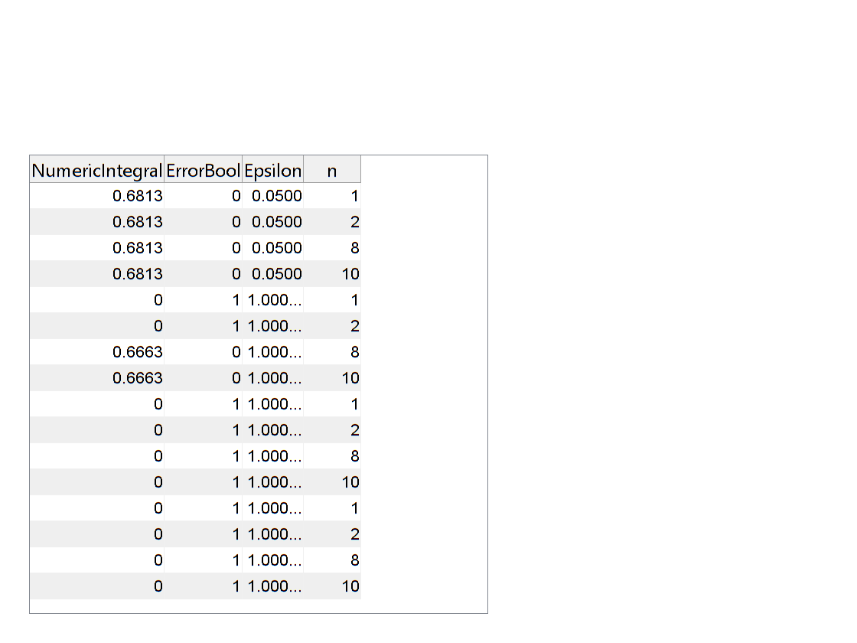
Published with MATLAB® R2016b

