Source Code:
Actual Algorithm:
function [sum,err]= adaptSimpson(a,b,e,n,f)
err=0;
del=b-a; %length of interval
sum=0; %initializes sum
h=del/2; c=(a+b)/2; %initial subinterval length, initial midpoint
k=1;
fa=f(a); fb=f(b); fc=f(c);
S=(fa+fc+fb)*h/3;
v=[a,h,fa,fc,fb,S];
while 1<=k && k<=n
h=v(k,2)/2; %half length of subdivisions of current subinterval
fy=f(v(k,1)+h); %function at left midpoint
St=(v(k,3)+4*fy+v(k,4))*h/3; %Simpson on left
fz=f(v(k,1)+3*h); %function at right midpoint
Stt=(v(k,4)+4*fz+v(k,5))*h/3; %Simpson on Right
if abs(St+Stt-v(k,6))<30*e*h/del %if local error tolerance is met
sum=sum+St+Stt+(St+Stt-v(k,6))/15; %intervals considered small enough, adds to integral
k=k-1;
if k<=0
break %terminates, as a sufficiently accurate answer has been reached
end
else %otherwise subdivide and continue
if k>=n
disp('Cant reach desired precision in this few intervals'); %error message,
err=1; %because the maximum number of subintervals has been exceeded
break
end
fv=v(k,5);
v(k,:)=[v(k,1),h,v(k,3),fy,v(k,4),St];
k=k+1;
v(k,:)=[v(k-1,1)+2*h,h,v(k-1,5),fz,fv,Stt];
%the preceeding lines prepare a new subdivision
end
end

Generating output table for 1a:
%creates a table of values for 4 values of epsilon and 4 values of n for
%problem 7.5.1a
f=@(x) sqrt(x);
es=[.05,.001,10^-5, 10^-12];
ns=[1,2,8,10];
ints=[];
epss=[];
errs=[];
N=[];
for i=1:4
for j=1:4
[int,err]=adaptSimpson(0,1,es(i),ns(j),f);
ints=[ints;int];
errs=[errs;err];
epss=[epss; es(i)];
N=[N;ns(j)];
end
end
T=table(ints,errs,epss,N,'VariableNames',{'NumericIntegral','ErrorBool','Epsilon','n'})
uitable('Data',T{:,:},'ColumnName',T.Properties.VariableNames,...
'RowName',T.Properties.RowNames);
Generating ouput table for 1b:
%creates a table of values for 4 values of epsilon and 4 values of n for
%problem 7.5.1b
f=@(x) sqrt(1-x);
es=[.05,.001,10^-5, 10^-12];
ns=[1,2,8,10];
ints=[];
epss=[];
errs=[];
N=[];
for i=1:4
for j=1:4
[int,err]=adaptSimpson(0,1,es(i),ns(j),f);
ints=[ints;int];
errs=[errs;err];
epss=[epss; es(i)];
N=[N;ns(j)];
end
end
T=table(ints,errs,epss,N,'VariableNames',{'NumericIntegral','ErrorBool','Epsilon','n'})
uitable('Data',T{:,:},'ColumnName',T.Properties.VariableNames,...
'RowName',T.Properties.RowNames);

Relevant Output:
Table 1a:
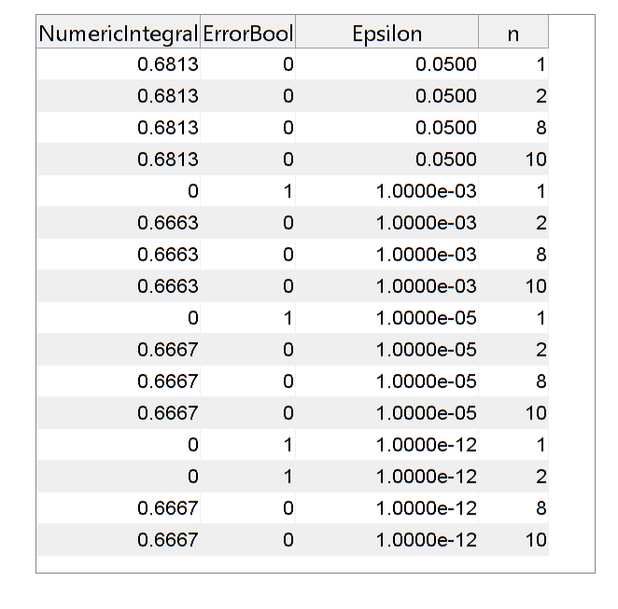

Table 1b:

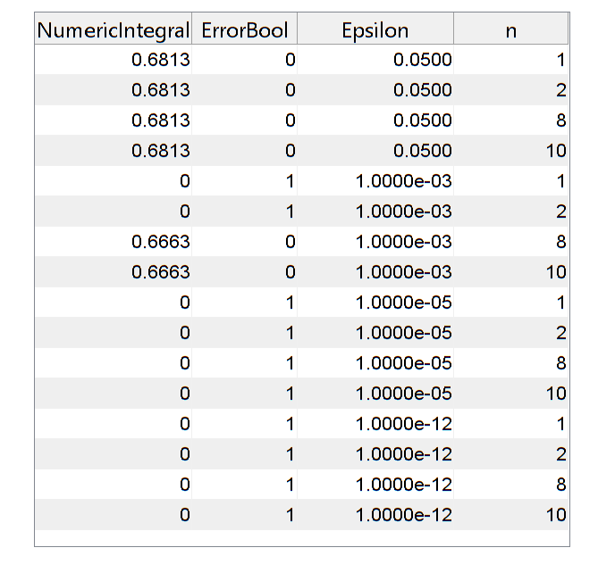

Analysis
I have been thinking about the errors for part b appearing more frequently, and the only thing that I can think of that may explain it is that the function in part b is vulnerable to catastrophic cancellation near the endpoint 1. I can’t think of why that would cause the algorithm to be more error prone. Perhaps it’s not. I intend to ask you about this.

