# Midterm Assignment

## Submitted by: Praneeth Krishna, Prateek Gangwal, Sakshi Arora

## Question 1: Regression and Classification

**Preprocessing Steps:**

* Loaded the dataset into a pseudo node Hadoop cluster.

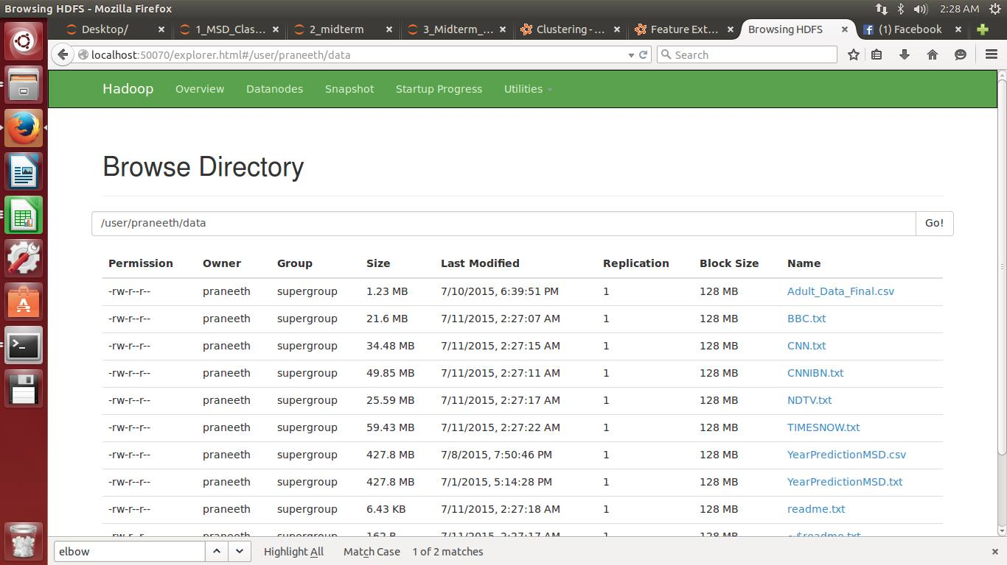

* Created a parse function, which parses through every line separated by delimiter (,) and written labeled points of features and labels.
* Data Caching is done using .cache to increase the performance.
* Data Exploration is done using mllib.stat library and performed function like mean, numberOfZeroes, variance, count etc among the data points.
* Calculated the Max and Min year to shift the labels according to our data requirements using the following code:

parsedDataInit = rawData.map(parsePoint) onlyLabels = parsedDataInit.map(lambda a: a.label) minYear = onlyLabels.min() maxYear = onlyLabels.max() print maxYear, minYear

#Shifting labels

parsedData = NewData.map(lambda a: LabeledPoint((a[0] - 1922),a[1:]))

print type(parsedData.take(1)[0])

# View the first point

print '\n{0}'.format(parsedData.take(1))

*Min -> 1922*

*Max -> 2011*

* Normalized the data using the normalizer in the mllib.feature using the following code:

from pyspark.mllib.feature

import VectorTransformer from pyspark.mllib.feature

import Normalizer

* Parsed the map function and created a binary variable for <1965 as 0 and >=1965 as 1 using the following code:

parsedData = NewData.map(lambda a: LabeledPoint((1 if a[0] >=1922 else 0),a[1:]))

**No Feature Reduction Regression**

* Data is spitted into training, validation and test data sets using randomSplit() using the following code.

weights = [.6, .2, .2]

seed = 42

parsedTrainData, parsedValData, parsedTestData = parsedData.randomSplit(weights,seed) parsedTrainData.cache()

parsedValData.cache()

parsedTestData.cache()

* Created a baseline model by taking average from all the years.
* Evaluated baseline model using Evaluation matrix RMSE using the following code:

labelsAndPredsTrain = parsedTrainData.map(lambda x:(x.label,76.39463))

rmseTrainBase = calcRMSE(labelsAndPredsTrain)

* Evaluated the model Base Line Model, LinearRegressionwithSGD, RidgeRegressionwithSGD, LassowithSGD.
* Compared the models using RMSE.

**Analysis:** LinearRegregressionwithSGD outperforms other models as it has the least RMSE of 15.71

**No Feature Reduction Classification**

* Evaluated the model SVMwithSGD, LogisticRegressionwithLBFGS, LogisticRegressionwithSGD.
* Compared the models using following metrics:

AreaUnderCurver

ConfusionMatrix

Error Evaluation

**Feature Engineering PCA**

* Implemented PCA in scala as Pyspark doesn’t support PCA.
* Top 20 variables were generated as output from PCA analysis.
* Applied the Regression and Classification models after doing feature engineering with PCA.

**Analysis:** Regression and Classification models after PCA outperforms other models without feature reduction.

## Question 2: Classification

**Preprocessing Steps:**

* The categorical variables were converted into numeric variables using the following steps:
  + Factorized the data using scala using the following code:

def cleanData(i : String): String = {

val a1 = i.split(",") val b1 : List[AnyVal] = List(a1(0).toDouble,convertCol1toInt(a1(1)),a1(2).toDouble,convertCol4toInt(a1(3)),a1(4).toDouble,convertCol6toInt(a1(5)),convertCol7toInt(a1(6)),convertCol8toInt(a1(7)),convertCol9toInt(a1(8)),convertCol10toInt(a1(9)),a1(10).toDouble,a1(11).toDouble,a1(12).toDouble, convertCol14toInt(a1(13)),convertCol15toInt(a1(14)))

b1.mkString(",")

}

* + The function *convertColtoInt* function is defined as follows:

def convertCol15toInt(s : String): Double =

{

val a2 = s match { case " <=50K" => 0 case " >50K" => 1 } a2

}

* + The categorical missing values were replaced by Mode function.
  + Created dummy variables using the following code:

features_dummies = pd.get_dummies(features1)

**Applying SVMwithSGD Classification:**

* Applied the model using the following code:

from pyspark.mllib.classification

import SVMWithSGD, SVMModel

# Build the model model = SVMWithSGD.train(parsedTrainData, iterations=1000,step=0.001,regParam=0.01)

* Evaluated the model on training data using the following code.

# Evaluating the model on training data

labelsAndPreds = parsedTrainData.map(lambda p: (p.label, float(model.predict(p.features)))) trainErr = labelsAndPreds.filter(lambda (v, p): v != p).count() /

float(parsedTrainData.count()) print("Training Error = " + str(trainErr))

* Performed model evaluation by observing *area under curve, confusion matrix and validation error.*

metrics = BinaryClassificationMetrics(labelsAndPreds) AUC = metrics.areaUnderROC APR = metrics.areaUnderPR print("train AreaUnderCurve = " + str(AUC))

p = np.array(labelsAndPredsval).collect() confusion_matrix(p[:,0],p[:,1])

**Applying LogicsticRegressionwithLBFGS Classification:**

* Applied the model using the following code:

model = LogisticRegressionWithLBFGS.train(parsedTrainData,iterations=1000,regParam=0.01)

* Evaluated the model on training data using the following code.

# Evaluating the model on training data

labelsAndPreds = parsedTrainData.map(lambda p: (p.label, float(model.predict(p.features)))) trainErr = labelsAndPreds.filter(lambda (v, p): v != p).count() /

float(parsedTrainData.count())

print("Training Error = " + str(trainErr))

* Performed model evaluation by observing *area under curve, confusion matrix and validation error.*

metrics = BinaryClassificationMetrics(labelsAndPreds)

AUC = metrics.areaUnderROC

APR = metrics.areaUnderPR

print("train AreaUnderCurve = " + str(AUC))

p = np.array(labelsAndPreds.collect()) confusion_matrix(p[:,0],p[:,1])

**Applying Decision Tree Classification:**

* Applied the model using the following code:

model = GradientBoostedTrees.trainClassifier(parsedTrainData, categoricalFeaturesInfo={}, numIterations=3)

* Evaluated the model on training data using the following code.

# Evaluate model on train instances and compute test error predictions = model.predict(parsedTrainData.map(lambda x: x.features)) labelsAndPredictions = parsedTrainData.map(lambda lp: lp.label).zip(predictions) testErr = labelsAndPredictions.filter(lambda (v, p): v != p).count() / float(parsedTrainData.count()) print('Test Error = ' + str(testErr)) print('Learned classification GBT model:') print(model.toDebugString())

* Performed model evaluation by observing *area under curve, confusion matrix and validation error.*

metrics = BinaryClassificationMetrics(labelsAndPredictions) AUC = metrics.areaUnderROC APR = metrics.areaUnderPR print("train AreaUnderCurve = " + str(AUC))

p = np.array(labelsAndPredictions.collect()) confusion_matrix(p[:,0],p[:,1])

## Question 3: Clustering

**Preprocessing Steps:**

* Combining the 5 Lib svm files into 1 Lib svm file using the following code:

cnn = "/home/praneeth/Downloads/Case3_TvNews/CNN.txt"

cnn1 = MLUtils.loadLibSVMFile(sc, cnn) x = points.union(cnn1)

cnnibn = "/home/praneeth/Downloads/Case3_TvNews/CNNIBN.txt"

cnnibn1 = MLUtils.loadLibSVMFile(sc, cnnibn) y = x.union(cnnibn1)

ndtv = "/home/praneeth/Downloads/Case3_TvNews/NDTV.txt"

ndtv1 = MLUtils.loadLibSVMFile(sc, ndtv) z = y.union(ndtv1)

tn = "/home/praneeth/Downloads/Case3_TvNews/TIMESNOW.txt"

tn1 = MLUtils.loadLibSVMFile(sc, tn) data = z.union(tn1)

* Normalized the data using the following code:

scaler2 = StandardScaler(withMean=True, withStd=True).fit(features)

**Applying K means:**

* The union and normalized file is used for the k means algorithm.
* The model is built using the in-built k means algorithm by specifying the max iterations and run.

clusters = KMeans.train(data2, 2, maxIterations=10, runs=10, initializationMode="random”)

clusters = KMeans.train(data2, 4, maxIterations=10, runs=10, initializationMode="random”)

clusters = KMeans.train(data2, 6, maxIterations=10, runs=10, initializationMode="random”)

clusters = KMeans.train(data2, 8, maxIterations=10, runs=10, initializationMode="random”

clusters = KMeans.train(data2, 10, maxIterations=10, runs=10, initializationMode="random”

* Evaluating the cluster by computing within set sum of squared errors.

from math import sqrt from numpy import array def error(point): center = clusters.centers[clusters.predict(point)] return sqrt(sum([x**2 for x in (point - center)])) WSSSE = data2.map(lambda point: error(point)).reduce(lambda x, y: x + y) print("Within Set Sum of Squared Error = " + str(WSSSE))

**Analysis:**

* **Within Set Sum of Squared Error (2) = 1605485.841**
* **Within Set Sum of Squared Error (4) = 1549285.453**
* **Within Set Sum of Squared Error (6) = 1460567.116**
* **Within Set Sum of Squared Error (8) = 1438714.297**
* **Within Set Sum of Squared Error (10) = 1425614.813**

