### 0.1 Introduction

Blah Blah Blah... Blah Blah Blah... Blah Blah Blah... Blah Blah Blah... Blah Blah Blah... Blah Blah Blah... Blah Blah Blah... Blah Blah Blah... Blah Blah Blah... Blah Blah Blah... Blah Blah Blah... Blah Blah Blah... Blah Blah Blah... Blah Blah Blah... Blah Blah Blah... Blah Blah Blah... Blah Blah Blah... Blah Blah Blah... Blah Blah Blah... Blah Blah Blah... Blah Blah Blah... Blah Blah Blah... Blah Blah Blah... Blah Blah Blah... Blah Blah Blah... Blah Blah Blah... Blah Blah Blah... Blah Blah Blah... Blah Blah Blah...

Table 1: A table

|  |  |  |
| --- | --- | --- |
|  |  |  |
| C1 | C2 | C3 |
|  |  |  |
| R1C1 | R1C2 | R1C3 |

A reference to Table 1 .

## 1 Equation

|  |  |
| --- | --- |
|  | (1) |

## 2 Figure as image

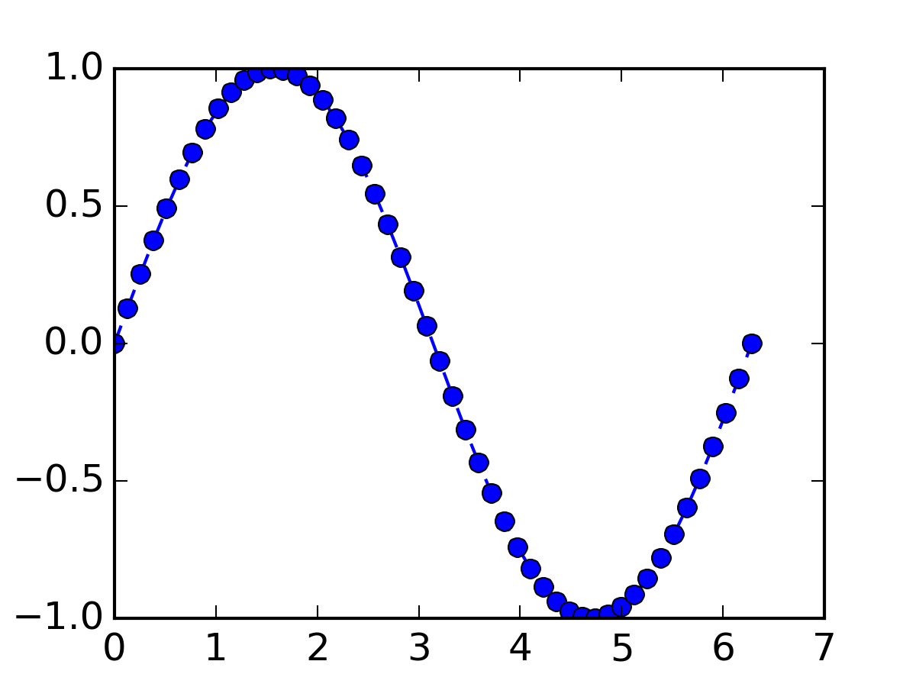

Figure 1: Figure as image

## 3 Figure using TikZ

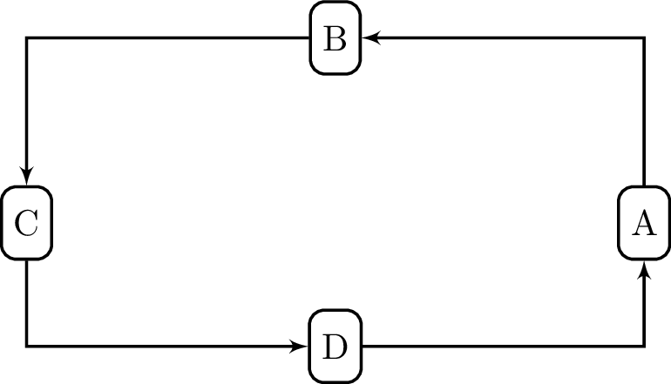

Figure 2: Figure using TikZ