**IASTracker**

Data Management Plan

(IAS Tracker v0)

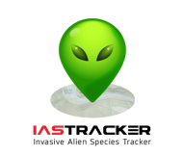

**Project by:** IC5Team

**Contact**: Ms. Blanca Botey

**e-mail:** ic5team.co@gmail.com

Table of Contents

1. INTRODUCTION/IAS TRACKER DESCRIPTION 2

2. DATA SETS 2

2.1 IAS TRACKER DATA SET 2

2.2 EXTERNAL DATASETS (TAULES EXTERNAS L’ANNA) 4

3. DATA AND METADATA STANDARDS 6

4. POLICIES OF ACCESS AND SHARING 7

5. POLICIES FOR RE-USE, DISTRIBUTION 8

6. PLANS OF ARCHIVING AND PRESERVATION 8

# 1. INTRODUCTION/IAS TRACKER DESCRIPTION

IASTracker is a Citizen Science project. Mainly, it is a complete tool (Web App and geoportal website) to identify Invasive Alien Species (IAS) in different parts of the European Union, fed with citizen’s collaboration in order to obtain a dataset of the distribution and spread of IAS in different areas. This information must fulfil a gap of geographic knowledge of IAS in some regions and help the scientific community and the envidronmental agencies to make progress in this field.

IASTracker will be available on a web site and on a mobile application. IASTracker App submits the following IAS data: IAS location, an optional brief note of the citizen, IAS images, an approximate amount of specimens and the observation date. IASTracker website will be a portal to query and analyze data observations.

# 2. DATA SETS

IASTracker contains various data sets divided in two groups, IASTracker data sets and External data sets. IASTracker data sets are citizen’s observations and images, IAS datasheets and IAS regions. Besides, IAS observations can be shown graphically along with external data to compare IAS distribution with earth observation products. Both data sets are detailed below.

## 2.1 IAS TRACKER DATA SET

|  |  |
| --- | --- |
| 1 | IAS Observations |
| Description | Site locations of IAS taken by users. |
| Format | postgreSQL database |
| Characteristics | UTF-8 encoding charset |
| Data source | Created using IAS Tracker App. It includes GPS data, notes, user nickname, date and IAS identifier. |
| Restrictions | None |
| Quality checks | IAS observations are revised by an expert who will decide if the data is good enough to appear as validated in IASTracker website. All new observations appear in the first place in the website as observed but not validated until the expert validates the observation and this changes its status from observed to observed and validated. |
| Volume estimate | Less than 1 Mb |

|  |  |
| --- | --- |
| 2 | IAS Images |
| Description | Images taken by IAS Tracker users |
| Format | JPEG |
| Characteristics | - |
| Data source | Created from IASTracker users devices. |
| Restrictions | None |
| Quality checks | IAS images are revised by an expert who will decide if the image is good enough to be shown in IASTracker website. |
| Volume estimate | Approximately 5 Gb |

|  |  |
| --- | --- |
| 3 | IAS datasheets |
| Description | IAS descriptions and images which guide the user in the identification of the IAS. |
| Format | Text/JPEG |
| Characteristics | UTF-8 encoding charset |
| Data source | IAS datasheets are shared by IC5Team as open data (EUPL). Texts and images of the datasheets that have other kind of licences are properly indicated.  IC5Team ensures that text and images published in its website and in the app accomplish with all the terms of licensing. |
| Updates | This data is updated from IAS Tracker platform.  A new datasheet will be created whenever a new IAS is included in the IASTracker list of species. (DMP-9) |
| Restrictions | None |
| Quality checks | It will be possible to update datasheets as IAS impact or distribution evolves in the territory. |
| Volume estimate | Less than 500 Mb |

|  |  |
| --- | --- |
| 4 | IAS Regions |
| Description | Predefined areas where IAS are expected to be found |
| Format | postgreSQL database |
| Characteristics | UTF-8 encoding charset |
| Data update | This layer will be updated using shape files from the IAS Tracker platform (DMP-9) |
| Restrictions | None |
| Quality checks | Integrity constrains defined in the tables that will maintain the referential database integrity. |
| Volume estimate | Less than 50 Mb |

## 2.2 EXTERNAL DATASETS (TAULES EXTERNAS L’ANNA)

Basemaps for geoportal website

|  |  |
| --- | --- |
| 1 | CORINE Landcover (CLC) |
| Description | Corine land cover 2006 is the year 2006 update of the first CLC database which was finalised in the early 1990s as part of the European Commission programme to COoRdinate INformation on the Environment (Corine) |
| Basemap Use | Geoportal web and mobile application |
| Provider | European Environment Agency (EEA) |
| Source | http://land.discomap.eea.europa.eu/arcgis/services/Land/CLC2006_Dyna_LAEA/MapServer/WMSServer? |
| GEOSS Core | No |
| Restrictions | None |
| Format | raster |
| Standard | OGC Web Map Service version 1.3 data provide, (WMS version 1.3.0) |
| Fees | Free of charge |

|  |  |  |
| --- | --- | --- |
| 2 | | SRTM_RAMP2_TOPO |
| Description | | Flat maps can create a 3-D effect by making some parts of the map dark and other parts light in RGB. This is called "shading" because it makes features on the surface look like they are casting shadows. |
| Basemap Use | | Geoportal web |
| Provider | | Remote sensing imagery from NASA Earth Observations (NEO) |
| Source | | http://neowms.sci.gsfc.nasa.gov/wms/wms? |
| GEOSS Core | | YES |
| Restrictions | | None |
| Format | | raster |
| Standard | | OGC Web Map Service version 1.3 data provide, (WMS version 1.3.0) |
| Fees | | Free of charge |
|  | | |
|  | | |
|  | | |

|  |  |
| --- | --- |
| 3 | MOD13A2_M_NDVI (Vegetation Index [NDVI] (1 month - Terra/MODIS) |
| Description | scientists use NASA satellites to map the "greenness" of all Earth's lands. These*vegetation index* maps show where and how much green leaf vegetation was growing for the time period shown. |
| Basemap Use | Geoportal web |
| Provider | Remote sensing imagery from NASA Earth Observations (NEO) |
| Source | http://neowms.sci.gsfc.nasa.gov/wms/wms? |
| GEOSS Core | YES |
| Restrictions | None |
| Format | raster |
| Standard | OGC Web Map Service version 1.3 data provide, (WMS version 1.3.0) |
| Fees | Free of charge |

Basemaps for mobile application

|  |  |
| --- | --- |
| 4 | Raster cartography of Catalonia |
| Description | ICGC has a single service that includes all the current ICGC maps and orthophotos organized by layers. For IAStracher application will be used two different layers, one for images and second for topographic map for all Catalonia region.  For images: Orthophoto of Catalonia 1:2.500 current  For topographic map: Topographic map of Catalonia 1:5.000 |
| Basemap Use | Mobile application |
| Provider | Institut Cartogràfic i Geològic de Catalunya (ICGC) |
| Source | http://geoserveis.icc.cat/icc_mapesbase/wms/service? |
| GEOSS Core | No |
| Restrictions | None |
| Format | Raster, Supported GetMap formats: GIF, PNG, BMP, JPEG and TIFF |
| Standard | OGC Web Map Service version 1.3 data provide, (WMS version 1.1.1) |
| Fees | Free of charge |

|  |  |
| --- | --- |
| 5 | Orthobeeldvorming* |
| Description | RGB orthophoto Brussels and Flandes |
| Basemap Use | Mobile application |
| Provider |  |
| Source | http://geo.agiv.be/inspire/wms/Orthobeeldvorming? |
| GEOSS Core | No |
| Restrictions | None |
| Format | Raster, JPEG |
| Standard | OGC Web Map Service version 1.3 data provide, (WMS version 1.3.0) |
| Fees | Free of charge |

*Informació a:

https://metadata.geopunt.be/zoekdienst/apps/tabsearch/?uuid=B7F7047A-987A-450C-AC5D-2464A56D257D

|  |  |
| --- | --- |
| 6 |  |
| Description | RGB orthophoto Wallonie |
| Basemap Use | Mobile application |
| Provider |  |
| Source |  |
| GEOSS Core | No |
| Restrictions | None |
| Format | Raster, JPEG |
| Standard | OGC Web Map Service version 1.3 data provide, (WMS version 1.3.0) |
| Fees | Free of charge |

# 3. DATA AND METADATA STANDARDS

IASTracker database is stored as PostgreSQL database. This database uses the PostGIS extension. The IASTracker website is developed using PHP over a MapServer server and the postgreSQL database. Quality control of the database is managed by defining integrity constrains in the tables that will maintain the referential database integrity.

CSV file format will be used for downloading IAS Observations and IAS data.

The entity-relationship diagram is shown in the following figure. This diagram will be updated to include the last minute changes.

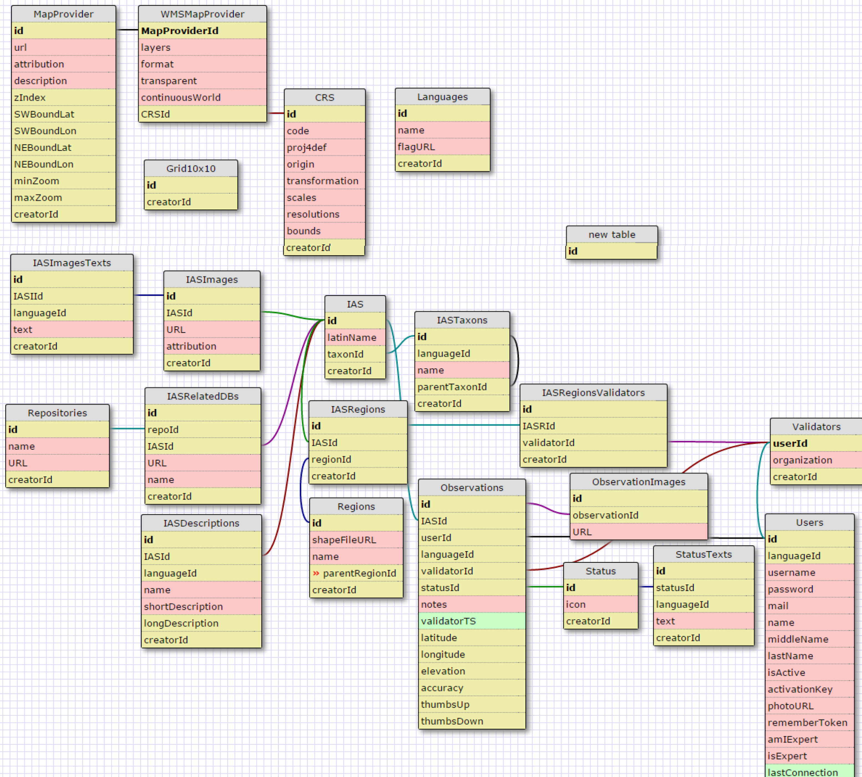

A data dictionary will be created that defines the table definition, table fields, and table field data types.

Metadata for geographic data and services will be produced using the ISO 19115 and ISO 19119.

# 4. POLICIES OF ACCESS AND SHARING

The data will be public and will be accessible through the IAS Tracker geoportal. The web data service will be well documented in the geoportal, so it will be able to be found by search engines.

The geoportal and the App will describe the conditions of use and the European Union public license (EUPL) that applies for the App source code.

All data contents as datasheets and images that will have a non EUPL (like CC BY-SA 3.0, CC BY-SA 2.1, ...) will be clearly indicated, and will be citated as required.

A Web Map Service (WMS of OGC) will be set up. This service will allow researchers and GIS users to integrate IASTracker data in their analysis works. The IAS Tracker data shared will be the main data set, the IAS observations, this data will include all necessary attributes who describe the records but also the attributes to know the quality of data, in this case GPS accuracy and validation of the observation status.

An appropriate protection of the users privacy, security, confidentiality will be taken throught the Spanish law LOPD, which accomplish with european directive about users data protection.

# 5. POLICIES FOR RE-USE, DISTRIBUTION

The data collected by IAS Tracker users will be open to be reused. IAS Tracker first step in installation is to get the agreement of the users to redistribute, and reuse all the information that they will collect. All data collected from the user will be suitable anonymised (if necessary) to avoid breaches of privacy or confidentiality.

Materials generated under the project will be disseminated in accordance with the European Union public license (EUPL).

IAS Observations datasheets have a persistent identifier, so they can be easy citated, nevertheless, it is defined in the geopotal how to citate IAS Tracker as a whole, and a proposal of citation for a IAS Observations datasheet..

# 6. PLANS OF ARCHIVING AND PRESERVATION

The IAS Tracker data manager will be in charge of the archivement and preservation of the data. He/she will be responsible of updating, maintaining, upgrading the database.

All original raw data files and data source processing programs will be versioned over time and maintained in a date stamped file structure with text files documenting the version and which changes have been done from previous version.

IAS Tracker database will be held in a public organism server. So the backups policies will follow this public organism backup policies. A weekly backup is granted.

IASTracker data is generated with the intention of providing long term data records for the use of citizens, science community and environment agencies in perpetuity.