|  |  |
| --- | --- |
| **Name** | Elizabeth Michael Akpan |
| **Student ID** | S1719014 |
| **Email** | EAKPAN200@caledonian.ac.uk |
| **Module** | Systems Programming |

Table of Content

**Introduction** **1**

**Tests and Results** **1**

**Screenshots of Results** **2**

**References** **4**

# Introduction

This is a documentation of the test process of an implementation of a client and server text-based application that uses synchronous TCP stream sockets.

The tests and corresponding results as well as screenshots as evidence of testing are documented.

# Tests and Results

|  |  |  |
| --- | --- | --- |
| **Test** | **Expected Result** | **Actual Result** |
| Display IP Address and Student Info | It is expected that the moment the user enters option ‘0’, the IP Address, Student name and student ID will be displayed on the client-side. | The details expected are displayed. Except for the IP address which displays as 0.0.0.0.  This can be seen in Fig.1. |
| Display 5 random numbers | It is expected that the moment the user enters option ‘1’, 5 random numbers will be displayed on the client-side. | This works perfectly and can be seen in Fig. 2. |
| Display System information | It is expected that the moment the user enters option ‘2’, the system information will be displayed on client-side. | This works perfectly and can be seen in Fig. 3. |
| Display File Names in the upload directory | It is expected that the moment the user enters option ‘3’, a list of the names of files in the upload directory will be displayed on the client-side. | This is not working in this iteration of the program and will be implemented in a later iteration.  This can be seen in Fig. 4. |
| Exit the program | It is expected that the moment the user enters option ‘4’, the program will be exited on the client-side.. | This works perfectly and can be seen in Fig. 5. |

# Screenshots of Results

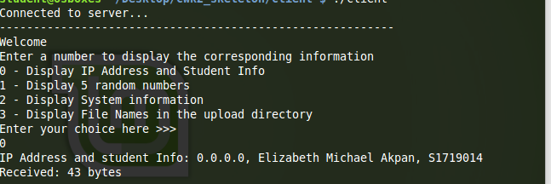

**Fig. 1 - Display IP Address and Student Info**

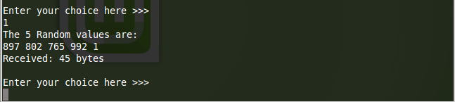

**Fig. 2 - Display 5 Random numbers**

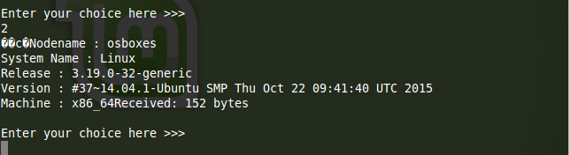

**Fig. 3 - Display System Information**

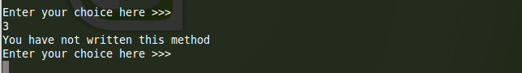

**Fig. 4 - Display file names in the upload directory shows nothing because the method will be developed in a later iteration**

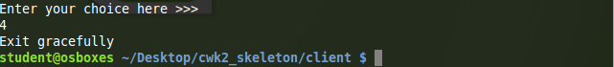

**Fig. 5 - Exit the program**



**Fig. 6 - Exiting the server side shows the value of the total execution time**

# References

In developing the program, I made references to Lab 7 for the total execution time, signal handler and system information methods.