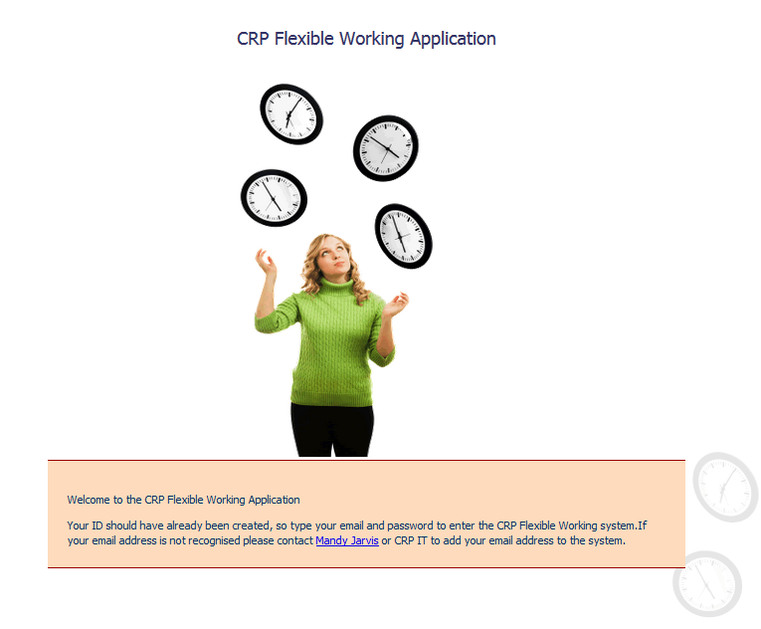

A new release of the FWS released on Monday 2nd September 2013 will have the following amendments and useful additions.

Contents

Views 3

User Information 3

Leave Dates 3

Team View 4

What’s NEW? 4

New Event Type Option 4

Creating a ‘remainder’ event 5

Scenario One 6

Scenario Two 7

What if…? 7

Period end changes 7

# Views

## User Information

The user information view has changed and is displayed differently for “Full” and “Part” time staff. The part-time users will see their leave displayed in Hours instead of days & hours and full-time staff will see their leave displayed in only days.

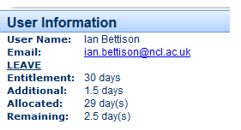The fundamental calculations of leave have been changed to work out leave wholly in hours. Below is an illustration of the view change.

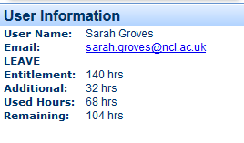

Full-time view is on the left and the part-time view is on the right.

## Leave Dates

The leave dates view has also changed for part-time users will view this in hours and full-time users will view this in hours and days. Below is an illustration of how the views differ for each user type.

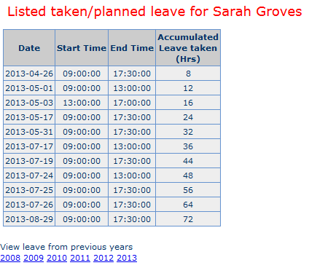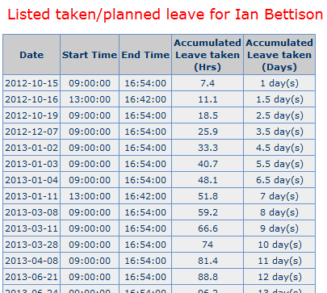

Full-time view is on the left and the part-time view is on the right.

## Team View

The team view, which is only available to managers of their respective teams, has also changed. The display is primarily in hours but leave for full-time staff has the equivalent in days alongside in brackets, as shown below.

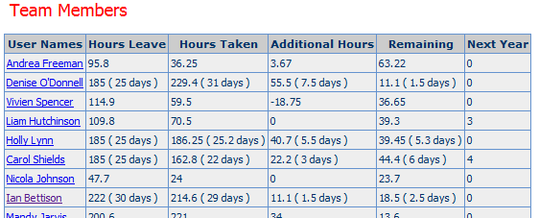

The next year column does show days for both full and part-time staff but this is only using the count function; this will display correctly once the end of the leave period reports have been run.

# What’s NEW?

## New Event Type Option

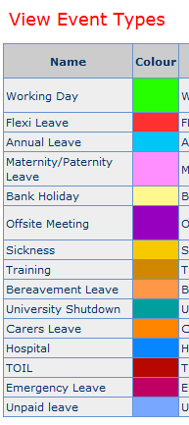The new event type option has been created for the item following this one. It is required to highlight the event types that will display the new drop down duration option of “Remainder”. This will be explained in the following section but here is the list of event types that will have this option available.

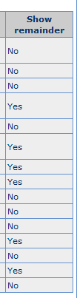

The “Show Remainder” option linked to the event types of:

1. Maternity/Paternity Leave
2. Offsite Meeting
3. Sickness
4. Training
5. Hospital
6. 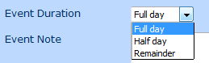Emergency Leave

…displays an additional option in the drop down list when selecting the Event Duration as shown.

The remainder function will make it a whole lot easier to enter events that fill in the latter part or remainder of the day.

## Creating a ‘remainder’ event

The idea behind a remainder event came about after discovering that users were entering hospital and part-sickness days as half-day events and the system would credit the users with more, or less, flexi time than was due to them. This caused the need for quite a considerable amount of work to put right and thus the remainder event came about.

Let’s discuss what used to happen…

A user would enter a hospital appointment leaving work at 14:00 and would enter either an end time of 17:00 or a half day Event Duration. For a full time member of staff a half day would equal 3.7 hours or 3 hrs 42 mins.

When added onto a 14:00 start this added up to a finish time of 17:42. A gain for the user of 48 mins; this is not good for audit purposes certainly as the user would carry this gain over to the next period and so on.

Another scenario is that the user works out the correct time to finish 16:54; this is perfect providing the user starts work at exactly 09:00.

What if they start at 08:30! Many users start at this time and starting at this time would provide the user with a 30 minute gain in flexi time as explained.

The hospital appointment is entered before the working day event, with the user needing to leave work at 14:00 to attend their 14:45 appointment. This is entered and authorised by their manager prior to the appointment in the majority of cases.

On the day of the Hospital appointment the user starts work at 08:30 and quite rightly adds that as the start time and 14:00 as the finish time for their working day event.

08:30 to 14:00 = 5hrs and 30 minutes

14:00 to 16:54 = 2hrs 54 minutes.

The hospital appointment of 2hrs 54 minutes is added to the users’ flexitime pot and is a gain of exactly 1 hour. Again too much flexi is being claimed by the user.

This is complicated for a full time user; how would a part time user cope? I hope you all have good calculators. No offence.

So now how does the remainder option work…

This option when selected calculates the correct end time for a hospital appointment firstly examining the users working pattern for that day and creating an end time for the remainder event which matches the pattern for that day. It works for both full and part time staff alike and the auditors are happy…well maybe.

This works in two ways lets go through the scenarios…

### Scenario One

Ok, everyone knows I’m a sickly person (not really) and I have managed to drag myself in, but whilst working I become more and more ill. I decide to leave at 12:00 having started work at 08:55, what do I do?

I add my working time into the FWS as normal 08:55 to 12:00 I then select to enter a sickness event and select the ‘Event Duration’ option of ‘Remainder’, as shown.

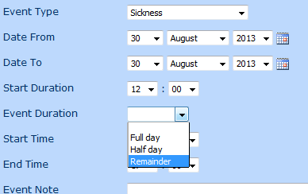What happens now is the FWS finds the first event of 08:55 to 12:00 and uses the start time to calculate the end time of the sickness event.

It checks the users working pattern finds out how many hours and mins the person is due to work on this particular day and creates the correct end time for the sickness event automatically.





As seen above the calculation of the working day (3hrs 5 mins) added to the Sickness event (4hrs 19 mins) adds up to the correct time of 7:24. Further confirmation is that the working day event and the sickness event match the time for an annual leave event on 06/09.

### Scenario Two

Referencing the hospital appointment described earlier.

The user starts their working day at 08:30 and leaves work at 14:00 for their hospital appointment which has been authorised hospital event starting at 14:00 and finishing at 16:54. When the user enters in the hospital event with the ‘Remainder’ option selected the system makes an assumption that the user will start their day at 09:00 and then automatically calculates the end time based on the assumed starting time.



Above is shown the hospital appointment that is created.

The user then enters the working day and starts work at 08:45 remember the system made an assumption of a 09:00 start.

The system has recorded that the hospital appointment is a remainder appointment and makes automatic changes to its end time to make sure that the time recorded always matches the time that is correct according to the users’ working pattern for that particular day.



As can be seen the hospital appointment has changed its end time to match the fulltime users’ working pattern and match exactly 7hrs and 24 mins.

## What if…?

As mentioned above this applies to a few different event types and sometimes those events may have exact finishing times, what happens then?

The remainder function is to allow you to input scenarios when you will not be able to make it back to the office after an event and that event does not overrun the normal finishing time of the user. If this were the case, let’s say a training course finishes at 16:30 every day for three days and it starts at 08:30. This really does not match an event with a Remainder option so don’t use it. If the Event Duration is left blank then as in all cases the Start Time and End Time entered by the user is used instead. So even if you only work from 08:45 to 13:30 on a Wednesday entering a training event with the times mentioned above would credit your flexi time with the additional time.

The remainder option should only be used when an event type will not allow a return to work and will not exceed the normal work pattern finishing time.

## Period end changes

For the last couple of period ends there has been issues with the carried-over values; the period end function was not bringing over the correct flexi time. This has been resolved in this release of the FWS.