Data & Signal Analysis in Neuroscience – Semester II 2010 מועד ב' 18.8.2010

- The test duration is 3 hours, there will be no extensions.
- A calculator (not programmable, laptop, etc.) and a single formula page are allowed. No bags, cell-phones, books are allowed near the student.
- In all the figures verify that your axes are defined and their units appear, present critical X and Y values.
- Write in a clear handwriting, scribbles will be ignored.
- Pay attention to the instructions:
  - ‘Calculate’ means an analytic solution.
  - ‘Estimate’ does not require the full analytic solution.
  - ‘Draw’ means exact function and X & Y values.
  - ‘Sketch’ means approximate values and shape of the function.

Open questions (answer 3 of 4, 28% each)

- Bilbo Baggins has a neuron which is part of the Orc sensing system. Upon sensing an Orc the neuron’s firing rate is described by a uniform distribution in the range [20-40] while upon sensing any other creature the firing rate is taken from a uniform distribution in the range [15-25]. Bilbo is currently walking in a forest where the apriori probability that the creature appearing is an Orc is 0.125.
  - What is the entropy of the Orc appearance? (5%)
  - Draw the probability distribution of firing rate of the neuron. (5%)
  - What is the differential entropy of the neuron? (5%)
  - Assuming that the firing rate [0-63] of the neuron is quantized using a 1 spike/sec resolution, what is the entropy of the neuron? (5%) What is the entropy if the quantization uses a 0.01 spikes/s resolution? (3%)
  - What is the mutual information between the quantized neuronal activity (at 1 spikes/s) and the appearance of the Orc? (5%)

- Gandalf has a bistable neuron whose ISI histogram (TIH) is shown below:

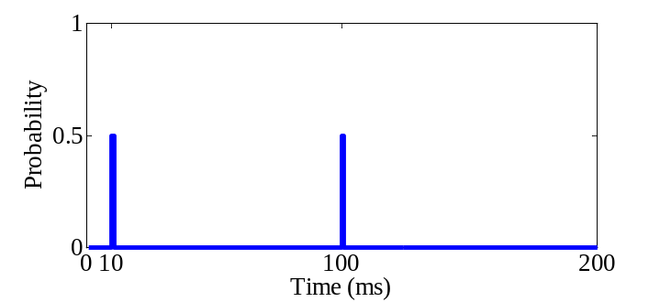
  - Describe two processes which may generate such an ISI histogram. (6%)
  - For each of the following measures, what is the value for each of the two processes. If they are equal explain why and if not explain the difference:
    - Coefficient of Variation (CV) (5%)
    - Fano Factor (FF) (5%)
    - Hazard function (6%)
    - Autocorrelation function (±500 ms) (6%)

- A stimulator emitting a single pulse regularly every 1 second is leading to a spike after 10 ms in neuron A following 80% of the stimuli. Neuron A is connected reciprocally with neuron B through synapses which have the latencies and transfer probabilities shown below:

5 ms delay
P=0.5 for spike
20 ms delay
P=0.5 for spike
1 stimulus/s
P=0.8 for spike
A
B
In all the following questions normalize the Y axis to probability.
  - Draw the post stimulus time histogram (PSTH) of neurons A & B following the stimulus. (10%)
  - Draw the autocorrelation functions of A & B and their cross correlation function (±500 ms) (9%)
  - Sketch of the power spectrum of each neuron and their cross spectrum. (9%)

- The famous UFO detector system is described in the figure below.

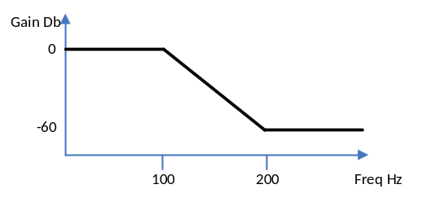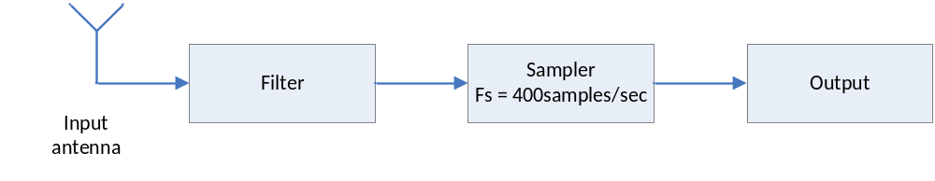

The filter’s frequency response is:

The antenna can receive the following inputs whose power spectral density is described below:
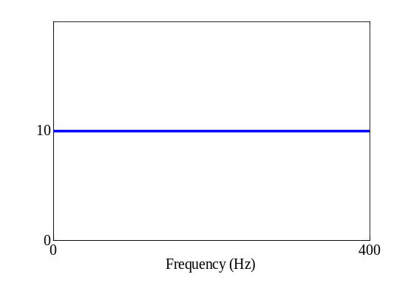
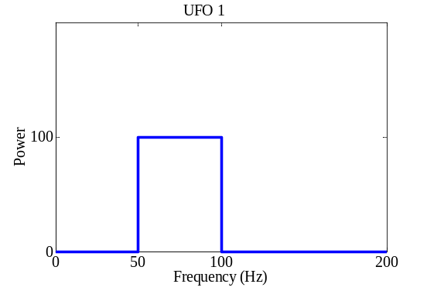
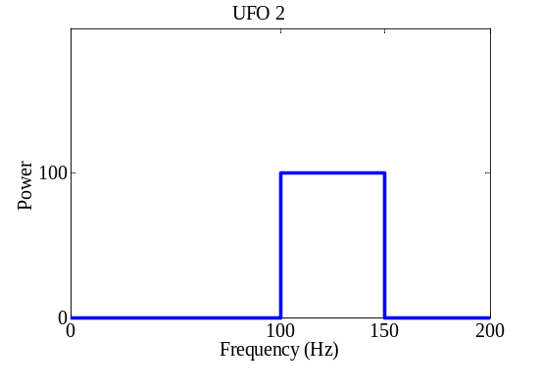
Background

  - Sketch the output’s PSD when: (8%)
    - No UFO signal if received.
    - UFO 1 appears
    - UFO 2 appears
    - Both UFO 1 & 2 appear.
Hint: Remember that the background is always there.
  - The sampler was broken and replaced by a cheaper sampler with fs = 160 [samples/sec].Repeat section (a) given the new sampler. (8%)
  - Assuming the following probability of signal pickup:

Option | Prior probability | P₈₀  Low High |  | P120  Low High
None | 0.975 | 0.8 | 0.2 | 0.7 | 0.3
UFO 1 | 0.01 | 0.1 | 0.9 | 0.6 | 0.4
UFO 2 | 0.01 | 0.6 | 0.4 | 0.1 | 0.9
Both | 0.005 | 0.2 | 0.8 | 0.2 | 0.8

Which option is the maximum aposteriori (MAP) estimator assuming a single recording of (P₈₀=High, P₁₂₀₌Low)? Explain. (6%).
d. How does this compare to the Maximum Likelihood estimator (MLE)? Explain. (6%)
Small open questions (2 of 3, 8% each)

- Frodo Baggins has a neuron which encodes the flight velocity of Golden Dragons. The spike triggered average velocity is given by the graph below:
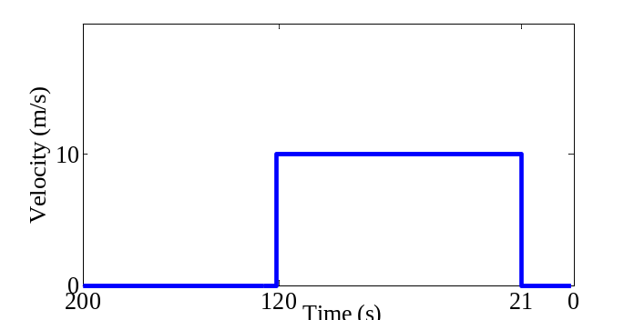

The dragon is flying back and forth over the treasure and its speed profile is described by the graph below:
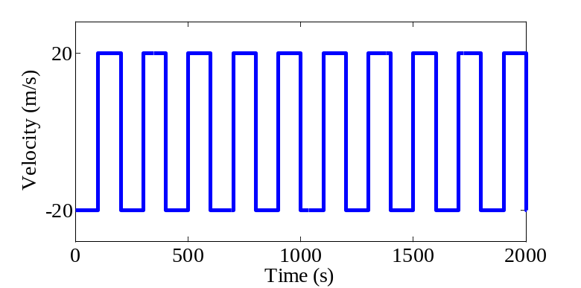

Sketch the neuronal firing rate overlaid on the Dragon flight rate.
(no need for Y values)

- The Triangular cricket uses three neurons to triangulate the location of its enemies. All the neurons have the same maximal and minimal firing rates. The table below shows the optimal directions and the firing rates for an unknown direction.

Neuron | Optimal direction | Firing rate
1 | 0 | 20
2 | 120 | 8
3 | 240 | 8

What is the unknown direction?

- Recording the firing rates of a pair of neuron yields four possibilities with equal probability (4,6), (8,6), (6, 4), (6,8). Are the two neurons correlated? Are the two neurons independent? Explain.

