Data & Signal Analysis in Neuroscience – Semester II 2010 28.7.2010

- The test duration is 3 hours, there will be no extensions.
- A calculator (not programmable, laptop, etc.) and a single formula page are allowed. No bags, cell-phones, books are allowed near the student.
- In all the figures verify that your axes are defined and their units appear, present critical X and Y values.
- Write in a clear handwriting, scribbles will be ignored.
- Pay attention to the instructions:
  - ‘Calculate’ means an analytic solution.
  - ‘Estimate’ does not require the full analytic solution.
  - ‘Draw’ means exact function and X & Y values.
  - ‘Sketch’ means approximate values and shape of the function.
- Orcs, Goblins, Golden Dragons, the fabled Dragon Slayer and even Bilbo Baggins are not really important for solving the questions (i.e. treat anything in capital as X).

Big open questions (answer 3 of 4, 28% each)

- Bilbo Baggins has a neuron which is part of the Orc sensing system. Upon sensing an Orc the neuron’s firing rate is described by a uniform distribution in the range [20-40] while upon sensing any other creature the firing rate is taken from a uniform distribution in the range [15-25].
  - Draw the ROC curve of the Orc identification. (9%)
  - Calculate the classification performance. (5%)
  - Sampling of the neuron 5 times during identical exposures yields the values [21 22 21 23 24]. What is the maximum likelihood estimator (MLE): Orc or not? (9%)
  - Assuming the prior probability of an Orc is 0.01. What is the maximum aposteriori (MAP) estimator assuming recorded values of [21 36 23 32 35] during exposures to the same creature: Orc or not? (5%)

- Gruesome Gnomes have the ability to walk either upright (p₀(s=U) = 0.75) or upside down (p₀(s=D) =0.25). Two neurons (N₁ and N₂) in the Gnome’s vestibular system fire differently when the Gnome is standing upright (U) or upside down (D).

 | R_{N1}=100 | R_{N1}=0 |  |  | R_{N2}=100 | R_{N2}=0
U | 80 | 20 |  | U | 90 | 10
D | 30 | 70 |  | D | 50 | 50

  - Calculate the entropy of the state of the Gnome. (6%)
  - Which of the neurons provides more information about the state of the Gnome? Calculate the information that it provides on the state. (12%)

 | R_{N1}=100  R_{N2}=100 | R_{N1}=0  R_{N2}=100 | R_{N1}=100  R_{N2}=0 | R_{N1}=0  R_{N2}=0
U | 80 | 10 | 0 | 10
D | 30 | 20 | 0 | 50

  - Assuming that the neurons display the joint probability shown in the table above. What is their joint entropy? Compare to the joint entropy in the independent case and explain. (10%)

- The MEG signal recorded by two Squids (SA & SB) is distributed Normally N(μ=0,σ=1). During three experiments the following covariance matrices were calculated (all higher moments are 0):

  - Sketch sample values of SA vs. SB for the three experiments (demonstrating the joint distribution). (9%)
  - Estimate the eigenvalues and eigenvectors for the three experiments. (9%)
  - In which experiment do the sensors display the highest redundancy and in which one the lowest? Explain. (5%)
  - For each of the experiments. Will ICA be useful for separating the signals picked up by the two squids? Explain. (5%)

- A scientist simulates a biological filter using the following discrete IIR filter.
y[n] = x[n] +α∙y[n-1], 0 ≤ α ≤ 1, fs = 100Hz. The scientist wants to see how the temporal and spectral responses are affected by α.

  - For α = 0, α = 1, α = 0.5. Sketch the filter’s impulse response and frequency response. Explain. (8%).
  - For α = 0.4 provide an equivalent FIR whose impulse response error < 10%. (6%)
  - Is it possible to find an equivalent FIR with impulse response error < 10% for all 0 < α < 1? If so, how does the number of elements depend on α? What happens when α=1? (8%)
  - Is this filter a low pass, high pass or bandpass? What is the dependency on α? Explain.(6%)
Small open questions (2 of 3, 8% each)

- The Green Grass Goblin has four neurons for identifying Elf movements with different optimal directions. All the neurons have the same minimal and maximal firing rates. The neurons fired at the following rates for an Elf approaching from direction X:

Optimal direction | 0 | 90 | 180 | 270
Firing rate for X | 20 | 10 | 4 | 8

Calculate the movement direction of the Elf using a population vector.

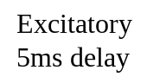
A
B
Inhibitory
10ms delay

- Two neurons of the motor system of the Oscillating Ostrich are connected to each other in a bidirectional manner. Both excitation and inhibition last for 1 ms before the return to baseline.

Sketch the cross correlation function (in the range ±100 ms).

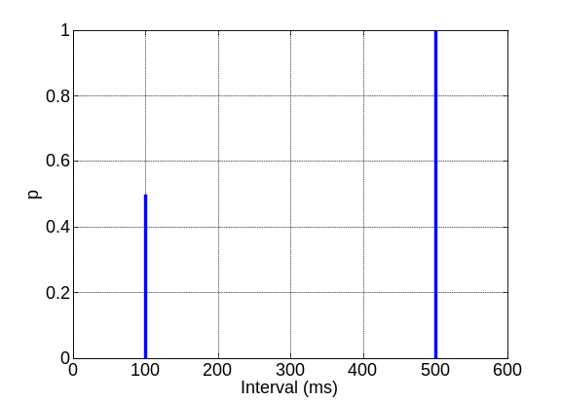

- The hazard function of the Dangerous Dwarf is shown to the right, Draw the autocorrelation function (in the range ±1 s). Assume a sampling rate of 1000 samples/s.

