**Team Name:** Team Space Invaders

**Project Title:** Space Invaders (Kinda)

**Team Members:** Iqbal Bhandal and Jason Block

**Description:**

The main premise of the game is to keep the player alive as long as possible. The more enemies destroyed, the more score the player earns. The enemy moves towards the player at a fixed speed. The player can move around, but they are not fixed on the y-axis. The player can move horizontally and vertically. The player earns 100 points from each enemy destroyed.

The player and enemy are objects that are derived by a ship class as seen in picture 1. The ship class contains variable for the ship's position, whether it is firing, whether it is destroyed and if it is moving. The player and enemies have a few differences in their classes. The player class has functions for inputted movements and the enemy class does not since it moves downward autonomously. In the first version of the game the enemies would also shoot, but when they did they would all do it at the same time, so we got rid of that later on.

Most of the game was implemented in the game class. The enemies and players are created in the Game::Game function as seen in picture 2. We used a switch statement to move through the different screens and have the game move through other processes. That can be seen in picture 3. The three basic functions at the in picture 4 display text. The first two just take in array pointers and display whatever we wanted them to display. The second one takes in variables and displays them on screen.

**Time Plan and Division of Labor:**

We worked on this project for two weekends. I had been working on my CSE 180 final project at the same time (would not recommend that class to anyone, unless they really want to work with ROS and have a few months prior of the class to figure out how the library works). We couldn't have been able to do this project without GitHub. Jason would work on it for a while and upload whatever he had changed on to GitHub. I would download it and do the same. Jason was a great partner for this project. We would run ideas off of each other to see if we could make it work with whatever the other is doing.

**Lessons Learned:**

While working on this final project and my CSE 180 final project, I learned how to manage my time to the dot. I made sure I could work on this project and at the same time have time for my other project. We also learned that we should test our code a few minutes before we present it. As you could probably remember our presentation didn't go as planned, it was kind of embarrassing. We had changed the speed of the enemy because we were trying to see if we could change the layout of the enemy. That didn't go to plan, so we reverted what we thought was all of the code, but it was not. I forgot to change the movement back to its normal speed which is why the enemy moved so fast that we could present the score and destruction of the enemy.

**Pictures:**

Picture 1:

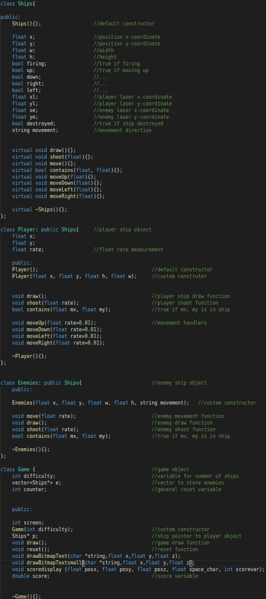

Picture 2:

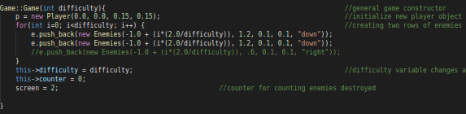

Picture 3:

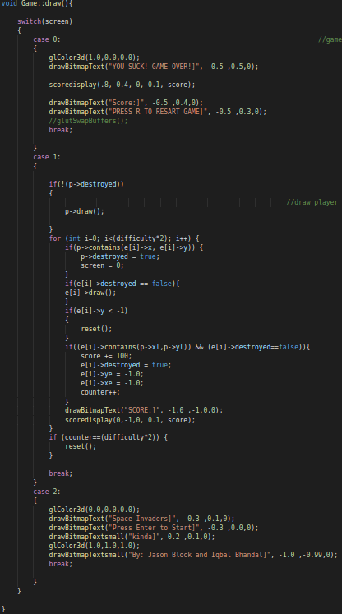

Picture 4:

