Alumni Management System
Project Documentation
Three-tier Alumni Management & Placement Platform
Built per AMS Tech Stack PRD v1.2
Version 1.0

Table of Contents

(In Word: right-click → Update Field to populate page numbers.)

1. Project Overview
The Alumni Management System (AMS) is a web platform that helps an institute's placement team maintain its alumni network and use it to place students. It centralises alumni and student data, runs outreach campaigns, tracks a referral/placement pipeline with service-level guarantees, gathers monthly hiring intelligence, and surfaces everything through role-based dashboards.
It is a three-tier application: a React single-page frontend, a Django REST API backend, and a PostgreSQL database, with Redis and Celery powering background jobs. The entire stack runs with a single Docker Compose command.
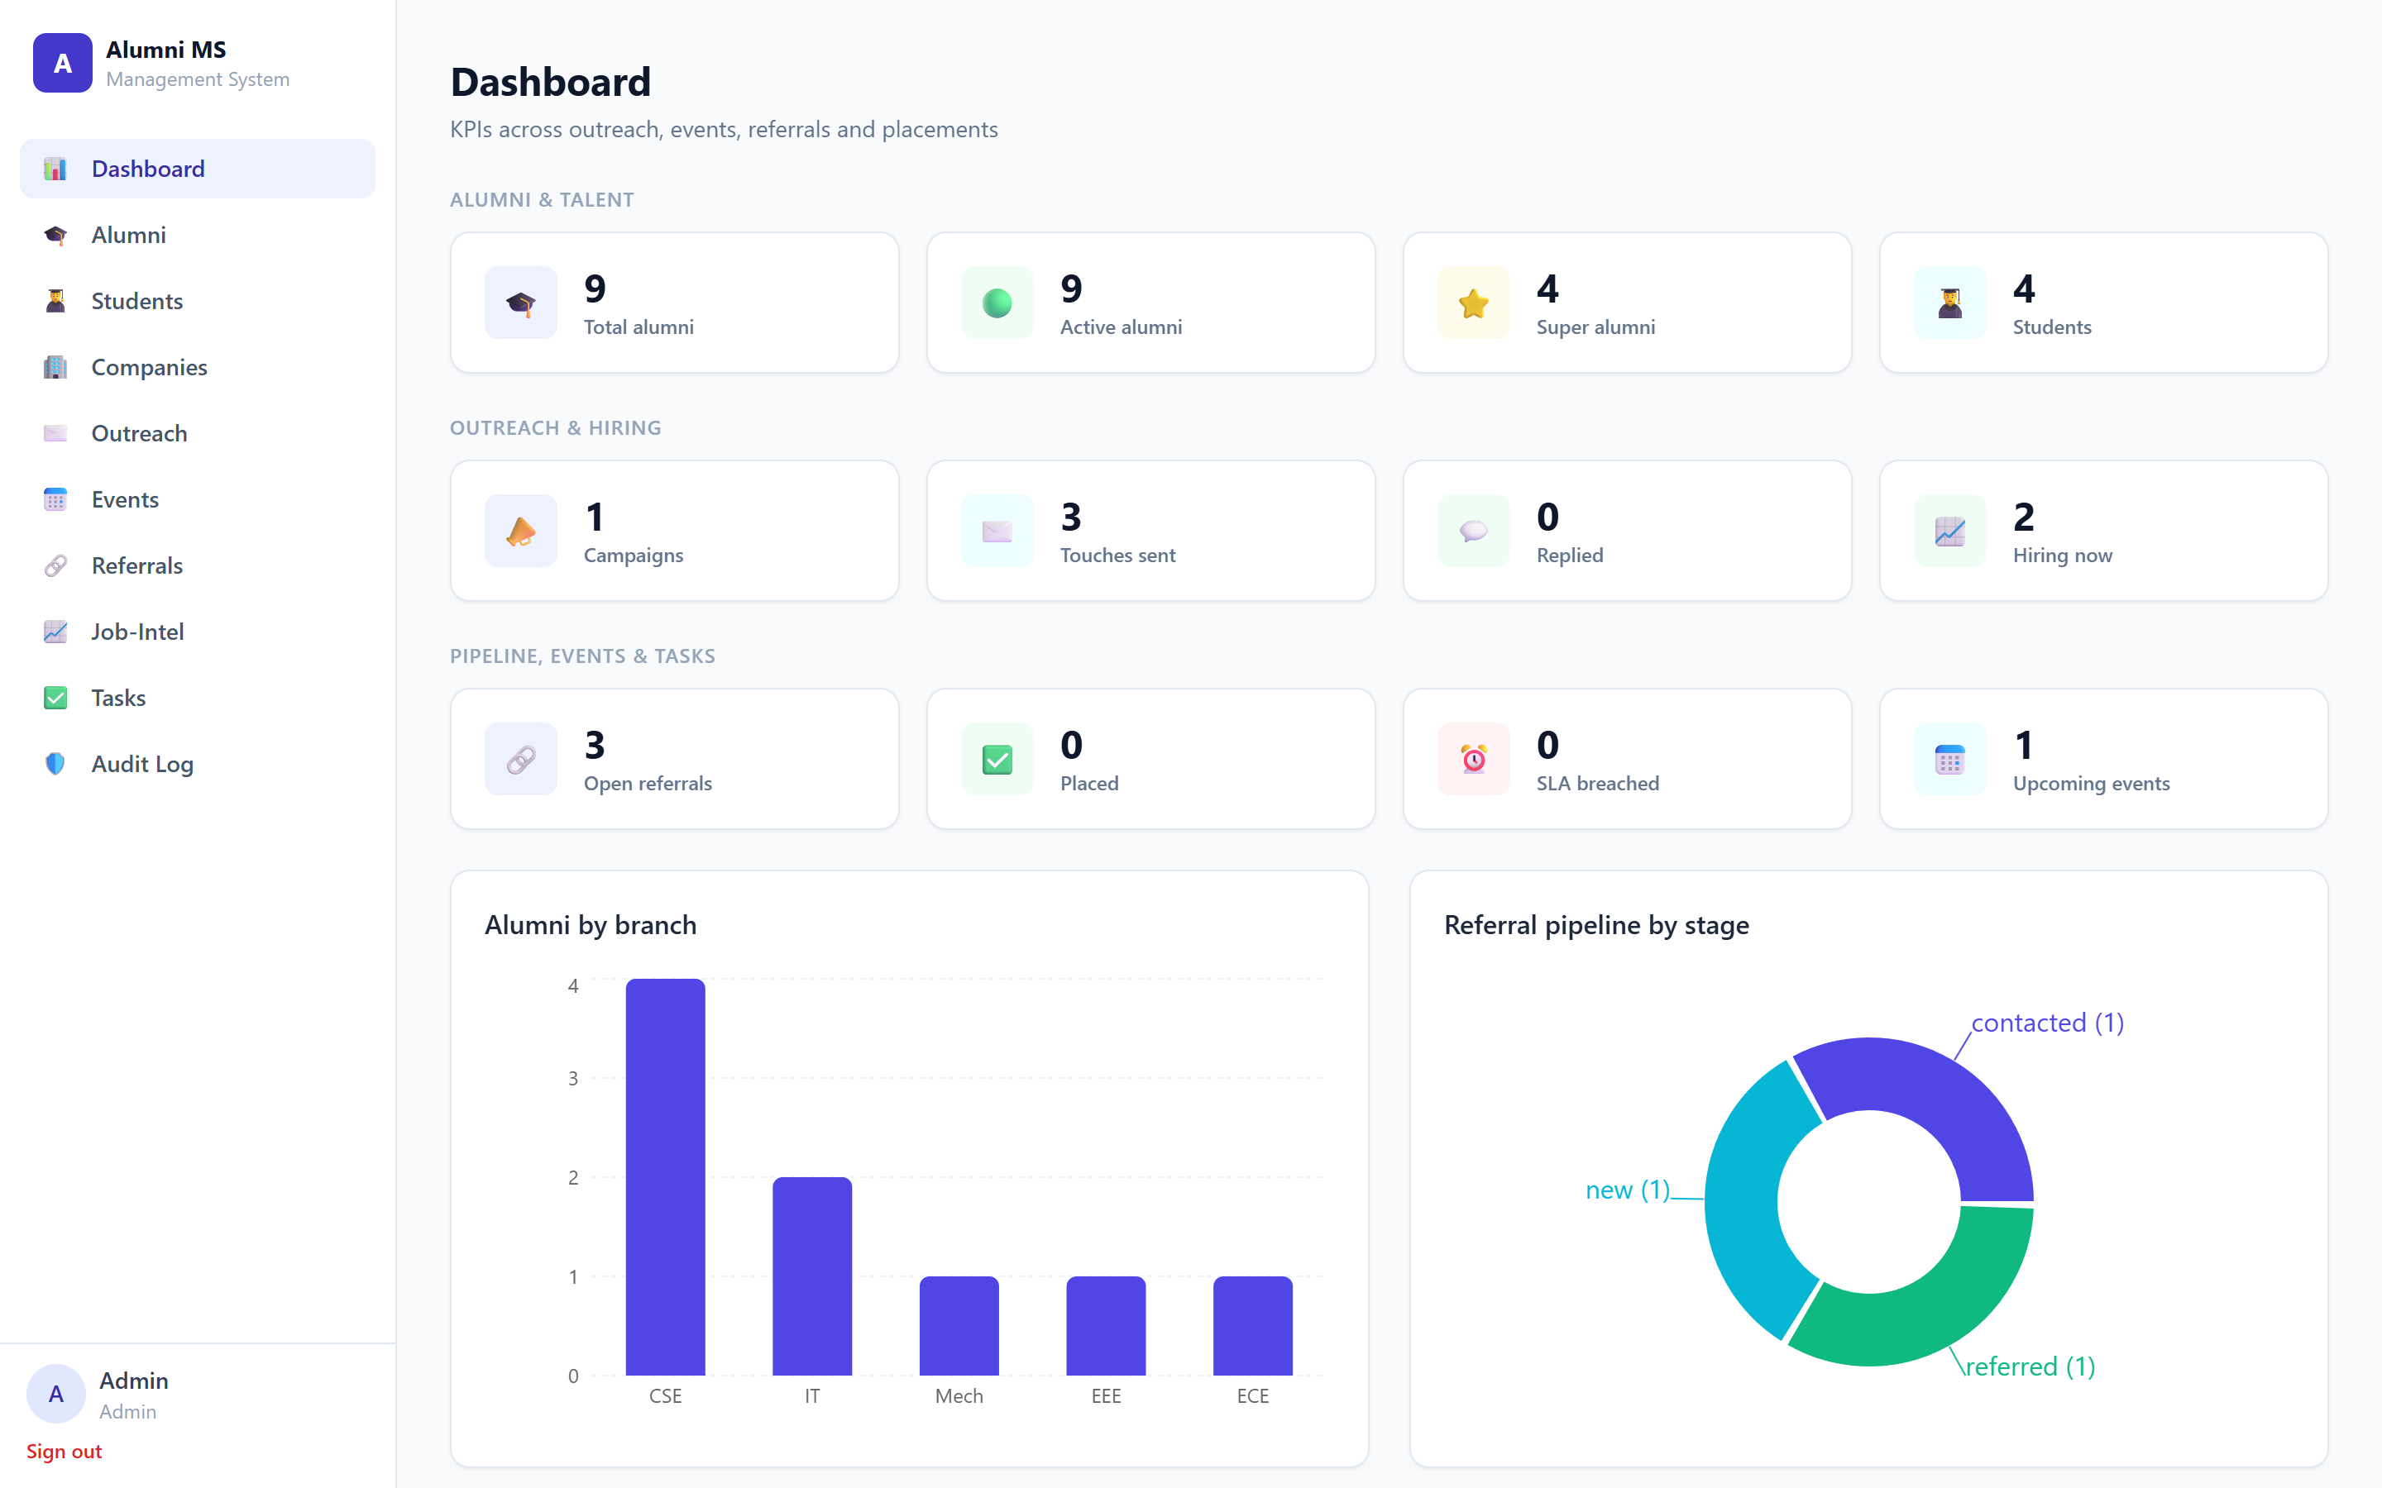
Figure 1 — Dashboard with live KPIs and charts

2. Technology Stack

2.1 Frontend
Technology | Version | Role
React | 18.3 | UI library — all pages and components
TypeScript | 5.4 | Type-safe JavaScript
Vite | 5.2 | Dev server and build tool (fast HMR)
Tailwind CSS | 3.4 | Utility-first styling / design system
React Router | 6.23 | Client-side page routing
TanStack Query | 5.40 | API data fetching and caching
Axios | 1.7 | HTTP client (JWT attach, 401 refresh)
Recharts | 2.12 | Dashboard charts (bar, donut)
PostCSS / Autoprefixer | — | CSS processing for Tailwind

2.2 Backend
Technology | Version | Role
Django | 5.0.6 | Web framework — models, ORM, admin
Django REST Framework | 3.15 | Building the REST API
SimpleJWT | 5.3 | JWT authentication (access / refresh)
django-cors-headers | 4.3 | Cross-origin access for the frontend
django-filter | 24.2 | API filtering (branch / city / domain)
drf-spectacular | 0.27 | Auto-generated Swagger API docs
psycopg2-binary | 2.9 | PostgreSQL driver for Python
Celery | 5.4 | Background / scheduled jobs
redis (client) | 5.0 | Broker client for Celery
xhtml2pdf | 0.2.16 | Talent brochure PDF generation
gunicorn | 22.0 | Production WSGI server
python-dotenv | 1.0 | Loads secrets from .env

2.3 Database & Infrastructure
Technology | Version | Role
PostgreSQL | 16-alpine | Primary relational database
Redis | 7-alpine | Celery message broker / cache
Docker & Docker Compose | — | Runs all 5 services with one command
Python | 3.12-slim | Backend container base image
Node | 20-alpine | Frontend container base image

3. System Architecture
AMS follows a classic three-tier architecture. The browser talks only to the REST API; the API owns all business logic and security and is the only tier that touches the database. Long-running and scheduled work is offloaded to Celery workers via Redis.
Flow: React frontend → Django REST API (logic + RBAC) → PostgreSQL. Redis + Celery handle asynchronous jobs.

3.1 Docker services
The docker-compose stack runs five coordinated services:
- db — PostgreSQL database (with health checks).
- redis — message broker for Celery.
- backend — Django REST API on port 8000; runs migrations and seeds demo data on first boot.
- worker — Celery worker + beat scheduler for background jobs.
- frontend — React / Vite app on port 5173.

4. Roles & Access Control (RBAC)
Access control is enforced on every API endpoint, not just hidden in the UI. A single role field on the user drives all permissions; admins always pass, read-only and alumnus roles can never write.
Role | Permissions | Typical user
Admin | Everything + Audit Log + delete | System owner
Coordinator | Add / edit all modules | Placement team lead
Volunteer | Add / edit data (limited) | Helper / junior member
Alumnus | View only (read) | An alumnus
Read-only | View only | Guest / reporting

5. Functional Modules
1. Dashboard
What: KPIs and charts aggregated across every module: alumni totals, active and super-alumni, students, campaigns sent vs replied, open and placed referrals, SLA breaches, hiring-now count, plus referrals-by-stage and alumni-by-branch charts.
Role: A single-glance view of overall system health.
Why: Drives decisions — shows where attention is needed.
2. Alumni Directory
What: Master alumni records: batch, branch, company, role-level, domain, city and contact details, plus Status, Super-Alumni flag, Willingness (1–5) and DPDP consent. Includes search/filters and CSV import/export (upsert by email).
Role: The core dataset the entire system stands on.
Why: Student placements come from this network, so data quality matters most here.
3. Students / Talent
What: Student talent profiles with GPA, skills, domain and project highlights. A Brochure button generates an auto-formatted two-page PDF résumé.
Role: The people the system aims to place.
Why: Gives alumni ready, professional profiles to act on.
4. Companies
What: Employer directory with name, sector and an 'on the placement list' flag.
Role: Links the referral pipeline and job-intel to specific employers.
Why: Keeps track of who is hiring and who is an official placement partner.
5. Outreach / Campaigns
What: Targeted email loop: create a campaign for a saved segment, Populate to add matching active alumni as contacts, then Send. Uses reusable message templates (context / ask / close) and tracks per-contact status (Pending / Sent / Replied / Bounced).
Role: Lets the team reach a whole segment instead of emailing one by one.
Why: Scales engagement and measures replies.
6. Events & Drives
What: Placement drives, webinars, meetups and mentorship events with date, venue, capacity and audience. Tracks RSVP and attendance. Creating an upcoming event auto-emails active, consenting alumni (BCC for privacy).
Role: Brings alumni and students together on one platform.
Why: More networking leads to more referrals.
7. Referrals Pipeline
What: The placement pipeline linking alumni, students and companies through stages New → Contacted → Referred → Interview → Offer → Closed, with a 48-hour follow-up SLA; missed follow-ups are flagged as breached.
Role: Tracks actual placements — the system's end goal.
Why: Keeps leads warm and adds accountability via the SLA.
8. Job-Intel / Hiring Pulse
What: A monthly hiring survey to alumni: are you hiring, which roles, and on what timeline (now / 1–3m / 3–6m / not hiring). Auto-triggers on the first of each month.
Role: Provides real-time hiring intelligence.
Why: Reveals who is hiring now so students can be targeted there.
9. Tasks
What: An internal task tracker by team (Outreach / Events / Referrals / Data) with assignee, due date and status (To-Do / Doing / Done / Blocked).
Role: Organises the placement team's work.
Why: Ensures nothing slips and ownership is clear.
10. Audit Log
What: A time-stamped record of every significant action — created / updated / deleted, SLA alerts, emails sent, pulse triggers. Visible to Admin and Coordinator only.
Role: Provides accountability and compliance.
Why: Under the DPDP Act, access to alumni PII must be traceable.
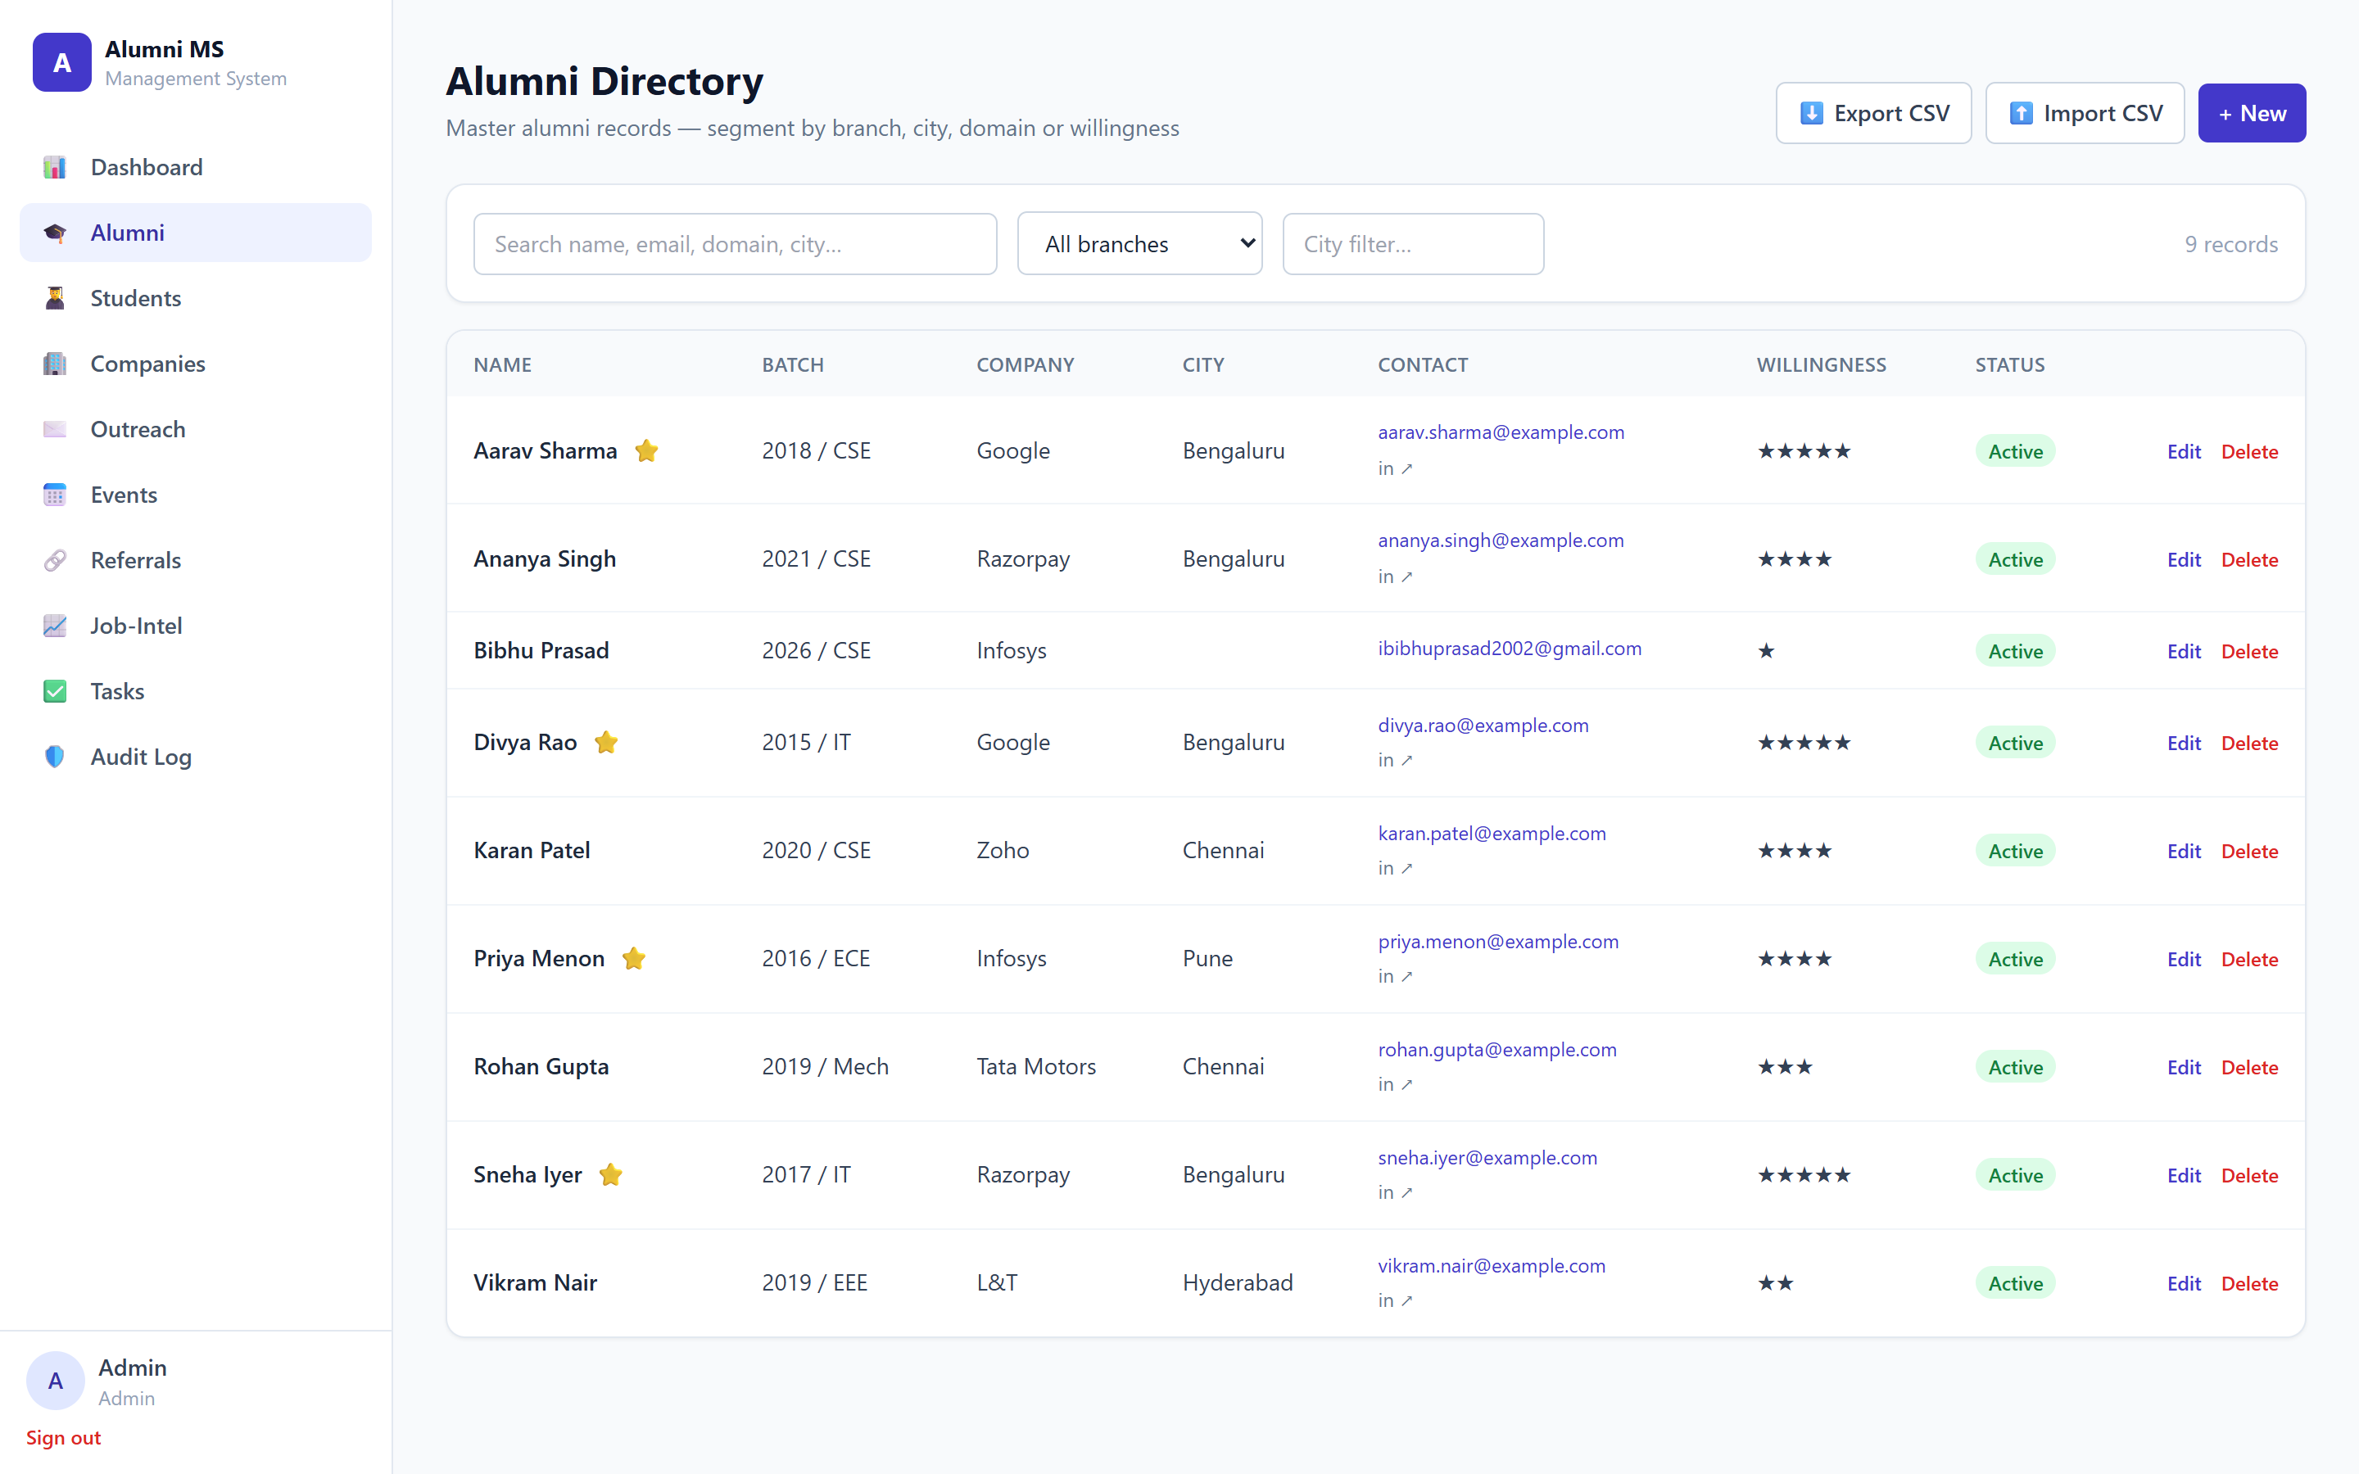
Figure 2 — Alumni Directory with filters, willingness and CSV import/export

6. Background Jobs (Celery + Redis)
Three jobs run automatically without any user action:
- Referral SLA check — flags referral leads whose follow-up has passed the 48-hour SLA, writing an alert to the audit log and dashboard.
- Event announcement — when an upcoming event is created, emails active, consenting alumni (recipients in BCC to protect PII).
- Monthly hiring pulse — on the first of each month, triggers the job-intel survey to active, consenting alumni.

7. Public Forms (no login)
Two forms are accessible without authentication so outsiders can contribute data directly:
- /forms/pulse — alumni submit their own hiring information.
- /forms/rsvp — event RSVP; responses land straight in the database.
This reduces friction — no account is required — and both forms are linked from the login page.

8. Core Data Model
The main entities and how they relate:
Entity | Key fields | Relationships
Alumni | name, batch, branch, status, willingness, consent | → Company
Student | name, batch, branch, gpa, skills | → Referrals
Company | name, sector, placement-list flag | ← Alumni, Referrals
ReferralLead | stage, outcome, last_followup_at (48h SLA) | Alumni ↔ Student ↔ Company
OutreachCampaign / Contact | segment_filter, template, status | → Alumni
Event / Participant | type, date, venue, RSVP, attended | → Alumni / Student
JobIntelResponse | hiring, roles, timeline | → Alumni
Task | team, assignee, due_date, status | → User
AuditLog | user, action, entity, timestamp | → User

9. Security & Compliance
- RBAC is enforced on every API endpoint, not just hidden in the UI.
- Alumni records are PII under India's DPDP Act — access is role-gated and key actions are written to the audit log.
- A consent flag records DPDP consent before storing or contacting an alumnus; bulk emails use BCC so recipients are not exposed to each other.
- Secrets live in environment variables (.env), never in code.
- Authentication uses JWT today; Google SSO (institute email) is the production target.

10. Setup & Running

10.1 With Docker (recommended)
- Copy .env.example to .env and adjust secrets.
- Run docker compose up --build.
- Migrations run and demo data is seeded automatically on first boot.

10.2 URLs
Service | URL
Frontend | http://localhost:5173
Backend API | http://localhost:8000/api/
API docs (Swagger) | http://localhost:8000/api/docs/
Django admin | http://localhost:8000/admin/

11. Demo Guide

11.1 Seeded logins
Role | Email | Password
Admin | admin@institute.edu | admin12345
Coordinator | coordinator@institute.edu | demo12345
Volunteer | volunteer@institute.edu | demo12345

11.2 Suggested demo order
- Login as Coordinator — the placement team's login.
- Dashboard — system health at a glance.
- Alumni — show consent / willingness / super-alumni and CSV import.
- Students — generate the Brochure PDF live.
- Companies — the employer directory.
- Outreach — run the segment → populate → send loop.
- Events — create an event; the announcement email goes out automatically.
- Referrals — advance a lead's stage and explain the 48-hour SLA.
- Job-Intel — show the hiring signal.
- Tasks — team coordination.
- Log in as Admin → open Audit Log to show everything is traced (RBAC punchline).
- Open a public form with no login to show alumni can submit data themselves.

