Code:  
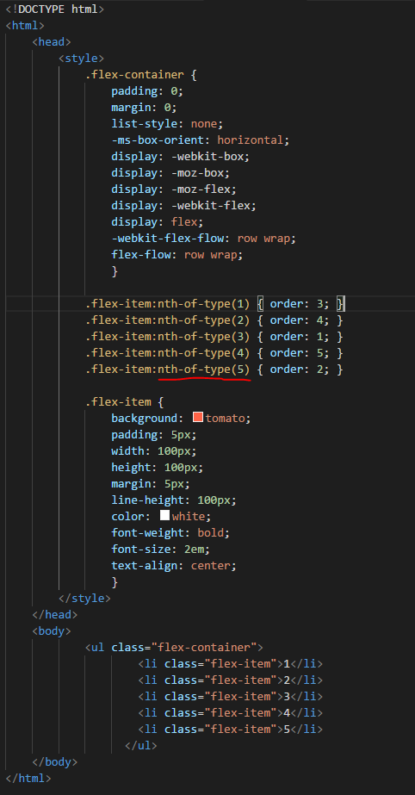

Flexbox Layout Module URL: <https://css-tricks.com/snippets/css/a-guide-to-flexbox/>

1. CSS :nth-of-type() Selector  
-The :nth-of-type(*n*) selector matches every element that is the *n*th child, of a particular type, of its parent. *n* can be a number, a keyword, or a formula.  
-**Tip:** Look at the [:nth-child()](https://www.w3schools.com/cssref/sel_nth-child.asp) selector to select the element that is the *n*th child, **regardless of type**, of its parent.

Example

Specify a background color for every <p> element that is the second p element of its parent:

p:nth-of-type(2) {  
    background: red;  
}

Example

Odd and even are keywords that can be used to match child elements whose index is odd or even (the index of the first child is 1).

Here, we specify two different background colors for odd and even p elements:

p:nth-of-type(odd) {  
    background: red;  
}  
  
p:nth-of-type(even) {  
    background: blue;  
}

Example

Using a formula (*an* + *b*). Description: *a* represents a cycle size, *n* is a counter (starts at 0), and *b* is an offset value.

Here, we specify a background color for all p elements whose index is a multiple of 3:

p:nth-of-type(3n+0) {  
    background: red;  
}

2. CSS :nth-child() Selector  
-The :nth-child(*n*) selector matches every element that is the *n*th child, regardless of type, of its parent. *n* can be a number, a keyword, or a formula.

Difference between nth-child & nth-type: <https://css-tricks.com/the-difference-between-nth-child-and-nth-of-type/>

3.CSS flexbox property: order

-Flex items are displayed in the same order as they appear in the source document by default. The order property can be used to change this ordering.

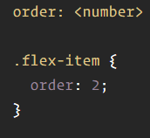

4.Difference between align-content and align-items in flexbox, CSS:

First, align-items is for items in a single row. So for a single row of elements on **main axis**, align-items will align these items respective of each other and it will start with fresh perspective from the next row.

Now, align-content doesn't interfere with items in a row but **with rows itself**. Hence, align-content will try to align rows with respect to each other and flex container.

5.CSS flexbox property: flex-grow  
-Basis: specify “justify-content”, “align-items”, “align-content”

- IT defines the ability for a flex item to grow if necessary. It accepts a unitless value that serves as a proportion. It dictates what amount of the available space inside the flex container the item should take up.

For example, if all items have flex-grow set to 1, every child will set to an equal size inside the container. If you were to give one of the children a value of 2, that child would take up twice as much space as the others.  
Code:  
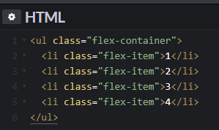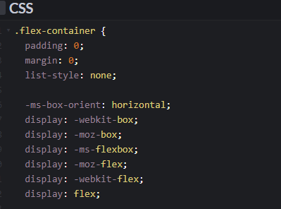

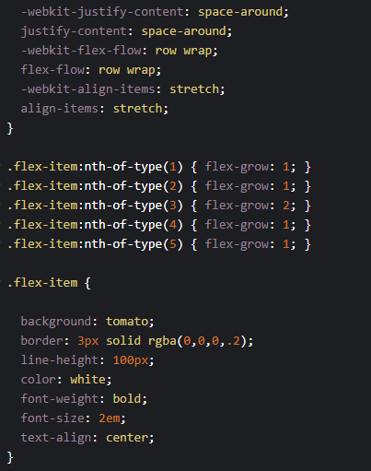

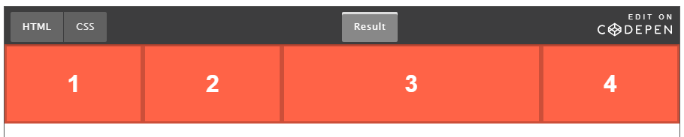

Website:

Jsfiddle, codepen, CSS trick, scrimba, html5 Doctor