1.CSS property text-align can only align BLOCKS to the right, but spans are INLINE elements.  
Inline elements: hyperlinks<a></a>, images<img>, form fields<input>, spans<span>

2.linear-gradient / radial-gradient:  
They are vendor-prefixed. And for IE Explorers which cannot deal with gradients, set the background with “background-color: black;” However, background-color should be above “background: linear-gradient”. This is how the browser render the CSS style sheet and HTML document. If background-color is below background: linear-gradient, all gradient styles are not rendered, or to say, be covered by background-color.  
 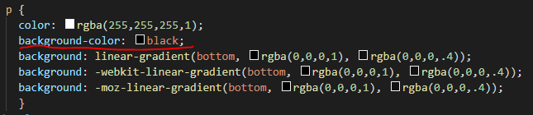

3. **background-image: Setting a Fallback Color**If a background image fails to load, or your gradient background is viewed on a browser that doesn't support gradients, the browser will look for a background color as a fallback. You can specify your fallback color like this:  
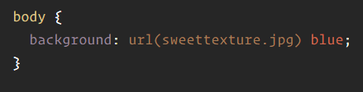

### 4. **Multiple Background Images** Be aware that there's a somewhat counter-intuitive [stacking order](http://css-tricks.com/stacking-order-of-multiple-backgrounds/). List the image that should be at the front first, and the image that should be at the back last. Use the background shorthand to set the values for each image individually.

5. linear-gradient: <https://css-tricks.com/snippets/css/css-linear-gradient/>

radial-gradient: <https://css-tricks.com/snippets/css/css-radial-gradient/>

6. Child and Sibling Selectors  
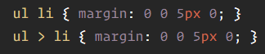  
The first selector above is a decendant selector. It will select any list items that are anywhere underneath an unordered list in the markup structure. The list item could be buried three levels deep within other nested lists, and this selector will still match it. The second selector above is a child combinator selector. This means it will only select list items that are direct children of an unordered list. In otherwords, it only looks one level down the markup structure, no deeper. So if there was another unordered list nested deeper, the list item children of it will not be targeted by this selector.

#### **Child combinator**

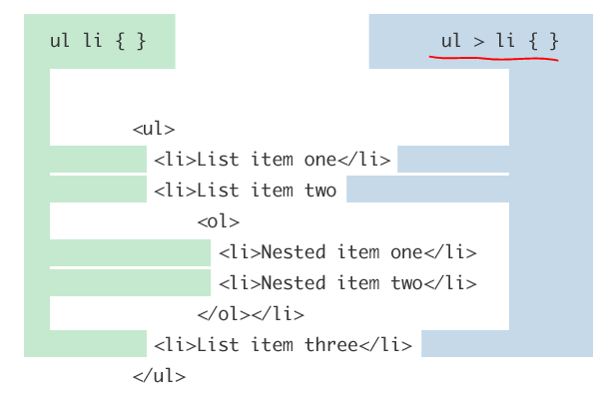

#### **Adjacent sibling combinatory** An [adjacent sibling](http://css-tricks.com/almanac/selectors/a/adjacent-sibling/) combinator selector allows you to select an element that is directly after another specific element.

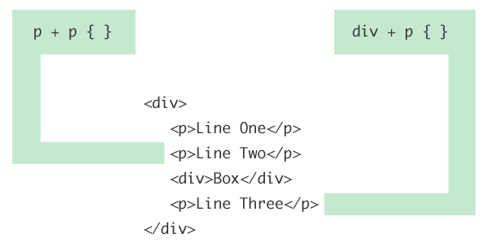

p + p { font-size: smaller; }

/* Selects all paragraphs that follow another paragraph */

#title + ul {margin-top: 0; }   
/* Selects an unordered list that directly follows the element with ID title */

#### **General sibling combinator**

The general sibling combinator selector is very similar to the adjacent sibling combinator selector we just looked at. The difference is that that the element being selected doesn't need to immediately succeed the first element, but can appear anywhere after it.  
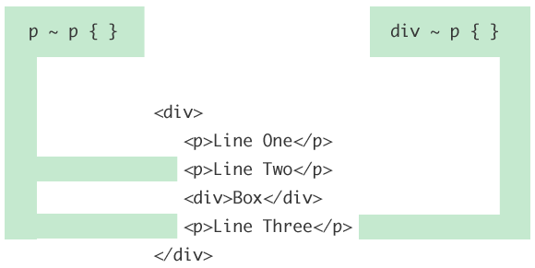

Note that in both the general sibling and adjacent sibling selectors the logic takes place within the same parent element. That's what siblings means... sharing the same parent.

URL: <https://css-tricks.com/child-and-sibling-selectors/>

7.Vertical margins collapse:  
Two <div>, div1 with margin-bottom:5px and div2 with margin-top:5px, the actual margin between these two <div> is 5px, not 10px, because the vertical margin collapse. Horizontal margins don’t apply this rule, only vertical margins collapse. If div1 with margin-bottom:10px and div2 with margin-top:5px, then the vertical margin is 10px.

8.Box Model:  
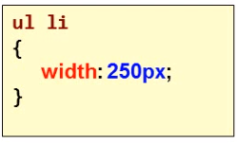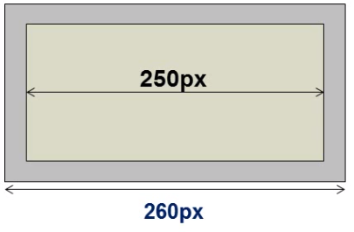

Here, “width:250px” is for the content area. Any margin, border, padding added will add the actual width. As illustrated, margin:5px will augment the actual width to 260px.

-Every element renders a box.

9.Visibility and Display:  
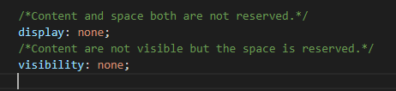  
Visibility is often applied with Javascript.