1.Text Properties:  
1)text-indent  
The text-indent property specifies the indentation of the first line in a text-block.  
**Note:** Negative values are allowed. The first line will be indented to the left if the value is negative.  
div.a {  
    text-indent: 50px;  
}  
  
div.b {  
    text-indent: -2em;  
}  
  
div.c {  
    text-indent: 30%;  
}  
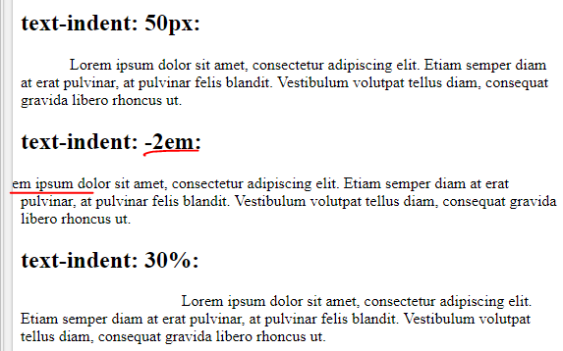

2)letter-spacing  
The letter-spacing property increases or decreases the space between characters in a text.  
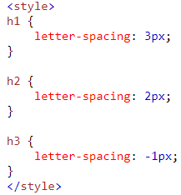 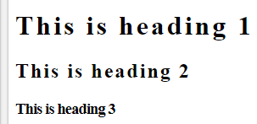

3)word-spacing  
The word-spacing property increases or decreases the white space between words. **Note:** Negative values are allowed.

4)text-decoration  
The text-decoration property specifies the decoration added to text, and is a shorthand property for:

* text-decoration-line (required)
* text-decoration-color
* text-decoration-style

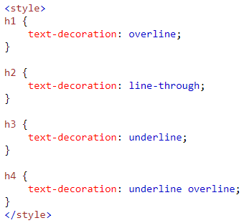 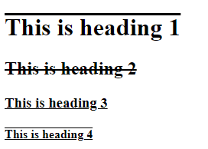

5)text-align  
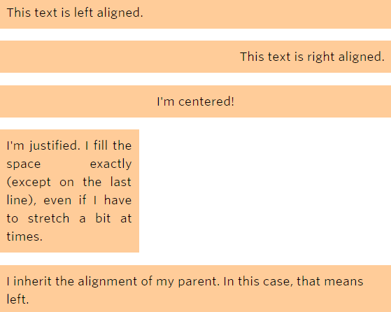

6)text-transform  
The text-transform property controls the capitalization of text.  
