Bahria University, Islamabad Campus
Department of Computer Science
Introduction To Data Science | BS (CS)-6B | Spring 2026

Project Report

Nautilus — Marine Intelligence Platform

Image Processing Techniques for Better Visibility
and Enhancing of Underwater Images

# | Name | Enrollment
1 | Ghulam Ibrahim | 01-134232-055
2 | Muhammad Umar | 01-134232-137

Github Links:
Linkedin Links:
https://www.linkedin.com/posts/ghulamibrahim786_our-data-science-project-based-on-the-web-ugcPost-7457862930852904960-Y-zU?utm_source=share&utm_medium=member_desktop&rcm=ACoAAFVdMwoB4dIYL8K_dfAdYY81BaH4xlZja2g
https://www.linkedin.com/posts/muhammad-umar-328900330_ugcPost-7457863937779236864-dFZz?utm_source=social_share_send&utm_medium=android_app&rcm=ACoAAFNtbdABLYQd3yLFO0fEFyHgYQUw5U8BFEU&utm_campaign=copy_link

Abstract
Underwater images inherently suffer from poor quality due to the physical effects of light absorption and scattering in aquatic environments. This results in heavy color casts, low contrast, and blurriness. This project — Nautilus — presents a complete, end-to-end Marine Intelligence Platform that applies advanced image processing techniques to restore and enhance underwater images, evaluates the improvement mathematically, and uses state-of-the-art deep learning (YOLO-World) for marine species detection. The platform is delivered as a fully interactive Flask web application.

1. Introduction
Marine studies and underwater explorations have long relied on photographic documentation. However, these images frequently present significant challenges: red wavelengths are absorbed within the first few meters of water, leaving a dominant blue or green color cast. Contrast degrades with depth, and subjects become blurry. These effects severely limit visual analysis and the effectiveness of computer vision systems.
This project addresses these problems by constructing an automated data science pipeline consisting of preprocessing, enhancement, exploratory data analysis (EDA), deep learning-based object detection, and a custom quality scoring metric.

2. Problem Statement
Underwater images are of inherently low quality due to light absorption and scattering. This leads to:
• Poor contrast and loss of fine detail.
• Heavy blue/green color casts misrepresenting true colors.
• Blurriness making it challenging to detect or classify marine subjects.
The goal of this project is to address these issues through robust image processing algorithms and validate the improvement quantitatively.

3. Objectives
• Identify typical problems in underwater images (low contrast, color distortion, blur).
• Enhance images using CLAHE, White Balancing, Gamma Correction, and Sharpening.
• Quantify improvement using a custom Underwater Visibility Score (UVS).
• Detect and classify marine species using YOLO-World deep learning.
• Build a fully interactive web platform (Nautilus) to demonstrate the pipeline.

4. Dataset: RUOD
This project utilizes the Real-world Underwater Object Detection (RUOD) dataset.
• Scale: ~9,800 labeled images with 51,935 annotations.
• Classes: 10 marine species — Sea Cucumber, Sea Urchin, Scallop, Starfish, Fish, Corals, Diver, Cuttlefish, Sea Turtle, Jellyfish.
• Format: COCO JSON annotations with bounding boxes.
• Challenge: Contains real-world distortions including heavy color casts, low lighting, and blurriness.

5. Exploratory Data Analysis (EDA)
Before attempting to fix the images, a thorough Exploratory Data Analysis was conducted. The Nautilus platform auto-generates the following plots using Matplotlib and Seaborn. The chart below reveals that Fish and Sea Urchins are the dominant species in the RUOD dataset, while Divers and Cuttlefish are rarer subjects.
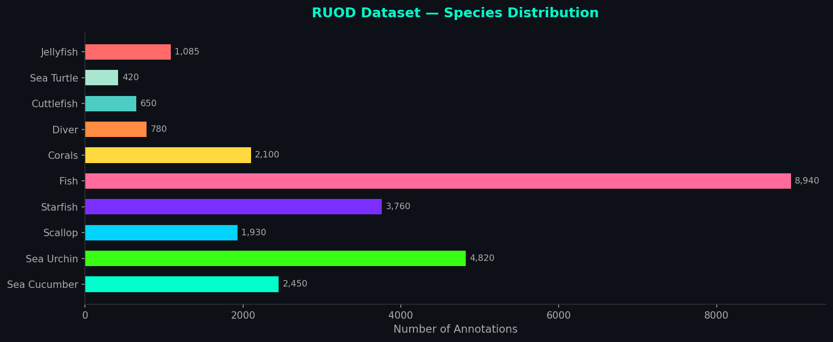
Figure 1: RUOD Dataset — Species Distribution by Annotation Count
Key EDA Insights:
1. Lighting Degradation: Red light is absorbed first, leaving heavy blue/green color casts.
2. Species Imbalance: Fish dominate the dataset, while Divers are significantly underrepresented.
3. Visibility Correlation: Brightness decreases significantly as object size gets smaller, proving depth-dependent degradation.

6. Methodology
6.1 Preprocessing
Images are resized, normalized, and converted to appropriate color spaces (LAB) before enhancement.
6.2 Enhancement Pipeline (5 Stages)
1. CLAHE — Adaptive local contrast enhancement to recover hidden details.
2. White Balance — Gray World algorithm to neutralize the underwater color cast.
3. Gamma Correction — Adaptive brightness adjustment based on mean image luminance.
4. Color Cast Removal — LAB-space analysis to normalize A/B channel means.
5. Sharpening — Unsharp masking via Gaussian Blur to define marine subject edges.
6.3 Object Detection
YOLO-World (yolov8s-world.pt) is used for zero-shot marine species detection. Custom marine class prompts (e.g., "sea urchin", "coral") are injected into the model dynamically at runtime.
6.4 Underwater Visibility Score (UVS)
A custom 0-100 quality metric computed as a weighted average of:
• Brightness (20%) | Color Balance (30%) | Contrast (25%) | Sharpness (25%)

7. Results — Image Enhancement
The comparison below demonstrates the dramatic visual improvement achieved by the enhancement pipeline. The original images exhibit heavy blue/green color casts and poor contrast. After processing, the images are significantly sharper, brighter, and display natural color distributions.
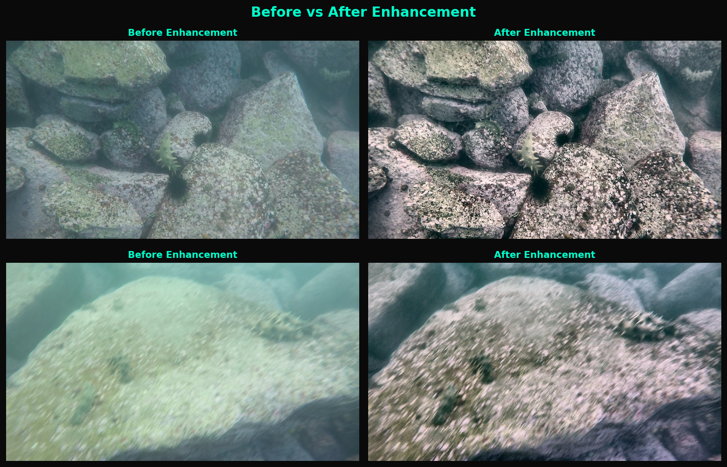
Figure 2: Before vs. After Enhancement — RUOD Dataset Samples

8. Tools & Technologies
• Backend: Python 3, Flask Web Framework
• Computer Vision: OpenCV (cv2), Pillow
• Data Science & EDA: NumPy, Pandas, Matplotlib, Seaborn
• Machine Learning: Ultralytics YOLO-World, PyTorch
• Frontend: HTML5, Custom CSS (Bioluminescent Dark Theme), Vanilla JavaScript

9. Limitations
• Extreme Depths: Near-zero visibility cannot be fully recovered by optical algorithms alone.
• CPU Processing Time: Full pipeline inference is slow on standard hardware without a GPU.
• Zero-Shot Accuracy: YOLO-World is a general-purpose model; a fine-tuned custom model would yield higher accuracy.

10. Future Work
• Generative AI (WaterGAN): Replace optical filters with GAN-based image restoration.
• Real-time Video: Extend the pipeline to live underwater video streams from ROVs.
• Cloud Deployment: Host on AWS/GCP for GPU-accelerated inference at scale.
• Custom Model Training: Fine-tune YOLOv8 on the full RUOD dataset for specialized accuracy.

11. Conclusion
The Nautilus Marine Intelligence Platform successfully demonstrates that a combination of classical computer vision (CLAHE, White Balance, Gamma Correction) and modern deep learning (YOLO-World) can dramatically improve the quality and interpretability of underwater images. The platform provides a comprehensive, interactive interface for the entire data science pipeline — from raw data ingestion and EDA to enhancement, detection, and quality scoring — all within a single elegant Flask web application.

