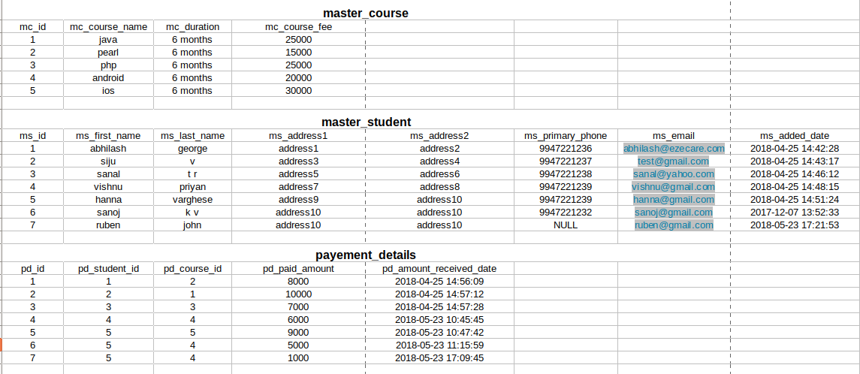
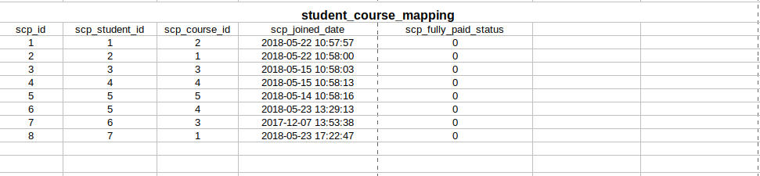

SQL PRACTICE QUESTIONS

- Write an SQL query to combine the columns “ms_first_name” and “ms_last_name” from master_student table using the alias name as ‘Student name’ .

- Print the list of courses having course fee greater than 22000 from the table ‘master_course’

- Write a query to select all record where name starts with ‘s’.

- Write a query to update the phone number whose first name= ‘sanal’ and last name= ‘TR’

- List First Name and email as a single field from Student Table.

6. Select TOP 2 Fees paid from Fees table

7. Write an SQL query to fetch “ms_first_name” from ms_student table in upper case.

8. List the name of students which are added on the month of April .

9. Write a query to arrange student name in the order of added date.

10. Write a query to select the names of students where the address (ms_address2) provided is address10.

11. Get Student details who joined before May 23, 2018. Result should list following fields: First Name, Last Name, Full Name, Course Name and Fees.

12. Write a Query to update last name of student in student table to “new last name”
where email starts with letter “a”.

