

VFR Manuál (Mk II)

Free application for pilots who would like to fly further than just around the chimney and do not have a current airport database, internet connection or are already on the way..

Contains basic useful information for arrivals, landings, map of the surroundings, situational maps of airfields and contact information. All charts are very easy to read while on still ground or airborne.

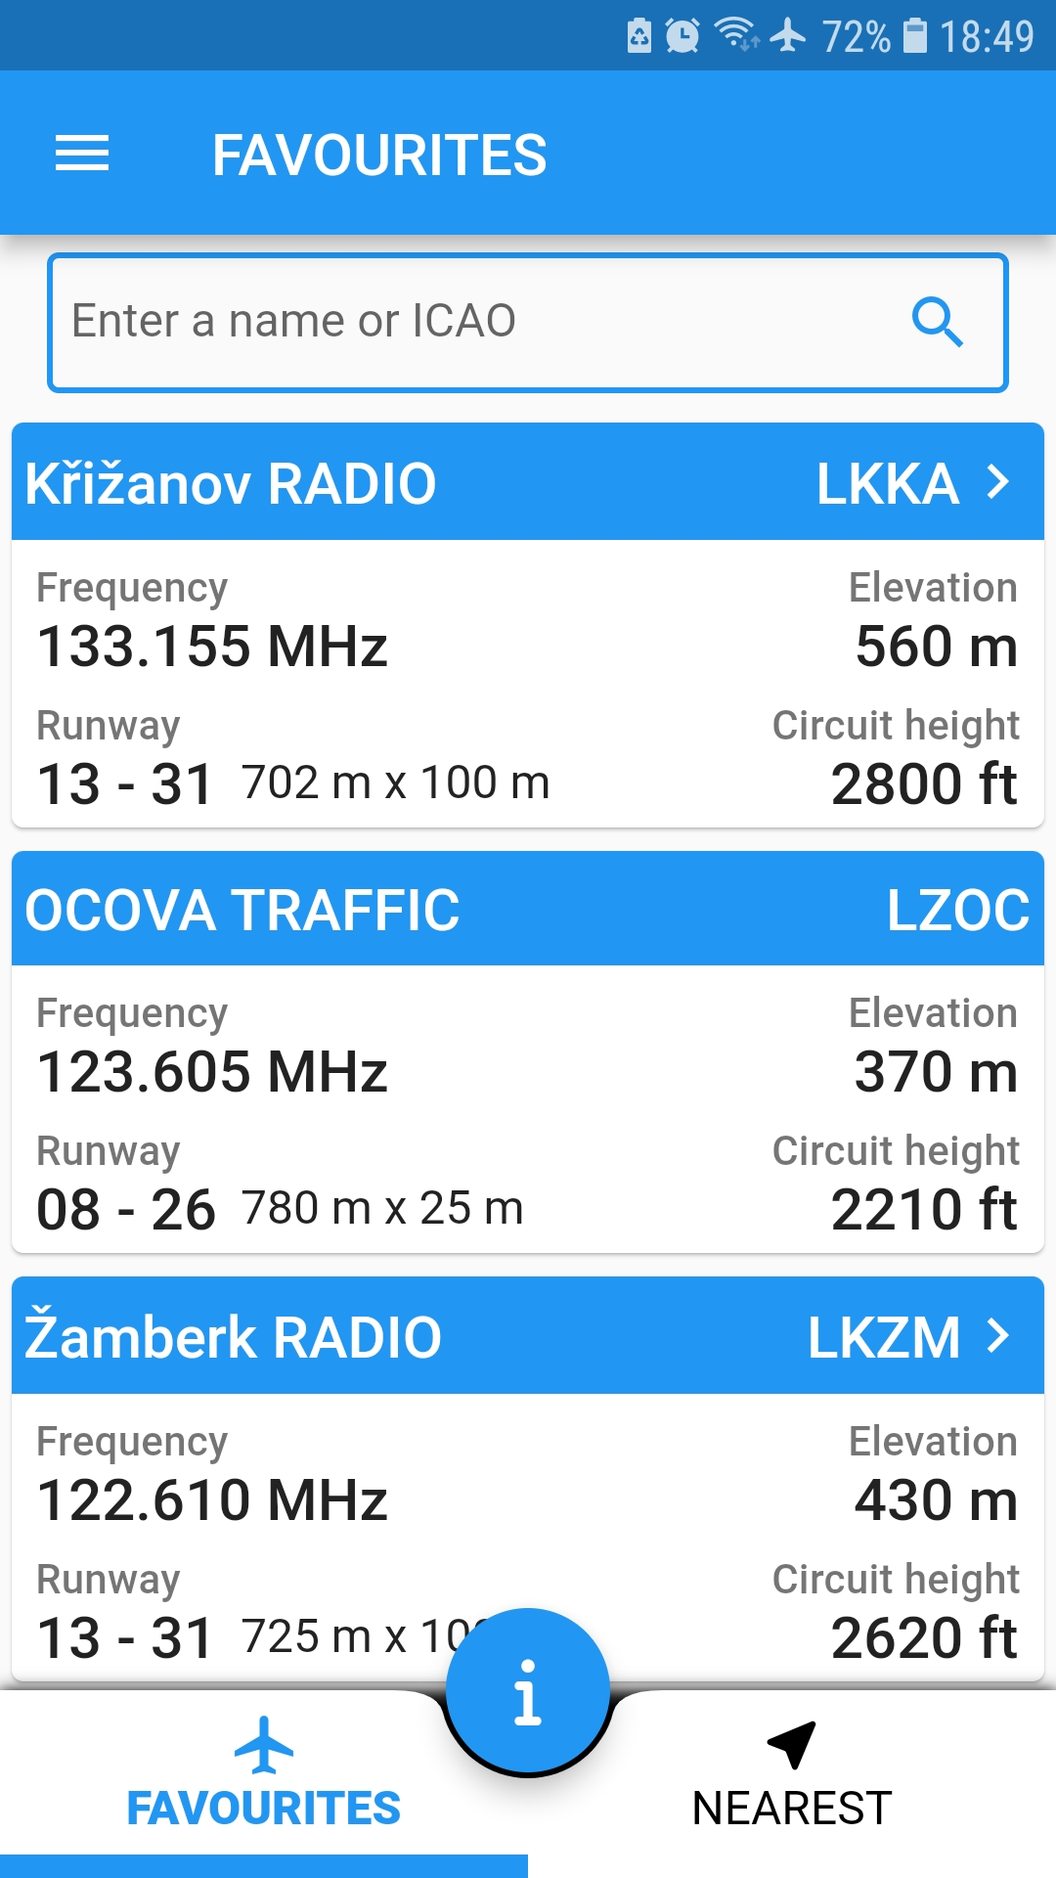
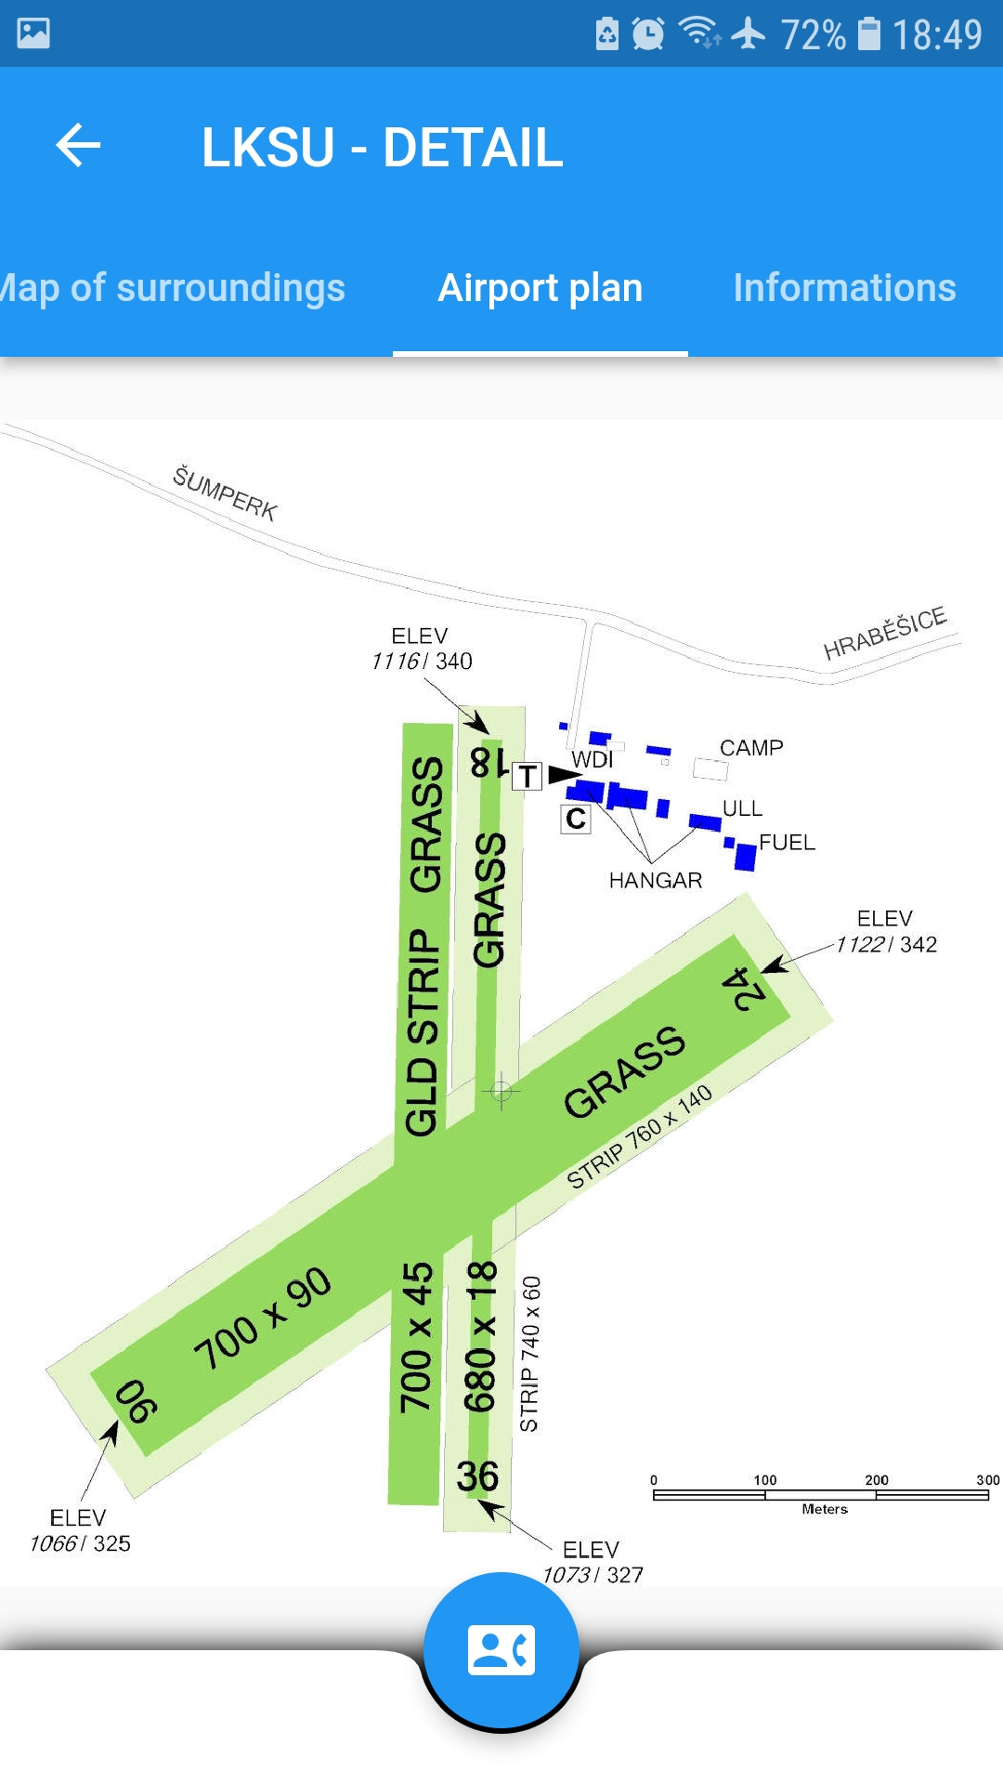
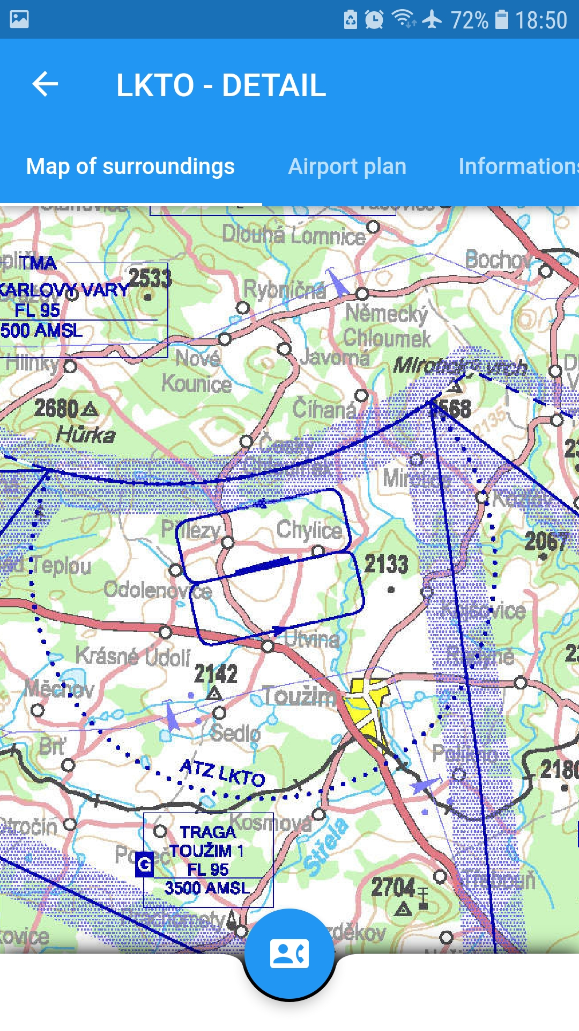




www.ibisek.com | logbook.ibisek.com | ogn.ibisek.com

