Classification: Decision Tree (CART)

# Introduction

An implementation of a classifier using the Decision Tree algorithm. The entire implementation of the decision trees algorithm is done native python and void of any data wrapper or data-mining tool. The implemented algorithm is tested on a dataset, for which accuracy metrics are evaluated.

# Data

The dataset used is shortened version of car evaluation data from the University of California Irvine (UCI) machine database available on Kaggle (Bohanec, 1997; Darlington, 2018). The dataset was originally developed for the presentation of DEX (Decision Expert) representing an expert system for multi-attribute decision making using modelled decision representation with trees (Bohanec & Rajkovič, 1988, 1990).

## Data Structure

The dataset is a multivariate dataset with seven attributes. The attributes and their unique values are described in the table below.

|  |  |  |  |
| --- | --- | --- | --- |
| **Attribute** | **Description** | **Type** | **Values** |
| Buying Price | Relative purchase cost of vehicle. | Categorical | vhigh, high, med, low |
| Maintenance Cost | Relative maintenance cost of car | Categorical | vhigh, high, med, low |
| Number of Doors | Number of doors on vehicle | Categorical | 2, 3, 4, 5more. |
| Number of Persons | Number of passengers including driver | Categorical | 2, 4, more. |
| Lug Boot | Size of the vehicle’s boot / trunk | Categorical | small, med, big |
| Safety | Degree of vehicle safety | Categorical | low, med, high. |
| Decision | Decision to purchase | Categorical | unacc, acc, good, vgood |

The dataset consists of 1728 records on vehicles collated. The multi-attribute nature of the dataset makes it suitable for the classification task. More so, the categorical nature of all the attribute is a reason for the selection of this dataset for use by the decision tree algorithm.

For the purpose of this report, six of the attributes in each record is set to features for the classification algorithm. Subsequently, maintenance cost, buying price, number of doors, number of persons, lug boot, and safety attributes are used as classification features. While the Decision attribute is used as a label for training and test the decision tree model.

## Data Collection

The data is downloaded through a link to the UCI database available on Kaggle. The downloaded data when unzipped contains a Comma Separated Value (CSV) file containing all the data records respectively. However, the column heads are missing. In the data cleaning Section, column heads retrieved from the data description are placed into the data.

## Data Pre-processing

The Pandas framework is used for data cleaning. The framework uses unique data objects called DataFrame and Series. The data cleaning task is described in the steps below which can be found in the “exercise.ipynb” project file.

### Inspection

The downloaded dataset was parsed into a pandas DataFrame. The dataset was then inspected for completeness using info() and describe() function. It was observed that the number of records for each attribute were 1728 correspondingly.

### Null Values

Next, the dataset is inspected for null values using the isnull().sum() member function of the DataFrame object. No null objects are found for the dataset.

### Separation / Conversion of Data to Features and Labels

Since, the algorithm is implemented in native python with no data wrappers, the DafaFrame object is converted to dictionary of all the attributes as keys and a list of their values. The data is then randomly separated into training data and testing data. 80 percent of the data is used for training while the rest is used for testing. The data is then separated into six features and “Decision” label.

# Algorithm

Decision Tree is a supervised learning technique that represents the decision-making process graphically. This predictive modelling technique is applied in statistics, data mining and machine learning. The tree designed in this project is a CART (Classification and Regression Tree) which allows its leaves to evaluate discrete and continuous data.

## Information Gain

Several mathematical and computation techniques are used in the development of the algorithm: information gain, node purity, entropy and logarithm. Information gain is refers to the amount of useful information derived by diving data by an attribute given may have already been divided by a previous attribute (Gopalan, 2020).

Mathematically,

$$gain = \{previsous gain\} - \sum_{value = i}^{unique values}{f(i)} * P(i)$$

where:

**P(i)** is probability of value

**F(i)** is entropy of value

### Entropy

Information entropy is an evaluation of the purity obtained if a dataset is split by the unique values of a feature. The purity obtained is evaluated by observing how the labels of each record within the split is distinguished from other labels of other unique values. A pure split would divide data perfectly using a feature to obtain well differentiated label values.

Mathematically,

$$entropy = \sum_{label values = i}^{unique label values}{- n_{i} \log_{2}{n_{i}}{}_{}}$$

where: **n** is a fraction of the number of records with that label value divided by the total number of records in data identifying a feature value.

## Algorithm and Pseudo Code

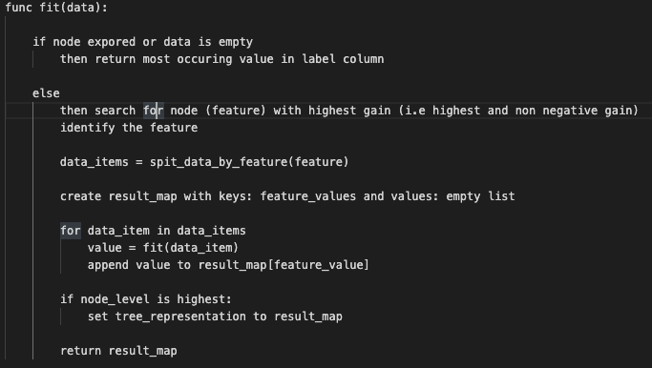

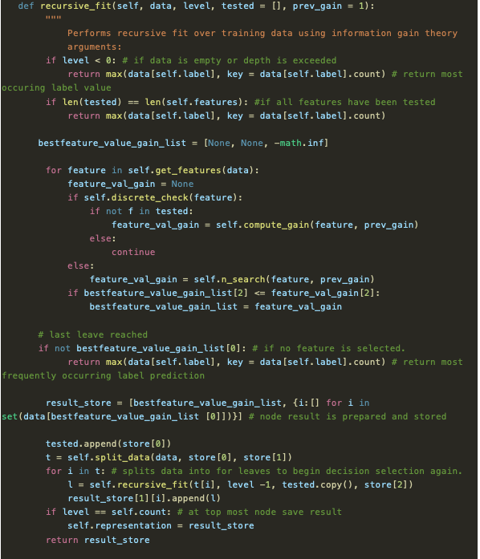

(Mitchel & Balcan, 2015; Strobl et al., 2009; Mitchell, 2006; Bohanec & Rajkovič, 1988)

# Testing

The unit test is prepared for all functions used in implementing the algorithm. Thus, the Pytest framework is used to implement these tests. The implementation passed all prepared unit tests module (Krekel, 2004).

# Performance Results

## Accuracy

|  |  |  |
| --- | --- | --- |
| **Tree Depth** | **Train (%) - Test (%) Ratio** | **Accuracy (%)** |
| 6 | 95:5 | 72.22 |
| 6 | 90:10 | 65.52 |
| 6 | 85:15 | 69.23 |
| 5 | 95:5 | 65.52 |
| 5 | 90:10 | 64.74 |
| 4 | 95:5 | 65.52 |

## Confusion Matrix

A confusion matrix plot of the first experiment is shown below:

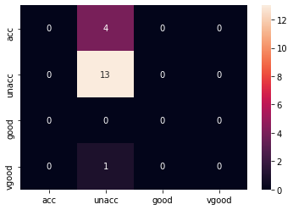

(Bhandari, 2020)

# Conclusion

The following can be concluded from the result on the algorithm implemented:

* Decision trees overfit data.
* Decision trees work best only with normalized data.
* Decision trees can be used for classification tasks.
* An increased depth of decision tree implies better performance.
* Decision trees require more percentage of total data to train.
* The misclassifications observed were as a result of abnormal data distribution.

# References

Bhandari, A. (2020). *Confusion Matrix for Machine Learning*. https://www.analyticsvidhya.com/blog/2020/04/confusion-matrix-machine-learning/

Bohanec, M. (1997). *UCI Machine Learning Repository: Data Set*. http://archive.ics.uci.edu/ml/datasets/machine-learning-databases/car/

Bohanec, M., & Rajkovič, V. (1988). KNOWLEDGE ACQUISITION AND EXPLANATION FOR MULTI-ATTRIBUTE DECISION MAKING *. *Proceedings of the 8th International Workshop ‘Expert Systems and Their Applications AVIGNON 88,’* *1*(Avignon 1988), 59–78.

Bohanec, M., & Rajkovič, V. (1990). DEX: An Expert System Shell for Decision Support *. *Sistemica*, *1*(1), 145–147.

Darlington, A. (2018). *Car Evaluation Data Set | Kaggle*. https://www.kaggle.com/elikplim/car-evaluation-data-set/version/1

Gopalan, B. (2020). What is Entropy and Information Gain? How are they used to construct decision trees? *Numpy Ninja*. https://www.numpyninja.com/post/what-is-entropy-and-information-gain-how-are-they-used-to-construct-decision-trees

Krekel, H. (2004). *pytest: helps you write better programs — pytest documentation*. https://docs.pytest.org/en/6.2.x/

Mitchel, T., & Balcan, M.-F. (2015). *Decision tree learning*. Machine Learning, Course 10-601. https://www.cs.cmu.edu/~bhiksha/courses/10-601/decisiontrees/

Mitchell, T. (2006). Machine Learning. In *Copyright*.

Strobl, C., Malley, J., & Tutz, G. (2009). An Introduction to Recursive Partitioning: Rationale, Application and Characteristics of Classification and Regression Trees, Bagging and Random Forests. *Psychological Methods*, *14*(4), 323–348. https://doi.org/10.1037/a0016973