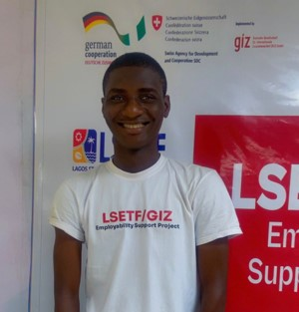
LAWAL IBRAHIM MAYOWA
Lagos State, Nigeria ibrahimlawal060@gmail.com | (+234)702-608-9954
PORTFOLIO :http://dev-iblawy-portfolio.netlify.app

EDUCATION B.Sc Sociology 2023

Ekiti State, Nigeria
Federal University Oye-Ekiti State

WORK EXPERIENCE WEBSITE MAINTENANCE (WORDPRESS) September 2025 EB Behavioral Health Clinic (Maryland, USA)

- Maintained and Updated the clinic’s WordPress website
- Enhanced website accessibility and improved overall user experience

CODING FACILITATOR - ByteTech (Part-Time) August 2025 Networking Academy
- Facilitated web development, training sessions for beginner and intermediate learners
- Mentored students in problem-solving and project development

CODING FACILITATOR - Haven Edu Services 2024 till date
- Teaching HTML, CSS, JavaScript,and react to students in coding bootcamps
- Created lesson materials and guided students through project-based learning
- Supported learners in building real-world applications

FRONTEND DEVELOPER - 8th Gear Hub Venture (Intern) 2024
- Collaborated with senior developer to build responsive web interfaces using React and Next.js
- Improved application performance and implemented UI enhancement
- Assisted in testing and debugging code across multiple devices

PERSONAL PROJECTS
➢ Currently building learn and connect, This is a web application design to revolutionize e-learning. A platform where students can learn and connect with their peers worldwide. I handled both the frontend and backend myself, using react, typescript and next.js. I used express.js for the server side, restful api (cors) for interrogation, middleware, and bcrypt for robust authorization and authentication and mongo db for efficient database management.

CERTIFICATION AND TRAINING

- National youth Service Corps (NYSC)
- Soft skill Certification of completion (LAG UP Youth skills) Program (GF Technology) 2024
- Web Design Certification of completion (GIZ) 2025

SKILLS AND INTERESTS Language: English (C1), German (A1)

Technical: Frontend developmental skills
HTML 5, CSS3,JavaScript,TypeScript,React,Next.js
Styling - Tailwind CSS, Responsive Design Tools - Git, GitHub, Figma, WordPress
Strong focus on creating clean scalable and user-friendly interfaces with seamless user experience.

Backend developmental skills
JavaScript,TypeScript, Node.js, Express.js
Database - MongoDB (Mongoose,ORM, CRUD operations)
API development : RestFul, API design and integration
Authentication and Security : JWT, Bycript, middleware handling
Tools : Postman, Git, GitHub,Render, Vercel
Committed to building efficient, secure and maintainable backend systems.
Professional: Problem-solving, good adaptability,time management, design thinking,effective communication, teamwork, conflict management
Interests: Football, Fitness, Reading, Trading and investments, Sustainability

REFERENCES

AVAILABLE ON REQUEST

