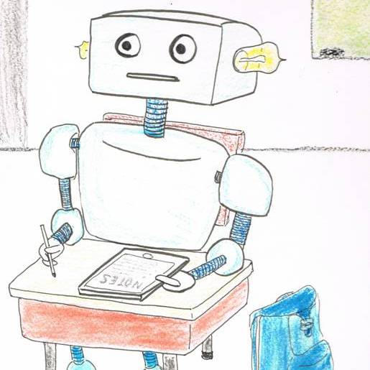
Kleine Bayessche AG

Ingo Blechschmidt


spricht am

Donnerstag, den 9. Juli 2015

um

14:00 Uhr

im

Raum der Wünsche
(oder sonst wo)

über das Thema:

Automatic Differentiation

Automatic differentation is the technologymagic which, given code to evaluate a function f : ℝ → ℝ, automatically gives you code to evaluate the derivative f' : ℝ → ℝ. This automatically generated code suffers from rounding errors of course, just as any numerical code does. But unlike with the naive approach of using the difference quotient, the results obtained by automatic differentiation are almost always very good, while the results obtained by using the difference quotient are rubbish.

The talk will give an introduction to automatic differentiation, including some remarks about its quirky history: The ideas behind automatic differentiation were discovered 300 years ago, then forgotten, and rediscovered some 30 years ago. Despite its great power and versatility, automatic differentiation is astoundingly easy to understand and implement. The talk will therefore have no prerequisites at all.

Dazu sind alle Interessierten herzlich eingeladen.
Kaffee, Tee und Gebäck während des Vortrags.

Weitere Vortragsplanung: http://bag.speicherleck.de/

