Contents

Employee Demographics 1

1. What are the most common education levels and fields of study among employees? 1

Geographic Analysis 1

2. How are employees distributed across different states? 1

Job and Role Insights 1

3. What are the largest and smallest departments in terms of employee count? 1

Salary and Benefits 1

6. What is the overall salary distribution? 1

7. Are there salary disparities based on gender, ethnicity, or location? 1

8. Is there a relationship between education level or field and salary? 1

Attrition Analysis 1

9. Does attrition vary by gender, marital status, or age group? 1

10. How does business travel frequency affect attrition? 1

11. What is the average tenure of employees who leave compared to those who stay? 1

12. Is there a relationship between overtime and attrition? 1

Performance and Tenure 1

13. What percentage of employees have not been promoted in the last 5 years? 1

14. Do employees with higher education levels stay with the company longer? 1

Other Relationships 1

15. Does distance from home influence attrition or performance metrics? 1

16. Are employees who work overtime compensated differently or promoted more frequently? 1

General Trends 1

17. Are there any trends in salary, promotion, or attrition based on hire date? 1

## Employee Demographics

### 1. What are the most common education levels and fields of study among employees?

Out of 1470 Employees, 69.3% of employees have a college degree. The two largest job roles are Sales Executive and Software Engineer with 22.2% and 20.0% of employees.

## Geographic Analysis

### 2. How are employees distributed across different states?

There are three different states where employees reside, 60% live in California. Illinois has 12% and 28% in New York.

## Job and Role Insights

### A pie chart with numbers and a few words Description automatically generated3. What are the largest and smallest departments in terms of employee count?

The largest Department is Technology and smallest is human resources

4. Which job roles have the highest average salaries?

Top three average salaries are HR Manager, Analytics Manager, Manger and with $449,330, $346,484, and $317,531 respectively.

5. What is the average number of years employees spend in their current role or with their current manager?

The average number of years an employee spends with their current manager is 2.24 years

## Salary and Benefits

### 6. What is the overall salary distribution?

|  |  |  |  |  |  |
| --- | --- | --- | --- | --- | --- |
| Pay Range | | Count | % overall | Attrition | Attrition Distro |
| $ - | $ 25,000 | 59 | 4% | 21 | 9% |
| $ 25,000 | $ 50,000 | 414 | 28% | 96 | 42% |
| $ 50,000 | $ 75,000 | 295 | 20% | 42 | 18% |
| $ 75,000 | $ 100,000 | 171 | 12% | 25 | 11% |
| $ 100,000 | $ 125,000 | 107 | 7% | 10 | 4% |
| $ 125,000 | $ 150,000 | 78 | 5% | 11 | 5% |
| $ 150,000 | $ 175,000 | 43 | 3% | 4 | 2% |
| $ 175,000 | $ 200,000 | 53 | 4% | 5 | 2% |
| $ 200,000 | $ 225,000 | 38 | 3% | 5 | 2% |
| $ 225,000 | $ 250,000 | 43 | 3% | 5 | 2% |
| $ 250,000 | $ 275,000 | 33 | 2% | 3 | 1% |
| $ 275,000 | $ 300,000 | 23 | 2% | 2 | 1% |
| $ 300,000 | $ 325,000 | 29 | 2% | 2 | 1% |
| $ 325,000 | + | 84 | 6% | 0 | 0% |

### 7. Are there salary disparities based on gender, ethnicity, or location?

It is apparent that living in a different state does not have a disparity, initially it looks like there is a large disparity between the genders, after drilling down there is 1.361% that skew the results with a boost of over $14,000 the next value. That would bring it down to $2,500 difference in the average instead of $16,000.

### 8. Is there a relationship between education level or field and salary?

The best degree of study would be human resources where it is almost $20,000 more than the next field of study. There is a difference of $50,000 between the highest and the lowest field of study. With the least being Technical Degree with an average salary of $95,000.

With in the level of education there is a $60,000 difference between a doctorate and having no formal education. However the difference between Bachelors and Masters is a difference of $2,250. And the difference of $36,600 between Masters and Doctorate.

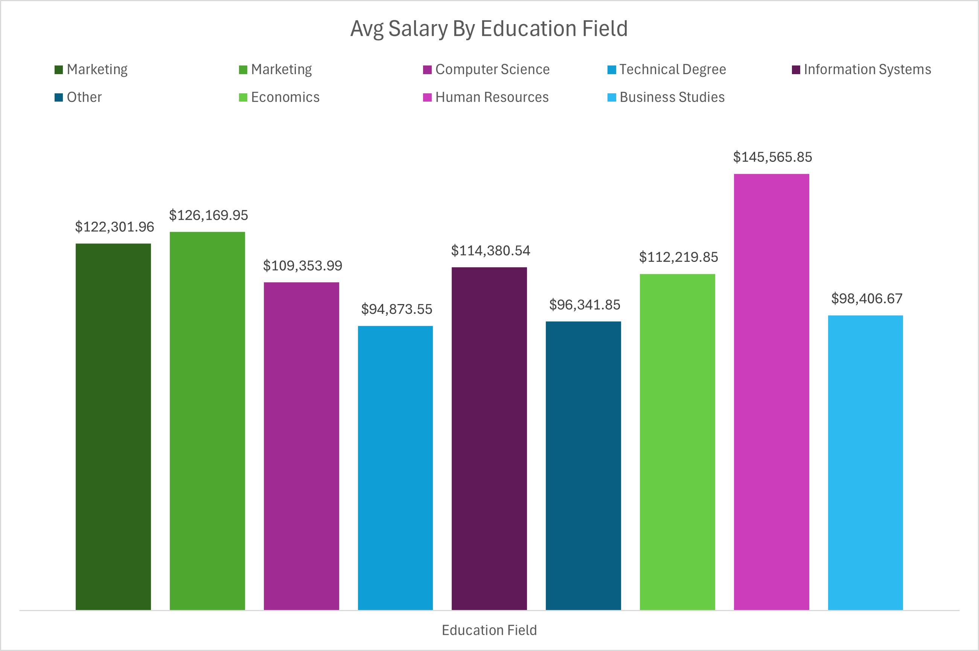

## Attrition Analysis

### 9. Does attrition vary by gender, marital status, or age group?

Attrition by Gender is quite related all between 3% difference, with an outlier of with 100% but that is out of 20 people and the rest have over 100 responses.

Attrition by Marital Status does have a range of 13% with 23% being single and divorced being 10%.

Attrition by Age Group attrition levels drop towards the upper end of the group. The lower end of the group has around a 19% attrition and the upper limit of 7%.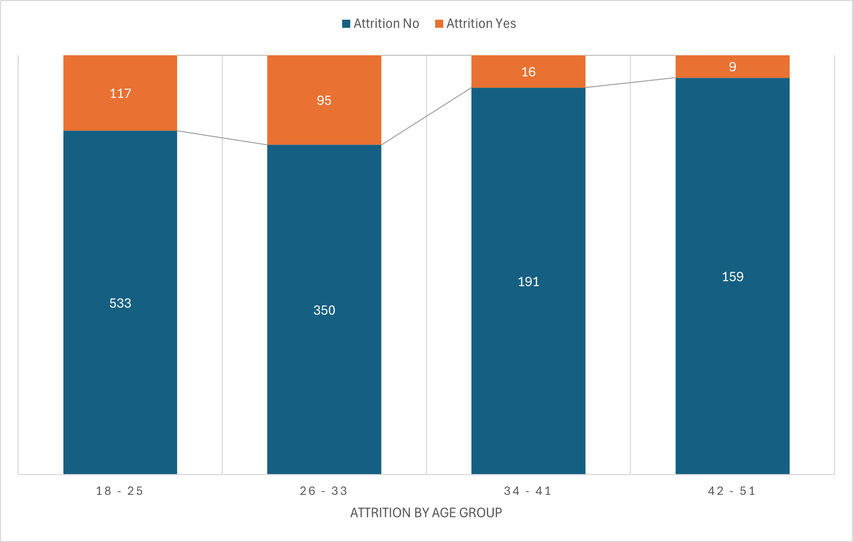

### 10. How does business travel frequency affect attrition?

Yes with the data evidence shows there is a clear correlation between travel and no travel. There is a 17% difference between those that travel and have attrition and those that do not travel and have attrition. With travel and attrition there a 25% yes response.

### 11. What is the average tenure of employees who leave compared to those who stay?

The average tenure of employees is just under a year at 0.991 years. With 140 employees leaving within the first year and 46 after the year mark, making up almost 80% of those that leave.

### 12. Is there a relationship between overtime and attrition?

There is a 90% increase in those responding that have attrition with working overtime vs the average of the total number of employees

## Performance and Tenure

### 13. What percentage of employees have not been promoted in the last 5 years?

34% have not been promoted within the last five years.

### 14. Do employees with higher education levels stay with the company longer?

The turnover rate is quite high, while those with the highest level of education stay longer by education group, they only represent 3% of the company overall. With the outlier removed, those with high school or lower education are higher than those with a masters or bachelors.

|  |  |  |  |  |
| --- | --- | --- | --- | --- |
| No Formal | High School | Bachelors | Masters | PHD |
| 4.74 | 4.98 | 4.51 | 4.21 | 5.00 |

## Other Relationships

### 15. Does distance from home influence attrition or performance metrics?

No, there is a difference of 3% over the total range of distance. Surprisingly the highest is the 1-9km range.

### 16. Are employees who work overtime compensated differently or promoted more frequently?

With the data recovered it does not show a significant correlation between overtime and compensation or pay. The difference between overtime is $2,000

## General Trends

### 17. Are there any trends in salary, promotion, or attrition based on hire date?

* As the years progressed the company started to promote people quicker.
  + This does not count if someone was promoted multiple times but seems like it would be within calculated range.
* The Attrition rate was within 6% either way based on year and how long someone has worked at the company. This could still be considered within the range of margin of error.
* Pay does show that they minimum pay has decreased sense inception of the company and the average pay rate has decreased overtime
* There is a 41% decrease on the average pay in the last 10 years