## Project Background

Insights and recommendations are provided in the following areas.

* Attrition Rates
* Pay to Attrition
* Overtime to Attrition
* Education To Attrition
* Age to Attrition
* Travel To Attrition
* Turnover Rate
* Promotion to Attrition
* Decrease in pay and how that can relate to attrition

Link out to technical

## Executive Summary

* The highest driver for leaving is overtime. 1/3 of employees that work overtime leave the company compared to 1/10 of employees leaving the company that do not work overtime.
* Employees that frequently travel for work will leave 25% of the time, compared to those that do not travel at 8% attrition. Those with light travel leave near the middle at 15%
* Those that are higher educated leave the company quicker than those with high school or lower.
* Those that are marked as single are more likely to leave the company as well as those between 18-33 are more likely to leave by over double their opposite groups respectively.

## Data Structure Overview

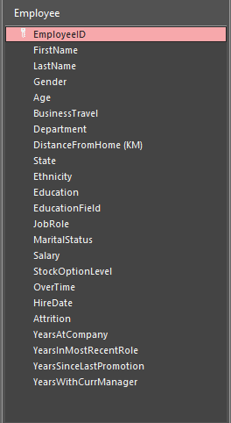

## Insights

### Distance to Attrition

15. Those that live farther away from the business are no more likely to leave the company than those that are 10km away. The group that is most likely to leave are those that live within a distance range of 1-9km.

### Education and Tenure

14. The average length of time that an employee stays with the country is 4.69. The only groups that stay longer than this are those with No Formal Education, High School Diploma, and PHD’s. Both the Bachelors and master’s on average leave sooner than this. The number of those with a PHD are far lower than the rest of the employee base making this an outlier.

|  |  |  |  |  |
| --- | --- | --- | --- | --- |
| No Formal | High School | Bachelors | Masters | PHD |
| 4.74 | 4.98 | 4.51 | 4.21 | 5.00 |

### When On Leaves

11. For those that leave the company an employee tends to leave in 1.5 years at the company.

### By Travel

10. When looking at the attrition rate to travel those that travel frequently have a 25% chance of leaving, any type of travel has a higher likelihood of leaving with 8% of those that do not travel leaving the company, then almost doubling that with some level of travel being 15% and 25% for those that frequently travel.

### Overtime to leave

12. For those that work overtime leave at a rate 1/3 of those that work overtime compared to 1/10 who do not work overtime. Compared to the company average at 16% to be double.

### Age Group

The younger demographic tends to leave the company more often than those in the elder group of the company. Over 34 shows a 100% decrease in from under 34.

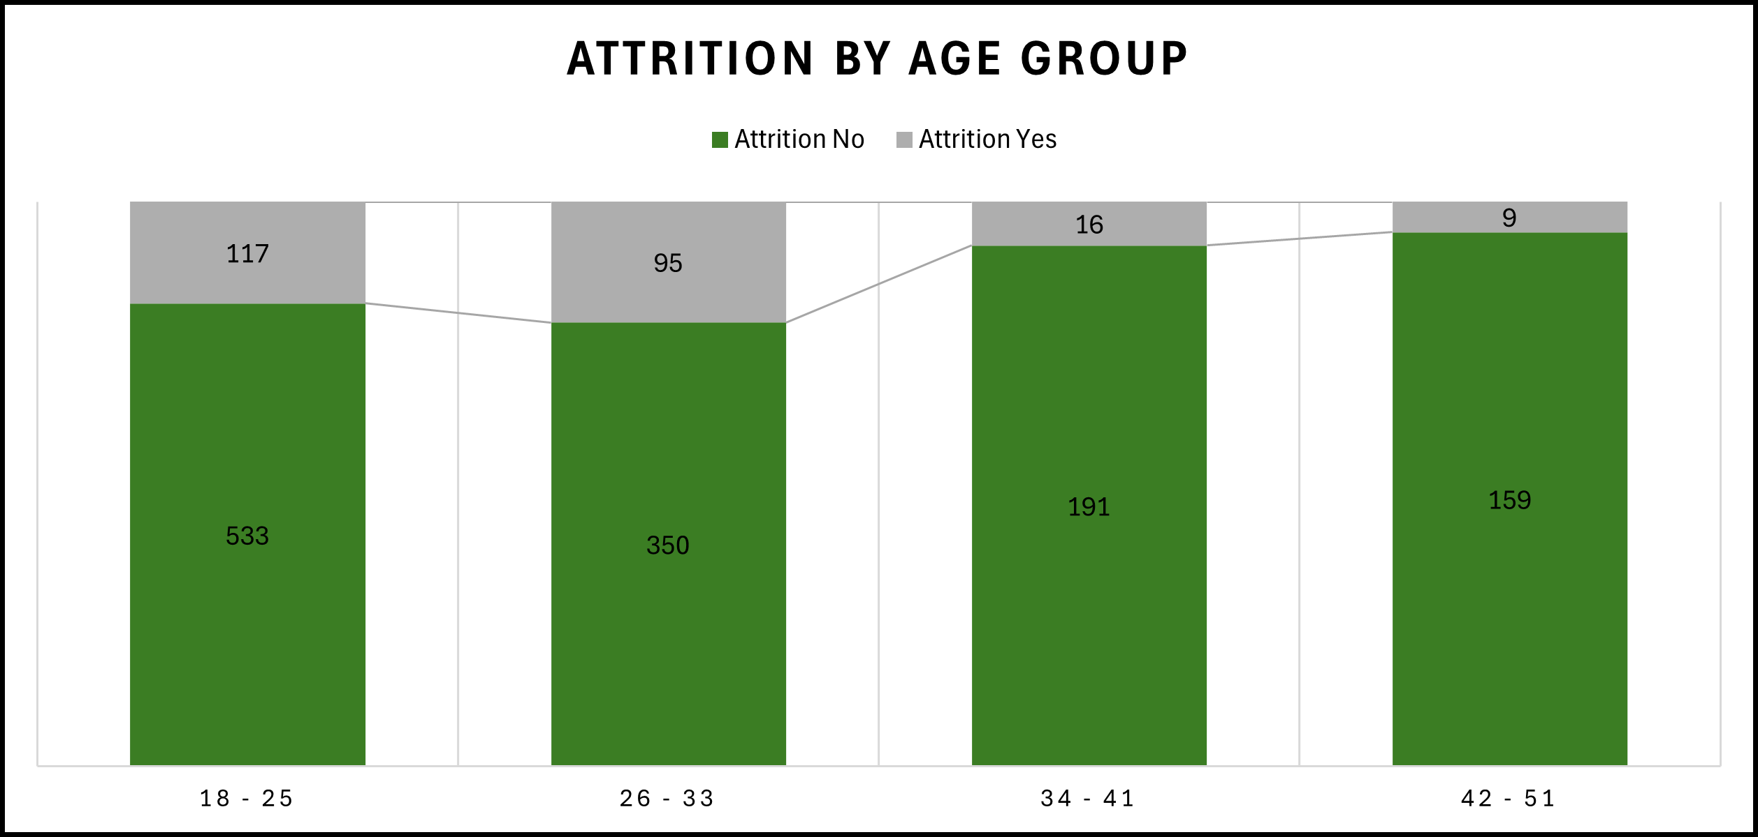

### Attrition by Marital Status

Those with a single relationship status have the highest rate of attrition.

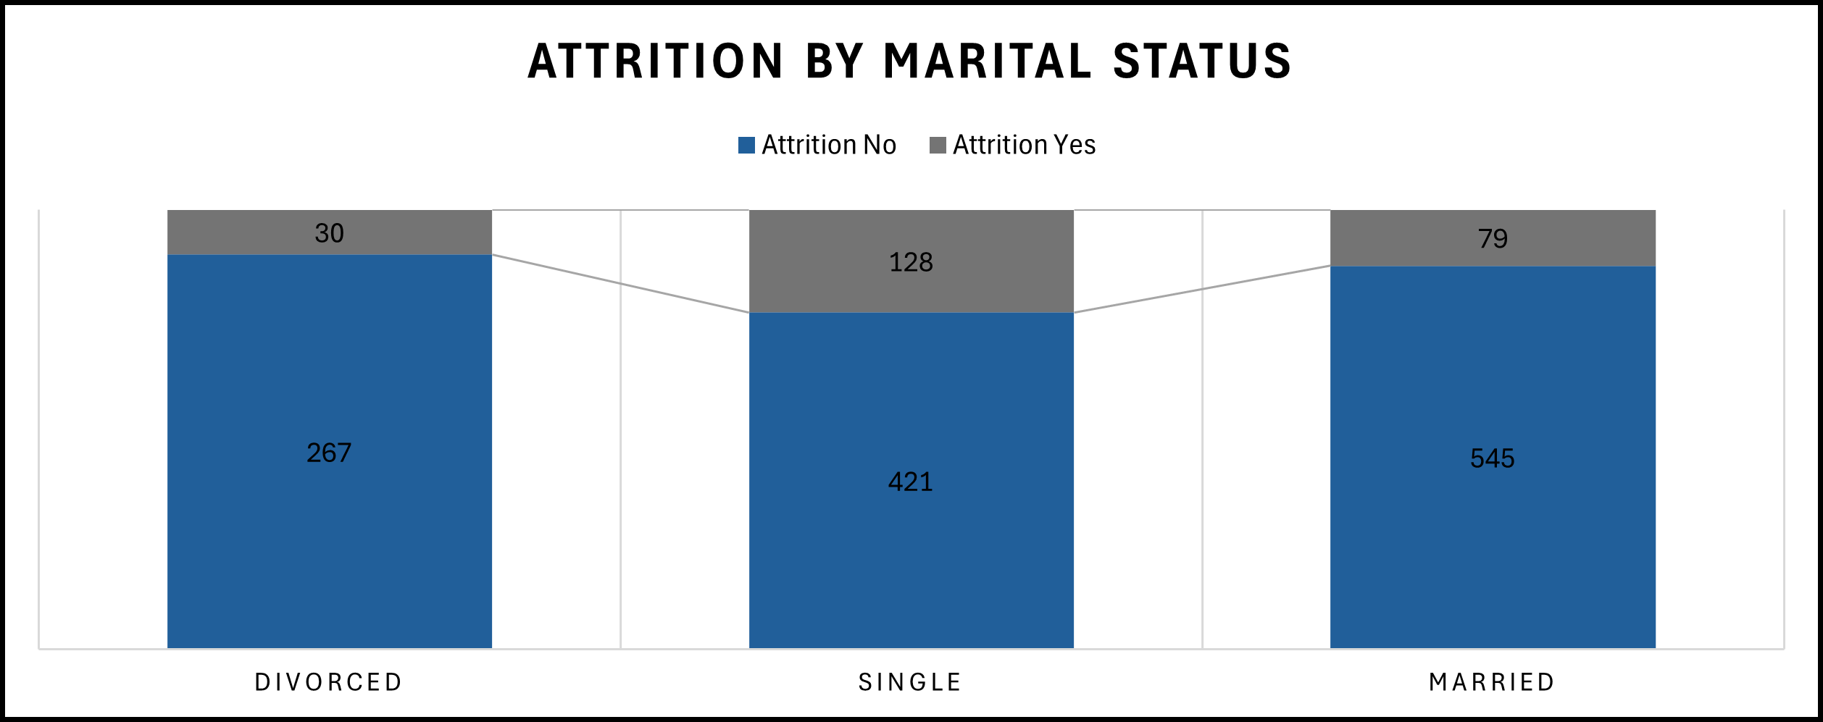

## Recommendations

1. Looking at factors that lead an employee to leave, the recommendations would be to look at overtime and try to cut back on how many employees work overtime hours.

2. Requiring less travel for a position can retain more employees and place that on jobs titles that are higher in the company.

3. Hiring employees that are younger and married or divorced or older in age can lead to longer tenure at the company.