2

|  |  |  |  |
| --- | --- | --- | --- |
| eso-logo | European Organisation  for Astronomical  Research in the  Southern Hemisphere | Organisation Européenne  pour des Recherches  Astronomiques  dans l’Hémisphère Austral | Europäische Organisation für astronomische  Forschung in der  südlichen Hemisphäre |

**AUSTRIAN In-Kind Contribution**

|  |
| --- |
| **MOLECFIT: Graphical User Interface and Tutorial** |
|  |
| VLT-MAN-ESO-19550-5928 Issue 1.3 |
| 26th September 2017 |

|  |  |  |  |
| --- | --- | --- | --- |
| Owner | Innsbruck ESO In-Kind Team | 22/09/2013 |  |
| Approve | ***TBF*** |  |  |
| Release | ***TBF*** |  |  |
|  | Name | Date | Signature |

CHANGE RECORD

|  |  |  |  |
| --- | --- | --- | --- |
| ISSUE | DATE | SECTION/PARA. AFFECTED | REASON/INITIATION DOCUMENTS/REMARKS |
| 1.0 | 31/07/2013 | All | Initial issue |
| 1.1 | 26/09/2013 | 2., 4.Tutorial | Added information requested during final review (RIXes ASM#11, PBA#4) |
| 1.2 | 01/04/2014 | All | General Update |
| 1.3 | 26/09/2017 | All | General Update |
|  |  |  |  |
|  |  |  |  |
|  |  |  |  |
|  |  |  |  |
|  |  |  |  |
|  |  |  |  |
|  |  |  |  |
|  |  |  |  |
|  |  |  |  |
|  |  |  |  |

The Authors of the Austrian ESO In-Kind Team Innsbruck:

Stefan Kimeswenger

Wolfgang Kausch

Stefan Noll

Marco Barden

Cezary Szyszka

Amy M. Jones

Institute for Astro- and Particle Physics, University of Innsbruck  
Technikerstr. 25/8, A-6020 Innsbruck / Austria

The authors of the European Southern Observatory:

Alain Smette

Andrea Mehner

Sabine Möhler

Gurvan Bazin

European Southern Observatory, ESO Headquarters  
Karl-Schwarzschild-Str. 2, 85748 Garching bei München / Germany

This page was intentionally left blank

# Content

1 2

Content 4

1 Introduction 5

1.1 Purpose and Overview of the Document 5

1.2 Overview of the Project 5

1.3 Applicable Documents 5

1.4 Abbreviations / Acronyms 5

2 The Reflex workflow 6

3 The GUI Interface 7

3.1 The Main Window 7

3.2 The Menu and the Action Buttons 10

3.2.1 File Menu 10

3.2.2 Mask Tool 11

3.2.3 Molecule Selection 12

3.2.4 The Wavelength Correction 13

3.2.5 Resolution and Fitting Kernel 14

3.2.6 Continuum 16

3.2.7 Background 16

3.2.8 Menu: Selection🡪Working Directory and Files 17

3.2.9 Menu: Selection🡪Other Settings / Preferences 18

3.2.10 The Console 18

3.3 The fit 20

3.4 Apply Correction 20

4 Tutorial 22

5 Software requirements / reference software versions 27

# Introduction

## Purpose and Overview of the Document

This document describes the use of the Graphical User Interface (GUI) and its REFLEX plug-in [reflex] for the molecfit programme. It is intended as a tutorial for the usage of this tool and the underlying programmes with some tips and tricks for obtaining good fits. The incorporated algorithms, a complete description of the parameters, and technical details on the input data format are described in the *Molecfit User Manual* [mUM].

## Overview of the Project

Molecfit fits a small number of telluric lines (i.e., lines originating in the Earth’s atmosphere) appearing in an input spectrum (either science or telluric standard star) to derive a telluric transmission spectrum for the whole spectral range of the input spectrum. It can then be to correct these features from the input spectrum or a series of spectra of astronomical targets obtained in similar conditions. The molecfit package is a development of an IDL prototype by A. Smette (ESO). Users of molecfit are requested to cite [Smette+15] and [Kausch+15].

The REFLEX workflow is intended to be part of any larger general purpose tool. It enables a user to define an initial set of parameters, and calls the Graphical User Interface (GUI) for optimizing the fit.

The GUI is written in python. As python is highly variable and modifiable, the developers tried to restrict it to a minimal set of instructions. The graphical tools matplotlib [mpl] and wx.Widgets [wxW] were used to implement the graphical interface. Numerical calculations are supported by the NumPy [NP] package. The FITS I/O is based on the astropy package [AstroPy].

## Applicable Documents

* [reflex] Reflex User Manual, rev. 3.8, VLT-MAN-19000-5037
* [Kepler] <https://kepler-project.org/>
* [mUM] Molecfit User Manual, VLT–MAN–ESO–19550-5772
* [mpl] Matplotlib: A 2D graphics environment
* Hunter, J.D., Comp. in Sci. & Eng., vol. 9/3, p90-95 (2007)
* and <http://www.matplotlib.org/>
* [wxW] wxWidgets 2.8.12: A portable C++ and Python GUI toolkit
* Julian Smart, Robert Roebling, Vadim Zeitlin, Robin Dunn, et al.
* March, 2011, <http://www.wxwidgets.org/>
* [NP] <http://www.numpy.org/>
* [AstroPy] <http://www.astropy.org/>
* [mpl-users] [matplotlib-users@lists.sourceforge.net](mailto:matplotlib-users@lists.sourceforge.net)
* [Smette+15] Smette et al. 2015, A&A 576, A77
* [Kausch+15] Kausch et al. 2015, A&A 576, A78

## Abbreviations / Acronyms

ASCII: American Standard Code for Information Interchange

CPL: Common Pipeline Language

CRIRES: CRyogenic high-resolution InfraRed Echelle Spectrograph

FITS: Flexible Image Transport System

GDAS: Global Data Assimilation System

GUI: Graphical User Interface

HITRAN: high-resolution transmission (database)

IDL: Interactive Data Language

I/O: input / output

IR: Infrared

LNFL: Line File

LBLRTM: Line By Line Radiative Transfer Model

NOAA: National Oceanic and Atmospheric Administration

PDF: Portable Document Format

PNG: Portable Network Graphics

VISIR: VLT Imager and Spectrometer for mid Infrared

# The Reflex workflow

The molecfit package includes a workflow based on REFLEX >v2.5 [reflex]. By installing the molecfit package with the installation script, the workflow is located in the directory <INST_DIR>/reflex. After starting the Reflex environment, the molecfit Reflex workflow can be loaded via the menu File 🡪 open. In the file selector box select the directory given above and select the file molecfit_reflex.xml. This opens the X-Shooter VIS arm example from the test set, which can be directly started.

Figure 1 shows the canvas of the Reflex workflow of molecfit. There are four main sections:

1. Input / Output parameters: to define the general input and output parameters;
2. Fitting parameters (see [mUM] for a comprehensive description): to define the parameters used for the fit of telluric lines in the inclusion regions;
3. Workflow instructions: to provide a quick help;
4. Workflow: to show the actual workflow with the Kepler (see [Kepler]) actors.

The parameters can be modified by a double click on the parameter’s name. There is no verification of that all parameters are consistent and compatible with the molecfit base code at this stage. We therefore recommend reading the [mUM].

After setting all required I/O and fitting parameters, press the run button  in the Reflex main toolbar. This writes an internally used parameter file corresponding to the user defined parameters, and invokes the GUI, which provides comprehensive possibilities to plot and iteratively running the molecfit base code to obtain a best fit.

# The GUI Interface

The GUI can be started independently from Reflex with the command molecfit_gui. This executable is installed into the same directory as the molecfit binary (<INST_DIR>/bin/ with <INST_DIR> being the directory used as installation path [mUM]).

The command molecfit_gui accepts one optional parameter: the name of a specific parameter file.

## The Main Window

The main window contains (from top to bottom; see Fig. 2): a menu bar with submenus, a region with the action buttons, guiding through the procedure step by step, a central plot area based on matplotlib and including a matplotlib specific toolbar at its lower left corner, a settings area containing checkboxes to activate/deactivate display features, a coordinate information box (if applicable), a file info region about the currently displayed data, and a tooltip line for short descriptions of elements (if applicable).

Once a spectrum is loaded (see section 4.6 of the User’s Manual for more information about the format of the spectrum), a graph with the raw input data (in black) is displayed in the plot area.

The coordinate information area shows continuously the coordinates of the mouse position in the graph. It provides the x,y coordinates (in world coordinates of the frame) of the mouse pointer, the pixel number (starting from 1) of the underlying data, and the data value at this pixel.

The checkboxes can be used to switch on/off an already calculated fit (in red - if applicable) and the difference data-fit (in blue – if applicable).

Defined masks can be shown in an overlay plane by activating the corresponding check boxes (red: exclusion masks defined by wavelength range; orange: exclusion masks defined by chip pixels) and the fitting regions (inclusion - green).

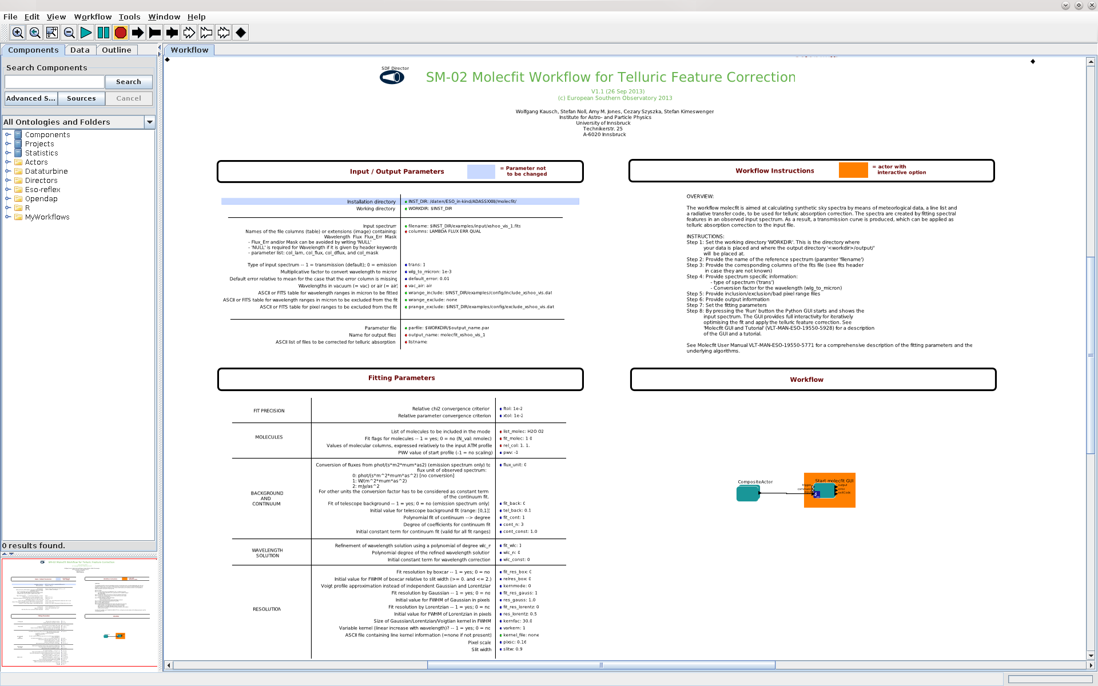

Figure 1:The molecfit Reflex canvas

|  |
| --- |
| *file information*  *tooltip(s)*  *coordinate information*  *checkboxes*  matplotlib *toolbar*  matplotlib *plot area*  *menu*  *action buttons* |
| **Fig. 2:** The layout of the main GUI window. |

|  |
| --- |
| **HOME BACK FORWARD MOVE ZOOM subplot SAVE** |
| **Fig. 3:** This matplotlib toolbar is displayed below all plotting areas of the GUI. |

The main operations triggered by the toolbar buttons are the following:

* Clicking on the HOME button redraws the original screen, layout, and plot zoom.
* Clicking the BACK and the FORWARD buttons un- or re-does the last operation.
* Clicking on the MOVE (cross arrow) button activates the MOVE functionality: the plot can be moved and shifted by holding down the left mouse button in the plot area. The mode is deactivated by clicking on the MOVE button again.
* Clicking on the ZOOM button activates the ZOOM functionality: the region to zoom is defined by holding down the left mouse button while moving; this region appears as a rubber band. On the other hand, executing the same operation by holding down the right mouse button reverses the scale; a small region corresponds to a significant zooming out.
* The subplot button allows a modification of the (sub)plot layout. This might be useful before exporting the plot as image.
* The SAVE button opens a file selector box allowing an image export. As the driver is part of the matplotlib, the possible formats depend on the installed version. As a minimum, the Portable Network Graphics (PNG) format is provided (see [mpl]).

NOTE: If either the MOVE or ZOOM functionality is activated, most of the other interactive operations of the GUI / matplotlib and their application (e.g. defining new masks, measuring data values, …) are disabled by the plot library.

The matplotlib plot areas, used in this GUI, are described in more detail in [mpl].

## The Menu and the Action Buttons

The main actions for the use of the fitting procedure and correction of the input file are available in both the menu bar and the action buttons on top of the plotting area. The main settings and preferences can be set in the menus. The help menu (“?”) activates a PDF viewer for the main molecfit documentation [mUM] and for this tutorial document.

### File Menu

The file menu loads pre-defined molecfit configuration files to the GUI. For this purpose, the standard file selector box of the system is opened. Its appearance depends on the settings of the user’s window manager and theme.

The selected directory starts from the working directory and filters files with the extension recommended by molecfit (“.par”) by default. The use of this extension is not a requirement.

A parameter file can also be saved (exported) using the file menu. “*Save*” saves and overwrites without further interaction the current one. In any case, a copy with the extension “.bak” is made before. “*Save As*” offers the opportunity to select a different file name; it queries before overwriting an existing file.

One of these save operations is **always** required **before** you start a FIT or APPLY the telluric correction. If it has not been done before starting any of these actions, the user is asked for it by default.

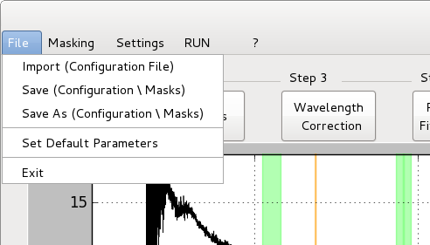

|  |
| --- |
|  |
| **Fig. 4:** The *File* pull-down menu |

It is also possible to set a “*default parameter set*”. As the wide variety of instruments, pipelines, and self-made software allow for infinite degrees of freedom, some parameters must be set in *Settings🡪Working Directory & Files* and in *Settings🡪Other Settings / Preferences*. In addition, it is likely that the shape of the line spread function and the fitting kernel parameters must be adjusted by the user. Setting “*default parameters*” applies only for the content of the GUI and thus still requires a “*Save …*” operation before invoking the underlying molecfit code.

### Mask Tool

The Mask tool allows the user to edit (manually or interactively) the masks. We give a quick overview of the mask definitions used by molecfit (for further details refer to [mUM]):

Inclusion regions (aka: fit regions – wrange_include) define the regions in which spectral features are fitted. If the default none is given, the whole spectral range of the input spectrum not covered by exclusion masks is used. However, in most cases, it is sufficient to select small spectral regions which allow for (1) a good determination of the column density of each of the molecules affecting the input spectrum and (2) the shape and parameters of the line spread function, if it is not fixed or provided. Therefore, ideally, the spectral regions should cover unsaturated lines and avoid spectral features which are intrinsic to the spectrum of the science target. In addition, large regions without any telluric features may dominate the ² and therefore provide poor constraints on the parameters to determine. Moreover, too large fitting ranges make the code very slow and can cause an unsatisfactory continuum fitting by low order polynomials. Note that exclusion regions have higher priority (see below). This means that in case of an overlap of inclusion and exclusion regions, the overlap part of the inclusion region will not be used for the fit.

Exclusion masks defined in the wavelength regime (aka: wavelength exclusion wrange_exclude) are used to define exclusion regions, which are motivated by physical problems, e.g. regions of (expected) stellar features of the target or completely opaque regions of the atmosphere. Exclusion masks overrule inclusion masks. It is only useful to define exclusion regions within the inclusion regions.

Pixel exclusion masks (prange_exclude): These are used due to technical reasons, e.g. bad pixels of the detector. Some pipelines provide them with the spectrum data. In this case, they are read from the FITS file (as ‘mask’ column in the fits file). It is only useful to define exclusion regions within the inclusion regions.

|  |
| --- |
|  |
| **Fig. 5:** The Mask Tool after definition of several masks. The colour coding is the same as described for the section for the main window. |

A new mask can be defined by using the mouse. First, select the type of the region by activating the corresponding check box (‘Enter Fit EDIT MODE’ or ‘Enter Mask EDIT MODE’). ***Click & Drag*** (keeping the button down) with the **LEFT** mouse button then creates a new mask. During dragging, the mask region is displayed (independent of the type) in light blue and turns to the corresponding colour as soon as the mouse button is released.

An existing mask can be edited by a **RIGHT** mouse click on a region (in case that there is no region defined at this position, the closest one is selected automatically). This opens a pop-up window.

The edit pop-ups allow the user to modify the region by directly inserting numbers for wavelength (or where applicable pixels), delete the whole mask, and, in case of the exclusion mask, to toggle them between *wavelength* and *pixel* mode. *The change is only forwarded to the code (and refreshed in the plot) when the SAVE button is activated.* The edit window does not have to be closed in order to change (by right button mouse click events) to another mask. The content of the window is automatically refreshed. However, unsaved changes are lost.

NOTE: Masks are not automatically exported / written to the mask files. This is done when saving the parameter files and activating the FIT. The mask files are defined in *Settings🡪Working Directory & Files.*

|  |
| --- |
|  |
| **Fig. 6:** The three different appearances of the mask edit window |

### Molecule Selection

The user can select seven main molecules for calculation and also options for ² fitting by the molecule pop-up menu. The numerical values correspond to abundances relative to those of the calculated for the used atmospheric profile. If the fit option is activated, these abundances are used as initial guess only. The final model values are defined by the fit itself. In the GUI, telluric lines caused by trace gases can only be calculated with the abundance given in the corresponding atmospheric profile. If needed, abundance for these gases can be fitted using the command line version.

Only molecules which have spectral features in the inclusion regions should be selected with the fit option checked. One can determine if a given molecule causes lines in a given region either by examining Figure 1 of Smette et al. 2015, or Figure 18 and following of the [mUM]; alternatively, another method is to select only this molecule with relative abundance of 1 (or larger) and only for calculation.

If weak features near major ones should be fitted, a two-step approach might be needed. As a first step, the fit should only include the molecules contributing to the largest features. As a second step, set the derived relative abundance values and uncheck the fit option for these molecules, then select the molecules causing the weakest lines and check the fit option.

|  |  |
| --- | --- |
|  |  |
| **Fig. 7:** The selection of the molecules. The main molecules allow ² fitting (left panel). The subpanel (right), opened by the button “trace gases”, allows the calculation of the molecules by selecting the abundance relative to the reference atmosphere. | |

### The Wavelength Correction

The wavelength correction (if activated) of molecfit is a robust and sophisticated algorithm. In the GUI, the user can only modify the selection of the Chebyshev polynomial degree and the selection of an initial offset (0th order parameter for a shift of the zero point of the wavelength calibration) Note that the wavelength correction is determined for the whole spectral range and only used for the fitting part; see [mUM] for more details, in particular for the meaning of the fitted values.

|  |
| --- |
|  |
| **Fig. 8:** The user controllable parameters for the wavelength correction |

### Resolution and Fitting Kernel

The line spread function (LSF) of the spectrograph strongly influences the ² values and thus the fit quality (see the [mUM] for details). The user is able to select and possibly combine a boxcar function (especially for narrow slits compared to the target extension) with Gaussian and Lorentzian shaped functions. In case of combined Gaussian + Lorentzian kernels, a Voigt approximation can be selected in most cases to speed-up calculations. The maximum width of the kernel used for the line profile convolution might influence the fit of strong features in spectrographs of very high resolution.

The option “variable with wavelength” activates a linear dependence of the width of the line spread function with wavelength. This might be useful for an echelle spectrograph with very wide wavelength coverage (e.g. X-Shooter). In this case, such behaviour is expected by the physics of the gratings / grisms.

The user can also provide a kernel defined in a file, in which cases, all other parameters are ignored. The file can either include the values of a constant line spread function for the all spectral range, of the values of the line spread function for each pixel of the input spectrum.

|  |
| --- |
|  |
| **Fig. 9:** The user controllable parameters for the line spread function / fitting kernel |

### Continuum

The fitting of the local continuum is solved robustly in the molecfit code itself for each of the inclusion regions. The user can switch on / off the continuum fit, provide a constant factor (0th order), and the degree of the polynomial. If the data is not normalised to continuum at unity, active fitting of the offset constant is absolutely required*. It is important that the offset constant be of comparable order of magnitude as the spectra*. For example, if the spectrum is of the order of 10-16 (in whatever units), molecfit will likely fail to provide a good fit if the offset constant is left to its default value of 1.

|  |
| --- |
|  |
| **Fig. 10:** The user controllable parameters for the continuum model. |

### Background

The telescope background emissivity is produced after the light has passed the atmosphere and is therefore not affected by molecular absorption. Thus, its contribution is only relevant when fitting sky emission spectra in the thermal infra-red. It is modelled as grey body with a user definable emissivity value (typically 10% to 20%).

|  |
| --- |
|  |
| **Fig. 11:** The user controllable parameters for the telescope background model. |

### Menu: Selection🡪Working Directory and Files

In this section, various settings for the used files and their internal structure can be modified / set. The base working directory is normally selected automatically by the starting command of molecfit_gui; alternatively, it can be changed by modifying the value of the ‘Base WORKING directory’ field. All results produced by molecfit are written to <working directory>/output/.

A different FITS input spectrum than the one defined in the parameter file loaded at the beginning can be selected by modifying the ‘Spectrum’ field.

The four parameters of the FITS file structure give the names of the image extensions (FITS image file) or columns (FITS binary table file). These cannot be auto-detected due to the wide variety of pipeline products. In the case of FITS images, the ‘Wavelength’ field should be set to NULL if the wavelength grid is provided by FITS header keywords. If the flux data is located in the primary data unit, the ‘Flux’ field should also be set to NULL. For errors and masks, the entry NULL means to switch off their use. To load the content also to the GUI, the use of the corresponding “read / import …” button is required.

|  |
| --- |
|  |
| **Fig. 12:** Parameters for the paths, filenames, and structure of the FITS files |

Three parameters deal with the fit region and mask files. The option ‘none’ is used if you do not want to use them. At the start of a fit, these parameters are checked against the existing masks and the user is prompted in case of discrepancy. If you want to force the masks to be read to the GUI, the button ‘read / import from files to GUI’ can be used.

The ‘Root name for the output files’ field defines a prefix which is added in front of all result files. A description of the results can be found in [mUM].

### Menu: Selection🡪Other Settings / Preferences

This selection box is used for all other parameters. A detailed description is available in [mUM].

In most cases, the user should only provide the factor by which the wavelength in the input spectrum should be multiplied so that it is expressed in µm, whether wavelengths are given in air or vacuum, and the instrument pixel scale on the sky – if the box car line spread function is chosen.

|  |
| --- |
|  |
| **Fig. 13:** Other parameters not covered before |

### The Console

The GUI provides a console window which shows the output of the underlying code.

|  |  |  |
| --- | --- | --- |
|  | | |
| **Fig. 14:** Molecfit GUI with its Console during an active fit | | |
|  | | |
| The Console can also be used to display (or return to) the last result file (‘.res’ file, e.g. molecular abundances), last log of a FIT, a ‘last APPLY log’ or a log of prepguitable (used to prepare data for the GUI display) to analyse errors and results.  It further allows to display the currently stored complete configuration file, and to compare it to the current (un-stored) settings in RAM of the GUI. The comparison is done by the UNIX diff command and thus may vary in its layout from distribution to distribution. Refer to the UNIX man page of the command for details. |  |
| **Fig. 15:** The Console (here displaying a FIT RESULT). |

## The fit

Once the settings are completed, the user can start the fit. This operation can last several minutes. During this process, the molecfit console and the console output are stored as ASCII files in the output directory together with the results.

If a fit already exists and the parameters have not been changed since the previous parameter file was created, the user is asked if he/she just wants to display the last result.

NOTE: This feature can be used also to load an already existing fit (e.g. from a previous session) to the display of the GUI. The only requirement is that parameters have not been changed.

|  |
| --- |
|  |
| **Fig. 16:** If there is already a fit file which is younger than the parameters and the input file, the user can just display the result without recalculation. |

## Apply Correction

This button invokes the calculation of the transmission spectrum for the entire wavelength range defined in the input data (i.e., also for masked regions) and then performs the correction of the whole data set. This last step may last even longer than the actual fit (e.g. in case of X-SHOOTER spectra, where small fit ranges for mainly H2O are usually sufficient). During the calculation, again a console is displayed. As result, a separate plot window is opened. This plot is restricted to zoom, move, and preview storage capabilities.

|  |
| --- |
|  |
| **Fig. 17:** If there already exists a corrected spectrum and this is younger than the fit files, the user can just display the result without recalculation. |

|  |
| --- |
|  |
| **Fig. 18:** *(Black): Pre-upgrade CRIRES L-band spectrum, with gaps between the detectors. The whole spectrum was used for the fit. (Red:) the best fit model. (Green): corrected spectrum*. |

The green spectrum shows the corrected data. The color of the other spectra are as in the main window (raw: black, red: model). As it can be seen here correction in areas without or with nearly no flux can lead to extreme results.

The current version of the GUI does not allow to apply the correction to all the files in a list. Instead use the command line corrfilelist <parameter file>.

# Tutorial

To start with, we recommend using a default parameter file which is adapted for your data. Parameter and data files used in the [Smette+15] and for X-shooter are available in the examples directory of the molecfit installation. Please note, although often good results are obtained with default parameters, there is no “golden way” to achieve the best fit.

1. Set input file (filename, incl. relative/absolute path), and output name space (output_name).
2. Set properties of your input data (trans, wlgtomicron, vac_air, columns, pixsc). If you are not sure about vac_air, try both. For column names / wavelength units, see the FITS header of your data. Also set slitw if not present in the FITS header.
3. Set inclusion/exclusion region files (wrange_inclusion, wrange_exclusion, prange_exclusion, incl. rel/abs paths).

|  |  |
| --- | --- |
| * 1. An inclusion (fit) region  definition for X-Shooter  in the NIR arm: | * 1. A pixel based exclusion (mask) region   2. of CRIRES to mask the chip boundaries: |
| * 1. 1.12 1.13   2. 1.47 1.48   3. 1.80 1.81   4. 2.06 2.07   5. 2.35 2.36 | * 1. 0001 0020   2. 1005 1044   3. 2029 2068   4. 3053 3112   5. 4057 4096 |

Caveat: Intrinsic spectral features of your object must be excluded!

|  |  |
| --- | --- |
|  |  |
| **Fig. 20:** An example for the improvement of the fit (here continuum shortwards of the masked region) after masking a line group. | |

For X-shooter, best results are obtained by correcting ranges of a few tens of nm at a time, instead of the whole spectrum.

1. Set list of molecules to be taken into account (list_molec, fit_molec, relcol). See Fig. 20 and Table 1. If you are not sure about the spectral ranges of features for your molecule, it might be useful only to activate the species without fitting the abundance. In such a case, the abundance found in relcol is used as a fixed value. Sometimes fitting the strong molecules like H2O, CO2, and O2 only in a first step and fixing the values to the results from this first run in a second iteration on fitting rare species might be useful.
2. For emission line spectra: set flux units (flux_unit), and switch on/off telescope emission (fit_back=1/0).
3. If your spectrum is not normalised to a continuum of 1.0, you have to activate continuum fitting (fit_cont=1, cont_n = degree of local polynomial) and/or set a value (cont_const). Otherwise you will get a (bad) solution with a continuum around unity.
4. Set instrumental profile according to your spectrograph. If you do not have any information, a Gaussian is a good starting point (fit_res_gauss=1, res_gauss=1). If your object is larger than the slit, you can add the boxcar (fit_res_box=1, relres_box=1).
5. If your instrument covers a very wide wavelength range (e.g. X-Shooter): Switch on the variability of the Kernel (varkern=1).
6. Optional in command line version: Set plot property (plot_creation).
7. Start fit.
8. NOTE: To load an already existing fit to the display of the GUI you may use the FIT option as described in section 3.3.
9. Check the output spectra (plots) and the result file (output/ <output_name>.res): 2, H2O column (expected range from very dry 0.5 mm to humid 20 mm). This is possible directly from the CONSOLE for the GUI version.
10. If the fit is good enough, continue with step 13. If not, check the following parameters:
11. Check the list of molecules. If a crucial molecule is missing, the fit cannot be good. If you are not sure whether a molecule affects the wavelength range involved, activate it.
12. Check whether your object shows intrinsic features in the defined fitting ranges. If so, modify fit range(s) to avoid fitting of non-atmospheric features.
13. Check continuum: Is it necessary to modify the polynomial fit (modify cont_n)? Increase if wavelength range is wide.
14. If the continuum in each inclusion region is highly variable: Increase cont_n and/or decrease fitting regions defined in wrange_include.
15. Is there significant deviation in the continuum (2-3 magnitudes are probably ok!). If yes 🡪 set cont_const.
16. Check wavelength calibration: P-Cygni profiles/constant shift visible? 🡪 modify wlc_const; check vac_air.
17. Check wavelength calibration: P-Cygni profiles/variable shift visible? 🡪 modify wlc_n. Be careful with high orders if the fit ranges are narrow compared to the full wavelength range.
18. Check the instrument profile. You can try to modify the shape of the kernel. Use boxcar in case your object is larger or in the order of the slit width. For high resolution spectra, you can include the Lorentzian and also try to significantly increase the parameter kernfac (e.g. for CRIRES kernfac = 300….1000 is a possible solution). For X-Shooter, omit Lorentzian and use Gaussian (kernfac = 3). You can also combine the kernels. Switch on varkern for wide wavelength ranges.
19. Play with the relative convergence criteria (ftol, xtol). This might improve the fits.
20. Apply telluric correction (calctrans).
21. Telluric absorption correction of a list of spectra. The correction function calculated from, e.g., a telluric standard star, can be invoked by: <INST_DIR>/bin/corrfilelist <parameter file>. The parameter file has to contain the path to an ASCII list of files to be corrected for telluric absorption (listname).

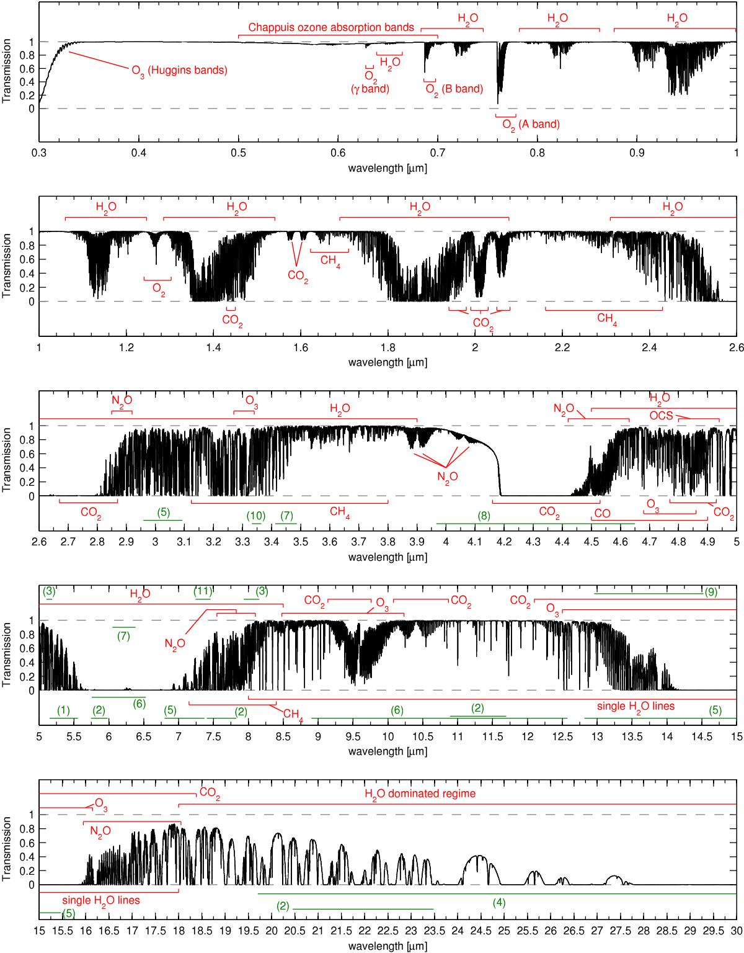

**Fig. 19:** Synthetic absorption spectrum of the sky between 0.3 and 30 μm calculated with LBLRTM (resolution R ∼ 10 000) using the annual mean profile for Cerro Paranal (Noll et al. 2012). The eight main molecules O2, O3, H2O, CO, CO2, CH4, OCS, and N2O contribute more than 5% to the absorption in some wavelength regimes. The red regions mark the ranges where they mainly affect the transmission, minor contributions of these molecules are not shown. The green regions denote minor contributions (see Table 1 of [Smette+15]) from the following molecules: (1) NO; (2) HNO3; (3) COF2; (4) H2O2; (5) HCN; (6) NH3; (7) NO2; (8) N2; (9) C2H2; (10) C2H6; and (11) SO2. (Figure from [Smette+15]).



Table 1: List of molecules (from [Smette+15]). An X in the column 'In standard profile' means that an atmospheric profile for the corresponding molecule is providing with the molecfit package. An 'f' in the column 'GUI' indicates that the relative abundance of the molecule can be fitted in the GUI; otherwise, a ‘c’ in this column indicates that it can only be calculated. The command line version allows one to fit the relative abundance of all molecules for which an atmospheric profile exists.

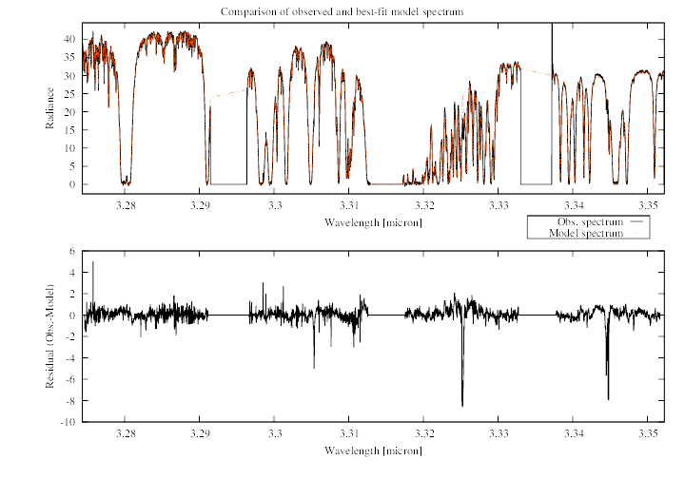 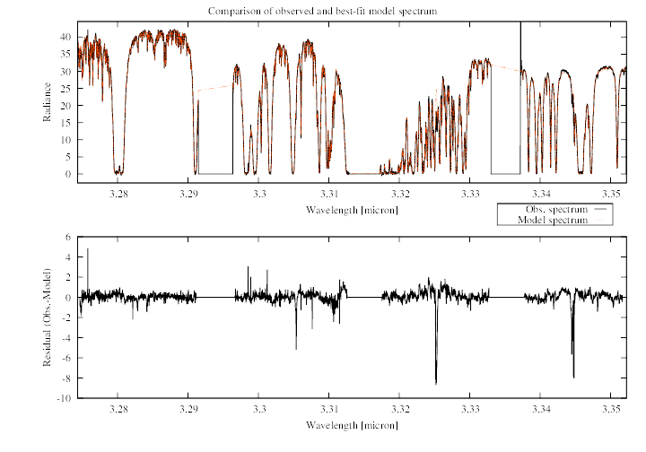

**Fig. 20:** Changing ftol = xtol = 0.01 (left panel) to 0.001 (right panel). The computing time was increased by about 40%.

# Software requirements / reference software versions

The following software versions and databases are defined as references:

* python v2.7[1]
* matplotlib v1.2 [2]
* numpy v1.6[3]
* astropy > v1.3[4]
* reflex > v2.5[5]
* molecfit, prepguitable, calctrans and its underlying software as described in [mUM]

In mutual agreement, later versions of these software packages and databases may be incorporated.

1. http://www.python.org/
2. http://matplotlib.org/
3. http://www.numpy.org/
4. http://www.astropy.org
5. https://www.eso.org/sci/software/reflex/