**Create, Secure, and Publish APIs with IBM API Connect 10**

5300_IBMpos

**Course Corrections Document**

**September 22, 2022**



**WD515 (Classroom)**

**ZD515 (Self-paced)**

**ERC 2.0**

About this document

This document contains information about issues that were encountered during deliveries of this course. These issues will be addressed in subsequent updates of the material.

You should review this document before the start of class, and use this list as the first point of reference if issues arise.

Student Exercises Guide items

**Exercise 2: Managing catalogs and consumer organizations, Section 1, Step 7d, page 2-10**

***Issue***:

This version of API Connect has a bug that occasionally produces a server error when the user tries to create a portal for the catalog in API Manager.

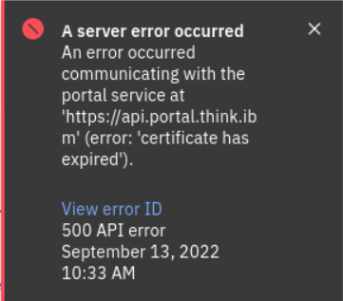

***Correction***:

Step-by-step instructions to do after Exercise 2, Section 1, Step 7d results in the portal creation error.

1. Verify that the email server from the docker container is still running. In the terminal, enter the following command:

docker ps | grep 2525 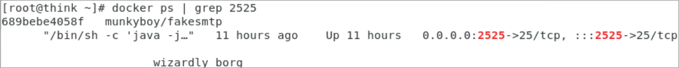

1. Delete the Staging catalog.
   1. In API Manager, select **Manage** from the navigation pane. Graphical user interface, text, application

      Description automatically generated
   2. Click the Staging catalog menu icon. Graphical user interface, application, Teams

      Description automatically generated
   3. Click Delete.

* 1. Select Delete on the dialog. Graphical user interface, text, application

     Description automatically generated

It may take some time before the Staging catalog disappears.

1. Reboot the system.
   1. Open the terminal.
   2. Reboot. In the terminal, enter the following command:

reboot



Press Enter.

* 1. Re-log in to the operating system.

1. Repeat Exercise 2.
   1. In the exercise book, start from Exercise 2, Section 1, Step 2.

Continue the exercise steps.

* 1. By Exercise 2, Section 1, Step 7d, the portal creation succeeds. Graphical user interface, text, application, email

     Description automatically generated
  2. Continue the exercises. Start Exercise 2, Section 1, Step 8. Graphical user interface, text, application, email

     Description automatically generated

Student Notebook items

None reported.

Course presentation items by unit

None reported.

***End of document***