IBM MQ TLS/SSL Wizard
User Guide
Version 2.0.0.2

January 2010, December 2014

Changes
Version | Released | Changes
V1.0 | August 2005 | -
V1.1 | November 2005 | - Added support for generating certificate requests.  - Fixed RACDCERT CONNECT incorrectly using CERTAUTH for self  signed certificates.  - Fixed instructions save adding “.html” as suffix if suffix already exists  - Changed certificate CN fields to combo box containing QMName and  certificate label name on first pass.  - Show the certificate label names (greyed out) on certificate panels.  - Added ST and (single) OU distinguished name attributes.  - Fixed Sender CA Properties panel field alignment problem.  - Fix File->Save As exceptions caused by blank entry fields.  - Change Windows commands to use runmqckm instead of gsk7cmd.  - Allow spaces in Windows and UNIX key database paths.
V1.2 | May 2006 | - Support for C, Java and JMS clients.  - Only CN, O and C are required by GSKit.  - Other misc. changes.
V1.3 | November 2006 | - Various fixes to client support  - Added new extra CipherSpecs  - Added CipherSpec to CipherSuite mapping for Java/JMS clients
V2.0 | November 2009 | - Improved CA model  - Improved GUI layout  - Improved script formatting  - Updated client samples for WebSphere MQ V7.0.1  - Added diagrams to each GUI page  - Added gsk7capicmd command option  - Added SSLFIPS support with restricted SSLCIPH values  - Added FIPS/Sigalg for gsk7capicmd support  - Added basic multiple OU support  - Added full SSLPEER to channel definitions  - Added certificate expiry  - Added sample build instruction examples to doc.  - Removed all MD5 hashing algorithms  - Removed backwards compatibility of data files (sorry, let me know if this  is a major problem for you)  - Changed SSLCAUTH so that it now defaults to REQUIRED  - Changed sample passwords to be unique for each key database  - Documentation updates  - Bug fixes  - Many internals updates
V2.0.0.1 | January 2010 | - Fixed quoting of SSLPEER strings  - Fixed italics font in instructions
V2.0.0.2 | December 2014 | - Released to GitHub  - Some updates to package names and some text to reflect preferences for TLS, and the new product name (IBM MQ).  - Convert docs to OpenOffice format

Chapter 1. WebSphere MQ SSL Wizard 5
Overview 5
Output Pre-requisites 5
Chapter 2. Using the Wizard 6
Basic operation 6
Page diagrams 6
Saving/Opening user data 6
Saving/Copying the generated instructions 6
The SSL Client and SSL Server 7
Accessibility 7
Chapter 3. Entry Fields 8
SSL Client Properties 8
SSL Client z/OS Properties 8
SSL Client UNIX/Windows Properties 8
SSL Client gsk7capicmd Properties 9
SSL Server Properties 9
SSL Server z/OS Properties 10
SSL Server UNIX/Windows Properties 10
SSL Server gsk7capicmd Properties 10
Channel Properties 11
SSL Client Certificate Properties 11
SSL Server Certificate Properties 12
Certificate Setup Choice 12
CA Setup Choice 12
CA System 12
CA z/OS Properties 13
CA UNIX/Windows Properties 13
CA gsk7capicmd Properties 13
CA Certificate Properties 14
Generated Instructions 14
Chapter 4. Further tasks 15
Passwords 15
Unreferenced Certificate Authority certificates 15
CRLs/OCSP 15
SSL key reset 15
Certificate Name Filtering 15
Chapter 5. Further information 16
Client Samples 16
FIPS 16
MD5 16
Name mangling 16
Appendix A – Page Order Diagram 18
Appendix B – GSKit command alternatives 19
Appendix C – Building client samples 20
Appendix D – Example diagrams 21
Example 1 21
Example 2 22
Example 3 23

Chapter 1. WebSphere MQ SSL Wizard

Overview
The WebSphere MQ SSL Wizard is a utility designed to ease the administration of a basic TLS/SSL channel. The WebSphere MQ SSL Wizard takes input in series of entry panels and then generates a set of instructions to enable the user to define and start a TLS/SSL channel. The instructions generated include both the platform specific commands for creating the certificates (e.g. using RACF or GSKit) and the MQSC commands used to define and start the WebSphere MQ channel.

The WebSphere MQ channel can either be an MCA channel between two queue managers or a client connection channel to a queue manager. Sample source and binaries are shipped with the WebSphere MQ SSL Wizard for clients written in C, Java and JMS.

The WebSphere MQ SSL Wizard generates instructions for z/OS, UNIX and Windows, although some instructions (e.g. MQSC) may be run on other platforms.

Output Pre-requisites
The WebSphere MQ MQSC commands generated by the WebSphere MQ SSL Wizard can be run on WebSphere MQ V6 and above. The certificate creation commands generated by the WebSphere MQ SSL Wizard are for RACF on z/OS and GSKit on UNIX and Windows.

Chapter 2. Using the Wizard

Basic operation
Enter data in each field displayed and press the Next button, until the Generated instructions page. The Previous button can also be used to go back. The generated instructions list the instructions and commands required to create the certificates and define the WebSphere MQ TLS/SSL channel.
Note: Several features are given sensible defaults. If you don’t understand the meaning of a field, leave the default value. If a required field is omitted, a message will be displayed.

Page diagrams
Each page contains a diagram indicating the component to which the page entry fields relate. The diagrams each contain the components involved to that point and the specific component relating to the page is highlighted in red. See Appendix E for examples of the diagrams.

Saving/Opening user data
The File->Open menu option is used to restore the data for all entry fields from a data file. The File->Save menu option is used to save the data for all entry fields to a data file.
Note: Data files from previous versions of the WebSphere MQ SSL Wizard are not compatible with WebSphere MQ SSL Wizard V2.0.x.

A file can be opened on startup of the WebSphere MQ SSL Wizard by adding the data filename to the command line, as follows: java -jar wmqsslwizard.jar sample_client.data
Note: The ‘-jar’ parameter may not be required.

Two sample data files, sample_client.data (for a client channel) and sample_mca_channel.data (for a queue manager to queue manager channel), are shipped in mo04.zip.

A data file can be used to store defaults values, where the supplied defaults are not suitable.

Saving/Copying the generated instructions
The Save Instructions button is used to save the generated instructions text to an html file (Firefox. The Edit->Copy menu item will copy either entire generated instructions text or the selected generated instructions text to the clipboard.

The SSL Client and SSL Server
The SSL Client is the channel which initiates communication - the client for a client/server connection channel and the sender for a sender/receiver channel.

The SSL Server is the channel which responds to a request from an SSL Client - the server for a client/server connection channel and the receiver for a sender/receiver channel.

Accessibility
Each button and entry field can be accessed in turn by pressing the TAB key. The File menu can be activated with Alt+F, the Edit menu with Alt+E and the Help menu with Alt+H. Once a menu is activated the menu items can be selected with the keys noted below.

Menu Item | Key
File-> New | N
File-> Open… | O
File-> Save As… | A
File-> Exit | X
Edit-> Copy | C
Help-> Help | P
Help-> About | T

The generated instructions text can also be copied to the clipboard using Ctrl+C. Data files can be opened using Ctrl+O. Data files can be saved using Ctrl+S.

Chapter 3. Entry Fields

This chapter holds information about each wizard page and information about the entry fields on those pages.
Note: Page order depends on user entry and not all pages are necessarily made visible. See Appendix A for details of page order.

SSL Client Properties
Note: The SSL Client is the channel which initiates communication - the client for a client/server connection channel and the sender for a sender/receiver channel.

The fields on this page hold information relating to the client or queue manager that will host the sender channel.
Field | Description
Client User | Select the radio button to create a client connection (rather than an MCA channel). Enter the user id of the client (e.g. user1) in the text field.
Java/JMS | Select the radio button to create a Java or JMS client (rather than a C client). This is the default.
Other | Select the radio button to create a C client connection (rather than a Java/JMS client).
QMGR Name | Select the radio button to create an MCA channel (rather than a client connection). This is the default. Enter the queue manager name (e.g. QM1) in the text field.
Host | The hostname (e.g. machine1)
Platform | The platform type (z/OS, UNIX or Windows)

SSL Client z/OS Properties
The fields on this page hold information relating to the z/OS queue manager that will host the sender channel.
Field | Description
Keyring | The name of the RACF keyring that will be created (e.g. QM1RING)
SSL Tasks | The number of SSL Tasks for the channel initiator (e.g. 5)
Chinit ID | The userid under which the channel initiator runs (e.g. VANSTON1)

SSL Client UNIX/Windows Properties
The fields on this page hold information relating to the client or the UNIX/Windows queue manager that will host the sender channel.
Field | Description
Key Database | The name of the key database file that will be created (e.g. /var/mqm/qmgrs/QM1/ssl/my.kdb)
Command | The GSKit command (runmqckm, gsk7cmd or gsk7capicmd). See Appendix B for more information.

SSL Client gsk7capicmd Properties
The fields on this page hold information relating to the parameters used on the gsk7capicmd command on the SSL client machine.
Field | Description
FIPS | If set, the “-fips” parameter is used on gsk7capicmd commands. See Chapter 5 for more info on FIPS.
Sigalg | Sets the “-sigalg <value>” parameter used on gsk7capicmd commands.

SSL Server Properties
Note: The SSL Server is the channel which responds to a request from an SSL Client - the server for a client/server connection channel and the receiver for a sender/receiver channel.

The fields on this page hold information relating to the client or the queue manager that will host the receiver or server connection channel.
Field | Description
QMGR Name | The queue manager name (e.g. QM2)
Host | The hostname (e.g. machine2)
Port | The TCP port for the listener (e.g. 1414)
Platform | The platform type (z/OS, UNIX or Windows)

SSL Server z/OS Properties
The fields on this page hold information relating to the z/OS queue manager that will host the receiver channel or server connection channel.
Field | Description
Keyring | The name of the RACF keyring that will be created (e.g. QM2RING)
SSL Tasks | The number of SSL Tasks for the channel initiator (e.g. 5)
Chinit ID | The userid under which the channel initiator runs (e.g. VANSTON2)

SSL Server UNIX/Windows Properties
The fields on this page hold information relating to the client or the UNIX/Windows queue manager that will host the receiver channel or server connection channel.
Field | Description
Key Database | The name of the key database file that will be created (e.g. /var/mqm/qmgrs/QM2/ssl/my.kdb)
Command | The GSKit command (runmqckm, gsk7cmd or gsk7capicmd). See Appendix B for more information.

SSL Server gsk7capicmd Properties
The fields on this page hold information relating to the parameters used on the gsk7capicmd command on the SSL server machine.
Field | Description
FIPS | If set, the “-fips” parameter is used on gsk7capicmd commands. See Chapter 5 for more info on FIPS.
Sigalg | Sets the “-sigalg <value>” parameter used on gsk7capicmd commands.

Channel Properties
The fields on this page hold information relating to the channel.
Field | Description
Channel name | The name of the channel (e.g. QM1.TO.QM2)
SSLFIPS | If set the SSLFIPS queue manager attribute is set to YES (else NO) and restricts the list of SSLCIPH values. See Chapter 5 for more info on SSLFIPS.
SSLCIPH | The cipher specification (e.g. DES_SHA_EXPORT)
SSLCAUTH | Tick for client authentication (i.e. The receiver channel will attempt to authenticate the sender channel’s certificate). This is checked by default.

SSL Client Certificate Properties
The fields on this page hold information relating to the TLS/SSL certificate for the client or queue manager that will host the sender channel.
Field | Description
Cert. label | Read-only. The certificate label (e.g. ibmWebsphereMQQM1)  NOTE: Labels are case-sensitive.
Common Name | The distinguished name common name (e.g. QM1)
Org. Unit | The distinguished name organizational unit (e.g. WebSphere MQ). Use a comma separated list for multiple OUs.
Org. | The distinguished name organization (e.g. IBM)
Locality | The distinguished name locality (e.g. Hursley)
State | The distinguished name state (e.g. Hampshire)
Country | The distinguished name country (e.g. UK)
Expiry | Certificate expiry in days. Defaults to 365.

SSL Server Certificate Properties
The fields on this page hold information relating to the TLS/SSL certificate for the client or the queue manager that will host the receiver channel or server connection channel.
Field | Description
Cert. label | Read-only. The certificate label (e.g. ibmWebsphereMQQM2)  NOTE: Labels are case-sensitive.
Common Name | The distinguished name common name (e.g. QM2)
Org. Unit | The distinguished name organizational unit (e.g. FIT Team). Use a comma separated list for multiple OUs.
Org. | The distinguished name organization (e.g. IBM)
Locality | The distinguished name locality (e.g. Hursley)
State | The distinguished name state (e.g. Hampshire)
Country | The distinguished name country (e.g. UK)
Expiry | Certificate expiry in days. Defaults to 365.

Certificate Setup Choice
The fields on this page hold information relating to whether a Certificate Authority (CA) is used.
Field | Description
Self signed certificates | Create self signed certificates
CA signed certificates | Create certificate requests to be signed by CA (and optionally create the CA)

CA Setup Choice
The fields on this page hold information relating to how a Certificate Authority (CA) is used.
Field | Description
Use an existing CA | Create certificate requests, send them to an existing CA, and receive the signed certificates.
Create a CA | Create a CA, create certificate requests, sign the certificate requests, and receive the signed certificates.

CA System
The fields on this page hold information relating to the Certificate Authority (CA).
Field | Description
Host | The hostname (e.g. machine3)
Platform | The platform type (z/OS, UNIX or Windows)

CA z/OS Properties
The fields on this page hold information relating to the z/OS queue manager that will host the Certificate Authority (CA).
Field | Description
Keyring | The name of the RACF keyring that will be created (e.g. WMQCAKR)
CA ID | The userid which owns the keyring (e.g.WMQCAUSR)

CA UNIX/Windows Properties
The fields on this page hold information relating to the client or the UNIX/Windows queue manager that will host the receiver channel or server connection channel.
Field | Description
Key Database | The name of the key database file that will be created (e.g. /var/mqm/wmqca.kdb)
Command | The GSKit command (runmqckm, gsk7cmd or gsk7capicmd). See Appendix B for more information.

CA gsk7capicmd Properties
The fields on this page hold information relating to the parameters used on the gsk7capicmd command on the CA machine.
Field | Description
FIPS | If set, the “-fips” parameter is used on gsk7capicmd commands.
Sigalg | Sets the “-sigalg <value>” parameter used on gsk7capicmd commands.

CA Certificate Properties
The fields on this page hold information relating to the TLS/SSL certificate for the CA that will sign the TLS/SSL certificates for the SSL client and SSL server.
Field | Description
Label | The certificate label (e.g. WMQCertAuth)  NOTE: Labels are case-sensitive.
Common Name | The distinguished name common name (e.g. WMQ CA)
Org. Unit | The distinguished name organizational unit (e.g. Security Ops). Use a comma separated list for multiple OUs.
Org. | The distinguished name organization (e.g. IBM)
Locality | The distinguished name locality (e.g. Hursley)
State | The distinguished name state (e.g. Hampshire)
Country | The distinguished name country (e.g. UK)
Expiry | Certificate expiry in days. Defaults to 365.

Generated Instructions
The main field on this page holds the generated instructions.

Note: The WebSphere MQ SSL Wizard assumes that objects (e.g. the WMQ channel and TLS/SSL artifacts) are being created for the first time. Be aware that this will negate the need for some commands if objects already exist.

Chapter 4. Further tasks

There are many other tasks that should be carried out when using the WebSphere MQ SSL Wizard and WebSphere MQ SSL in general. Some of these are summarized below.

Passwords
Many GSKit commands require a password. Cryptographic security is largely dependent on password length and complexity - longer, more complex passwords are better. The commands generated by the WebSphere MQ SSL Wizard use the passwords passclient, passserver, and passca. You should replace the generated password strings with your own passwords.

Unreferenced Certificate Authority certificates
TLS/SSL key databases usually contain many default Certificate Authority signer certificates. All unreferenced Certificate Authority signer certificates should be deleted from key databases (e.g. gsk7capicmd -cert -delete -label "VeriSign Class 3 Secure Server CA" -db my.kdb -pw password –fips).

CRLs/OCSP
If using a Certificate Authority to sign certificates it is important to use CRLs or OCSP to prevent the use of revoked certificates. OCSP is generally considered a better option.

SSL key reset
SSL key reset minimizes the amount of encrypted data that can be decrypted if the secret key is discovered. The use of SSL key reset should be considered.

Certificate Name Filtering
On z/OS, message CSQX632I is output if no userid is associated with a remote certificate. This message indicates that the channel initiator userid is being used instead of a userid that relates to the remote certificate. Because the channel initiator userid is usually given a high level of access to queue manager resources, it should not usually be used by the channel. It is therefore recommended that the distinguished name of the remote certificate be mapped to a userid using certificate name filtering. See http://publib.boulder.ibm.com/infocenter/wmqv7/v7r0/topic/com.ibm.mq.csqzas.doc/sy12660_.htm

Chapter 5. Further information

Client Samples
Client application samples are supplied for the purpose of testing the SSL connection.

The client source files are found in directory client_samples/src and the client binaries are found in client_samples/bin. For examples of building the source, see Appendix C

Note: ‘.exe’ binaries were built and are designed to be executed on the 32bit Windows platform.

FIPS
When FIPS is required, it applies to build-time administrative operations such as key database generation and certificate signing as well as to run-time functions such as the channel's cipherspec.

The build-time options are available only when selecting the gsk7capicmd. If gsk7capicmd is selected, the FIPS option is available on the following panels:
- SSL Client gsk7capicmd Properties
- SSL Server gsk7capicmd Properties
- CA gsk7capicmd Properties

A key database or certificate generated with non-FIPS methods cannot retroactively be made compliant. But key databases and certificates generated with FIPS-compliant methods can be used in both FIPS-compliant and non-FIPS-compliant systems. For these reasons the default is to always set the FIPS checkbox.

The runtime option is the SSLFIPS checkbox on the Channel Properties panel. If set, it controls restricts the list of SSLCIPH options available and sets the SSLFIPS queue manager attribute to YES.

MD5
No MD5 hash algorithms are available in the WebSphere MQ SSL Wizard because they are considered cryptographically broken.

Name mangling
WebSphere MQ mangles queue manager names for directory paths (on UNIX and Windows), so the path generated for key databases may not be correct for the queue manager.

Appendix A – Page Order Diagram
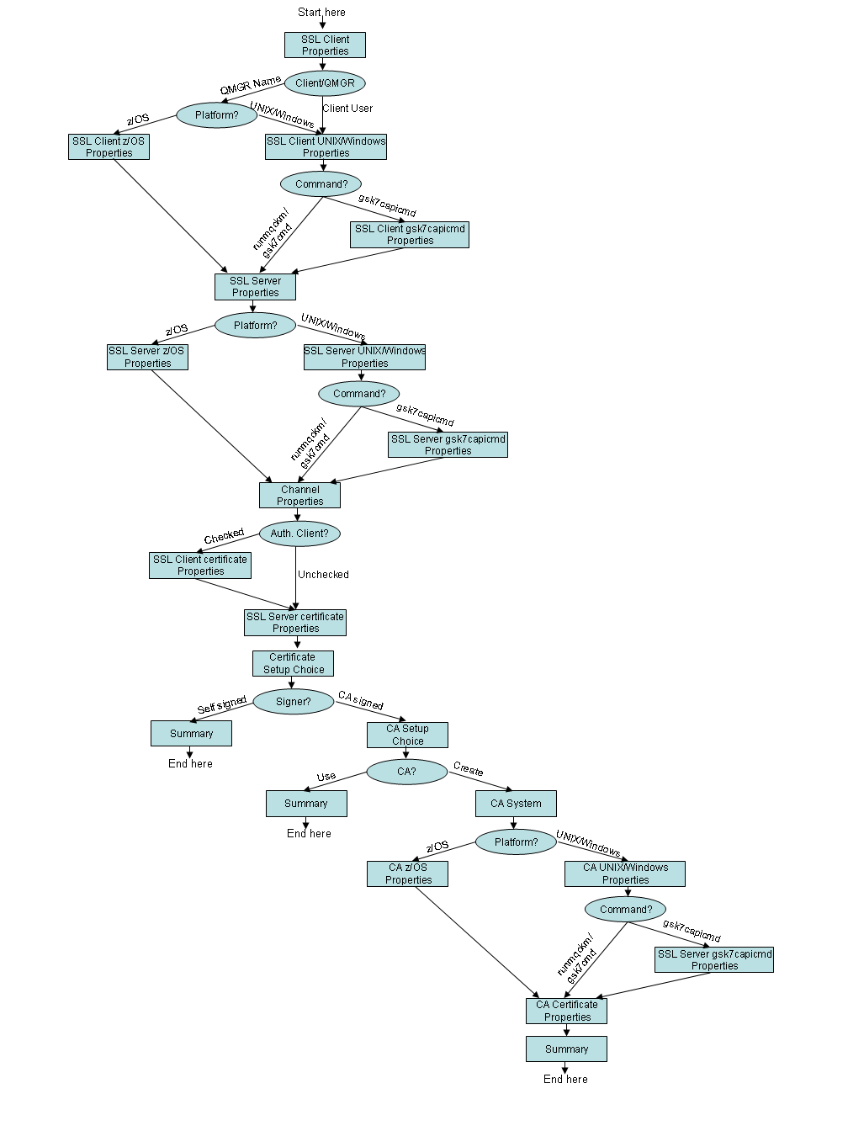

Appendix B – GSKit command alternatives

Command | Platform | FIPS compliant | Notes
runmqckm | Windows | No
gsk7cmd | Unix | No
gsk7capicmd | Windows and Unix | Yes (using “-fips” parameter and subject to notes below*) | Supports “-sigalg”

* http://publib.boulder.ibm.com/infocenter/wmqv7/v7r0/topic/com.ibm.mq.csqzas.doc/sy11010_.htm

Appendix C – Building client samples
The following examples are included for convenience. For detailed build instructions, see the WebSphere MQ Infocenter.

Build SSLSample.java on Linux 32 bit:
javac SSLSample.java

Build SSLSampleJMS.java on Linux 32 bit:
javac SSLSampleJMS.java

Build SSLSample.c on Linux 32 bit:
gcc -m32 -o SSLSample.exe SSLSample.c -I/opt/mqm/inc -L/opt/mqm/lib -Wl,-rpath=/opt/mqm/lib -Wl,-rpath=/usr/lib -lmqic

Build SSLSample.java on Windows 32 bit:
javac SSLSample.java

Build SSLSampleJMS.java on Windows 32 bit:
javac SSLSampleJMS.java

Build SSLSample.c on Windows 32 bit:
cl /MT SSLSample.c mqic32.lib

Appendix D – Example diagrams

Example 1
This diagram shows that a user has chosen…
- a WMQ client to queue manager connection (rather than a queue manager to queue manager connection).
- to authenticate the client, so there is a certificate (scroll) in the key database of the SSL Client.
- to create an internal CA (rather than use an external CA or self-signed certificates)

The diagram also shows that user is currently creating the CA certificate.

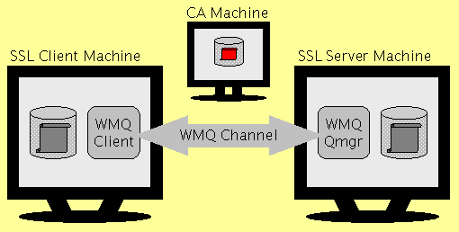

Example 2
This diagram shows that a user has chosen…
- a queue manager to queue manager connection (rather than a WMQ client to queue manager connection).
- to not authenticate the client, so there is not a certificate (scroll) in the key database of the SSL Client.

The diagram also shows that user is currently creating the SSL Server certificate.

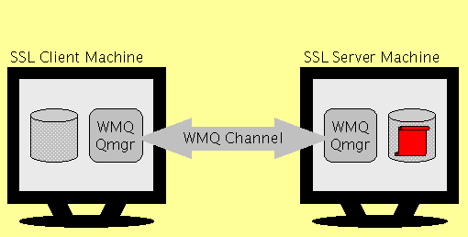

Example 3
This diagram shows that a user has chosen…
- a queue manager to queue manager connection (rather than a WMQ client to queue manager connection).

The diagram also shows that user is currently defining components relating to the SLS Client queue manager. And also that the user has not defined many components yet.

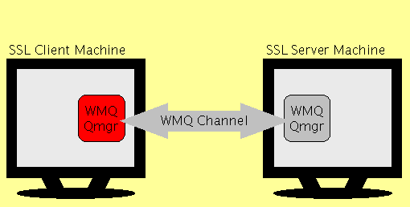
Appendix E – Acknowledgments

Many people have provided very valuable feedback on MO04, but special thanks go to Mike Horan, Neil Casey, and T.Rob Wyatt for their significant contributions made during development of V2.0.

