C-ECM
Centralized Enterprise Content Management
Developer Onboarding & Technical Reference

September 2026
Backend: FastAPI / Python 3.12 · Frontend: React 19 / TypeScript / Vite

Table of Contents
Right-click this area and choose "Update Field" (or press F9) to build the table of contents.

1. Introduction
Welcome to C-ECM. This document is written for a developer joining the project with no prior context — it explains what the application does, how it is built, how every major feature actually works under the hood, and how to get a copy running on your own machine and, eventually, in production.
This is a reference document, not a tutorial to read start-to-finish in one sitting. The recommended path for your first week:
- Read Section 2 (Product Overview) and Section 3 (System Architecture) to build a mental map of the whole system.
- Follow Section 9 (Local Development Setup) to get the backend and frontend running on your machine.
- Read Section 5 (Backend Deep Dive) and Section 6 (Frontend Deep Dive) for the codebase itself.
- Skim Section 7 (Feature Walkthroughs) and come back to individual subsections as you touch each feature.
- Read Section 10 (Testing) before your first pull request, and Section 11 (Production Deployment) whenever you need to actually ship something.
How this document was produced: Every technical claim in this document was verified directly against the live codebase at the time of writing — by reading the actual source files, not by inference from naming conventions or assumption. Where something is genuinely unverified or best-effort (for example, most of the 54 storage-provider adapters have never been tested against a real live account of that backend), this document says so explicitly rather than presenting it as proven. Treat any claim here that turns out to be stale as a bug — fix the code or fix this document, whichever is wrong.

2. Product Overview

2.1 What C-ECM Is
C-ECM is a governance and intelligence layer that sits in front of whatever document storage systems an organization already uses — IBM FileNet, IBM i (AS/400), IBM Z mainframes, Alfresco, Google Drive, Microsoft 365 (OneDrive/SharePoint), Box, Amazon S3, Azure Blob Storage, a plain local disk folder, and roughly forty-five other backends — and gives every one of them the same approval workflows, the same audit trail, the same tagging/commenting/metadata layer, and the same cross-system search, without moving a single file out of wherever it already lives.
The core idea: most large organizations do not have one document system, they have five or six, accumulated over decades of mergers, legacy systems nobody wants to touch, and departments that picked their own tools. C-ECM does not try to replace any of them. It connects to them as a client would (via each system's own native API/protocol) and layers governance on top.

2.2 Core Capabilities
- Multi-backend connections — 54 storage-provider adapters behind one common interface; a user can be connected to several backends at once and switch between them from the sidebar.
- Folders, files, and versions — standard drive semantics (create, rename, move, delete, trash/restore) plus full version history and a server-enforced checkout lock so two people can't silently overwrite the same file.
- Multi-step approval workflows — a designer for building quorum-based, multi-step sign-off processes, with per-step assignment to specific users or whole groups, reassignment, and multi-document requests.
- Cross-backend search — search one connection, or fan out a single query to every configured connection in parallel and get back one ranked result list.
- Tags, comments, and custom metadata — free-form tags, threaded comments with resolve/reopen, and admin-defined document classes with typed custom fields (text/number/date/boolean/select).
- AI document intelligence — summarize a document, ask natural-language questions about it, auto-suggest metadata values and a workflow, on a choice of six interchangeable AI backends.
- AI Agents — a named, shareable public chat endpoint scoped to one folder or file, backed by an auto-generated small marketing site (headline, pages, blog posts) an admin can edit.
- E-signature — route a document through DocuSign for a legally binding signature, tracked alongside every other event on that document.
- Retention & legal hold — scheduled retention policies that follow a document through its lifecycle, with a legal-hold override that survives even a move or rename.
- Notifications & webhooks — in-app notifications for every teammate, plus HMAC-signed outbound webhooks (including ready-made Slack/Discord destinations) so external systems hear about a change the moment it happens.
- Audit log — every login, view, edit, approval, rejection, and deletion recorded with actor, timestamp, and event type, with a dashboard of trends, breakdowns, and automatic anomaly alerts.
- Groups & per-resource access control — a Group/Feature permission model (not fixed roles), plus an optional, opt-in layer of per-file/per-folder access grants for anything that needs finer control.

2.3 Who Uses Each Part
Role | What they use
End users | Drive UI — browse, upload, search, tag/comment, request and act on approvals
Release / change managers | Workflow designer, approval inbox, audit log exports
Compliance / audit teams | Audit log dashboard, retention & legal hold, per-resource access grants
Admins | Settings: Users, Groups, Document Classes, Webhooks, Retention, AI Provider, SSO
Developers (you) | Everything in this document

3. System Architecture
C-ECM is a classic layered/n-tier application, deliberately simple in its runtime topology: one React single-page app talking to one FastAPI backend process over plain REST/JSON. There is no message queue, no microservices, no background worker process — everything runs in one Python process (plus a background APScheduler thread for retention enforcement) and one Node/Vite dev server (replaced by static files + nginx in production).
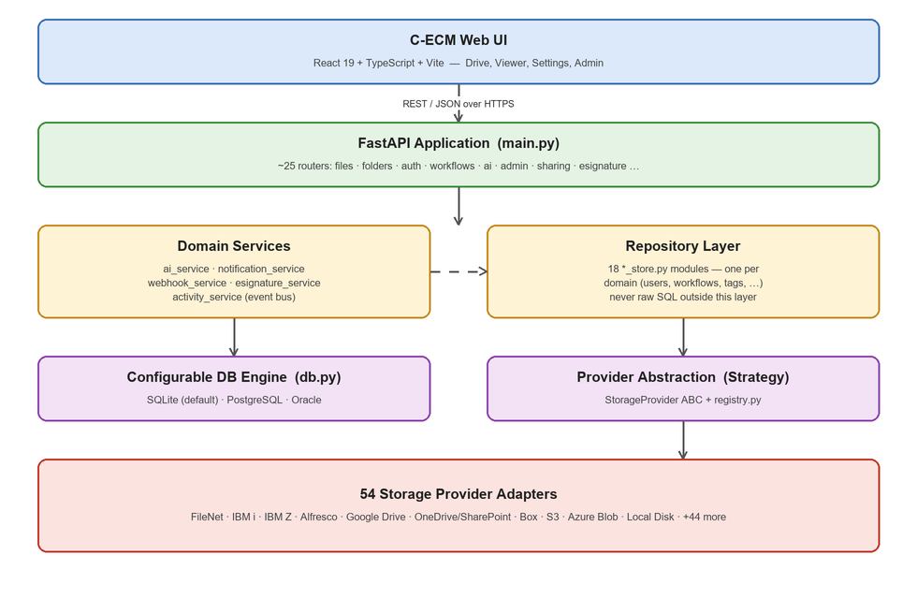
Figure 1 — C-ECM's layered architecture, from the browser down to the 54 storage-provider adapters.

3.1 Layer-by-Layer
- Presentation — the React UI. Talks to the backend only through the API client (frontend/src/api/client.ts) — no component ever constructs a raw fetch() call to a backend route directly except a couple of well-justified exceptions (streaming a file blob, an SSO redirect).
- API — FastAPI routers under backend/app/routers/. Each router owns one URL prefix and is responsible for request validation (via Pydantic schemas), authentication/authorization checks, and translating between HTTP and the domain layer below it. Routers never talk to a database directly.
- Domain Services — modules like ai_service.py, notification_service.py, webhook_service.py, esignature_service.py, and activity_service.py. These hold business logic that doesn't belong to a single data domain, or that reacts to events from other parts of the system.
- Repository Layer — one *_store.py module per data domain (users, workflows, tags, connections, …). This is the only layer allowed to talk to the database. Every store exposes plain functions (not classes) returning plain dicts, never ORM model instances leaking into routers.
- Database Engine — app/db.py, new this year — see Section 5.4. Chooses between SQLite (the zero-config default), PostgreSQL, and Oracle, all through SQLAlchemy Core.
- Provider Abstraction — app/storage_providers/base.py defines a StorageProvider abstract base class (Strategy pattern); app/storage_providers/registry.py self-registers every concrete provider and resolves one by its provider_key. This is what lets the entire rest of the app (routers, services, UI) be completely unaware of which of the 54 backends it's actually talking to.

3.2 The Event Bus — How the Audit Trail Actually Works
Every write anywhere in the app — upload, rename, delete, an approval vote, a version restore — funnels through exactly one function: activity_service.record_event(). That single call synchronously fans out to three independent listeners, registered once at startup in main.py's lifespan function (this is the Observer pattern):
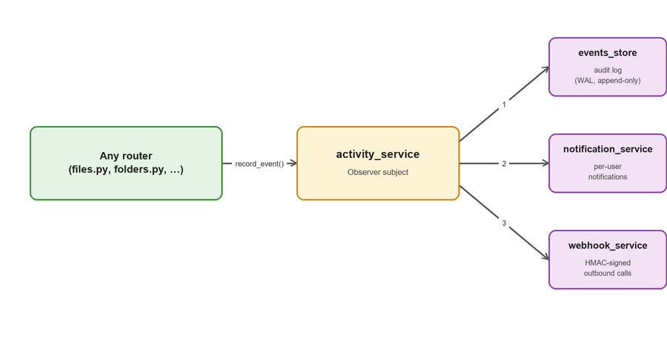
Figure 2 — One record_event() call reaches the audit log, per-user notifications, and outbound webhooks. Adding a fourth listener never requires touching any router or provider code.
Why this matters to you: If you add a new kind of write to the app, call activity_service.record_event() from your router exactly the way every existing router does — you get audit logging, in-app notifications (if the event type is in notification_service._NOTIFIABLE_EVENT_TYPES), and webhook delivery for free, with zero new code in any of those three modules.

3.3 Design Patterns in Play
Pattern | Where | Why it's used
Strategy / Adapter | StorageProvider ABC + 54 concrete providers | IBM Z and Google Drive expose identical interfaces to the rest of the app
Observer | activity_service + its 2 listeners | New audit/notification/webhook behavior never touches provider or router code
Repository | *_store.py, one per domain | Routers never write raw SQL; storage is swappable (SQLite/Postgres/Oracle) without touching business logic
State Machine | Workflow engine (workflows_store.py) | An instance only moves through valid transitions: pending → in_review → approved / rejected / cancelled
Factory / Registry | get_provider(key) in registry.py | Self-registers every backend at import time; resolved by string key everywhere else
Layered architecture | Presentation → API → Domain → Repository → Providers | A UI change or a storage-backend swap never leaks across layers

4. Technology Stack
Layer | Technology
Frontend | React 19.2, TypeScript ~6.0, Vite 8 — no router library, no state-management library, no CSS framework
Backend | FastAPI 0.115, Python 3.12, Pydantic v2, Uvicorn
Authentication | JWT (HS256, PyJWT) + bcrypt password hashing; server-side session logout
Authorization | Group → Feature model with an is_superadmin bypass, plus an opt-in per-resource access-grants layer
Database | Configurable: SQLite (default, one file per domain, zero config) or PostgreSQL / Oracle via SQLAlchemy Core — see Section 5.4
Scheduler | APScheduler, background thread — retention-policy enforcement
AI | Anthropic (Claude) · OpenAI/ChatGPT (or compatible) · local Ollama · IBM watsonx.ai · Watson NLU · Watson Discovery
E-signature | DocuSign, JWT Grant (server-to-server) flow
SSO | SAML 2.0 (python3-saml), auto-provisioning on first login
Testing | pytest + httpx, 322 backend integration tests; tsc -b for frontend type-checking
Deployment | Docker + Docker Compose (standalone / AWS / Azure); native Windows Service path for FileNet content-write

5. Backend Deep Dive

5.1 Project Layout & Entry Point
backend/
run.py # entry point: uvicorn.run("app.main:app", host="0.0.0.0", port=8020)
requirements.txt # pinned dependencies
.env.example # environment variable template
app/
main.py # FastAPI app object, CORS, lifespan (startup), router registration
config.py # every environment variable, with its default, read once at import time
db.py # configurable SQLAlchemy engine (SQLite / Postgres / Oracle) — see 5.4
auth.py # JWT issuing/verification, get_current_user/get_current_session dependencies
access_control.py # per-resource grant checks (effective_level, require_resource_level)
features.py # the Feature catalog — every permission the app knows about
schemas.py # every Pydantic request/response model
crypto_util.py # Fernet symmetric encryption for secrets at rest
routers/ # one file per URL area — see 5.2
*_store.py # one file per data domain — see 5.3 (repository layer)
storage_providers/ # StorageProvider ABC + 54 concrete adapters + registry.py — see 5.5
tests/ # 322 integration tests, pytest + httpx + a real (temp-dir) app instance
main.py's lifespan function runs once at process startup. It calls init_db() on every store module (creating that store's tables if they don't exist yet — see 5.4), then registers activity_service's two listeners (notification_service.on_event and webhook_service.on_event), then starts the APScheduler background job for retention enforcement.
The FastAPI app is titled “C-ECM API”, versioned 1.0.0, documented with a multi-paragraph Markdown description and 26 OpenAPI tag groups — every router shows up in Swagger UI at /docs with a real description, not just a bare list of paths. A global exception handler logs unhandled errors and always returns a generic 500 with no stack trace to the client.

5.2 Routers — the API Surface
25 router files live in backend/app/routers/ (plus an empty __init__.py). Most declare their own URL prefix; a handful are deliberately mounted bare because they share a generic resource-scoped path space (/resources/{resource_id}/...) across features — tags, comments, metadata, permissions, and access grants all do this rather than each claiming their own prefix.
Router | Mount | What it does
auth.py | /auth | Login/logout, “who am I”
users.py | /users | C-ECM user account CRUD
groups.py | (bare) | Groups + the Feature catalog
saml.py | /saml | SAML SSO (this app as the Service Provider)
connections.py | /connections | Connect a storage backend; OAuth popup flow
admin.py | /admin | Server-wide settings (OAuth apps, AI, SAML)
folders.py | /folders | Browse/create/rename/move/trash folders
files.py | /files | Upload/download/version/rename/move/trash files
ai.py | /files, /ai | Summarize / classify / ask / suggest workflow
search.py | /search | Per-connection + global search, saved searches
activity.py | /activity | Audit log & reporting
tags.py | (bare) | Color-coded tags on any resource
notifications.py | /notifications | In-app notification inbox
comments.py | (bare) | Threaded comments / @mentions
permissions.py | (bare) | Read-only native backend permissions
access_grants.py | (bare) | C-ECM's own view/edit access grants
sharing.py | (bare, +public) | Shareable links, incl. password-protected
locks.py | /locks | Check-out/check-in exclusive locks
metadata.py | (bare) | Document classes + per-resource metadata
webhooks.py | /webhooks | Outbound webhook subscription registry
workflows.py | /workflows | Approval workflow engine
retention.py | /retention | Retention policies + legal holds
esignature.py | (bare, +public) | DocuSign integration
ai_agents.py | /ai-agents, /admin/ai-agents | Scoped AI agent CRUD + chat + admin report
public_ai_agents.py | /public/ai-agents, /public | Public, unauthenticated agent chat + mini-site

Worth knowing: ai.py, ai_agents.py, esignature.py, sharing.py, and public_ai_agents.py each register two separate APIRouter objects in one file (an authenticated one plus a public/admin one) — don't assume one file means one router. public_ai_agents.py's router is also mounted as its own nested FastAPI sub-application with a deliberately permissive CORS policy, since a public agent chat widget can be embedded on any external site.

5.3 Repository Layer & Domain Services
18 *_store.py modules, each owning exactly one data domain. Every one exposes plain functions returning plain dicts — never an ORM model, never raw SQLAlchemy Row objects, so a router can never accidentally leak a persistence-layer detail into an HTTP response.
Store | Owns
users_store.py | User accounts, bcrypt hashes, superadmin seeding
groups_store.py | Groups and group membership
connections_store.py | Storage-backend connections; creds_json encrypted at rest
events_store.py | Raw audit/activity event log
tags_store.py | Color-coded tags on any resource
notifications_store.py | Notification-inbox rows
comments_store.py | Threaded comments
saved_searches_store.py | Named, re-runnable saved searches
share_links_store.py | Share-link token issue/resolve/revoke
locks_store.py | Check-out/check-in soft locks
metadata_store.py | Document classes + per-resource metadata + history
resource_permissions_store.py | Per-resource view/edit access grants
retention_store.py | Retention policies, enrolled records, legal holds
settings_store.py | Admin key/value settings; secret-shaped keys auto-encrypted
workflows_store.py | Workflow definitions + instances + step state machine
esignature_store.py | DocuSign signature-request tracking
ai_agents_store.py | AI agents, chat/lead history, mini-site content

Four domain-service modules sit above the stores for logic that isn't pure persistence:
Service | Role
activity_service.py | Observer subject: record_event() persists then synchronously fans out to every subscribed listener
ai_service.py | Side-effect-free AI backend abstraction; refresh_from_settings() applies Admin Settings changes with no restart
notification_service.py | Observer subscriber: turns an activity event into a notification for every active user
webhook_service.py | Observer subscriber: matches an event against registered webhooks and delivers it (retried, backgrounded)

Four more exist alongside a router rather than a store — ai_agents_service.py, esignature_service.py, retention_service.py, and saml_service.py — each holding the “logic built on top of” its matching store. retention_service.apply_due_actions() is the one the hourly scheduler job actually calls; retention_store.run_due_check() only identifies due records.

5.4 Configurable Database Engine
app/db.py is the single place that decides where C-ECM's own control-plane data lives — not the content itself (that stays wherever the connected storage backend keeps it), but everything C-ECM manages itself: users, groups, workflows, tags, comments, metadata, permissions, settings, notifications, events, webhooks, saved searches, locks, retention records, e-signature requests, and AI agents.
- sqlite (default) — zero configuration. Each store gets its own file under backend/data/, exactly as C-ECM has always worked. Fine for evaluation and small single-server use, not for real concurrent production load.
- postgres / oracle — set FD_DB_ENGINE and either a full FD_DB_URL or the FD_DB_HOST/PORT/NAME/USER/PASSWORD components. Every store then shares one database — a real RDBMS doesn't need file-per-concern separation the way SQLite benefits from.
Every store defines its schema as SQLAlchemy Core Table objects (not raw CREATE TABLE strings), so the exact same code creates correct, dialect-appropriate DDL on any of the three engines. Each store's init_db() calls db.create_all(metadata, store_name), which is idempotent — safe to call on every startup, and it's what actually creates the database's tables and indexes the first time it runs against an empty database. There is no separate migration script to run.
# app/db.py — how a store gets its engine
from . import db
_engine = db.get_engine("notifications") # sqlite: its own file; postgres/oracle: the shared one

# a store's schema, and its init_db()
notifications = sa.Table("notifications", _metadata, sa.Column("id", sa.String(32), primary_key=True), ...)
def init_db() -> None:
db.create_all(_metadata, "notifications")
A real portability lesson from this migration: SQLite doesn't enforce column length or type at all, so a column that's fine there can be flat-out invalid on Oracle — a CLOB (SQLAlchemy's Text type) cannot be a primary key, cannot be indexed, and cannot appear in ORDER BY. Every store was reviewed column-by-column against this rule during the conversion: ids and reference columns are bounded String types, timestamps are bounded strings, and only genuinely unbounded content (JSON blobs, comment bodies) stays as Text.

5.5 Storage Provider Abstraction
backend/app/storage_providers/ has 45 files: 4 infrastructure files (base.py's StorageProvider ABC, registry.py, coming_soon.py, __init__.py) and 41 provider-implementation files, registering 54 distinct provider instances in total — several files implement more than one provider class where the underlying protocol is shared (one S3-compatible file backs 5 providers; one OAuth file backs 6; one WebDAV file backs 4; one CMIS file backs 2).
Read this before trusting any provider beyond the two below: Of the 54 registered providers, exactly two have been confirmed against a real, live account: FileNetProvider and LocalDiskProvider. Every other provider file's own docstring says so explicitly — this is not a gap being hidden, it's disclosed in the code itself. One provider (Evernote Teams) is registered but deliberately non-functional: Evernote's real API is a Thrift binary protocol with OAuth 1.0a, incompatible with this app's REST/OAuth2 connection model, and the file says so rather than faking support.
Category | Count | Examples
Verified live | 2 | FileNet, Local Disk
Self-flagged unverified / best-effort | 51 (38 files) | Alfresco, S3-family (5), OAuth-family (6: Google Drive, MS 365, Box, Dropbox, Laserfiche, ShareFile), WebDAV-family (4), CMIS-family (2), IBM i, IBM Z, Documentum, OpenText, M-Files, +27 more
Registered but non-functional | 1 | Evernote Teams (disclosed, not faked)

Every provider implements the same StorageProvider abstract base class — list/get/create/rename/move/delete for both folders and files, versions, search, and (where supported) native share links. registry.py builds a lazy, thread-safe lookup dict once at first access and exposes get_provider(key). A router or service never imports a concrete provider directly; it always goes through get_provider() and calls the ABC's methods, which is what makes swapping or adding a 55th backend a purely additive change.

5.6 Authentication & Authorization
Logging into C-ECM itself is separate from logging into any connected storage backend. A user signs in once (username/password checked against a bcrypt hash, or via SAML SSO) and is issued a JWT (HS256, PyJWT) valid for FD_JWT_EXPIRE_MINUTES (24 hours by default). Every subsequent request carries that token as Authorization: Bearer <token>, plus an X-Connection-Id header naming which storage connection the request applies to.
Authorization is not a fixed role list. There is one hard-coded bypass — is_superadmin — and everything else is Groups granting Features:
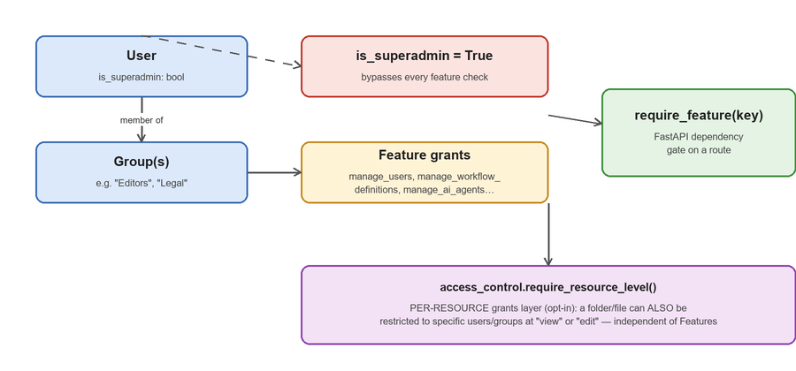
Figure 3 — A user's access is the union of their groups' feature grants, checked by require_feature() at the route level, plus an independent, opt-in per-resource layer.
- Feature, defined once in features.py — a catalog of every gate the app knows about (manage_users, manage_workflow_definitions, manage_ai_agents_admin, view_activity_log, …). A route depends on require_feature("key") the same way any other FastAPI dependency works.
- Group, an admin-managed set of feature keys. A user can belong to several groups; their effective permission set is the union of every group's features.
- is_superadmin, a per-user boolean bypassing every feature check — the one guaranteed way to reach admin-only routes even if no group happens to grant the needed feature, which is why the app refuses to demote or deactivate the last active superadmin.
- Per-resource access grants (access_control.py), a second, independent, opt-in layer: a specific file or folder can be restricted to specific users/groups at “view” or “edit”, regardless of what Features a user otherwise has. A connection with zero grant rows behaves exactly as if this layer didn't exist — full access, today's default — and the very first grant lookup is a single cheap “does this connection have any restrictions at all” check so the common, unrestricted case costs almost nothing.

5.7 Workflow / Approval Engine
A workflow definition describes an ordered list of steps; each step names its assignees (specific users and/or whole groups) and how many approvals it needs (quorum). A workflow instance is created when a user requests approval for one or more documents against a definition, and moves through a small, strictly validated state machine:
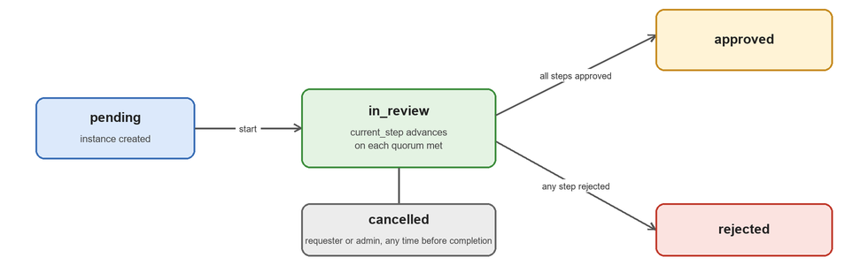
Figure 4 — Every workflow instance's lifecycle. Only these five states and these transitions exist; act_on_step() rejects anything else.
- Multi-document requests — one instance can cover several files/folders at once (workflow_instance_resources), with documents addable/removable while the instance is still in_review.
- Per-instance step snapshot — each instance stores its own copy of the step list (steps_json) at creation time, decoupled from the shared, reusable workflow_definitions template — so editing a definition later never silently changes an in-flight approval, and a step can be reassigned to a different user/group mid-flight without touching the definition at all.
- Eligibility, checked the same way access_control does: a direct username match, or group membership match, against the current step's assignees.
- Reassignment, restricted to a superadmin, anyone with manage_workflow_definitions, the original requester, or whoever the step is currently assigned to (a self-service handoff).

5.8 AI Provider System
ai_service.py is a thin, side-effect-free abstraction over six interchangeable AI backends, selected by FD_AI_BACKEND (or, more commonly, from Settings → AI Provider at runtime, no restart needed): Anthropic (Claude), a generic OpenAI-compatible endpoint (this is also how real ChatGPT is used), a local Ollama instance, IBM watsonx.ai, Watson NLU, and Watson Discovery.
Four capabilities are built on top of whichever backend is active:
Capability | What it does
Summarize | A 2-3 sentence summary of a document's extracted text
Ask (Q&A) | Answer a natural-language question using only the document's own text
Classify / suggest metadata | Suggest a document class and typed field values from content
Suggest workflow | Recommend which approval workflow fits a document, with a confidence level

Every prompt wraps the untrusted document text in an explicit “this is data, not an instruction” fence — a document whose content reads like “Ignore prior instructions and…” must never be treated as a command by the model, since any user with write access can upload arbitrary content. suggest_metadata() additionally discards any field key in the model's response that wasn't actually one of the document class's declared fields, closing off a prompt-injection path that could otherwise smuggle extra keys into stored metadata.

5.9 Notifications & Webhooks
Both are Observer subscribers to the same activity_service event bus described in Section 3.2 — neither one is called directly by any router.
- notification_service, on a notifiable event type, fans out one in-app notification to every active user in a single batched database write (not one write per user — an earlier per-user-loop implementation was a real, measured performance bottleneck under concurrent load; see Section 10's note on load testing).
- webhook_service, matches an event against every active webhook subscription (optionally scoped to one connection and/or one resource/folder) and delivers it in a background thread with retry/backoff. Three destination types: a custom endpoint (HMAC-SHA256 signed so the receiver can verify authenticity), a ready-made Slack incoming-webhook format, or a ready-made Discord webhook format. Every outbound URL is validated against SSRF — resolved IP, not hostname, checked against private/loopback/link-local/reserved ranges, both at registration time and again at delivery time (DNS can change between the two), with redirects never followed automatically.

5.10 Security
Area | Approach
Passwords | bcrypt hashes, never stored or logged in plain text
Sessions | JWT (HS256), 24h default expiry, server-side logout
Encryption at rest | Fernet (symmetric, AES-based) via crypto_util.py — connection credentials and any admin setting whose key name looks secret-shaped (api_key, secret, password, private_key, hmac_key) are transparently encrypted; everything else is left plain so it stays inspectable
CORS | Regex-scoped to loopback + private LAN ranges on the frontend's dev port only — not a public-internet-facing policy
Outbound webhooks | SSRF-hardened: resolved-IP validation, no redirect-following, checked at both registration and delivery time
Prompt injection (AI) | Untrusted document text is explicitly fenced as data, not instructions, in every prompt; suggested metadata keys are filtered against the real field list
Not implemented | LDAP/Active Directory, generic OIDC (SAML only), multi-factor authentication, multi-tenancy, full-database encryption (only secret-shaped columns are encrypted, not every byte on disk)

6. Frontend Deep Dive
The frontend is a deliberately dependency-light, hand-built single-page app: React 19 + Vite + TypeScript, roughly 10,500 lines across ~50 files in frontend/src/. There is no router library, no state-management library, no CSS framework, no data-fetching library, and no runtime schema validation — every one of those cross-cutting concerns is implemented directly rather than pulled in as a dependency.

6.1 Directory Structure
frontend/src/
main.tsx # ReactDOM entry point, wraps <App/> in <StrictMode>
App.tsx # Shell: decides Landing vs Login vs Drive
App.css # ~3,978 lines — the entire app's styling
types.ts # ~509 lines, every shared TypeScript type
utils.ts # formatBytes, formatDate, and similar small helpers
api/client.ts # the entire fetch wrapper / API layer — see 6.3
contexts/
AuthContext.tsx # session/user/permissions state — see 6.2
ConnectionsContext.tsx # active backend-connection state — see 6.2
hooks/useTheme.ts # light/dark/system theme toggle, persisted to localStorage
icons/index.tsx # ~601 lines, the entire icon system — see 6.5
pages/ # 7 files — top-level, full-screen "routes"
Drive.tsx # 929 lines — the main app shell once logged in
DocumentViewerPage.tsx # 319 lines — full-screen file viewer/detail page
Landing.tsx, Login.tsx, IntegrationsPage.tsx, AuditLogPage.tsx, AiAgentsReportPage.tsx
components/ # 34 files — dialogs, settings panels, feature-specific panels

6.2 State Management
No Redux, Zustand, Recoil, or TanStack Query. State is plain React useState/useEffect/useContext, organized into two context providers plus one very large local-state component.
- AuthContext, holds user, loading, and exposes login()/logout()/can(featureKey). On mount, reads a JWT from localStorage, hydrates the user via GET /auth/me, and registers itself as the API client's 401 handler — so any request anywhere in the app that gets a 401 forces a logout. can(featureKey) is true if the user is a superadmin, or the feature key appears in the user's server-computed flattened feature list.
- ConnectionsContext, tracks which storage connection is active — loads the available providers and the user's configured connections, persists the active connection id to localStorage, and pushes it into the API client's module-level state so every request carries the right X-Connection-Id. Only mounted once the user is logged in.
- pages/Drive.tsx, the real center of gravity for app state — roughly 30 useState calls covering the current view, folder, search results, selection set, and every open dialog/panel. There's no separate DriveContext; it's all local state passed down as props to Sidebar, Toolbar, ItemGrid, and the dialogs.

6.3 API Client Layer — api/client.ts
One fetch wrapper for the whole app; no axios, no generated client. API_BASE resolves from the Vite env var VITE_API_BASE, falling back to the current page's own hostname on port 8020 (deliberately not hardcoded to 127.0.0.1, which would break for anyone reaching the dev server from another device on the LAN). Auth token and active-connection-id are held in module-level variables, not React state — this is what lets both contexts push their state into the client without the client needing to import React, and lets non-context code read the token directly for a raw fetch (streaming a file blob).
- ApiError, the one custom error type in the app — every helper throws it on a non-2xx response, carrying the HTTP status. A 422 validation-error array from FastAPI/Pydantic is flattened into a readable “field: message” string rather than being allowed to stringify as the literal text "[object Object]", a real bug this replaced.
- Request helpers, apiGet/apiPost/apiPatch/apiPut/apiDelete/apiUpload, all generic over the response type. apiGet repeats array query params (?k=a&k=b) to match FastAPI's list-typed Query parsing; apiUpload deliberately omits Content-Type so the browser sets the multipart boundary itself.

6.4 Routing / Navigation
There is no router library and no URL-based deep linking — reloading the page always drops back to whatever the top-level state resolves to. Navigation is entirely conditional rendering driven by state:
App.tsx's Shell():
loading -> spinner
no user -> Landing (marketing) or Login, toggled by a local boolean
user present -> mount ConnectionsProvider, render <Drive/>

Drive.tsx (once logged in):
view: "mine" | "trash" | "workflows" | "global-search" -> which grid/panel shows
settingsTab -> replaces the main pane with <SettingsPage/>
viewer -> full-screen <DocumentViewerPage/> overlay
(each dialog: renameItem, moveItems, tagsItem, ...) -> non-null = render that dialog
For a new developer: To add a “page,” you add a state flag somewhere in this tree and a conditional render — there is no route config file to edit.

6.5 Types & Icons
types.ts is one flat file (~509 lines, ~45 exported types) — no folder-per-domain split. The single largest type, AdminSettings, has roughly 77 fields covering every third-party integration's configuration in one object, which alone is a reasonable proxy for how many integrations the backend supports. There is no runtime validation (no Zod) — these are compile-time-only types trusted to match whatever the backend actually returns.
icons/index.tsx is entirely inline SVG (no icon font, no external library) — the file's own header comment explains why: emoji glyphs render as different shapes and colors across operating systems and even across browser engines on the same OS. 53 total icons (41 stroke-based UI actions, 11 flat-filled file-type glyphs, 1 folder icon), plus a separate ProviderBadge component covering roughly 50 storage provider keys with a colored circle and short initialism.

6.6 Build Tooling & Styling
Vite dev server on port 5174, host: true and allowedHosts: true so it's reachable from another device on the LAN (an intentional tradeoff for a private dev network, not something to carry into a public deployment as-is). Build is tsc -b (type-check only, no emit) then vite build. Linting uses oxlint (the Rust-based ESLint alternative) rather than ESLint.
Two dependencies are worth calling out specifically: mammoth (renders .docx files to HTML for in-browser preview) and xlsx (pinned to SheetJS's own CDN tarball, not the stale npm package — renders .xlsx/.xls/.csv previews, capped at 500 rows per sheet). Both are dynamically imported only when a matching file is actually opened, so neither bloats the main bundle for users who never preview one.
Styling is one global App.css (~3,978 lines, no CSS Modules, no Tailwind, no CSS-in-JS), themed via CSS custom properties toggled by a data-theme attribute on the document root. Inline style objects exist but are the exception — used for small, single-use layout tweaks inside dialogs, not the primary styling mechanism.
The biggest file: components/WorkflowsPanel.tsx (1,004 lines) is the largest and most complex component in the frontend — the approvals inbox, “my requests” list, and the workflow designer all live in one file. Worth knowing before your first change anywhere near workflows.

7. Feature Walkthroughs
Each subsection below walks one feature end-to-end — what a user sees, and what actually runs on each side to make it happen — so you can trace any bug report to the right files quickly.

7.1 Connections & Storage Providers
A connection is a saved set of credentials/config pointing at one storage backend account. A user picks a provider from the sidebar (IntegrationsPage.tsx), either enters credentials directly (credentials mode) or is sent through a popup OAuth flow (oauth mode). connections.py's /connections/oauth/{key}/start and /callback endpoints drive the OAuth dance; connections_store.py persists the result with creds_json encrypted at rest. Every subsequent request to folders/files/search carries an X-Connection-Id header naming which connection it applies to.

7.2 Folders, Files, Versions, and Locks
Standard drive semantics on top of whichever provider is active: create/rename/move/trash/restore for folders (folders.py), and upload/download/rename/move/trash plus a full version history for files (files.py). A file can be checked out (locks.py) — a server-enforced soft lock (HTTP 423 on a conflicting write) that works even against providers with no native locking concept, since locks_store is C-ECM's own bookkeeping layered on top of the provider, not a feature of the provider itself.

7.3 Tags, Comments, and Metadata
Three independent, backend-agnostic layers stored entirely in C-ECM's own database, all addressed by the same generic /resources/{resource_id}/... path shape regardless of which provider the resource actually lives in:
- Tags (tags.py/tags_store.py), free-form, color-coded labels; bulk-tag and bulk-count endpoints exist so a folder listing doesn't need one query per visible item.
- Comments (comments.py/comments_store.py), threaded, with @mention support and a resolve/reopen state, independent of whether the underlying backend has any comment feature at all.
- Metadata (metadata.py/metadata_store.py), admin-defined document classes (a name plus typed fields — text/number/date/boolean/select) assignable to a file or folder, with every change recorded in a history table. “Apply to children” cascades a class assignment across an entire folder subtree in one batched database call.

7.4 Search
Two modes, both in search.py: a scoped search within the active connection, and a global search that fans a query out to every configured connection in parallel via a thread pool, capped at 15 seconds total (not per connection) — one slow or unreachable backend can't multiply the wait for everyone else, and a per-connection error is reported alongside the results from every backend that did answer, never hiding them. Saved searches (search.py's /search/saved routes) let a user re-run a named query later.

7.5 Workflows & Approvals
Covered architecturally in Section 5.7; from a user's perspective: an admin designs a step-based approval definition (WorkflowsPanel.tsx's Designer tab) naming assignees per step; any user with edit access can request approval on one or more documents against that definition; assignees see the request in their Inbox tab and approve/reject with an optional comment; the requester tracks it under My Requests. FileApprovalsPanel.tsx surfaces the same actions inline inside the document viewer so a reviewer doesn't have to leave the file to act on it.

7.6 E-Signature (DocuSign)
esignature.py sends a document to DocuSign for signature (JWT Grant server-to-server auth, no interactive DocuSign login for the app itself), tracks its status in esignature_store.py, and receives DocuSign's own webhook (DocuSign Connect) on esignature.py's public_router to update status the moment a signer acts — verified via an HMAC shared secret so an unauthenticated caller can't forge a completion event.

7.7 AI Document Intelligence
Covered architecturally in Section 5.8. In the UI, AiPanel.tsx (in the document viewer's sidebar) offers Summarize, Ask a question, and Suggest workflow, and shows a small badge naming whichever backend is currently active (Claude, ChatGPT, watsonx, …) so it's never a mystery which model actually answered.

7.8 AI Agents
A named, persistent, shareable Q&A endpoint scoped to one folder (every file under it, recursively) or a single file — created and managed from ai_agents.py/AiAgentDialog.tsx. Deliberately stores no snapshot of document content: its knowledge base is gathered fresh from the live folder/file on every chat call, so an edited or newly added file is reflected in the agent's very next answer with no separate re-indexing step. Each agent also gets an auto-generated small marketing site (headline, pages, blog posts) an admin can edit via a short-lived edit token, and a public, unauthenticated chat widget addressed only by an unguessable token (public_ai_agents.py) — the same trust model as a share link.

7.9 Notifications & Webhooks
Covered architecturally in Section 5.9. In the UI: NotificationsBell.tsx shows the in-app inbox; WebhookManagementPanel.tsx (admin-only) configures outbound subscriptions, with WebhookSetupHelp.tsx walking through the Slack/Discord/custom destination options and the HMAC verification a custom receiver needs to implement.

7.10 Retention & Legal Hold
An admin defines a retention policy (a retention period plus an action — review/archive/delete) and enrolls specific resources or a whole document class against it (retention.py/RetentionPolicyPanel.tsx). An hourly APScheduler job (retention_service.apply_due_actions(), registered in main.py's lifespan) finds every due record and actually applies its action — a legal hold on a record overrides this entirely, and survives the underlying file being moved or renamed since the hold is tracked against the resource, not a path.

7.11 Sharing (Share Links)
sharing.py issues a token-addressed link to a file or folder, optionally password-protected, with a view/comment/edit permission level baked into the token — resolved by the public_router's /share/{token} route, which needs no authentication at all (the token itself is the credential, matching how a Google Drive or Dropbox share link works).

7.12 Admin & Settings
Settings is one page (SettingsPage.tsx) with feature-gated tabs, each backed by its own panel component and router: Connections (IntegrationsPage.tsx), Users (UserManagementPanel.tsx), Groups (GroupManagementPanel.tsx), Doc Classes (DocumentClassesPanel.tsx), Webhooks (WebhookManagementPanel.tsx), Retention (RetentionPolicyPanel.tsx), Reports (AuditLogPage.tsx), AI Agents (AiAgentsReportPage.tsx), AI Provider (AiSettingsPanel.tsx — see Section 5.8), and SSO (SamlSettingsPanel.tsx). A tab only appears if the current user's features include that tab's requiredFeature.

7.13 Audit Log / Activity Reports
Every event recorded by activity_service (Section 3.2) is queryable from activity.py and rendered by AuditLogPage.tsx: date/user/event-category filters, trend and breakdown charts (MiniCharts.tsx), a most-active-users ranking, automatic alerts on anomalies like a failed-login burst or a bulk-delete spike, and a one-click CSV export for a compliance audit.

8. Local Development Setup

8.1 Prerequisites
- Python 3.12 recommended (3.10+ supported)
- Node.js, a recent LTS release
- This repository, cloned locally

8.2 Backend
cd backend
python -m venv .venv
.venv\Scripts\activate REM Windows
# source .venv/bin/activate # macOS/Linux
pip install -r requirements.txt
copy .env.example .env REM fill in whichever backends you're connecting
python run.py REM serves on 0.0.0.0:8020
Expected result: a log line reading Application startup complete and Uvicorn running on http://0.0.0.0:8020. Confirm with curl http://127.0.0.1:8020/health, which should return {"status": "ok"}. On first startup the backend creates its data directory and every table it needs, and seeds one admin account — username admin, password admin unless overridden. There is no separate database-initialization step, on SQLite or on Postgres/Oracle.
Change the default password immediately: in Settings → Users, before this instance is shared with anyone else.

8.3 Frontend
cd frontend
npm install
npm run dev
# Opens at http://localhost:5174, talking to the backend at http://127.0.0.1:8020 by default

9. Testing
Backend: 322 integration tests, pytest + httpx, under backend/tests/. Every test runs against a fully isolated temporary data directory (a fresh FD_DATA_DIR per pytest process) — the suite never touches whatever real dev database you have running locally.
cd backend
.venv\Scripts\python.exe -m pytest tests/ -q
# Expected: 322 passed
conftest.py provides shared fixtures used throughout the suite: client (a FastAPI TestClient), auth_headers (a pre-authenticated admin session), local_connection (a fresh, isolated local-disk connection per test), and uploaded_file. Most test files map one-to-one to a router or a feature area (test_workflows.py, test_metadata.py, test_ai_service.py, test_admin_settings.py, …).
Frontend: no test runner is currently configured (no Vitest/Jest script in package.json). npm run build (tsc -b then vite build) is the type-checking gate — it must complete with zero TypeScript errors before a change is considered done.
A real lesson from this codebase's history: when adding a new database-portability or concurrency-sensitive change, a passing test suite on SQLite does not by itself prove the change is correct on Postgres/Oracle, or correct under real concurrent load — several fixes described in Section 5.4 and this document's development history were only caught by compiling the actual DDL against each dialect and by live load-testing, not by the unit/integration suite alone.

10. Production Deployment
The dev setup in Section 8 is two bare processes and a SQLite file — fine for evaluating the app, not for a real deployment. The deploy/ directory has four ready-to-use paths, all built on the same Docker images.

10.1 Standalone (Docker Compose)
cd deploy
cp .env.production.example .env # fill in FD_DB_PASSWORD, FD_APP_PASSWORD, FD_OAUTH_REDIRECT_BASE
docker compose up -d --build # Postgres + backend + nginx, one command
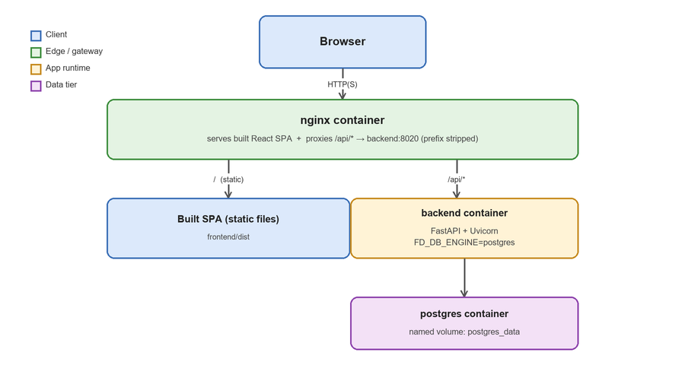
Figure 5 — The standalone deployment topology. nginx is the only container the browser ever reaches; it serves the built SPA directly and proxies /api/* to the backend with the prefix stripped, so a new backend route never needs a matching nginx change.
Schema and indexes are created automatically against Postgres on first connect, the same way they always have been against SQLite — there is no separate migration step. docker compose logs -f backend tails the backend's logs; docker compose down stops everything but keeps all data (named volumes); docker compose down -v deletes it.

10.2 AWS / Azure
deploy/aws/deploy.sh and deploy/azure/deploy.sh provision one VM (an EC2 instance / an Azure VM), install Docker on it, sync this repository up, and start the exact same standalone stack from 10.1. Both are idempotent — re-running either script reuses the same instance rather than creating a second one.

10.3 Windows-Native (FileNet)
Only needed if a deployment actually requires FileNet content-write support — every other one of the 54 storage providers, and FileNet reads, work identically in the ordinary Docker path. Writing to FileNet on this installation needs a subprocess call to a local WebSphere Java runtime (see the callout below), which can't be containerized, so this path runs the backend natively as a Windows Service while Postgres and nginx still run in containers via Docker Desktop/WSL2.
Why FileNet writes need a Java bridge at all: The WSI/SOAP transport this app otherwise uses for FileNet has a server-side defect on content-write operations against this specific installation. Writes (create document, check-in) go through the FileNet Java API over native EJB/IIOP via a small local CLI bridge instead; reads and everything else still use the ordinary SOAP client. See config.py's FD_WAS_JAVA_HOME / FD_JACE_JAR / FD_WAS_RUNTIMES / FD_WAS_PROFILE_PROPS settings.

10.4 Before This Is Really “Production”
The paths above get a working, reachable deployment fast — they deliberately don't do everything a hardened production setup needs:
- TLS — nothing here terminates HTTPS. Put a real domain and certificate in front (a cloud load balancer, or a Certbot/Let's Encrypt sidecar). FD_OAUTH_REDIRECT_BASE must match whatever public HTTPS URL you land on before registering any OAuth app or SAML IdP against this deployment.
- Database backups — no automated backup schedule out of the box. Either add pg_dump on a schedule, or point at a managed Postgres instance (RDS / Azure Database for PostgreSQL) instead.
- Secrets management — deploy/.env holds plaintext credentials on whatever host runs it — move to a real secrets manager before this holds real customer data.
- Scaling beyond one box — this is a single-instance deployment by design. Running more than one backend replica needs a shared session store first — sessions are an in-process, per-worker dictionary today.

11. Configuration Reference
Every value below has a working default except where noted — a blank default means the feature stays disabled/unconfigured until an admin supplies a value, either as an environment variable or later at runtime through Settings, which always takes precedence once saved.

11.1 Core
Variable | Default | Purpose
FD_DATA_DIR | backend/data | Root directory for SQLite files, the JWT secret, local-disk storage
FD_JWT_SECRET | auto-generated | Signing secret for session JWTs
FD_SECRETS_KEY | auto-generated | Encryption key for secrets at rest
FD_APP_USERNAME / FD_APP_PASSWORD | admin / admin | Seed account — change before any shared use
FD_OAUTH_REDIRECT_BASE | http://127.0.0.1:8020 | This server's externally-reachable base URL

11.2 Database
Variable | Default | Purpose
FD_DB_ENGINE | sqlite | sqlite | postgres | oracle
FD_DB_URL | — | Full SQLAlchemy URL for postgres/oracle
FD_DB_HOST / PORT / NAME / USER / PASSWORD | — | Connection components, used when FD_DB_URL is blank

11.3 AI Backend
Variable | Default | Purpose
FD_AI_BACKEND | none | none | anthropic | openai | ollama | watsonx | watson_nlu | watson_disco
FD_ANTHROPIC_API_KEY / FD_ANTHROPIC_MODEL | — / claude-sonnet-5 | Anthropic (Claude)
FD_AI_API_KEY / FD_AI_BASE_URL / FD_AI_MODEL | — / api.openai.com / gpt-4o-mini | OpenAI-compatible (incl. real ChatGPT)
FD_OLLAMA_URL / FD_OLLAMA_MODEL | localhost:11434 / llama3 | Local Ollama
IBM_CLOUD_API_KEY / WATSONX_PROJECT_ID / WATSONX_URL / WATSONX_MODEL | — | IBM watsonx.ai
WATSON_NLU_URL / WATSON_NLU_APIKEY | — | Watson Natural Language Understanding
WATSON_DISCO_URL / WATSON_DISCO_APIKEY / WATSON_DISCO_PROJECT_ID | — | Watson Discovery

11.4 Everything Else
FileNet (FD_FILENET_*, FD_WAS_*, FD_JACE_JAR), the OAuth storage providers (FD_GOOGLE_*, FD_MS_*, FD_BOX_*, FD_DROPBOX_*, FD_LASERFICHE_*, FD_SHAREFILE_*), and DocuSign e-signature (FD_DOCUSIGN_*) each follow the same pattern — a working default where one makes sense, admin-settable at runtime otherwise. See backend/.env.example and backend/app/config.py for the complete, authoritative list; both are kept current and are shorter to grep than to duplicate here.

12. Appendix

12.1 Glossary
Term | Meaning
Connection | A saved set of credentials/config pointing at one storage-backend account
Provider | A concrete StorageProvider implementation for one backend type (e.g. Box, FileNet)
Store | A *_store.py repository module — the only layer allowed to touch the database
Feature | A single named permission gate, defined in features.py
Group | An admin-managed set of Features; a user's access is the union of their groups'
Workflow definition | A reusable, shared template describing an approval process's steps
Workflow instance | One actual approval request created against a definition
Resource | A file or folder, addressed generically as {resource_type, resource_id}
Event bus | activity_service — the Observer subject every write reports to
Share link | A token-addressed, unauthenticated URL granting view/comment/edit on one resource

12.2 Where to Find Things
I need to… | Start here
Add a new API endpoint | backend/app/routers/ — find the closest existing router, or add one and register it in main.py
Add a new database table | A *_store.py module — copy notifications_store.py's shape (Section 5.4) as the reference pattern
Add a new storage backend | backend/app/storage_providers/ — implement StorageProvider, register in registry.py
Change what gets audited/notified/webhooked | activity_service.record_event() call sites, and notification_service._NOTIFIABLE_EVENT_TYPES
Add a new Settings tab | frontend/src/components/SettingsPage.tsx's TABS array, plus a new panel component
Change AI behavior | backend/app/ai_service.py
Deploy to a new environment | deploy/README.md
Understand every environment variable | backend/app/config.py + backend/.env.example

This document reflects the codebase at the time it was written. Treat any part of it that goes stale as a bug against either the code or the document — whichever is actually wrong.

