Welcome to C-ECM
A Quick-Start Guide for New Users
No experience needed — just a web browser and a login

Everything you need for your first day, and a reference for everything after it.

Table of Contents
Right-click this area and choose "Update Field" (or press F9) to build the table of contents.

1. Welcome
If today is your first day using C-ECM, this guide is for you. It assumes you know nothing about the system yet — not how it works behind the scenes, not any special terminology, nothing. By the end of Section 3, you'll be able to sign in, find your way around, and open or upload a document. Everything after that is there for when you need it — approvals, search, AI help, sharing — you don't need to read it all today.
How to use this guide: Read Sections 1 through 3 now. Skim the section titles for everything else so you know it's there, and come back to the relevant section the first time you actually need to do that thing.

2. What Is C-ECM?
C-ECM is where your team's important documents live, get reviewed, get approved, and get found again later — no matter which system they actually happen to be stored in.
Here's the problem it solves: most organizations end up with documents scattered across several different systems — one team uses a shared drive, another uses a specialized document system, IT keeps things somewhere else again. Finding the right version of something, getting it signed off properly, and proving later who approved it and when, becomes a scavenger hunt across five different tools.
C-ECM sits in front of all of those systems and gives you one consistent way to work with documents wherever they live: the same search, the same approval process, the same activity history, no matter which underlying system a particular document is actually stored in. To you, it just looks and feels like one shared drive.

2.1 What You Can Do With It
- Browse and organize — folders and files, exactly like a shared drive you may already know.
- Search — find a document by name, or search across every connected system at once.
- Get approvals — send a document through a defined sign-off process and track exactly where it stands.
- Comment and tag — leave notes on a document for your team, and label things so they're easy to find later.
- Ask AI about a document — get a quick summary, or ask a question about its content, without reading the whole thing.
- Share safely — send a link to someone outside your team, without emailing the file itself.
- Stay notified — know the moment something you care about changes, gets commented on, or needs your approval.

3. Your First Day
Five steps, and you're productive. Here's the whole journey at a glance:
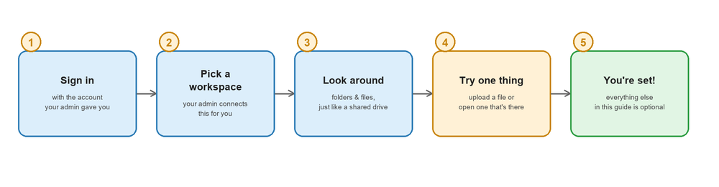
Your first five minutes in C-ECM.

3.1 Signing In
Go to the C-ECM web address your admin gave you. Enter the username and password you were given, and select Sign In.
If your organization uses single sign-on: you may see a “Sign in with your company account” option instead — use that, and you won't need a separate C-ECM password at all.
Change your password the first time you sign in if you were given a temporary one — you'll find this under Settings → Users once you're in.

3.2 Choosing Your Workspace
C-ECM can connect to more than one document system at once — your company might have one for contracts, another for HR files, another that's just a shared folder. Each one of these is called a connection, and you switch between them from the sidebar on the left.
In most cases your admin will have already set up the connection(s) you need before your first day — you shouldn't need to configure anything yourself. If the sidebar is empty, or you can't find a connection you were told to expect, that's the first thing to ask your admin about.

3.3 Your Workspace at a Glance
Once you're in, everything happens on one main screen. Here's what each part does:
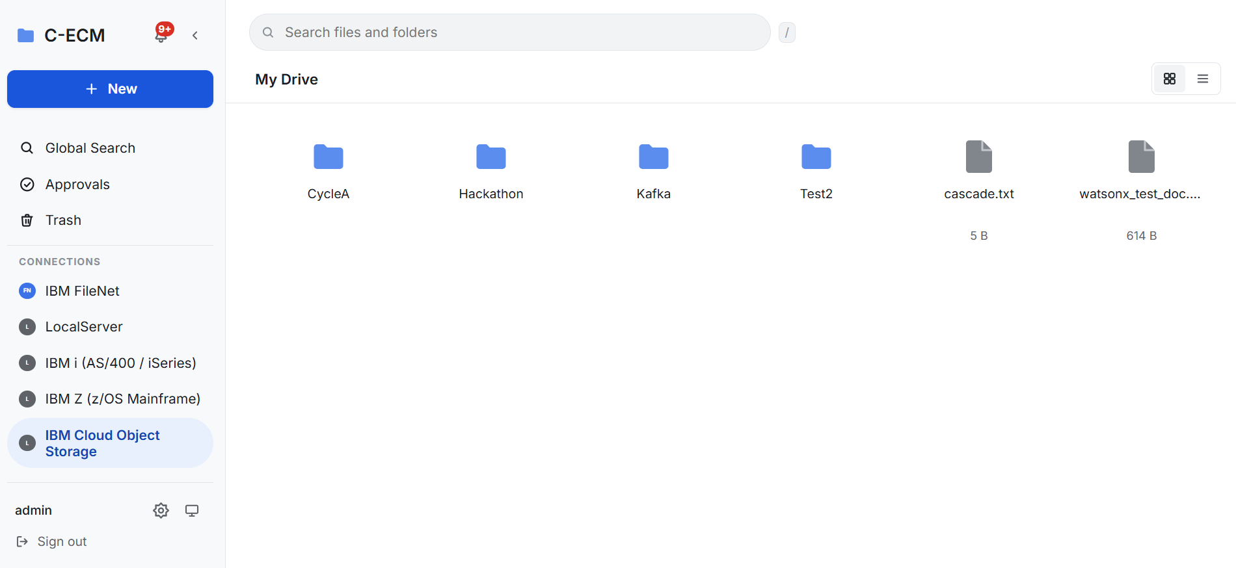
The main C-ECM screen — the same layout every time, wherever you are in the app.
Area | What it's for
Sidebar (left) | Switch between connected systems, jump to My Files/Trash/Approvals, open Global Search or Settings
Top bar | See where you are, search the current folder, switch between grid and list view
Bell icon | Your notifications — a small dot appears when you have something new
Main area | Your folders and files. Click a folder to open it; click a file to view it

4. Everyday Tasks

4.1 Uploading a Document
1. Open the folder you want to upload into.
2. Click Upload (or drag the file straight from your computer into the browser window).
3. Choose the file from your computer.
4. That's it — it appears in the folder immediately, ready for anyone else with access to see it.
Uploading the same filename into a folder again doesn't overwrite the old one — it creates a new version instead, and the old one is still there if you ever need to go back to it (see 4.6).

4.2 Downloading a Document
Click a file to open it, then choose Download — or select one or more files in the grid and use the download action in the toolbar to get several at once.

4.3 Finding Things — Search
There are two search boxes, for two different jobs:
- Search (top bar), looks inside the folder/connection you're currently in — use this when you roughly know where something is.
- Global Search (sidebar), looks across every connected system at once and brings back one combined list — use this when you're not sure where something is, or want to check everywhere at once.
You can save a search you run often — look for the Save Search option next to your results — so you never have to retype it.

4.4 Tags and Comments
Two lightweight ways to add context to a document without changing the file itself:
- Tags — short, color-coded labels (like “Urgent” or “Q3 Budget”) you attach to a file or folder so it's easy to filter and find later. Add one from the file's detail view.
- Comments — a running conversation attached to a document, visible to anyone with access to it. Use @ to mention a specific teammate — they'll get notified. Mark a comment Resolved once it's been addressed, so the thread stays easy to scan.

4.5 Custom Fields (Metadata)
Some document types have extra structured fields your organization has set up — for example, an invoice document type might have Invoice Number and Amount fields. If a document has these, you'll see them in its detail view under Properties, and your admin can require certain ones to be filled in before the document counts as complete.

4.6 Version History
Every time a file is uploaded again over an existing one, C-ECM keeps the previous version instead of throwing it away. Open a file's Version History to see every past version, download an older one, or restore it as the current version if a recent change needs to be undone.
Checking out a file: if you're about to make a series of edits and want to make sure nobody else overwrites your work in the meantime, use Check Out first — it locks the file for editing until you check it back in.

5. Requesting and Giving Approvals
This is how C-ECM replaces the “can you sign off on this?” email thread. Instead of a message that gets buried in someone's inbox, an approval request is tracked, timestamped, and visible to everyone who needs to see it — including proof, later, of exactly who approved what and when.
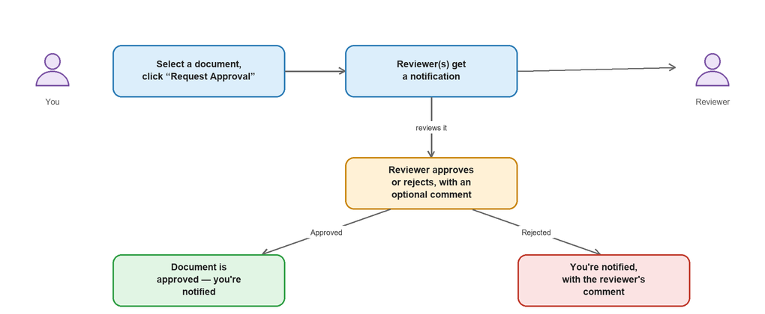
The approval journey — from your request to the final decision.

5.1 Requesting Approval on a Document
1. Select the document (or several documents at once) you need approved.
2. Click Request Approval and choose which approval process applies (your admin sets these up — common ones might be “Manager Sign-off” or “Legal Review”).
3. Add an optional note explaining what you need reviewed.
4. Submit — the right people are notified automatically.
You can track every request you've made under Approvals → My Requests, including exactly which step it's on and who it's currently waiting on.

5.2 Reviewing and Acting on a Request
If you're an assigned reviewer, you'll see pending requests under Approvals → Inbox, and also right on the document itself when you open it. For each one, you can:
- Approve — moves the request to its next step, or completes it if yours was the last one.
- Reject — stops the request; add a comment explaining why so the requester knows what to fix.
Some approval processes need more than one person's sign-off at a single step (a “quorum”) — you'll see how many approvals a step still needs right on the request.

5.3 Reassigning a Request
If a request is sitting with someone who's out, or was simply sent to the wrong person, it can be reassigned to someone else without starting the whole process over. This can be done by the person who requested it, the person it's currently assigned to, or an admin.

6. Getting Help from AI
Every document has an AI Insights panel that can save you from reading the whole thing just to find one piece of information.

6.1 Summarize a Document
Open a document, find the AI Insights panel, and select Generate under Summary. In a few seconds you'll get a short, plain-language summary of what the document actually says.

6.2 Ask a Question
Type a question in plain English — for example, “What's the payment due date?” or “Who are the parties to this agreement?” — and the AI answers using only the content of that specific document. If the answer isn't in the document, it will tell you that honestly rather than guess.
Which AI is answering: a small badge next to the panel names whichever AI service your organization has configured (for example, Claude or ChatGPT) — this can vary by organization, but works exactly the same way from your side either way. If you don't see an AI Insights panel at all, your organization hasn't turned this feature on yet — ask your admin.

7. Sharing Documents with People Outside Your Team
Instead of emailing a file (which immediately creates an out-of-date copy the moment the original changes), share a link. Open the document, choose Share, and pick what the recipient can do with it — View only, Comment, or Edit. You can also protect the link with a password, and revoke it at any time from that same Share panel — the link simply stops working the moment you do.

8. Staying in the Loop — Notifications
The bell icon in the top bar shows you what's happened recently on documents you're involved with: a new comment, a version uploaded, an approval that now needs your action, and more. Click it to see the full list, and select any notification to jump straight to what it's about.

9. Signing Documents Electronically
For documents that need a legally binding signature (contracts, agreements), C-ECM can send them out through DocuSign directly from the document's detail view — choose Send for Signature, add the signer's name and email, and track its status (sent, viewed, signed) right alongside everything else that's ever happened to that document.

10. Tips, Shortcuts, and Good Habits
- Use Global Search first if you're not 100% sure which folder or connection something is in — it's faster than clicking through folders.
- Tag as you go, not after the fact — a label takes five seconds to add when you're already looking at the document, and much longer to add to a hundred documents later.
- Comment instead of emailing about a specific document — the conversation stays attached to it forever, instead of living in someone's inbox where nobody else can ever find it again.
- Check the version history before assuming a file is wrong or out of date — the version you need might just be one click away.
- Ask AI before reading top to bottom on a long document — a quick summary or a direct question is often all you actually need.

11. Getting Help
If you… | Do this
Forgot your password | Use the “Forgot password” link on the sign-in page, or ask your admin to reset it
Can't see a folder or connection you expect | Ask your admin — access is granted per person/group
Don't see an approval you're expecting to act on | Check Approvals → Inbox; ask the requester to confirm you were named as a reviewer
Get an error you don't understand | Note what you were doing and take a screenshot, then contact your admin or IT support
Have a question this guide didn't answer | Ask your admin — they can also point you to the full technical documentation if needed

Welcome to the team — you're ready to go.

