Application

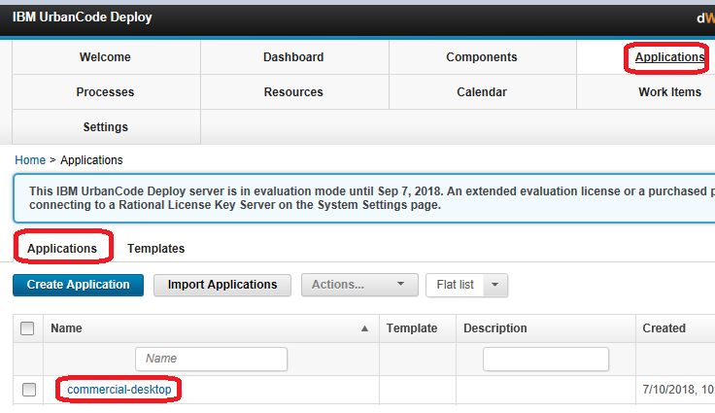

Component template

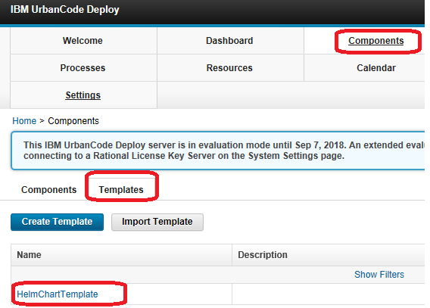

Components:

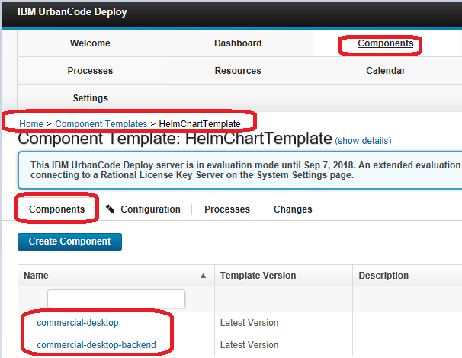

Agent

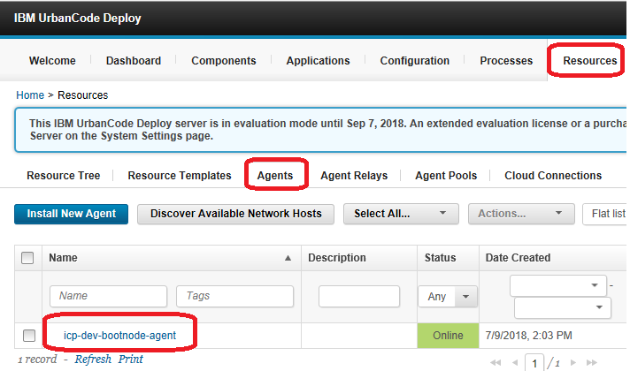

Agent Pool

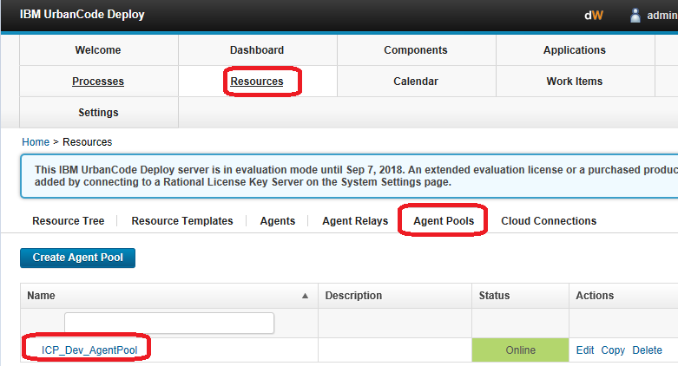

Resources

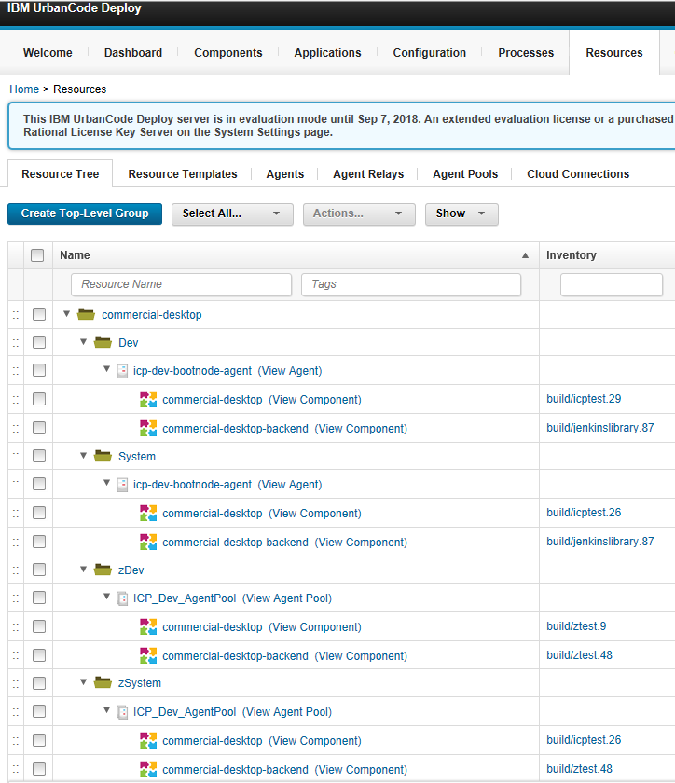

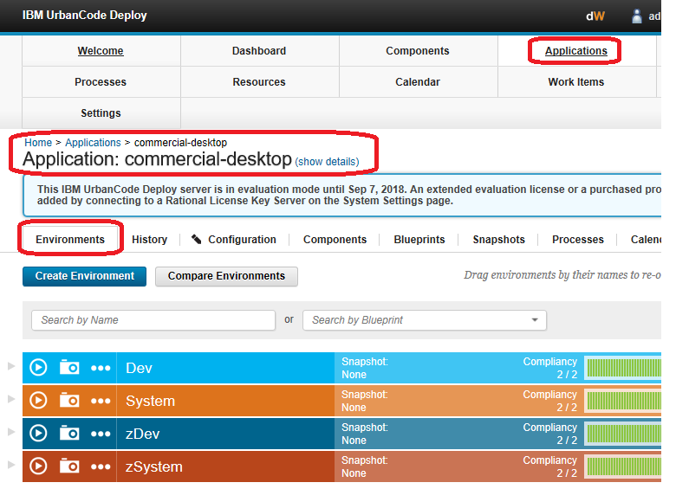

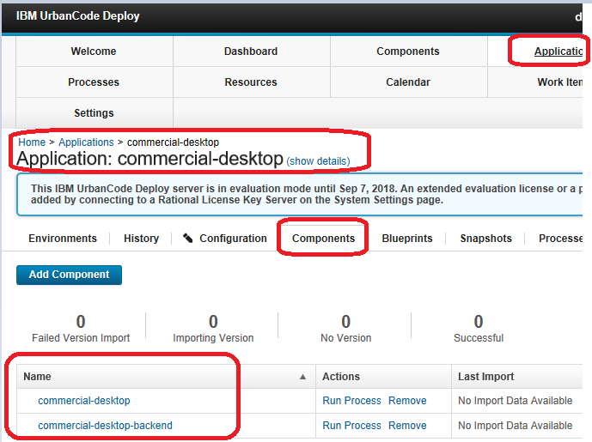

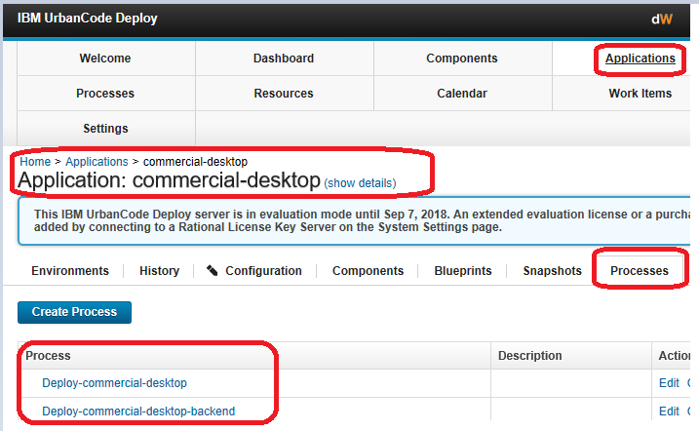

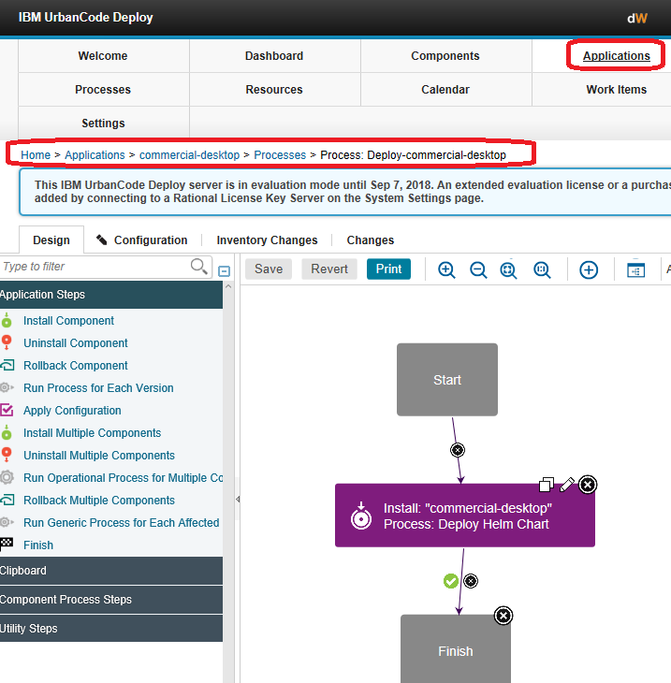

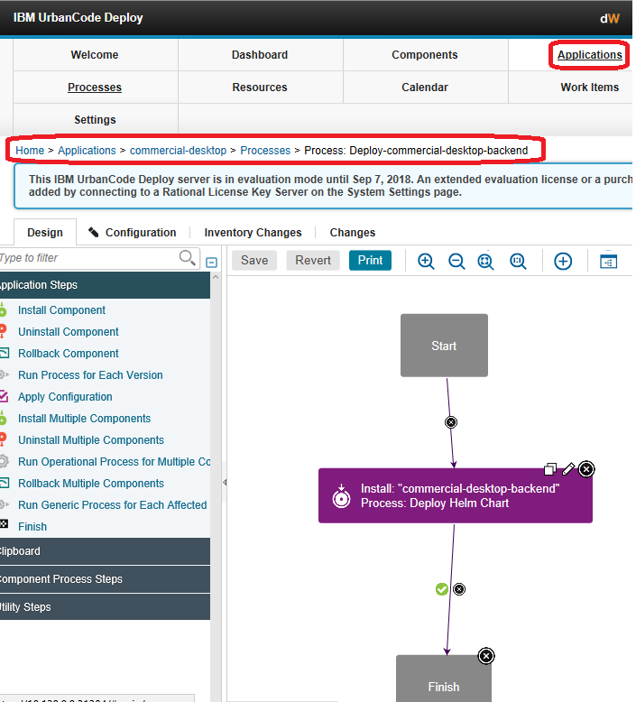

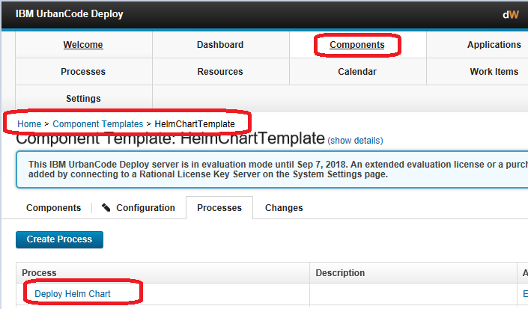

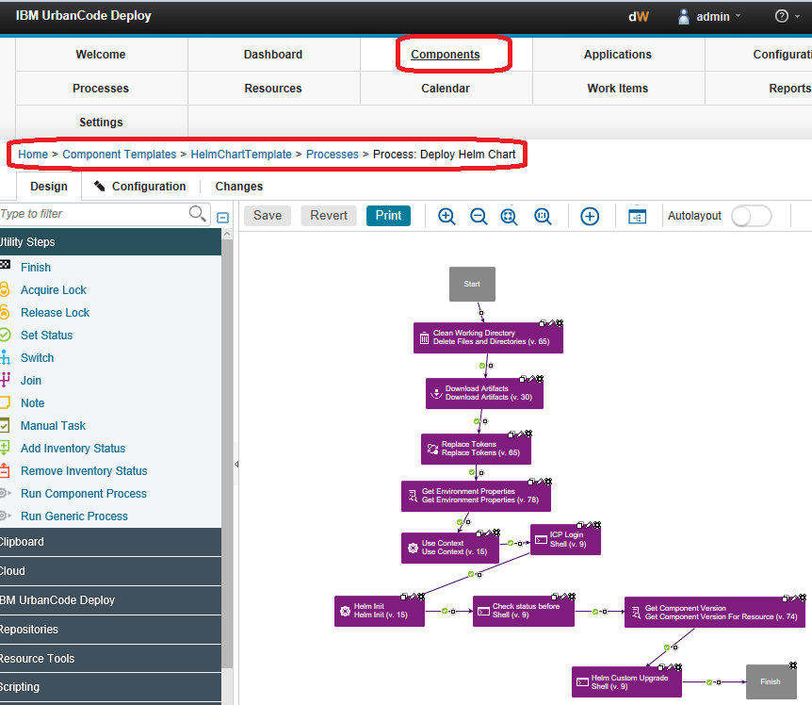

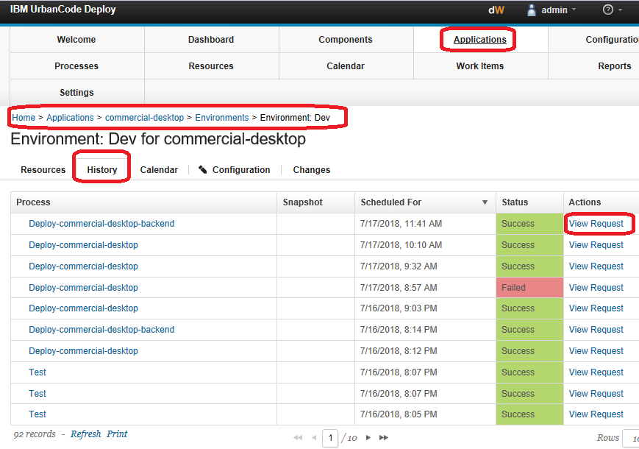

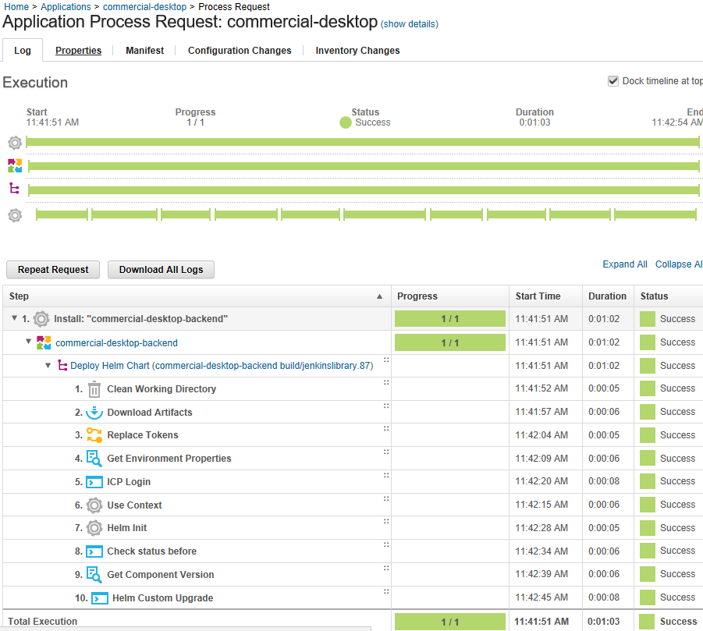

|  |
| --- |
| echo "Environment Name = ${p:environment.name}"  echo "Component Name = ${p:component.name}"  echo "Current selected Component Version Name = ${p:version.name}"  rc=`cut -d. -f1 <<< ${p:version.name} 2>&1`  echo "temporary rc = $rc"  rc=`echo "${rc}" | sed -r 's/[/]+/-/g' 2>&1`  echo "Git Branch = $rc"  hr="${p:component.name}-${p:environment.name}-${rc}"  echo "Old Helm release = ${p:helm.release}-${rc}"  echo "New Helm release = ${hr}"  echo "Ensure helm release name only contains lower case."  echo "Helm release (all lower case) = ${hr}"  hr=`echo "${hr}" | tr '[:upper:]' '[:lower:]' 2>&1`  echo "Ensure helm release name has < 53 characters, and cut off after 53th character."  hr=`cut -c-53 <<< ${hr} 2>&1`  echo "Final Helm release = ${hr}"  helm upgrade ${hr} ./helm_chart --namespace ${p:icp.namespace} --install --wait --timeout 30 --tls --debug |
| var exit = properties.get('exitCode');  commandOut.println("initial step exitCode = " + exit);  var passed = 0;  commandOut.println("initial passed = " + passed);  scanner.register("STATUS: DEPLOYED", function(lineNumber, line) {  var value = line.replace("STATUS: ", "");  properties.put("Value", value);  passed = 1;  });    scanner.scan();  var currentValue = properties.get('Value');  commandOut.println("STATUS = " + currentValue);  commandOut.println("Determined passed = " + passed);  if (passed == 1) {  commandOut.println("passed is 1. found keyword. Override Failure and set status to Success !!!");  properties.put('Status', 'Success');  } else {  commandOut.println("passed is not 1 -> keyword not found. Failure.");  properties.put('Status', 'Failure');  }  commandOut.println("Final step status = " + properties.get('Status')); |
| echo "Check release status: namespace = ${p:icp.namespace} , release name = ${p:helm.release}"  helm ls --deployed --namespace ${p:icp.namespace} --tls | awk '/${p:helm.release}/ {print "Counter: " $2}' |