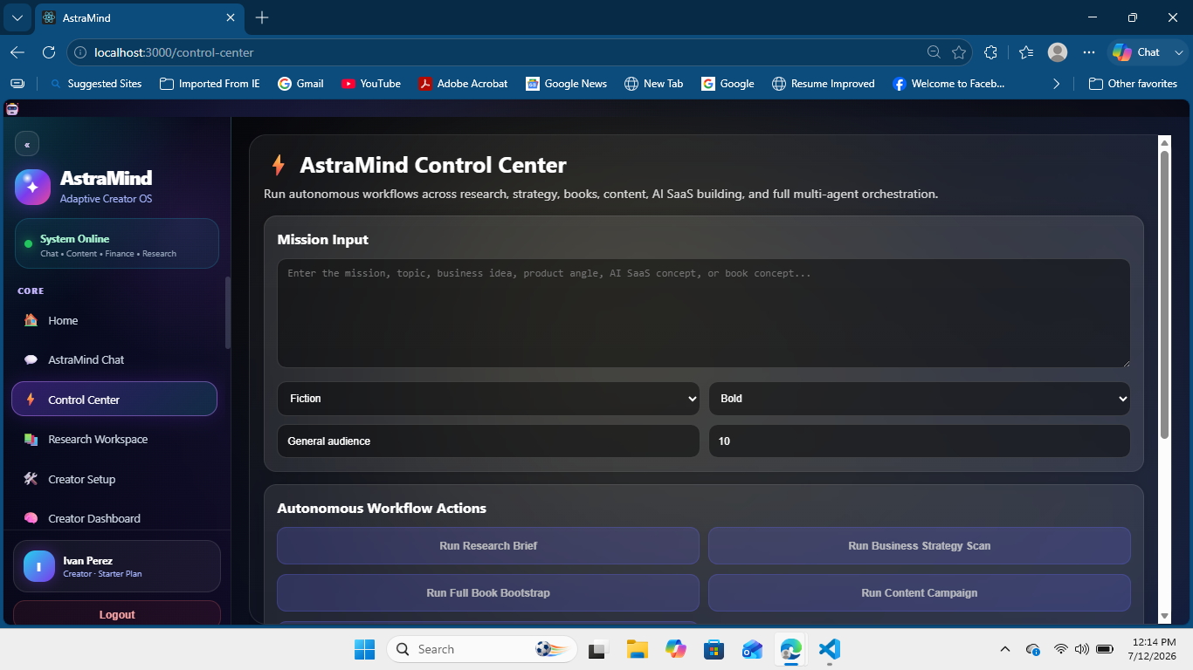

AstraMind Integration Design Report
Runway text-to-video contract repair and mission-aligned research safeguards |  | Prepared by AstraMind Engineering  July 2026

Contents

Executive summary 2
At a glance 2
Introduction 2
Key findings 3
Context and conditions 3
Patterns in the evidence 3
Implications 3
Recommendations 4
Conclusion 4
Appendix 5
Notes 5
Source placeholders 5

Executive summary
The content pipeline reached Runway, but task creation failed before generation because a text-only Gen-4.5 payload was sent to the image-to-video endpoint. The adapter also allowed prompts beyond the installed Runway contract maximum.
The integration now targets /v1/text_to_video, trims prompts to 1,000 UTF-16 characters, and prints nested provider errors as structured JSON. Research filtering also requires a meaningful overlap with the original mission before external material may influence creative direction.

At a glance
- Root cause: endpoint and prompt-length contract mismatch.
- Safeguard: mission-specific terms must match research evidence.
- Verification: 27 kernel tests pass and the production build compiles.

Introduction
The requested mission is an AstraMind capabilities presentation, script, and video. The observed run correctly classified the request and entered the content pipeline, then failed at Runway task creation. After that failure, autonomous research attached a generic TikTok-trends source and produced an unrelated trend hook.
This report records the integration contract repair and the mission-integrity boundary needed before another paid generation attempt. It does not claim a completed external render; that remains the final live acceptance test.

Key findings
Two independent defects were visible in one run: provider payload validation blocked video generation, while weak lexical relevance allowed a generic trend source to influence the mission. Both issues were reproducible from the supplied log and traceable to bounded adapter and filtering code.

Context and conditions
The installed Runway SDK defines a dedicated text-to-video union for model gen4.5: duration 2-10 seconds, promptText up to 1,000 characters, and ratio 1280:720 or 720:1280. AstraMind used the correct host and API version but posted that payload to /v1/image_to_video and sliced prompts at 5,000 characters.

Patterns in the evidence
The mission-integrity score previously accepted any source above a small cosine-style token threshold. Generic production words could therefore create a false match. The revised gate removes generic request vocabulary and requires at least one retained mission term in addition to the score threshold.

Key takeaway. Provider correctness and topic correctness are separate gates; successful API submission must never authorize unrelated research to redirect the user mission.

Implications
The repaired boundary reduces avoidable provider charges, makes failures diagnosable, and prevents a pre-launch product demonstration from becoming a generic social-trends video. A live provider run is still required because local tests validate contracts and orchestration, not account credit, moderation, or remote availability.
Control | Observed state | Release implication
Runway request | Wrong route; oversized prompt allowed | Task rejected before generation
Research relevance | Generic trend source accepted | Mission drift in hook and angle
Verification | Tests and build pass | Ready for one controlled live run

Recommendations
Use a staged acceptance run that proves the provider request, returned media URL, mission continuity, and customer-visible package before broadening the pipeline.
- Run one bounded mission. Submit the AstraMind capabilities demonstration with a short scene prompt, Gen-4.5, five-second duration, and 1280:720 ratio.
- Inspect each gate. Confirm task creation, polling, SUCCEEDED output, media download, and that research is either AstraMind-relevant or explicitly excluded.
- Record acceptance evidence. Capture the task ID, final media URL, source count, continuity score, and visible Creator Studio package; redact credentials from all evidence.

Conclusion
AstraMind is locally ready for the next controlled integration test. The request now matches Runway text-to-video, error details are actionable, and irrelevant trend research is rejected before it can alter the mission.
Release approval should follow one successful external render and a UI confirmation that the generated package exposes the playable media URL rather than a generic failure state.

Appendix

Notes
Verification completed locally: all 27 kernel tests passed, including the Runway route/header/polling contract and mission-integrity rejection case. The optimized React production build compiled successfully.
Verification limitation: no paid Runway task was submitted during this code change. Remote account balance, provider moderation, and final playback remain live acceptance criteria.

Source placeholders
- Runway SDK 3.21.0. TextToVideoCreateParams type contract. Local dependency, inspected July 2026.
- AstraMind server trace. Runway validation failure and autonomous research output. 12 July 2026.
- AstraMind source. src/core/content/runwayEngine.js and MissionIntegrityEngine.js. Updated 12 July 2026.
- AstraMind kernel verification. 27 tests and production build output. 12 July 2026.

Release note. Repeat the live acceptance test after any provider model, route, or request-schema change.

