Prerequisites
- Eclipse Mars IDE for Java EE
http://www.eclipse.org/downloads/packages/eclipse-ide-java-ee-developers/marsr
- Use Eclipse Marketplace to install Migration Toolkit for Liberty Tech Preview 8.5.5 Eclipse Plugin
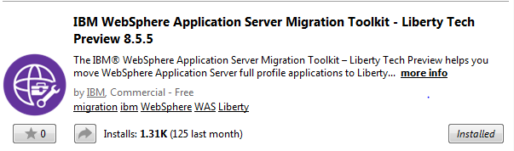

- Use Eclipse Marketplace to install Migration Toolkit for Competitive Migration Eclipse plugin
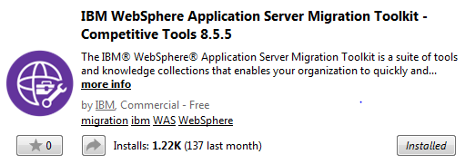
- Use Eclipse Marketplace to install Bluemix tooling for Eclipse
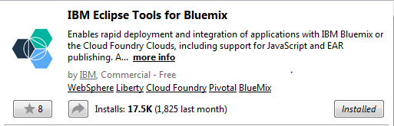
- Ensure you have downloaded Apache Tomcat 7 as explained in the Pre-requisites document.
- Ensure you have downloaded WAS Liberty 8.5.5.6 as explained in the Pre-requisites document.

- Install Java JRE 1.7
http://www.oracle.com/technetwork/java/javase/downloads/jre7-downloads-1880261.html

Migration Flow:
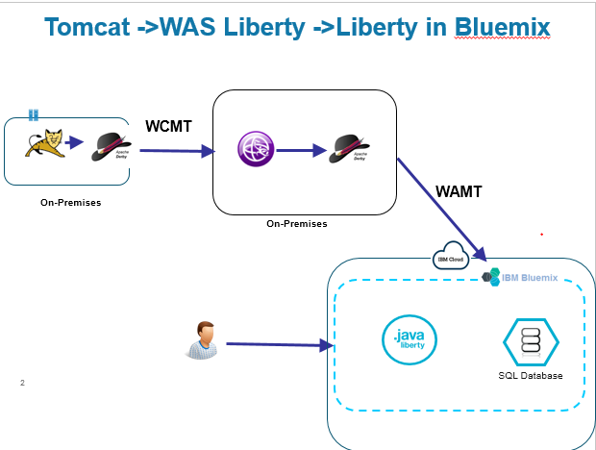

Deploy RedbookLibrary Application on Apache Tomcat 8 Server
We will first deploy the application on Apache Tomcat Server to better understand the overall business flow of the application. We will then verify that the same behavior is maintained after the application is migrated to a standalone Liberty server, and then deployed on Liberty for Java runtime in Bluemix.

Configure Tomcat runtime profile
- Go to Servers tab, right click and select New > Server
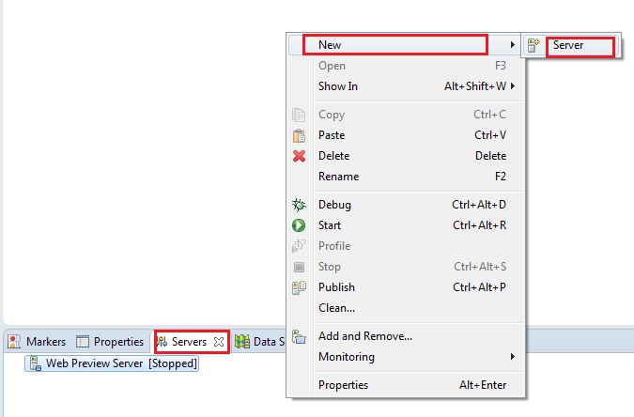
- Expand Apache and select Tomcat v8.0 Server. Leave the Server’s host name and Server name to default value. Click Next

- Click Finish to complete the configuration of a new Tomcat server.

Import and Configure WAR file
- Go to link https://github.com/kgb1001001/RedbookLibrary and download zip . You need RedbookLibrary.war . Later in Step 3.1, you will need manifest.yml file.
- In Eclipse, click File > Import. Type WAR in the search/filter field. Select WAR file and click Next.
- Click the Browse button next to the WAR file field and navigate to the WAR file downloaded in Step 1. The Web project field will be populated automatically.
Make sure to uncheck the Add project to an EAR option.
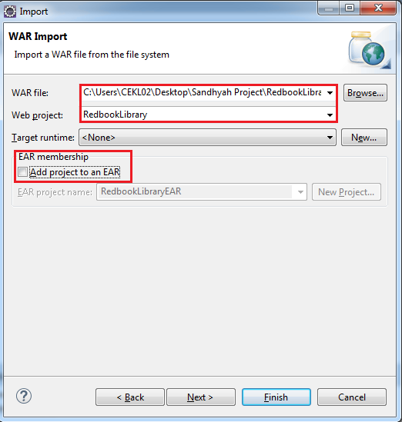
- Click Finish.
- If a popup dialog opens and ask to switch to the Web Perspective, select Yes.

Application Deployment on Tomcat Apache Server
- Now we will deploy the application into the Apache Tomcat server. Go to the Server tab, right click Tomcat server and select Add and Remove.
- Select RedbookLibrary, click Add then Finish
- Right click Tomcat server again, and select Start.
- Wait for the server status to show Started, Synchronized then browse to http://localhost:8080/RedbookLibrary. You should see the following page.
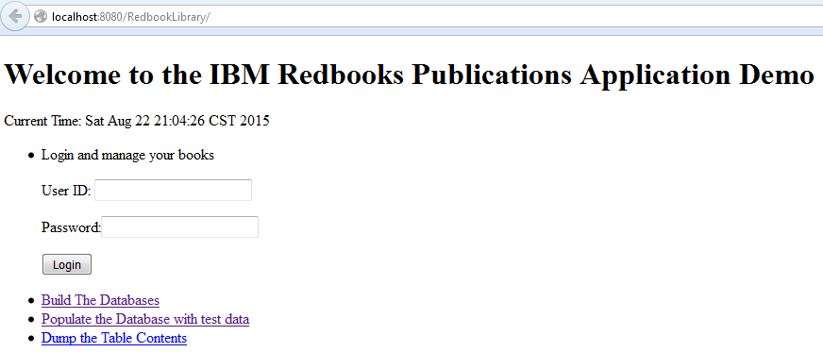
- Click the Build the Databases link, and you should see the success message “Databases created”
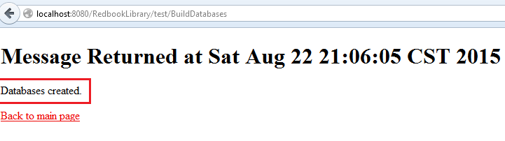
- Click the Back to main page link, then click Populate the Database with test data. You should see the success message “Databases populated”
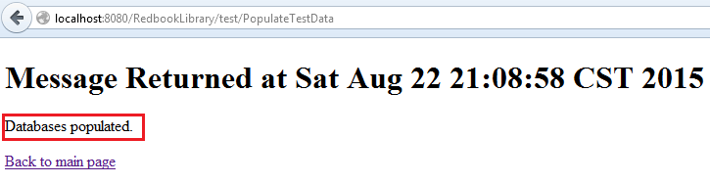
- Click Back to main page again. Now try to login with the username user1 and the password password1. If you see the Member Home page, then congratulations, you have completed your first deployment of application on Tomcat Apache server.
- In the Servers tab, right click on RedbookLibrary and remove the application from the Tomcat server.

Migrate to standalone Liberty Server using Eclipse

Configure WebSphere Application Server Liberty profile
- Stop the Apache Tomcat server if you have not already done so.

- In the Server tab, right click any empty space then select New > Server. Choose WebSphere Application Server Liberty Profile.
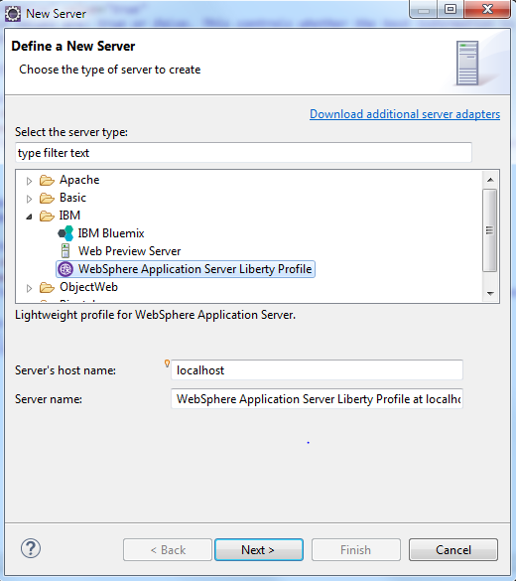
- Click Next
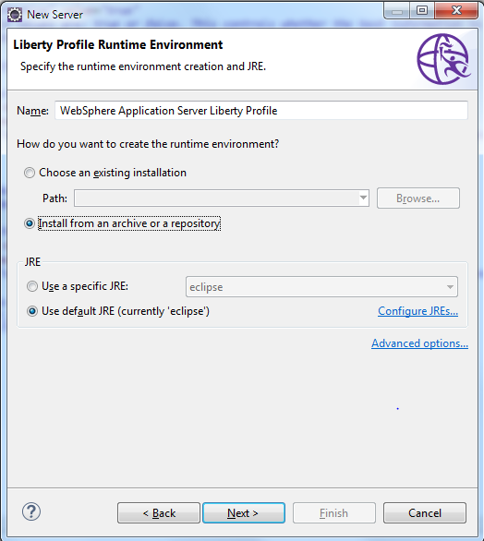
- Select Install from an archive or a repository.
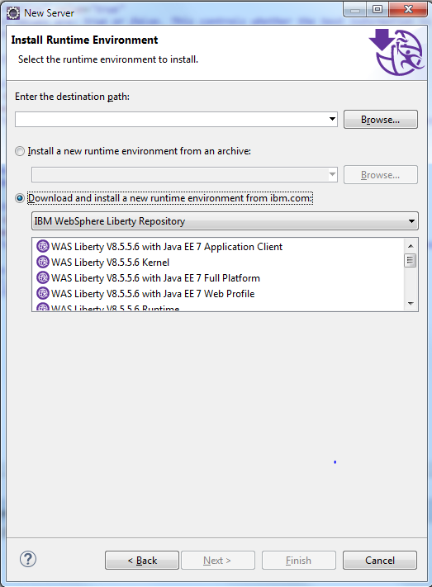
- Select Download and install a new runtime environment from ibm.com
- Enter the destination path as C:\wlp (or an appropriate path for your workstation OS)
- Select WAS Liberty V8.5.5.6 Runtime from the drop down list and click Next.
- Click Next again, brings up the License Acceptance popup, accept the license.
- Click Next, Next and Finish
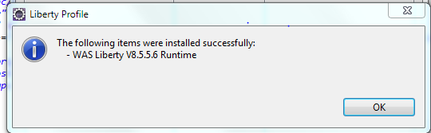
- Click on OK

- Now copy the derby.jar file from the lib directory from the db-derby-10.11.1.1-bin installation to the c:\wlpjee6\wlp\usr\shared\resources directory

Migrate Tomcat server configuration and application configuration to WebSphere Liberty

- In the Servers tab, stop Tomcat server. Right click and select Migrate Tomcat Configuration.
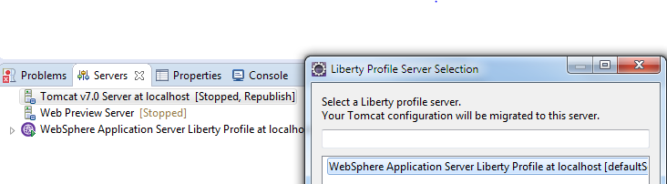
Select WebSphere Server Liberty Profile at localhost[defaultServer] and click OK.
On successful Tomcat server migration, you will see the following :
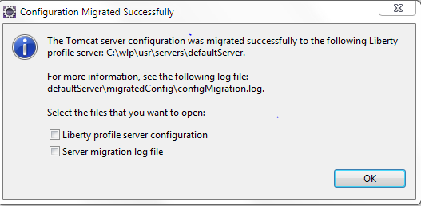
Click OK.
- Right click on RedbookLibrary project in Project Explorer and select Migrate Tomcat Configuration.
- Again, Liberty Profile Server Selection menu will pop up. Select WebSphere Server Liberty Profile at localhost[defaultServer] and click OK.
- On successful Tomcat server migration, you will see Configuration Migrated Successfully. Click OK.
- In Servers tab, right click on WebSphere Application Server Liberty Profile at localhost and select Start.
- Next, right click on RedbookLibrary project, select Run As-> Run on Server and choose WebSphere Application Server Liberty at localhost

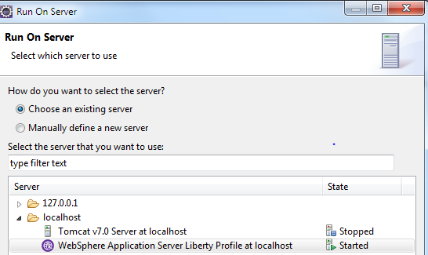
- Click Finish.
- Click Build the Databases. You should see the success message “Databases created”
- Click Back to main page, then click Populate the Database with test data. You should see success message “Databases populated”
- Click Back to main page again, and try to login with the username user1 and the password password1. If you see the Member Home screen, then congratulations, you have completed the migration of the application from Tomcat server to WebSphere Liberty Profile Server!

Migrate to Liberty Runtime on Bluemix Server
We will now migrate the existing RedbookLibrary application to be deployed into Liberty Runtime on Bluemix Server. This time, instead of the embedded Derby database, we will try to connect the application with SQLDB instance in IBM Bluemix.

Scan Application Binaries & Application Source to determine cloud readiness of the application

Using the Binary Assessment Tool on Application Binaries
You have downloaded the tool as part of pre-requisites.
Install the tool : java -jar binaryAppScannerInstaller.jar
After installing, go to the wamt subdirectory
Run the analysis from the wamt subdirectory: java -jar binaryAppScanner.jar \directory-containing-war-file.

- This command provides you with the high level technology analysis results (in HTML).
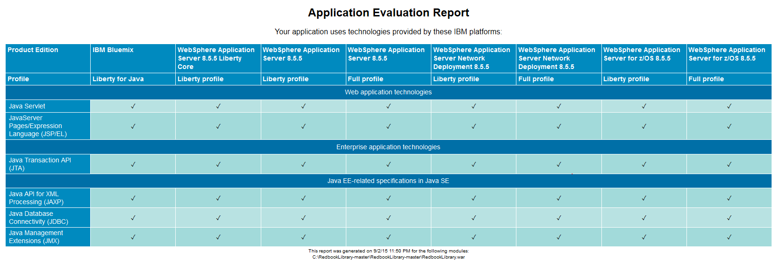
- Next, you can run a detailed analysis report, which highlights potential issues as you move to the cloud. The files, line numbers, and includes reference material for handling these problems. From the wamt subdirectory: java -jar binaryAppScanner.jar \directory-containing-war-file --analyzeMigrationDetails --targetAppServer=bluemix. This also produces an HTML file.

- Analyze results to choose your deployment topology
The Tech preview of the binary scanner provides important analysis information for our application.
- In the High Level Analysis, Under Web application technologies, we see that this application uses Servlet and JSP. This is, of course, not surprising for a Tomcat application. All the technologies will migrate to Liberty for Java runtime on Bluemix, as shown in column 1.
- Under Java EE-related specifications, we see the application uses JDBC. This application will also run in Liberty for Java on IBM Bluemix, however, we will need to decide how to actually handle the database.
- The detailed analysis provides us more information. Most of the areas flagged are from the local Derby database we used with Tomcat, and don't apply when we move to the cloud. You can easily see the rules that are flagged from derby files by looking at the File name detail.
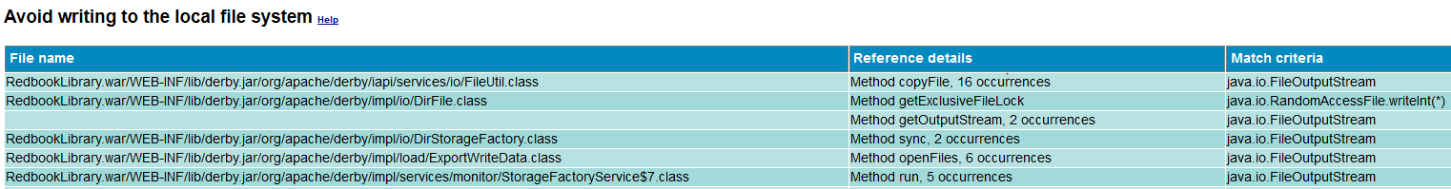
- Once we eliminate the issues coming from the files with derby, the rules that we need to pay attention to for cloud migration are Capture log information, HTTP Session Persistence, and Use SQL Database Service.

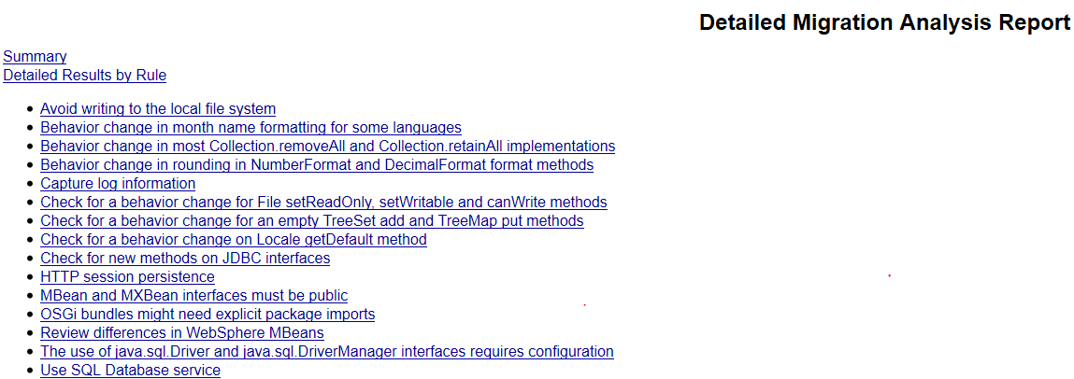

- For the database, the recommendation is to use SQL Database service in Bluemix, we will do that in this Lab.
- The report also flags Capture Log Information as something to check for in the application. When we look at the help, we see: "Applications can log to System.err/System.out so that Cloud Foundry's Loggregator component picks up the log entries. Using Loggregator, you can tail application logs and dump a recent set of application logs." In our application, we're using the standard Java logging facility and also logging to the default location, which is System.out. So it will be automatically picked up by the Loggregator.
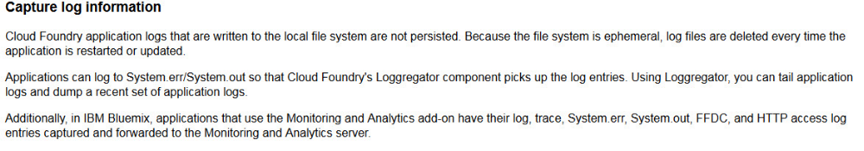
- HTTP Session Persistence can be handled by using Session Cache Cloud Services. Since we don’t have multiple instances of the App running, we can add Session Cache service at a later point.

Using Migration Toolkit for Competitive Migration
Migration Toolkit for Competitive Migration is provided by IBM to assist migrations from third party application servers to WebSphere Application Server, Liberty and Bluemix. The Migration Toolkit accelerates migrations, makes them quick and cost efficient.
The Migration Toolkit scans applications and reports any potential migration problems. The tool has contextual help that explains the finding and provides suggestions on how to fix it. For some cases, quick fixes exist that can apply changes to the code on your behalf.
Note: Make sure you are using the Java EE perspective.
- You have installed IBM WebSphere Application Server Migration Toolkit – Competitive Tools 8.5.5 as a pre-requisite to this Lab.

- Right click on RedbookLibrary and select Software Analyzer Configurations.
- Name your Software Analyzer Configuration as WAS Liberty to Bluemix and Analyze the application
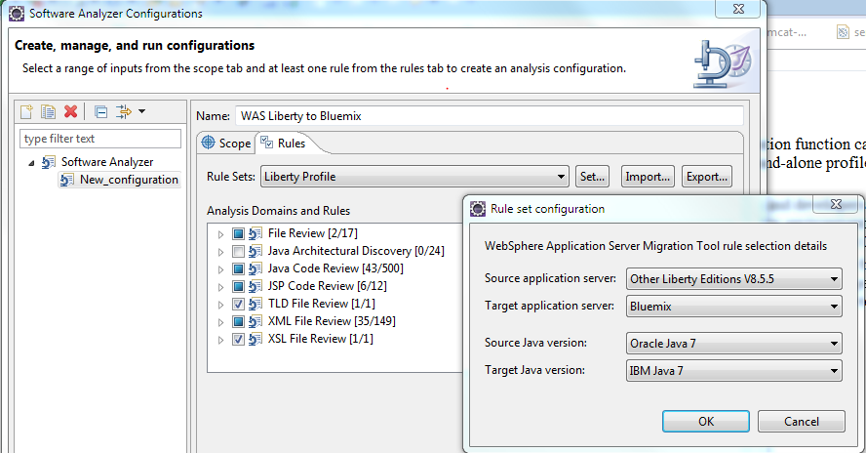
- Review and apply All Quick Fixes shown for the META-INF/context.xml file

- Login to bluemix.net , create a SQLDB service, give it the name library_db.
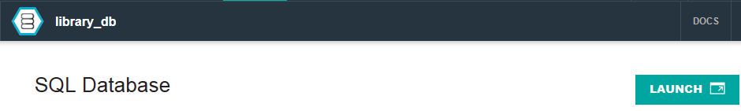
- Copy manifest.yml file from the folder where you unzipped the GitHub project:

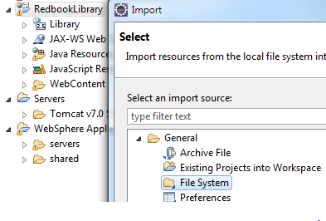
- Specify folder where you have unzipped the RedbookLibrary project from GitHub., select manifest.yml and click Finish
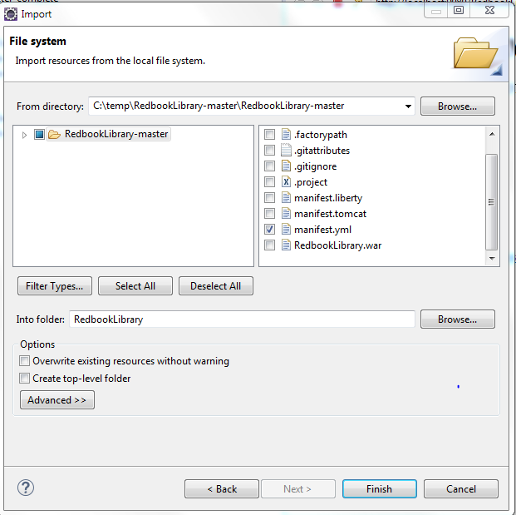
- In Servers tab, Click New->Server and select IBM Bluemix, Click Next
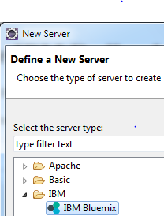
- Enter Bluemix credentials and click Next. Select your space for deploying the application in Bluemix.
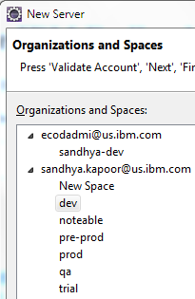
Click Next.
- No need to add RedbookLibrary to Bluemix server. Click Finish.
- Right click on RedbookLibrary project. Select Run As -> Run on Server. Select IBM Bluemix.
- Choose a name for your application
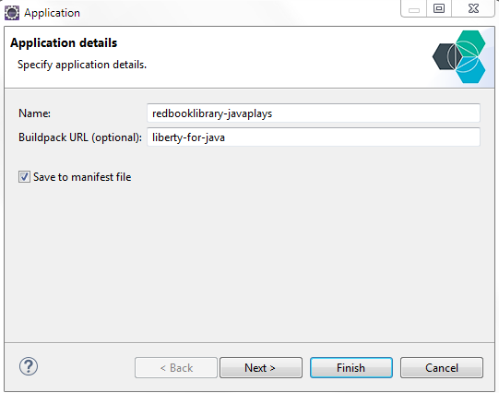

- Click Next
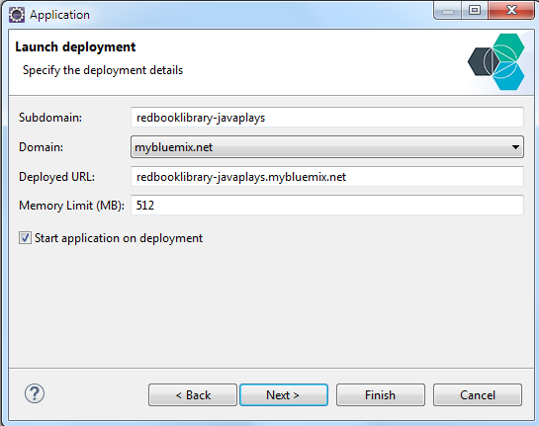
When the application is started, open http://redbooklibrary.eu-gb.mybluemix.net/RedbookLibrary in a browser.
- Click Build the Databases. You should see the success message “Databases created”.
- Click Back to main page, then click Populate the Database with test data. You should see the success message “Databases populated”.
- Click Back to main page again, and try to login with the username user1 and password password1. If you see the Member Home screen, then congratulations, you have completed the migration of RedbookLibrary application to Liberty Profile Server running on Bluemix!

End of Lab

